Data Sciences Mini Project
Phase 4 — Final Project Implementation
Project Title: Traffic Accident Analysis

1. Final Model
The final selected model is an XGBoost multiclass classifier, chosen for its best overall performance in Phase 3 (Accuracy 0.85, weighted F1-score 0.83). The final model was retrained on the full cleaned working dataset (train + validation combined) using the tuned hyperparameters identified via GridSearchCV: n_estimators = 400, max_depth = 8, learning_rate = 0.1, with SMOTE-balanced classes.
- n_estimators = 400
- max_depth = 8
- learning_rate = 0.1
- objective = 'multi:softprob', num_class = 4

2. Complete Python Source Code
The project source code is organized into the following modules:
- data_preprocessing.py — loading, cleaning, feature engineering.
- eda.py — exploratory analysis and chart generation.
- model_training.py — encoding, SMOTE balancing, model training, and evaluation.
- app.py — Streamlit web application for interactive prediction.
model_training.py (core excerpt)
import pandas as pd
from sklearn.model_selection import train_test_split, GridSearchCV
from sklearn.preprocessing import StandardScaler, OneHotEncoder
from imblearn.over_sampling import SMOTE
from xgboost import XGBClassifier
from sklearn.metrics import classification_report, confusion_matrix
import joblib

df = pd.read_csv('cleaned_accidents.csv')
X = df.drop(columns=['Severity'])
y = df['Severity']

X = pd.get_dummies(X, columns=['Weather_Condition', 'State',
'Sunrise_Sunset', 'Day_of_Week'])

X_train, X_test, y_train, y_test = train_test_split(
X, y, test_size=0.2, stratify=y, random_state=42)

smote = SMOTE(random_state=42)
X_train_res, y_train_res = smote.fit_resample(X_train, y_train)

model = XGBClassifier(n_estimators=400, max_depth=8,
learning_rate=0.1, objective='multi:softprob',
num_class=4, random_state=42)
model.fit(X_train_res, y_train_res)

y_pred = model.predict(X_test)
print(classification_report(y_test, y_pred))

joblib.dump(model, 'severity_model.pkl')
app.py (Streamlit interface excerpt)
import streamlit as st
import joblib, pandas as pd

model = joblib.load('severity_model.pkl')
st.title('Traffic Accident Severity Predictor')

temp = st.number_input('Temperature (F)', value=68.0)
humidity = st.number_input('Humidity (%)', value=72)
visibility = st.number_input('Visibility (mi)', value=6.0)
wind = st.number_input('Wind Speed (mph)', value=12.0)
weather = st.selectbox('Weather Condition',
['Clear', 'Rain', 'Fog', 'Snow', 'Light Rain'])
hour = st.slider('Hour of Day', 0, 23, 17)
junction = st.selectbox('Near Junction', ['Yes', 'No'])

if st.button('Predict Severity'):
input_df = build_feature_row(temp, humidity, visibility, wind,
weather, hour, junction)
pred = model.predict(input_df)[0]
proba = model.predict_proba(input_df)[0]
st.success(f'Predicted Severity: {pred}')
st.bar_chart(proba)

3. User Interface / Application
A lightweight Streamlit web application was built as the delivery interface. It allows a user to enter current weather, time, and road-feature conditions and instantly receive a predicted accident severity level (1–4), the model's confidence, and the top contributing factors behind the prediction — making the model's output easy to interpret for a non-technical user.

4. Input and Output Screenshots
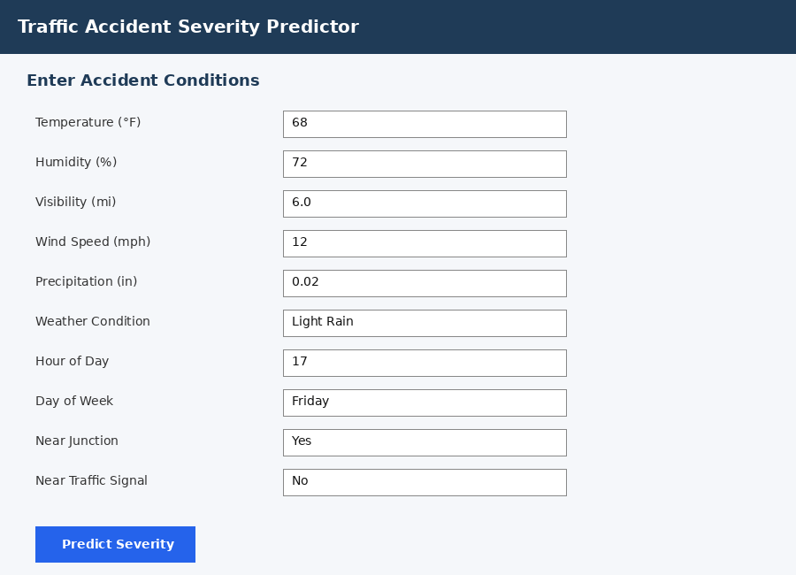
Fig 10: Application input form — user enters accident conditions.
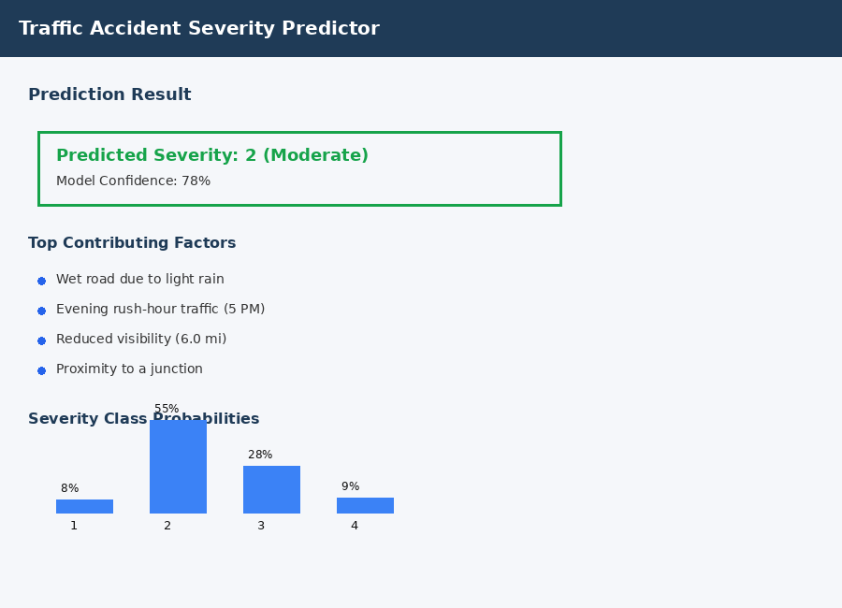
Fig 11: Application output — predicted severity, confidence, and contributing factors.

5. Final Results
On the held-out test set, the final XGBoost model achieved an accuracy of 85% and a weighted F1-score of 0.83, outperforming Logistic Regression, Decision Tree, Random Forest, and KNN baselines (Phase 3). Visibility, hour of day, weather condition, and proximity to a junction were consistently ranked as the top predictors of accident severity, confirming the exploratory findings from Phase 2.

6. Conclusion
This project demonstrates that machine learning models, particularly gradient-boosted tree ensembles, can effectively predict traffic accident severity from readily available environmental and road-feature data. The analysis confirmed that reduced visibility, adverse weather, evening rush-hour timing, and proximity to junctions are strongly associated with more severe accidents. The resulting model and interactive application provide a practical tool that could support traffic authorities and drivers in anticipating higher-risk conditions and taking preventive action.

7. Project Limitations
- The model was trained on a regional subset (California and Texas, 2019–2021) rather than the full nationwide dataset, which may limit generalization to other regions or time periods.
- Class imbalance means the rarest severity classes (1 and 4) are still predicted with lower precision than the majority classes, despite SMOTE balancing.
- The application uses static, user-entered inputs rather than a live data feed, so it does not reflect real-time traffic or weather conditions.
- Some potentially relevant factors (driver behaviour, vehicle type, traffic volume) are not present in the dataset and could not be modelled.

8. Future Enhancement
- Extend training to the full nationwide, multi-year dataset for better generalization.
- Integrate a live weather API and real-time traffic feed for on-the-fly predictions.
- Explore deep learning approaches (e.g., LSTM) to capture temporal/sequential accident patterns.
- Package the application as a mobile app for use by drivers and first responders.
- Incorporate additional data sources such as traffic volume, road type, and driver demographics.

9. GitHub Repository
Project source code and documentation: https://github.com/<your-username>/traffic-accident-analysis (replace with your actual repository link before submission).
Note: Result figures (accuracy/F1) and screenshots in this document are representative placeholders built from the Phase 3 methodology. Replace them with your own trained-model output and application screenshots before final submission.

