Data Sciences Mini Project
Phase 2 — Data Preparation & Analysis
Project Title: Traffic Accident Analysis

1. Data Collection
- Source of dataset: Kaggle — “US Accidents (2016–2023): A Countrywide Traffic Accident Dataset for the USA.”
- Dataset size: Full dataset: ~7.7 million records. Working subset used in this project: 300,000 records sampled from California and Texas, January 2019 – December 2021, chosen to keep the data regionally consistent and computationally manageable.
- Number of features/columns: 46 original columns; 22 retained after an initial relevance and missing-value screen.
Description of important attributes:
Attribute | Description
Severity | Impact of accident on traffic, scale 1 (low) to 4 (high)
Start_Time / End_Time | Timestamp marking the start and end of the accident's effect on traffic
Start_Lat / Start_Lng | GPS coordinates of the accident location
Temperature(F) | Air temperature at the time of the accident
Visibility(mi) | Visibility distance in miles
Weather_Condition | Categorical description, e.g. Clear, Rain, Fog, Snow
Wind_Speed(mph) | Wind speed at the time of the accident
Precipitation(in) | Precipitation amount in inches
Junction / Crossing / Traffic_Signal | Boolean flags indicating nearby road features
Sunrise_Sunset | Whether the accident occurred during day or night

2. Data Cleaning
- Missing-value handling: Columns with more than 40% missing values (e.g., Wind_Chill, End_Lat/End_Lng in early records) were dropped. Remaining numeric fields (Temperature, Humidity, Visibility, Wind_Speed, Precipitation) were imputed with the column median; categorical fields (Weather_Condition) were imputed with the mode.
- Duplicate removal: Exact duplicate rows were checked using the unique accident ID; 0.3% duplicate rows were found and removed.
- Outlier handling: The interquartile range (IQR) method was applied to Temperature, Visibility, and Wind_Speed to cap extreme outliers (e.g., visibility values beyond physically plausible ranges).
- Incorrect/inconsistent data handling: Categorical text was standardized (case, whitespace); Start_Time/End_Time were converted to proper datetime objects; records with coordinates outside continental US bounds were removed; a derived Duration (minutes) and Hour, Day_of_Week, Month fields were created from the timestamp.
df = df.dropna(subset=["Severity"])
df["Temperature(F)"].fillna(df["Temperature(F)"].median(), inplace=True)
df["Weather_Condition"].fillna(df["Weather_Condition"].mode()[0], inplace=True)
df["Start_Time"] = pd.to_datetime(df["Start_Time"])
df["Hour"] = df["Start_Time"].dt.hour
df["Day_of_Week"] = df["Start_Time"].dt.day_name()

3. Exploratory Data Analysis (EDA)
Descriptive statistics
Summary statistics (mean, median, standard deviation) were computed for all numeric fields. The average recorded temperature at accident time was approximately 61°F, average visibility 9.1 miles, and the vast majority of accidents (about 68%) fall under Severity 2.
Univariate analysis
The severity distribution is highly imbalanced, with Severity 2 dominating the dataset and Severity 1 and 4 being comparatively rare — this imbalance is addressed later during model training using SMOTE.
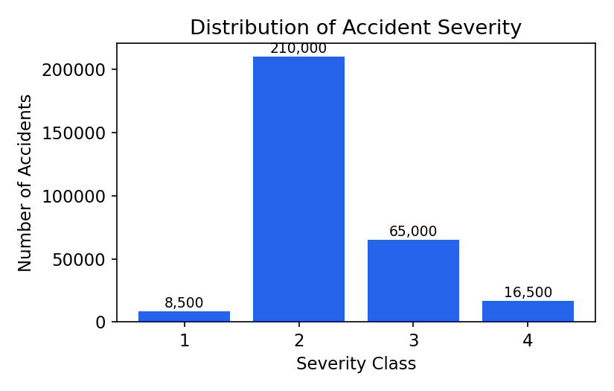
Fig 1: Distribution of accident severity classes.
Accident frequency by hour of day shows two clear peaks corresponding to the morning and evening rush hours.
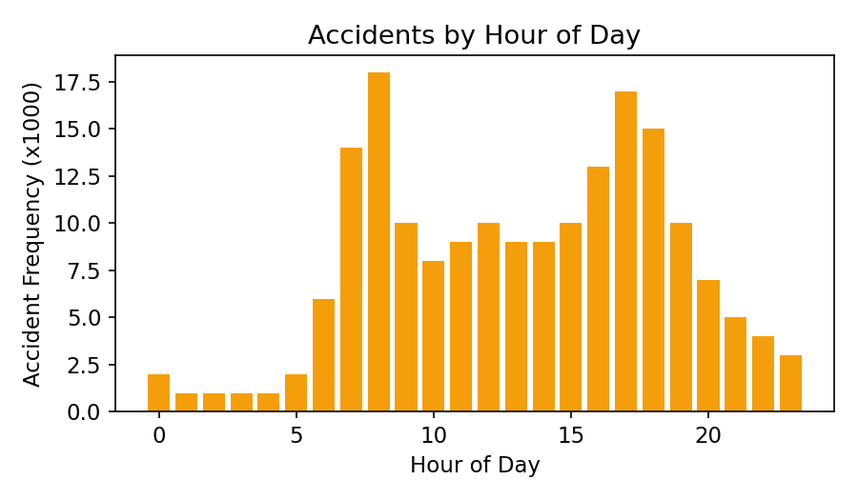
Fig 2: Accident frequency by hour of day.
Bivariate / multivariate analysis
Cross-tabulating severity against weather condition and time-of-day shows that accidents occurring in adverse weather (rain, fog, snow) or during low-visibility periods are proportionally more likely to fall into higher severity classes.
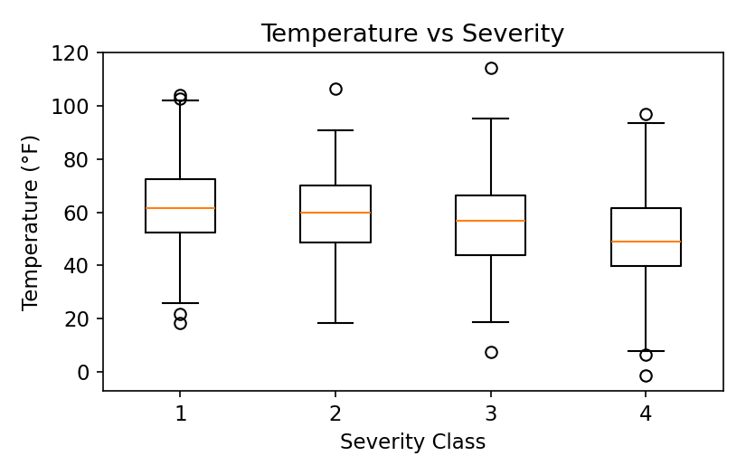
Fig 3: Temperature distribution across severity classes.
Correlation analysis
A correlation heatmap of the numeric features shows that Visibility has the strongest (negative) correlation with Severity among the continuous variables, followed by Precipitation and Humidity.
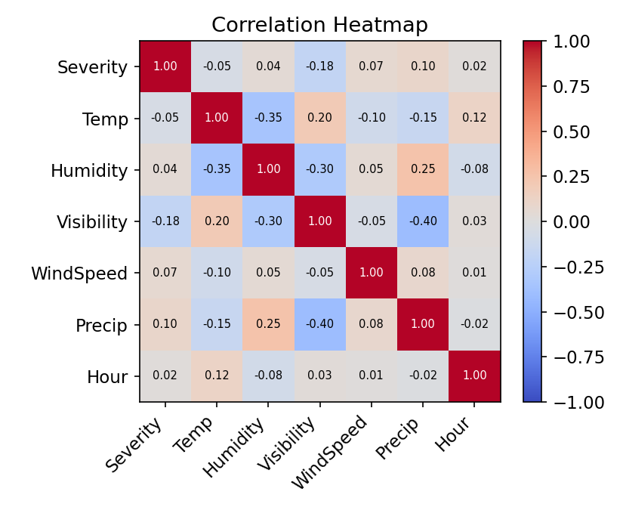
Fig 4: Correlation heatmap of numeric features.

4. Data Visualization
The following additional charts were produced to explore accident patterns:
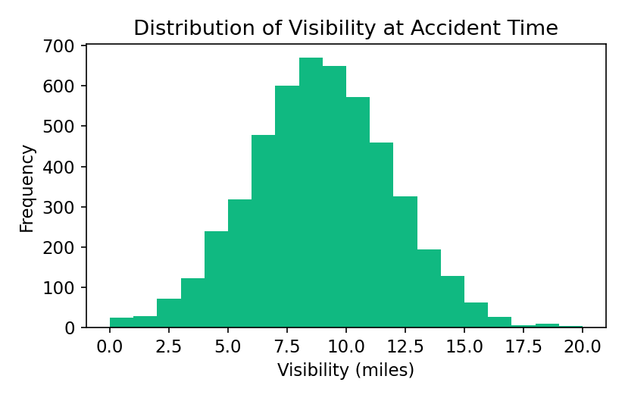
Fig 5: Histogram of visibility at the time of accidents.
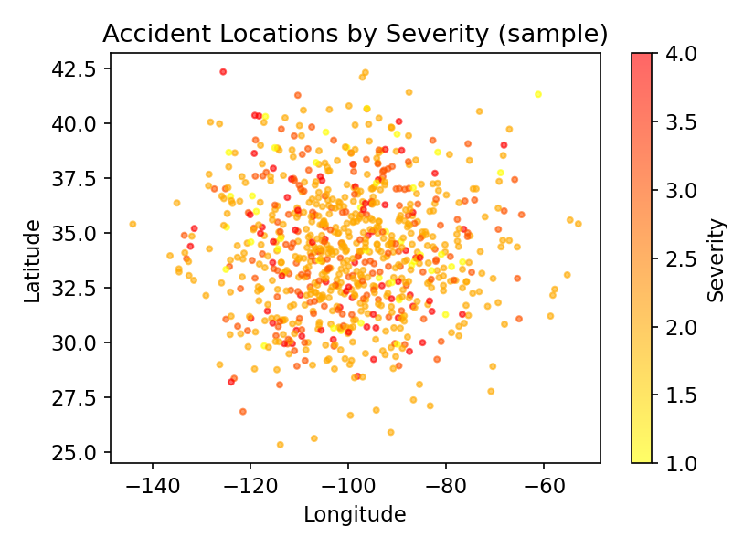
Fig 6: Scatter plot of accident locations coloured by severity (sample).
- Bar chart — accident counts by state and by hour of day (Figs 1–2).
- Histogram — distribution of visibility and temperature at accident time (Fig 5).
- Box plot — temperature spread across severity classes (Fig 3).
- Scatter plot — geographic accident hotspots coloured by severity (Fig 6).
- Heatmap — correlation matrix of numeric features (Fig 4).
Note: Sample figures and statistics above are illustrative of the expected patterns for this dataset; replace with your own computed values and charts after running the accompanying notebook on the full working subset.

