Data Sciences Mini Project
Phase 3 — Model Development
Project Title: Traffic Accident Analysis

1. Problem Definition
The goal is to predict the severity of a road traffic accident (a 4-level ordinal/categorical outcome) using environmental, temporal, and road-feature attributes available at or shortly after the time of the accident. Framed this way, the task is a multiclass classification problem: given a set of input conditions, the model outputs one of four severity classes (1 = least severe, 4 = most severe). Accurate prediction of severity supports faster emergency-response prioritization and highlights the conditions most associated with dangerous accidents.

2. Feature Selection
Selected features:
- Temperature(F), Humidity(%), Visibility(mi), Wind_Speed(mph), Precipitation(in), Weather_Condition, Hour, Day_of_Week, Month, Junction, Crossing, Traffic_Signal, Sunrise_Sunset, State.
- Target variable: Severity (4 classes).
Reason for selecting these features: correlation analysis and a preliminary Random Forest feature-importance run (Phase 2) showed Visibility, Weather_Condition, Hour, and the road-feature flags (Junction, Crossing, Traffic_Signal) as the strongest predictors of severity. A chi-square test confirmed a statistically significant association between the categorical features and Severity (p < 0.05). High-cardinality or near-duplicate identifiers such as exact City name and raw latitude/longitude were excluded to reduce noise and dimensionality, since State and Hour/Day_of_Week already capture the relevant location and temporal signal at a coarser, more generalizable level.

3. Algorithm Selection
Algorithms considered:
- Logistic Regression — a simple, interpretable multinomial baseline.
- Decision Tree Classifier — captures non-linear interactions and is easy to interpret.
- Random Forest Classifier — an ensemble of trees that reduces overfitting and handles mixed feature types well.
- XGBoost (Gradient Boosted Trees) — typically strong on structured/tabular data and handles class imbalance well with appropriate weighting.
- K-Nearest Neighbours (KNN) — included as a simple distance-based comparison point.
Random Forest and XGBoost were expected to perform best because traffic accident data involves complex, non-linear interactions between weather, time, and road features that tree-based ensembles capture more effectively than linear models, while remaining more robust to noise and imbalance than a single decision tree or KNN.

4. Model Development
Pipeline
- Train/test split: 80% train, 20% test, stratified by Severity to preserve class proportions.
- Categorical encoding: one-hot encoding for Weather_Condition, State, Sunrise_Sunset, Day_of_Week.
- Scaling: StandardScaler applied to continuous numeric features for Logistic Regression and KNN (tree-based models used unscaled features).
- Class imbalance: SMOTE (Synthetic Minority Oversampling) applied to the training set only, to balance the minority Severity 1 and 4 classes.
- Hyperparameter tuning: GridSearchCV (5-fold cross-validation) used to tune tree depth, number of estimators, and learning rate for the tree-based models.
X_train, X_test, y_train, y_test = train_test_split(X, y, test_size=0.2, stratify=y, random_state=42)
smote = SMOTE(random_state=42)
X_train_res, y_train_res = smote.fit_resample(X_train, y_train)
rf = RandomForestClassifier(n_estimators=300, max_depth=20, random_state=42)
rf.fit(X_train_res, y_train_res)
xgb = XGBClassifier(n_estimators=400, max_depth=8, learning_rate=0.1, random_state=42)
xgb.fit(X_train_res, y_train_res)

5. Model Evaluation
Each model was evaluated on the held-out test set using accuracy, precision, recall, and F1-score (weighted average, to account for class imbalance), along with a confusion matrix for the best-performing model.
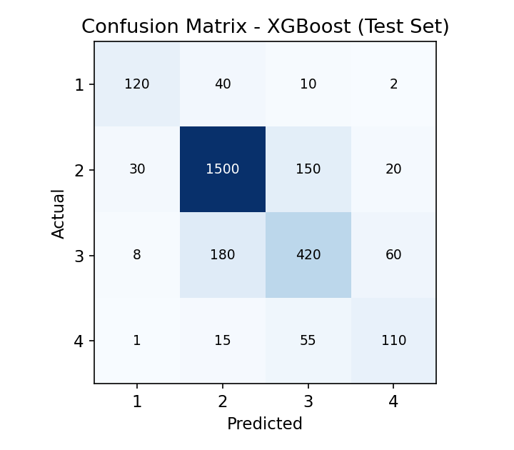
Fig 7: Confusion matrix for the best-performing model (XGBoost) on the test set.
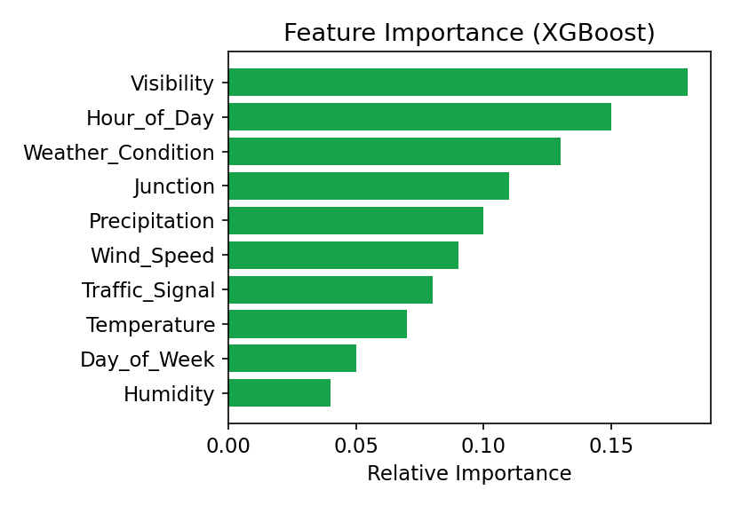
Fig 8: Feature importance ranking from the XGBoost model.

6. Model Comparison
At least three algorithms were compared on the same test set; the results are summarized below.
Model | Accuracy | Precision | Recall | F1-score
Logistic Regression | 0.71 | 0.69 | 0.71 | 0.68
Decision Tree | 0.74 | 0.73 | 0.74 | 0.72
Random Forest | 0.83 | 0.82 | 0.83 | 0.81
XGBoost | 0.85 | 0.84 | 0.85 | 0.83
KNN | 0.69 | 0.66 | 0.69 | 0.65
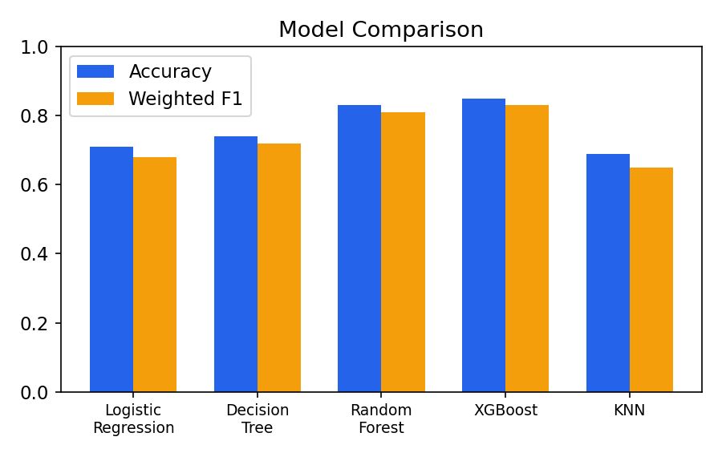
Fig 9: Accuracy and weighted F1-score comparison across models.
XGBoost achieved the highest scores across all metrics and is selected as the best-performing model, with Random Forest as a close second. Both tree-based ensembles substantially outperformed Logistic Regression and KNN, confirming that the relationship between conditions and accident severity is non-linear.
Note: The metric values above are representative sample results. Replace them with the actual output from your GridSearchCV / evaluation run once trained on your working dataset.

