Michelle Niland

PHYS 152 Experiment: 3/23/18

Lab Mates: Emma Fischer, Briana Leger, Michael Nelson

Title: Analyzing the Local Magnetic Field in Three Dimensions with the Use of Compasses and Helmholtz Coils

Introduction:

From using compasses in the field, we expect the magnetic field where we are standing to point directly north, but it actually points down into the earth. From analyzing the 3D field of a bar magnet, we can infer the shape of the magnetic field of earth be imagining there is a huge bar magnet inside the earth. The aim of this lab is to try to get a sense of the local magnetic field by measuring the angle from north and what the dip angle into the earth is, and to measure it by creating a field with the coil and measuring the deflection that occurs from it. I hypothesize that the values we found in lab will be slightly different than the accepted values from the large amount of ferrous material in the lab room, but will be relatively close.

Procedure:

In this lab, we first used the magnaprobe to sketch the 3D magnetic field from a bar magnet, and then set up the Helmholtz coils with the Hampden and the Keithley multimeter to sketch the 3D Field as well. Then we determined the horizontal declination of the magnetic field with the compass with the curtain being north 0 degrees and the cabinets being south 180 degrees. Also, we each measured the local field dip by first aligning the compass with north and south, and rotating the compass 90 degrees. Finally, we set up the Helmholtz coils with a compass in the center aligned with the north/south of the compass and a power supply of 5 volts that is controlled by the voltage divider. We used the voltage divider to control the amount of voltage and current through the coils and recorded the needed current to deflect the needle from -60 to 60 degrees incrementing by 10. From this, we calculated the local horizontal field and local total field for our lab room.

Results:

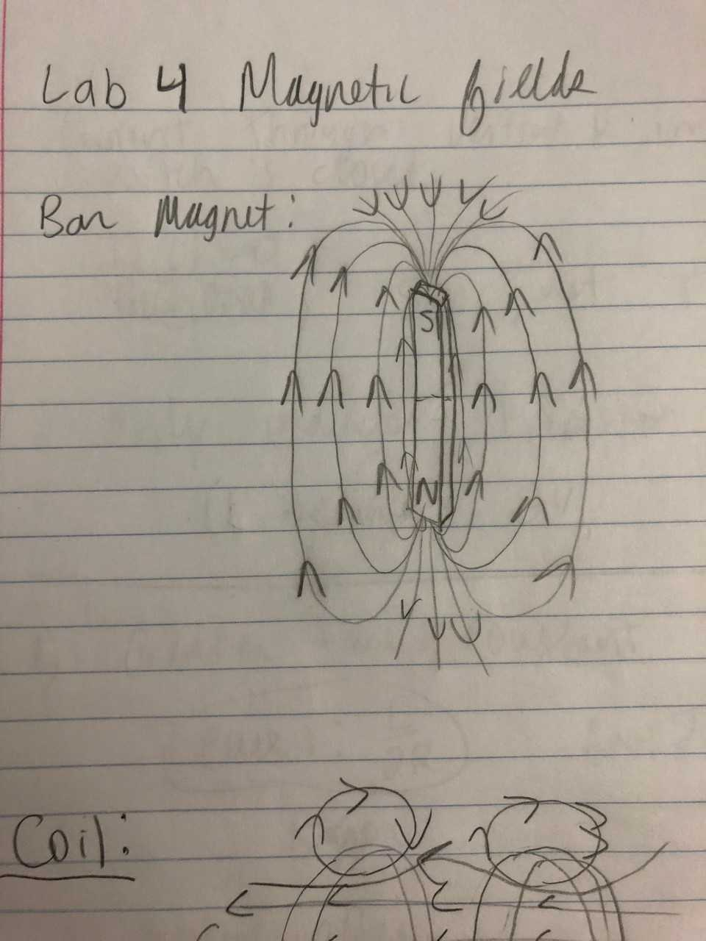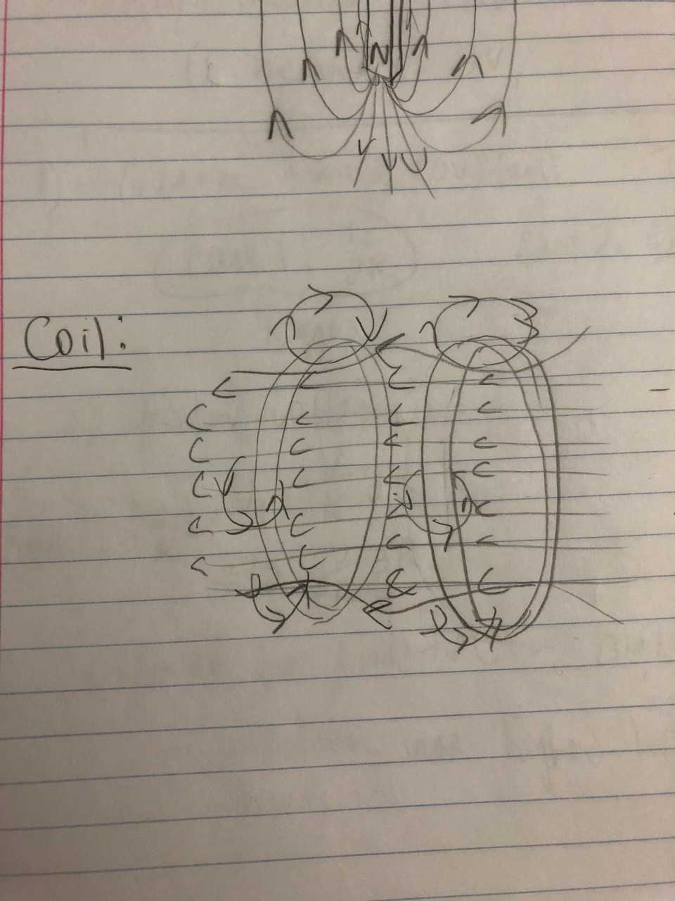

For both cases, the magnetic field exists in 3D space, for the bar magnet the field points from the north pole to the south pole as shown, all around the magnet. For the coils, (much harder to draw), the field is pretty uniform inside and through the two coils. Near the edge of each coil, there are smaller loop fields as shown going around the edges.

Our coils have 126 edges, and we measured the separation to be 10.4 cm. We measured from outside edge of one coil to inside edge of the other coil because we are looking for the separation distance from the center of one coil to the center of the other, and since they are the same width this is the same as outside edge to inside edge.

Local field measurements:

We measured the local horizontal plane angle to be 12 degrees counterclockwise from 0 (pointing west, left when facing the curtains.)

Dip angle:

|  |  |  |
| --- | --- | --- |
| dip angle | person | angle below horizontal |
|  | 1 | 78 |
|  | 2 | 67 |
|  | 3 | 66 |
|  | 4 | 69 |
|  | average | 70 |
|  | Standard Deviation | 5.477225575 |

Compass deflection measurements and calculations with average and standard deviation:

|  |  |  |  |  |
| --- | --- | --- | --- | --- |
| degrees | current mA | B coil (T) | B earth horizontal (T) |  |
| 10 | 6.77 | 7.37515E-06 | 4.18265E-05 |  |
| 20 | 10.68 | 1.16346E-05 | 3.19659E-05 |  |
| 30 | 13.75 | 1.49791E-05 | 2.59445E-05 |  |
| 40 | 17.3 | 1.88464E-05 | 2.24603E-05 |  |
| 50 | 19.1 | 2.08073E-05 | 1.74594E-05 |  |
| 60 | 20.45 | 2.2278E-05 | 1.28622E-05 |  |
| -10 | -15.57 | -1.6962E-05 | 9.61949E-05 |  |
| -20 | -22.83 | -2.4871E-05 | 6.83317E-05 |  |
| -30 | -27.32 | -2.9762E-05 | 5.15494E-05 |  |
| -40 | -29.43 | -3.2061E-05 | 3.82084E-05 |  |
| -50 | -31.77 | -3.461E-05 | 2.90411E-05 |  |
| -60 | -32.55 | -3.546E-05 | 2.04726E-05 |  |
|  |  |  | 3.80264E-05 | average |
|  |  |  | 2.30388E-05 | Standard Deviation |

The magnetic field of the coil and the magnetic field for local horizontal was calculated using the formula in the lab manual.

Analysis:

From this graph, the value of Tan theta that gives a B coil of 0 is the horizontal intercept, 3/10. Taking the Arctan of this to get the angle, it is 16.7 degrees. This should be 0 degrees, since when the coils aren’t producing a field, there should be no deflection when the compass needles are aligned with the north and south. I believe this is due to systematic error, which I will discuss in the next section.

The local horizontal magnetic field from averaging the calculations is 3.80264E-05 T while the horizontal magnetic field from the graph is 2.2430E-05 T. The slope value is within one standard deviation of the average value, but our standard deviation is pretty high because there is a lot of variability in our dataset. I’m not sure which value to trust more because of the systematic errors of this experiment, but for the sake of calculations I will use the slope from the graph.

Using the formula from the lab manual, the total local magnetic field strength using the slope horizontal value and average dip angle is 6.5581 E-5 Tesla.

Using all of these calculations and measurements, the local magnetic field relative to the room is 6.5581 E-5 Tesla in magnitude, oriented 70 degrees below vertical and 12 degrees counterclockwise.

From the NGDC calculator, the field strength is 5.3264E-5 Tesla total, with a horizontal component of 1.8945E-5, oriented 69 degrees below horizontal and 14 degrees west. This is actually very close to our calculations. It is only 1 degree off for the dip angle, and two degrees off for the horizontal angle. Our magnitude for total is off by 1.2317E-5 Tesla, and comparing with the slope horizontal value, we were only 3.485E-6 Teslas off.

Discussion:

The systematic errors that may have affected our measurement was that in the lab room, there are large amounts of ferrous material which would have affected the local magnetic field. We were also unable to completely clear the lab table, because of the power supply and our computers. We also noticed this trying to take different measurements at different spots on the lab table and we were getting different results. For each part we stuck to the same spot to make the error consistent throughout. This is different than random error, like measuring the dip angle, which is just human error in using instruments that only have finite precision. We also ran into some errors trying to make our measurements for the positive angles 10 through 60. For a while we could only move the needle in the negative direction and it wouldn’t switch over. I am surprised our calculations still turned out pretty good given the uncertainty in this experiment.

To improve the results of the experiment, I would do it in a room with much less ferrous material, or at least remove all metal from the table while collecting measurements, which we were unable to do here.