**--For Running application**

**npm run start_DynamoTool**

**FOR BUILD**

DynamoTool

**npm run build_DynamoTool**

**URLs**

**DynamoTool**

[**http://localhost:4300/login?cc=CD**](http://localhost:4300/login?cc=CD)

**http://localhost:4300/login?cc=DS**

**DynamoTool**

**http://localhost:4300/login?cc=DS**

**UserName: Niharika**

**Password:12345**

**ngx material time picker npm package used for time selection**

[**https://www.npmjs.com/package/ngx-material-timepicker**](https://www.npmjs.com/package/ngx-material-timepicker)

[**https://github.com/Agranom/ngx-material-timepicker**](https://github.com/Agranom/ngx-material-timepicker)

**https://www.npmjs.com/package/ngx-mat-timepicker**

**Steps to deploy code on staging**

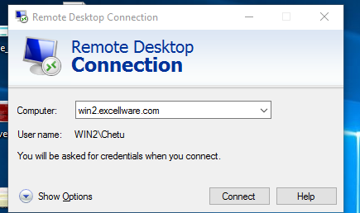

Click on Connect button 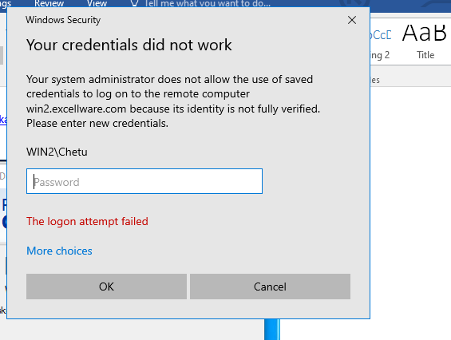

Click on More Choices

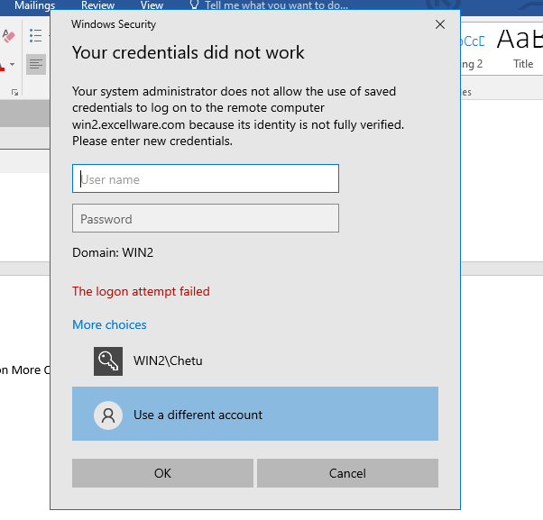

Username Chetu

Password **Dynamo#2020**

Go to path as shown in screenshot on client server

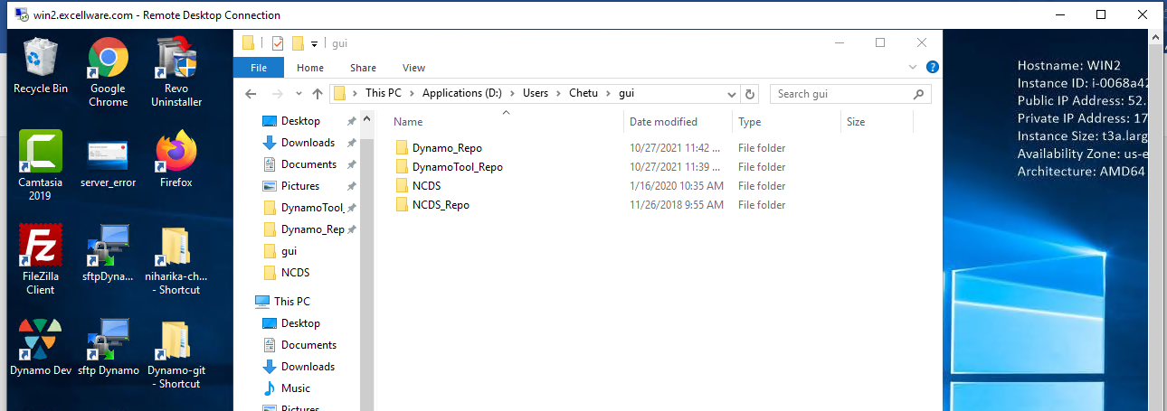

Make folder, if there is need to deploy code on staging, make current date folder in both application folder and copy dist file from D:\28May2021\Angular

**DynamoTool**

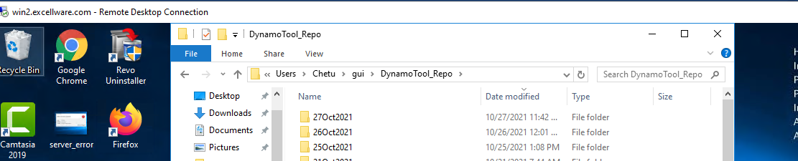

After copying files in folder go to home screen as shown in screenshot 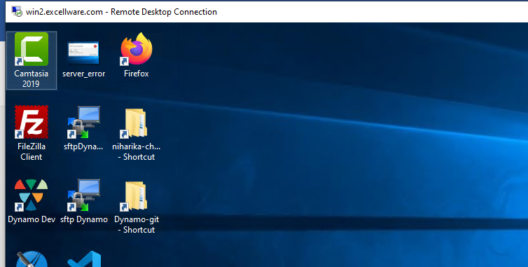

**It’s written sftpDyna… (this is for dynamoTool )**

**Double click on any icon , the ui will be like as shown in screenshot below** 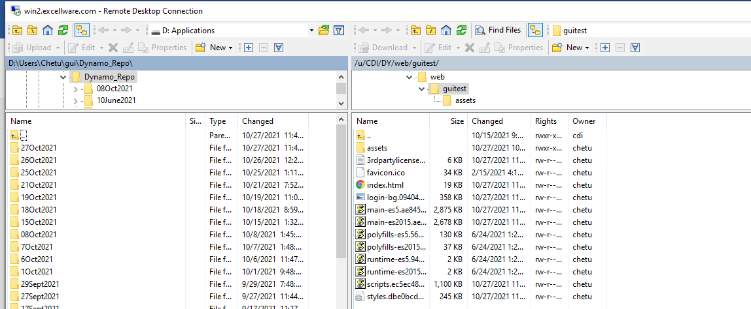

**On right hand side Cltr+A then right click, icon for delete (X) click on it and open folder from left side where you copy the code, ctrl+A and drag from mouse from left to right**

**After deployment, check on staging url with below**

Staging site url

<https://dev.excellware.com/CD/guitest/login?cc=CD> https://dev.excellware.com/CD/guitest/login?cc=DS

1. Username niharika Password 12345
2. [niharikas@chetu.com](mailto:niharikas@chetu.com) Password 12345

Right click mouse and click on **Git Bash here** it will show below screen

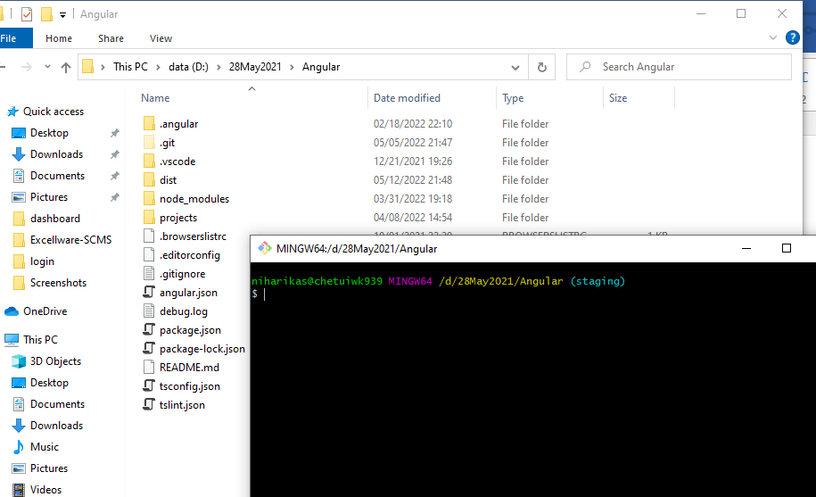

GIT COMMANDS

1. git status
2. git add .
3. git commit –m “name of tickets”
4. git push origin staging
5. In last execute git status to check status