**What Is What**

**Introduction:**

* Excellware ([www.excellware.com](http://www.excellware.com/)) is the complete ERP solution for industries such as Distribution, Wholesale, Retail, E-Commerce, Rental and more.
* Excellware is the developer and provider of *Dynamo – point of sale* Quick & efficient customer experience with instant new account creation, emailed or printed receipts, gift receipts, integrated credit card processing, and more.
* Application is capable for supply chain, Inquiry, sales order processing, Inventory control, general ledger and reporting.

1. **Login:**

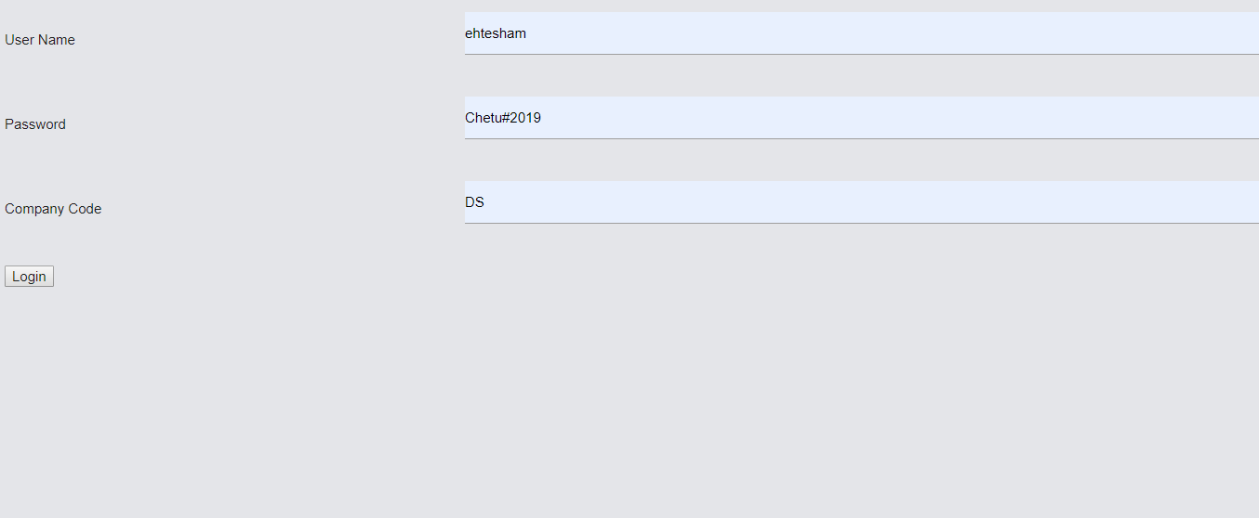

This login page only require in local environment.

User has to enter username, password and company code and perform login operation.

1. **Item Inquiry Page:**
2. Item Search Phrase: 14, 14hsss, 14hsss12 etc and call the “getItemInquiryList” function with API like “/dyn/dyitem/search?SearchPhrase=14hsss” in “itemInquiry.component.ts” component.

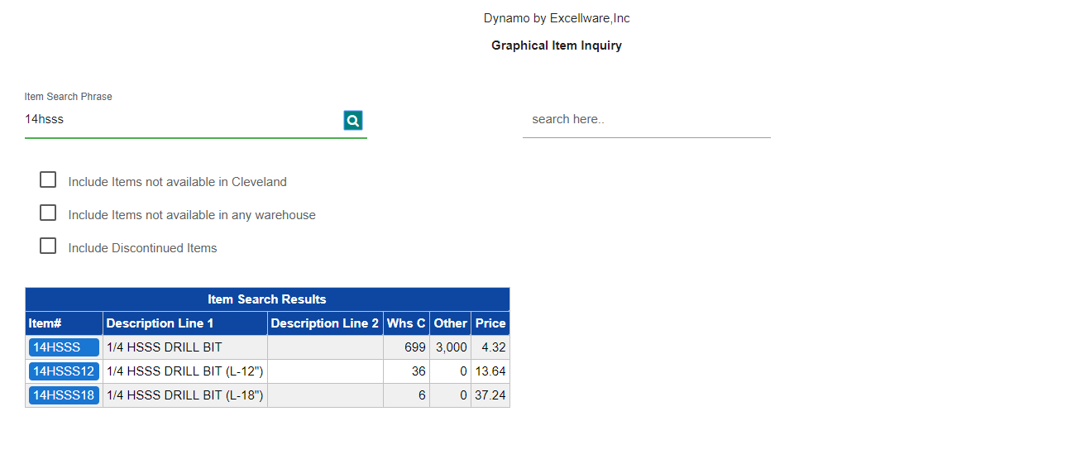

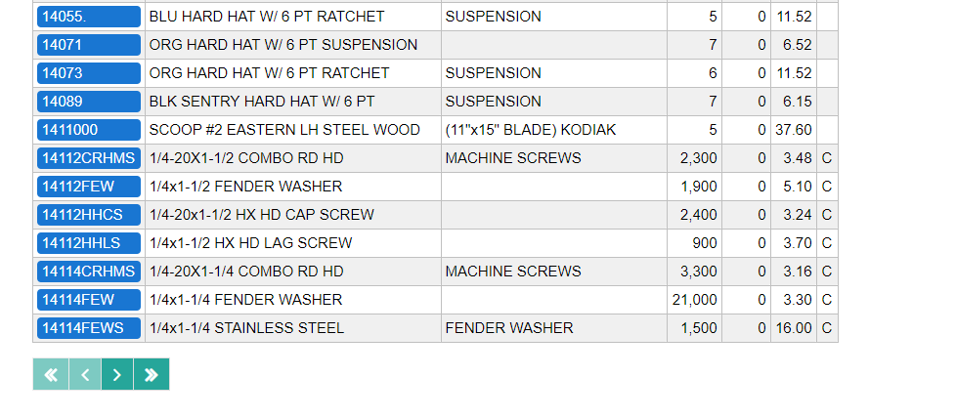

1. We are maintaining paging on server side with calling “navChangedHandler” event on itemInquiry page.
2. Click any of Item# then it will redirect with hexkey to other page like editItemInquiry.
3. **Edit Item Inquiry Page:**

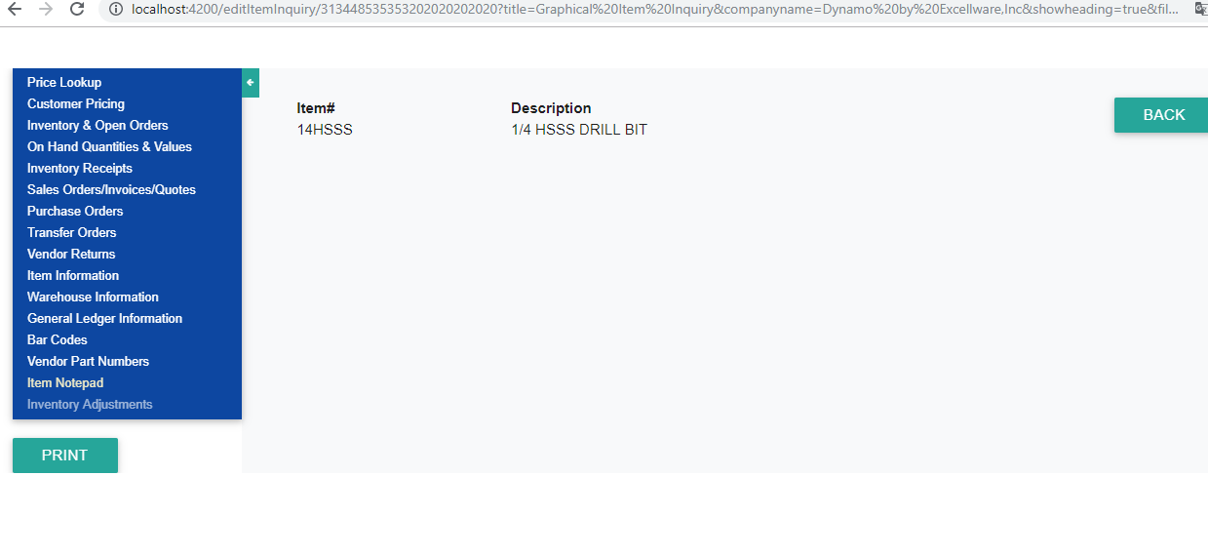

1. Here on page load we are calling the “getIteminquiry” and “getMenuListByhexkey” function with API like /dyn/dyitem/inquiry?hexkey=” and “/dyn/dtmenu/appMenu/get?ddname=IM01&appname=IM100&hexkey=” and bind the left App Menu and top header data in “editInquiry.component.ts” component.
2. When we click any from left menu then we call “getSelectedItemInquiry” and pass the “optionApi” as JSON response in “editInquiry.component.ts” component.

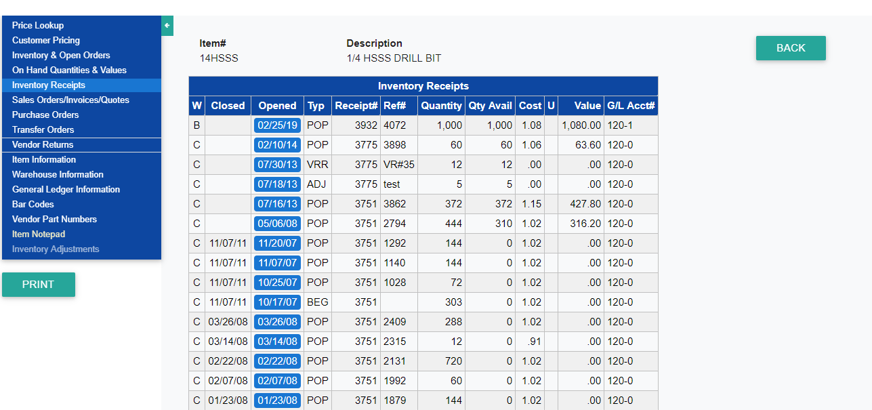

1. When we click link like “Opened” column then open it in popup like

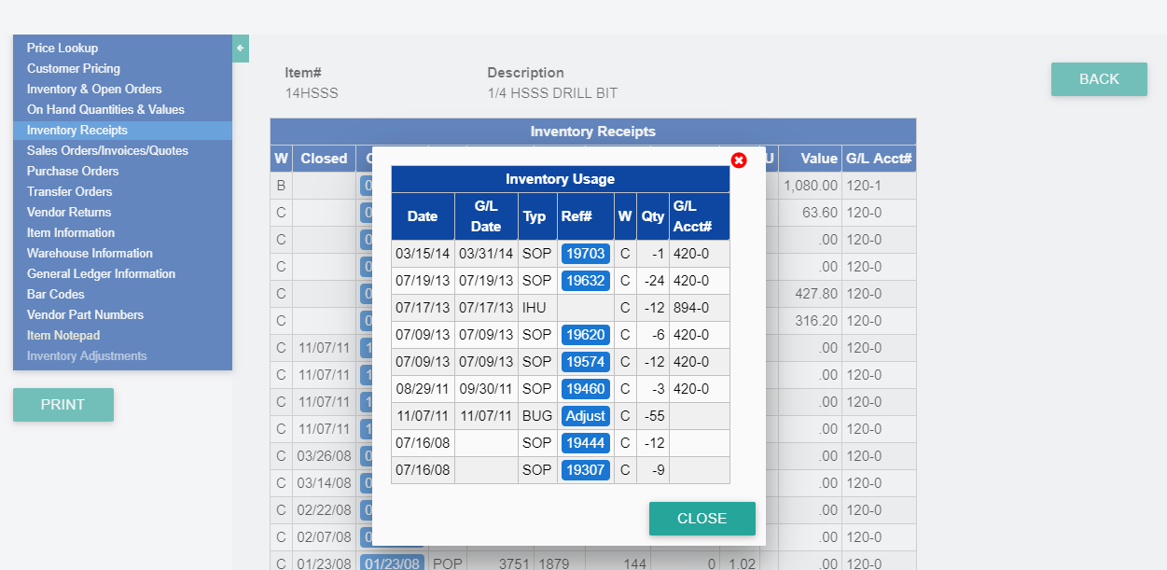

1. When we click link like “Ref#” then it will open the new window with page name like “editdtInquiry” and passing the hexkey and API in the URL and calling the API like “getInventorySelectedData” and passing the hexykey and API as JSON response.

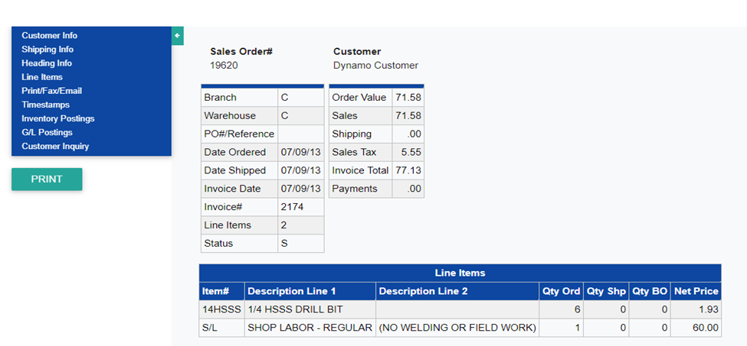

1. When we click any from left menu then we call “getSelectedItemInquiry” and pass the “optionApi” as JSON response in “editdtInquiry.component.ts” component.

**4. Dynamo Login: -**

i) On the page load we call the API “getsetupAPILog” method with passing the company code(cc) and calling the API like “/dyn/dylogin/setup?companyCode=” and company code(cc) taking from the URL.

**API Response:-**

i) loginText:- set the text at runtime on Dynamo Login pgae.

ii) logoURL:- set the image as logo response.

iii) cancelURL:- set the cancel URL on cancel button.

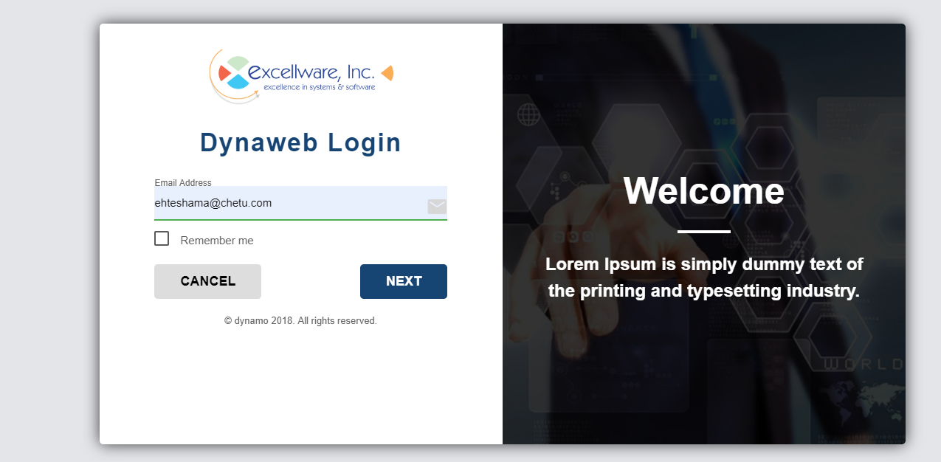

ii) After enter the email then we call the “getemailAPI” method with API like “/dyn/dylogin/email?email=” with passing the email.

1. After the email validate from the server side we just call the “getpasswordAPI” method with “/dyn/dylogin/login” API and passing the password as body with JSON format.

**Dynamo Tools**

**menuItemMaintenance:** In this page we can maintain the application menu by drag and drop.

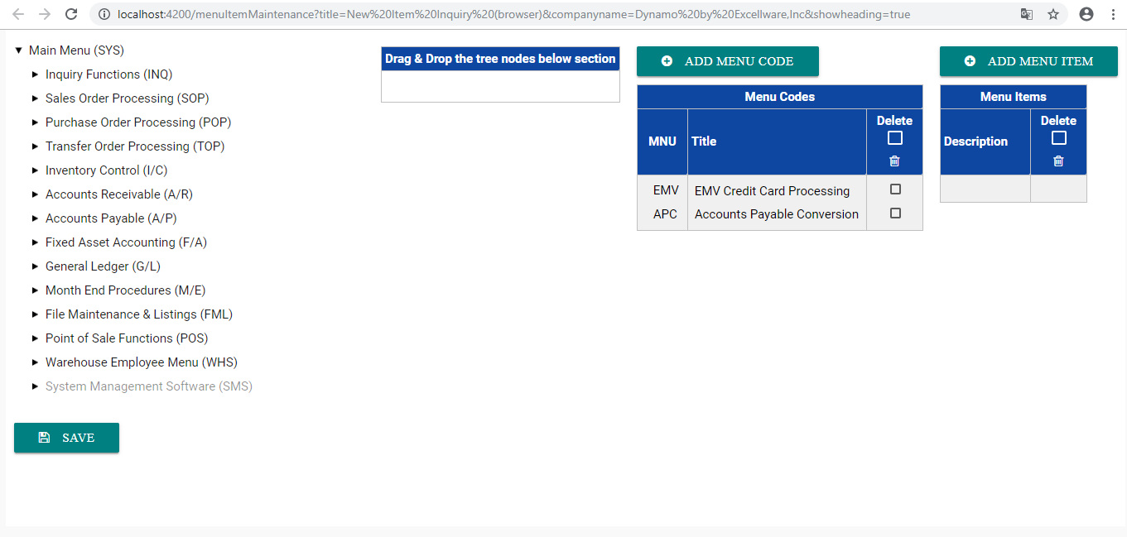

1. On page load we are calling “getItemGridListUsingToken” on server side when token is present with same service name function with API like “/dyn/dtmenu/guiMenu/maintenance?t=” and “getItemGridList” on local server when token is not present with same service name function with API like “/dyn/dtmenu/guiMenu/maintenance” and service name is “itemMaintenance.service.ts” and we are getting six array data like data and button details like save, Add Mneu code and Add menu item.
2. **Save :-** when user click save button then we call “saveTreeNode” and post data “dataPost” with same function in service with API name as JSON response.
3. **Add Menu Code/ Item :-** When we click then we call “getButtonReceipt” function with service name is “menuApiCall” and API send as JSON response.

**User Prefrence page:** In this page we can dynamically set the client application color.

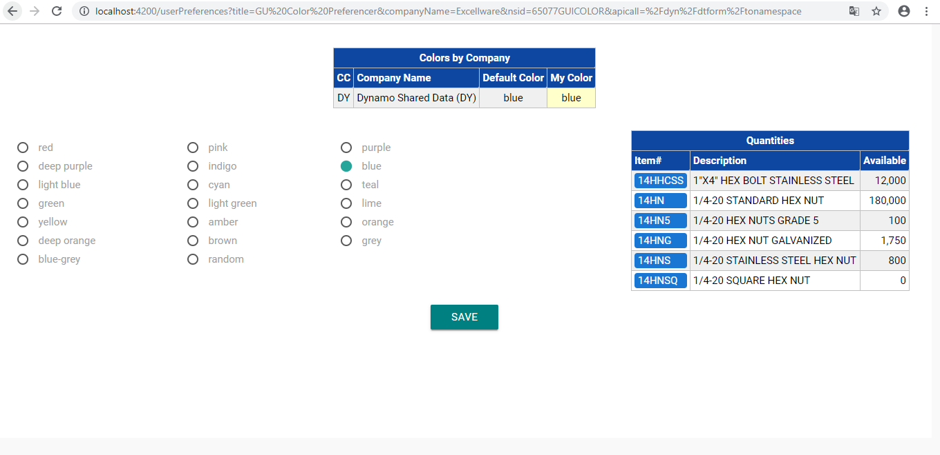

i) On page load we are calling “getUserColorWithToken” on server side when token is present with same service name function with API like “/dyn/dtuser/getColors?t=” and “getUserColor” on local server when token is not present with same service name function with API like “/dyn/dtuser/getColors” and service name is userprefrence.service.ts”.

ii) Save:- when user click save button then call “saveUserPreference” with same service function name with API “/dyn/dtuser/putColors” and service name is userprefrence.service.ts”.

**Generic Page :-** In this page we can bind form dynamic as JSON response like “displayGrid”, “displayView” and “dtForm”.

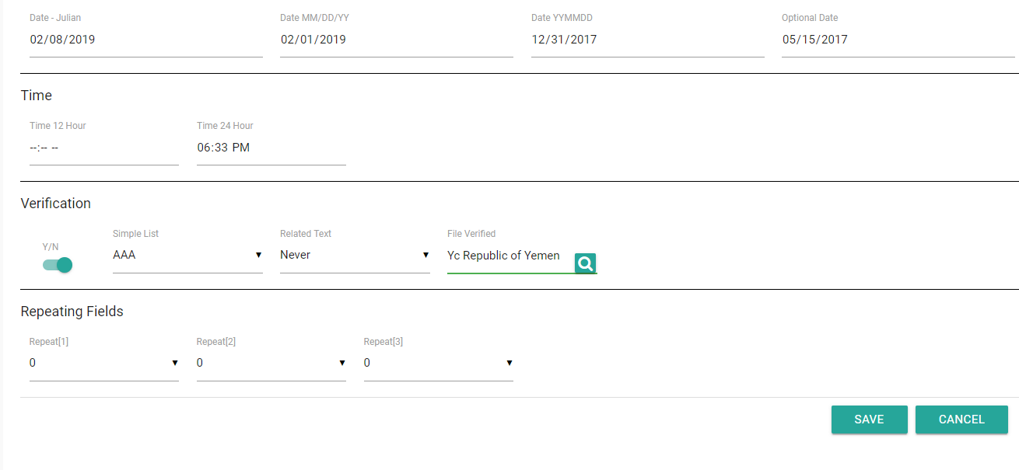

i) **Save:-** when user click save button we are get the data by “receiveDtForm” function in genericPage.Component.ts and call the “menuNext” service to the “itemMaintenance.service.ts.

**Thank You**