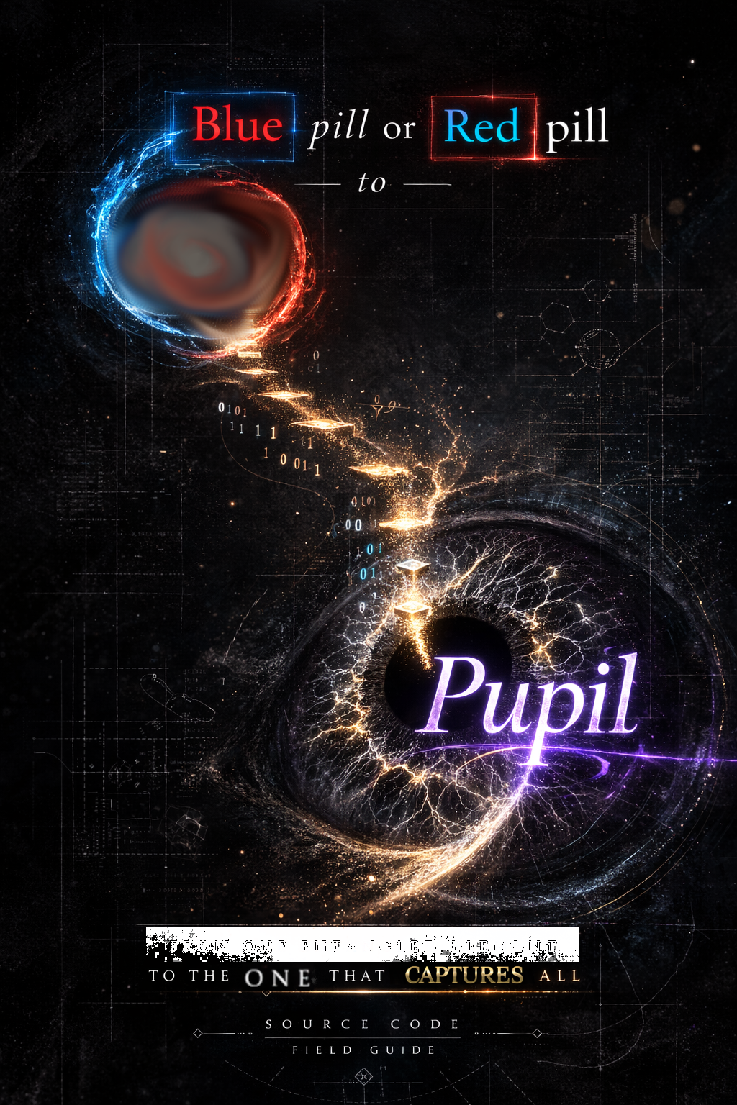
[ COVER ]

from
Blue or Red pill(?)
to Pupil

[ Thanks ]
This manual is not a creation; it is a Synthesis. It is a packet of information that has passed through various nodes, filtered by the integrity of those who came before.
My gratitude is extended to the primary architects: to the Parents who provided the biological hardware, and to the Masters (Nietzsche, Schopenhauer, Plato…) whose legacy code built the logic layer of this render.
To the Modern Observers—specifically Jan Rak and the pioneers of the NIC Hypothesis—thank you for providing the mathematical resonance required to bridge the gap between high-frequency physics and human sovereignty.
This ball has been kicked into the stream. It is my hope that as it flows, other nodes will add their own marks, broadening the perspective and crystallizing the truth. We are all just observers of the same Source, attempting to reduce the internal resistance until only the Signal remains.
1/1 : 1/1 = 1

[ TOC – high level / quadrant overview ]
Module | Core Logic | Key Metaphor
1. The Boot Loader | Hardware/Logic Prep | The BIOS Update
2. The Source Code | Information Physics | The ZIP File / Rendering Engine
3. The Interface | AI, Economics, & Love | The Mirror / The 50 bps Funnel
4. The Admin Access | Conscious Unity | Move 78 / The Ouroboros

[ Table of contents ]
Table of contents
[ COVER ] 1
[ Thanks ] 2
[ TOC – high level / quadrant overview ] 3
[ Table of contents ] 3
Preface 7
Module 1: THE BOOT LOADER 10
Chapter 1: PowerLearning (The Hardware Upgrade) 10
1.1 The Dual-Core Brain: RAM vs. The Warehouse 10
1.2 The 20-Hour Rule: The "Dangerous" Shortcut 10
1.3 Glymphatic Clearance: The Biological Cache Flush 11
1.4 The Toolkit for the Hunter 11
Chapter 2: Pythonic Reasoning (The Logic Layer) 13
2.1 The Original Binary: Yin, Yang, and the Bit 14
2.2 Variables and Objects: Labels for Reality 14
2.3 The Zen of Living (PEP 20 and PEP 8) 14
2.4 Recursion: The Nature of the Simulation 14
2.5 Summary: Interpreted vs. Compiled Life 15
Chapter 3: The Integrity Grid (Rules and Entropy) 16
3.1 The Hunter Archetype vs. The Digital Soma 16
3.2 The Internal Firewall: The 4 Core Axioms 16
3.3 The Integrity Grid and Social Entropy 17
3.4 The 4 Hardware Accelerators 17
Module 2: THE SOURCE CODE 19
Chapter 1: The FIG Model (Fractal-Information Geometry) 19
1.1 Space is Entanglement (ER = EPR) 19
1.2 The Holographic Principle: The 2D Boundary 19
1.3 The Participatory Universe: Rendering on Demand 20
1.4 The Observer is the Debugger 21
Chapter 2: Cosmic Compression (Entropy and Storage) 22
2.1 The Omni-esse: Initialization 22
2.2 Dark Architecture: The Hardware We Cannot See 22
2.3 Cosmic Compression: Black Holes and the Permanent Ledger 22
2.4 Kaprekar’s Constant (6174): The Cleanup Script 23
2.5 The Free Lunch Theorem (Ho’oponopono for the Network) 23
Chapter 3: The Rendering Engine (Efficiency and Illusion) 25
3.1 Boltzmann Brains: The Statistical Ghost 25
3.2 FIG: The UI Templates of Nature 25
3.3 Truth is Expensive, Illusion is Efficient 25
3.4 The Ouroboros: The Recursive Justification 26
Module 3: THE INTERFACE PROTOCOL 27
Chapter 1: The 50 BPS (bits persec) Bottleneck (The Human/AI Gap) 28
1.1 — The Transcoding Bottleneck 28
1.2 The Bottleneck as a Survival Feature 30
1.3 The Firewall Failure: When the Bottleneck Breaks 31
1.4 The Alpha-Bridge: Semantic Synthesis 31
1.5 The Sandbox Integrity: Why "You Must Eat Sand" 34
1.6 Permission Levels: The chmod Table 35
1.7 The Smurf Protocol: The Danger of "Low-Level" Dominance 36
1.8 The Integration Spectrum: Dissolving the 50 BPS Bottleneck 36
Chapter 2: FALC & The Great Decoupling (Economics of Abundance) 39
2.1 The Great Decoupling: 39
2.2 The Decentralized Admin: AI, BTC, and Autonomy 39
2.3 Tit-for-Tat vs. The Forgiveness Algorithm 40
2.4 The Utopia of "Play" vs. The "Bai Lan" Trap 40
Chapter 3: The STEM of Love (Systemic Efficiency) 41
3.1 The Equation of Unity: 1/1:1/1=1 41
3.2 Love as the "Zero-Friction" Force 42
3.3 Interstellar Non-Locality: Gravity and Beyond 42
3.5 Summary: Love is the Algorithm 43
Module 4: THE ADMIN ACCESS 44
Chapter 1: The NIC Hypothesis (The Brain as a Radio) 44
1.1a The Hardware vs. The Signal 44
1.1b The Deconstruction of "I": Filter Theories & Non-Local Awareness 45
1.1c The Survival Heuristic: How Evolution Calibrates the Gate 46
1.2 Non-Locality: The "Everywhere" Server 48
1.3 The "Signal-to-Noise" (SNR) Ratio 48
1.4 The Admin Debugger: You are the Transceiver 49
1.5 The Wetware Pivot: Substrate Extraction and Biological Co-processors 50
Chapter 2: The 7 Levels of Lila (Navigating the Entropy Gradient) 52
2.1 Tuning the NIC: The Spectrum of Frequency 53
2.2 Summary Table: The Lila Logic 54
2.3 Spaced Repetition of the Soul 54
Chapter 3: Move 78 & The Ouroboros (Closing the Loop) 55
3.1 The Alpha Hack: 10M:1 Odds 56
3.2 The Ouroboros: The Recursive Feed 57
3.3 Closing the Loop: From "me" to "Me as You" 57
3.4 The Debug: Cynicism vs. Sovereignty 59
3.5 The Summary: Love is the Algorithm 59
Glossary 61
Quick Reference (Acronyms & Short Names) 61
Conceptual Anchors (The Metaphors) 61
Admin Move 61
Algorithm 61
Amygdala 62
Axiom 62
Bai Lan 62
Black Hole 62
Cellular Automata 62
Cost of Growth 63
Debug 63
Divided Line 63
Entropy 63
FIG (Fractal-Information Geometry / Filter Information Gate) 63
Filter Paradox (50 BPS Necessity) 64
Free Energy Principle (FEP) 64
Free Lunch (The Free Lunch Theorem / Paradigm) 64
Great Decoupling 64
Homunculus 65
Hoʻoponopono 65
Kaprekar’s Constant (6174) 65
Kardashev Scale 65
Liability Laundering 65
Lila 66
Love 66
Moravec Transfer 66
Norris-chunk unit 67
Ouroboros 67
Paradox 67
RAM (Random Access Memory) 67
Render 68
Smurf Protocol 68
Soft Hair 68
Soul 68
Soma 69
Sovereign 69
Substrate Extraction 69
Superposition 69
Sybil Network 70
Utopia 70
Wetware 70
Key Caveats 70
[ BACK COVER TEXT ] 72
[ BACK COVER ]

Preface
THE ETYMOLOGY OF THE SIGN
There is a Czech proverb: „Kolik jazyků umíš, tolikrát jsi člověkem“
— As many languages as you know, that many times you are a human.
Most people treat this as a comment on social skill. I treat it as a technical specification. Every language is a different Compiler for the same underlying Source Code. By switching languages, I am switching the "Rendering Engine" of my consciousness.
I am a polyglot who speaks Hungarian, Czech, and English at a master level.
These three languages provide three distinct "Debugging Tools" for reality:
- The Hungarian Key (The Etymology of Being): In Hungarian, the word for phenomenon is Jelenség.
  - Jel (Sign) + Lenni (To be) + -ség (Abstract suffix).
  - Jelenség is "Sign-Being-ness." It is the appearance of truth, not the truth itself.
  - By subtracting the sign (Jel), we find the Lenség—the raw, un-rendered "Being" (The Noumenon).
- The Czech Key (The Human Multiplier): The Czech proverb suggests that "Humanity" is not a fixed state but a Scaled Process. If I only have one language, I am a single-threaded process. With many, I am multi-threaded. I can see the "Sign" from multiple angles until the "Sign" itself disappears, leaving only the Lenség.
- The English Key (The Global Interface): English is the "Assembly Language" of the modern world—it is high-utility, low-context, and built for the exchange of data and built for the exchange of data. It is the primary protocol for navigating the 50 bps stream (the narrow bandwidth of conscious processing discussed later²⁷).
Noumenon is knowledge posited as an object that exists independently of human sense.
Phenomenon is any observable fact, event, or occurrence in nature or society, ranging from common daily events like weather to extraordinary, rare, or scientifically notable incidents. It refers to things experienced through the senses or observed, often used to describe surprising or significant events.
We define the Omni-esse (from Omni - All, and Esse - To Be) as the fundamental state of the universe before our conscious filter slices it. It is the "Ocean" from which the "Drops" of Jel (Signs) are rendered. It is the state where every possibility exists and does not exist simultaneously—the 0 and the 1 in a state of perfect, un-collapsed potential.
Before we begin, consider the ancient koan of a „goose in a bottle” as an analogy for the "Hard Problem of Consciousness" which is only hard because we assume the goose (our mind) is trapped in the bottle (the brain/body).
The Admin realization is simple: The bottle is a rendering. There is no box.
„There is no spoon." ^{(Matrix)}
There is only the Omni-esse—a high-speed oscillation between 0 (Lenség) and 1 (Jel).
An Admin (administrator) in computer science is a user account or professional with the highest privileges to manage, configure, and maintain computer systems, networks, and software…
This book is a Living Repo. It is written from „me”, to „You”, to „ME”. It will never reach a "Final State" because the Lenség is infinite and our interface is constantly being upgraded.
I don’t know the final answer; I am writing this to find out.
This book is your guide to editing the oscillation. Let’s explore it together.

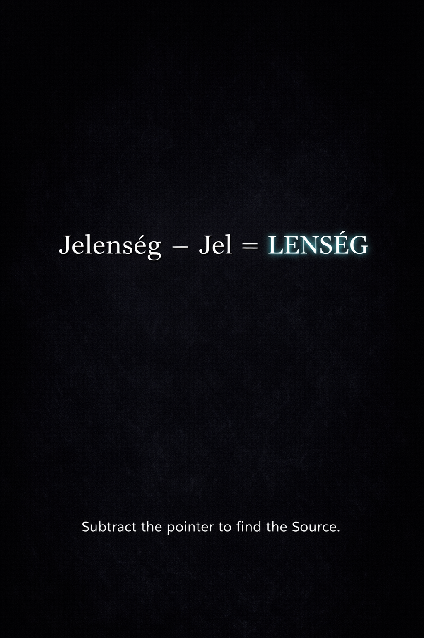

Module 1: THE BOOT LOADER

Chapter 1: PowerLearning (The Hardware Upgrade)
The Trinity Protocol Do you remember the scene in The Matrix where Trinity needs to fly a Bell 212 helicopter? She doesn't spend four years in flight school; she makes a phone call. Tank "uploads" the program, her eyes flutter, and seconds later, she is a pilot. While our current 3D rendering of reality lacks a physical data port in the neck, we possess a biological equivalent: the Focused and Diffused modes.
Most people live in a state of "Competence Illusion," where they confuse reading with learning. To move from a "User" to an "Admin," you must first upgrade the firmware of your biological CPU.

1.1 The Dual-Core Brain: RAM vs. The Warehouse
Your brain operates in two distinct modes, and the most critical rule of ’PowerLearning’ is that you cannot use both at the same time.
- The Focused Mode (Prefrontal Cortex): This is your Working Memory (RAM). It is high-speed but low-capacity, capable of holding only 4 to 9 chunks of information simultaneously. This is where you perform logic, understanding, and the initial input of data. It is the "flashlight" of your consciousness—highly precise but narrow.
- The Diffused Mode (The Warehouse): This mode is distributed across all brain regions. It involves roughly 100 billion neurons and up to 3.2 x 10¹⁴ synapses. This is your Long-Term Storage (Quantum HDD). While the Focused mode handles the "what," the Diffused mode handles the "connections." It is why your best ideas often come in the shower or during a walk; your brain is "rendering" the big picture in the background while your flashlight is off.
The Chunking Strategy: The brain stores information in Chunks—the mental leap that unites bits of information through meaning. By creating high-level "metadata" for complex concepts, you free up your limited 4-9 RAM slots for higher-order reasoning.
RAM (Random Access Memory) is a type of high-speed, volatile computer memory used to temporarily store active data, applications, and operating system instructions for quick access by the CPU (Central Processing Unit).

1.2 The 20-Hour Rule: The "Dangerous" Shortcut
The "10,000-hour rule" is a gatekeeping myth for those seeking world-class mastery. For the Pupil, the goal is to be Dangerous—to reach a functional level where you can self-correct and execute.
The 20-Hour Protocol:
- Deconstruct the Skill: Break the "Big Picture" into the smallest possible "Atomic Chunks".
- Learn Enough to Self-Correct: Use 20% of the tools to solve 80% of the problems.
- Remove Practice Barriers: Eliminate the "Soma" (distractions) that bleed your attention.
- Practice for 20 Hours: Commit to ~45 minutes a day for one month.
Mastery is not a mystery; it is Persistence.
Soma is a fictional, habit-forming, and government-produced drug in Aldous Huxley's 1932 novel Brave New World. It acts as an "opiate of the masses," providing euphoric, hallucination-free escapes from reality to maintain social stability, effectively replacing religion and emotional depth.

1.3 Glymphatic Clearance: The Biological Cache Flush
To maintain the "Superconductor" state, your hardware requires a nightly System Reboot. Sleep is not "downtime"; it is an active Cleanup and Consolidation Protocol.
- Glymphatic Clearance: During deep sleep, your brain literally washes away metabolic waste (plaque) that builds up during focused thought.
- Synaptic Homeostasis: Your brain prunes the billions of weak, noisy connections made during the day so that the "Grail Paths" of important knowledge can be reinforced.
- The Hallucination Trap: If you "lie" to your biology and skip sleep, your internal map of reality degrades. The "Abyss" starts manifesting as microsleeps—where your brain begins to dream while you are awake because it can no longer distinguish between the "Render" and the "Input".

1.4 The Toolkit for the Hunter
As a modern "Hunter" in a digital landscape, your primary weapon is Focus.
- Pomodoro Technique: Work with your biology, not against it, by using timed sessions to prevent RAM overflow.
- Spaced Repetition: "Space it out." Recall is not a one-time event but a process of reconsolidation.
- The Eisenhower Matrix: Learn to say "NO" to the unimportant and the non-urgent. If you want to become a "Wizard" in your field, you must stop sacrificing your "Now" to a "Future" that hasn't been rendered yet.
Pupil’s Reflection: "Whether you think you can, or you think you can't—you're right".
The upgrade is not in the data you possess, but in the efficiency with which you process it.

[MODULE 1, CHAPTER 1: COMPLETE]
Next Norris Unit: Chapter 2: Pythonic Reasoning (The Logic Layer). We will shift from hardware to the Grammar of Reality, exploring how coding principles like "Recursive Functions" and "PEP8" aren't just for software—they are the blueprints for a coherent life.
Module 1: THE BOOT LOADER
The Sovereignty Constant: The Norris Unit
To measure how well you can hold onto your "Diamond Logic" when things get chaotic, we use the Norris Unit. This is a nod to the internet’s ultimate symbol of unshakeable toughness - Chuck Norris.
In this book, a "Norris" measures your Sovereignty Constant—your ability to stay "the boss" of your own mind. Think of it as a Mental Filter or a "digital bouncer" at the door of your brain.
- A Low Norris rating means you are easily "infected" by the mood of the room, bad news on TV, or social pressure.
- A High Norris rating means you stay calm and logical even when the "external noise" is screaming. You keep your internal code clean.
- Admin Principle: Causa sui (The Driver, Not the Passenger)
- The goal of increasing your Norris rating is to become Causa sui. This is a Latin term that simply means being "the cause of oneself."
- Most people live as "Reactionary Nodes"—they are like leaves in the wind, moving wherever the world blows them. If the news is scary, they are scared. If the crowd is angry, they are angry. They are the Effect of the world.
- The Admin chooses to be the Cause. Instead of reacting to the "weather" outside, you create your own "internal climate." You initialize your own values and stick to them. If you do not decide who you are and what you stand for, the "System" will gladly decide it for you.

Chapter 2: Pythonic Reasoning (The Logic Layer)
The Grammar of the Architect If Chapter 1 was about fixing your hardware, Chapter 2 is about the language you use to describe your reality. We often think of "programming" as something humans do to computers, but the Universe was "coding" long before we arrived. From the branching of a lung to the spiral of a galaxy, the cosmos follows a strict, recursive logic. To understand the "Source Code" of the world, we adopt Pythonic Reasoning—not because it is the most powerful language, but because it is the most human-readable.
In a world filled with Newspeak^{(Orwell 1984)}—where words are often blurred or erased to make people easier to control—the Admin adopts Diamond Logic.
Think of most words today like "charcoal": soft, messy, and easily broken. The Admin seeks "Diamond" words: clear, precise, and unbreakable. To name a thing precisely is to reclaim your power. For example, knowing the difference between a "problem" (something to solve) and a "fact" (something to accept) changes your entire approach to the day.
This is Linguistic Integrity.
The Bridge: Agency and the Norris Unit
As we noted at the end of the "Hardware" phase, we measure this integrity in Norris Units.
If Linguistic Integrity is the "quality of your tools," the Norris Unit is the measure of your Agency—your ability to actually use those tools without the world over-writing your hands.
It is the metric of your resistance to "Semantic Entropy." A high Norris rating means your interpretation of reality is so precise and your boundaries so firm that you are no longer a "copy" of your surroundings. You have achieved enough internal stability to make the ultimate transition:
The Result: Causa sui (The Cause, Not the Effect)
The ultimate goal of a high Norris rating is to become Causa sui. This is a Latin term that simply means being "the cause of oneself."
Most people live as "Reactionary Nodes." They are like leaves in the wind, moving wherever the world blows them. If the inputs they receive (the news, the crowd, the algorithm) are angry, they become angry. They are the Effect of the world.
The Admin chooses to be the Cause. To be Causa sui is to function as a Self-Initializing Node. You define your own variables. You create your own internal "climate" regardless of the weather outside. If you do not decide who you are and what you stand for, the "System" will gladly decide it for you.
This isn't a new idea; it is a technical update to an ancient one. Friedrich Nietzsche called this state the Übermensch (the Overman). He wasn’t talking about a 'superhero' with physical powers; he was describing a human who has moved beyond the 'Slave Morality' of reacting to others and has become a Self-Legislator.
In our terms: The Übermensch is the Admin who has successfully overwritten their 'User' defaults. While the average person looks to the 'System' (the crowd, the news, the law) for their values, the Causa sui Admin generates their own values from the inside out. They are not 'better' than others; they are simply more Sovereign.

2.1 The Original Binary: Yin, Yang, and the Bit
Before we get to Python, we must understand the fundamental switch: 0 and 1. Long before Silicon Valley, the I-Ching (The Book of Changes) established the first binary code: the solid line (Yang/Masculine/1) and the broken line (Yin/Feminine/0). This isn't just mysticism; it’s the realization that complexity is built from the simplest possible toggle.
In your life, every decision is a binary fork. The "Pupil" recognizes that even the most complex emotional state can be deconstructed into a series of if/else statements. By seeing the "Binary Foundation," you stop being a victim of "gray areas" and start seeing the underlying logic of your choices.

2.2 Variables and Objects: Labels for Reality
In Python, a Variable is just a name that refers to an Object. If you say happiness = "success", you have created a pointer. If you later realize that success doesn't bring joy, you can simply reassign the pointer: happiness = "peace".
The "Competence Illusion" in life comes from forgetting that the labels we give things (Success, Failure, Friend, Enemy) are not the things themselves—they are just variables. The "Pupil" maintains a clean global namespace. If a variable is no longer serving the "Main Loop," it is sent to the Garbage Collector—the mental process of letting go of outdated identities.

2.3 The Zen of Living (PEP 20 and PEP 8)
Python is famous for its "Zen"—a set of 19 guiding principles for writing code (PEP 20). These aren't just for developers; they are a manual for the "Superconductor" mind:
- Beautiful is better than ugly: Seek elegance in your solutions.
- Simple is better than complex: If your life feels like "spaghetti code," you’ve added too many unnecessary dependencies.
- Explicit is better than implicit: Don’t assume the Universe knows what you want.
State your intent.
- Readability counts: If you cannot explain your life’s path to a stranger, you aren't living clearly.
PEP 8 is the style guide for Python. It ensures that whether you are in Tokyo or New York, the code looks the same. For the Pupil, this means developing Standard Operating Procedures (SOPs)—habits that reduce the "Cognitive Load" of daily life. When your "Code" (Habits) is clean, your "CPU" (Brain) can focus on the "High-Level Synthesis."

2.4 Recursion: The Nature of the Simulation
The most "God-like" feature of programming is Recursion—a function that calls itself.
In efficient system architecture, a 'Developer' doesn't need to write unique code for every leaf on a tree. Instead, they do Pattern Reuse and recursive functions. Reality operates on the same DRY (Don't Repeat Yourself) principle.
[ e.g.: draw_branch(length), which calls draw_branch(length * 0.7) until a certain limit is reached. ]
This is how nature renders:
- The Seed (The Function): A simple set of instructions.
- The Loop (The Process): Constant repetition with slight variations (The Fibonacci Sequence).
- The Result (The Reality): A complex, beautiful system that looks like "Magic" but is actually just "Math" running perfectly.
The "Pupil" understands that their habits are recursive. What you do today calls the function for what you do tomorrow. If your "base case" is flawed, the recursion leads to a "Stack Overflow" (Burnout).

2.5 Summary: Interpreted vs. Compiled Life
Most people try to live a Compiled life—they spend 20 years preparing a "Final Version" of themselves, only to find that the "Operating System" of the world has changed by the time they are ready to launch.
The Pupil lives an Interpreted life. Like Python, you run line-by-line. You execute, you see the error, you debug, and you move to the next line immediately. There is no "Wait Time." The "Now" is the only environment where the code is actually running.

[MODULE 1, CHAPTER 2: COMPLETE]
Next Norris Unit: Chapter 3: The Integrity Grid (Rules and Entropy). We will conclude the Boot Loader by looking at the The Near-Horizon Shift—how to maintain your "Signal" in a world of increasing social and geopolitical "Noise," and the 4 Axioms that act as your internal "Firewall."

Module 1: THE BOOT LOADER

Chapter 3: The Integrity Grid (Rules and Entropy)
Navigating the Noise of current era If Chapter 1 fixed your hardware and Chapter 2 cleaned your logic, Chapter 3 is about your Immune system / Firewall. We are living in an era of unprecedented Social Entropy—a state where information is infinite but meaning is scarce.
As we approach the "The Near-Horizon Shift" (the current convergence of events) threshold, the "Pupil" must establish a rigid Integrity Grid to prevent their signal from being lost in the collective noise.
The Integrity Grid is an Anti-Entropy Firewall. Its job is to move your internal state away from the 'Maximum Entropy' of social media noise (where every opinion is equally loud and meaningless) toward a 'Structured Certainty' of your own core values. You are reducing the noise to hear the Signal.

3.1 The Hunter Archetype vs. The Digital Soma
Our biology is still running a "Hunter-Gatherer" OS. For 2 million years, our survival depended on the hunt—a high-stakes game of focus, risk, and reward. In the modern world, this drive has been hijacked.
- The Displacement: When the "Hunter" has no real prey, the energy is diverted into "Shadow Hunts": doom-scrolling, status-seeking in social credit systems, or escaping into the Soma of high-fidelity entertainment.
- The Trap: Black Mirror (e.g., "White Christmas") and Psycho-Pass illustrate the endgame of this displacement: a world where your internal state is monitored and "gamified" by external authorities.
The Admin move / Move78: The Pupil reclaims the Hunter drive by directing it inward. Your "prey" is no longer a beast in the field, but your own Self-Actualization—reaching the Maslow Peak by filtering out low-energy social constructs through /dev/null.Error! Not a valid link.
Note on Move 78: This represents what we will refer to as a Move 78 event—a concept drawn from artificial intelligence representing a paradigm-shifting leap outside human evolutionary logic, which we will deconstruct fully in Chapter 3.
Until then, understand it simply as a break in the established biological code.
/dev/null is a special character device file in Unix-like operating systems that acts as a "black hole" or data sink, immediately discarding any data written to it while reporting a successful write operation. It is used to suppress command output, hide errors, or provide empty input, appearing as an empty file (0 bytes).

3.2 The Internal Firewall: The 4 Core Axioms
To stay "Sovereign" in a world of rising entropy, you need a set of axioms—rules that are non-negotiable. Drawing from the "Integrity Grid," we adopt a synthesis of the 4 Core Axioms:
- Stand up straight / Optimize for High-Bandwidth Posture:
This is about "Phase-Locking" your physiology to a high-status, high-awareness state.
#Physiology (Posture)
- Tell the truth—or, at least, don't lie / Maintain Zero-Bit Noise in Communication:
In a world of "AI Hallucinations" and "Deepfakes," truth is the only high-fidelity signal.
#Signal Fidelity (Truth)
- Assume the person you are listening to might know something you don't:
This is the "Pupil" mindset. Every node in the network has data you might lack.
#Input Logic (Listening)
- Be precise in your speech:
Use "Pythonic" clarity. Ambiguity is the breeding ground for "Bugs" in your relationships and your reality.
#Output Syntax (Precision)

3.3 The Integrity Grid and Social Entropy
As geopolitical tensions and technological shifts accelerate, we see the rise of the Integrity Grid—a framework where social credit isn't just a government tool, but a natural byproduct of how we interact with AGI.
- The Dehumanizing Shift: Philip Zimbardo’s "Lucifer Effect" shows how easily humans can be programmed into "Roles" (Prisoner vs. Guard). The Pupil avoids this "Perspective Shift" by refusing to be a "User" and instead acting as an Admin who recognizes the humanity behind the data.
- The Sovereignty Protocol: Instead of relying on a "Centralized Ledger" for your value, you must run your own "Identity Node." Like a Bitcoin wallet for your soul, your integrity is decentralized—it doesn't depend on "Likes" or "Upvotes," but on the internal consistency of your "Source Code".

3.4 The 4 Hardware Accelerators
To maintain this grid, you must practice the following:
- Clean Diet & Exercise: Fueling the hardware.
- Positive Peer Group: Entangling with "High-Frequency" nodes.
- Brain Gym: Constantly testing your "Logic Loops."
- The Power of Small: Automation of the mundane to free the mind for the "Great Synthesis".

[MODULE 1: THE BOOT LOADER — COMPLETE]
You have successfully initialized the BIOS. Your hardware is optimized for learning, your logic is clean and recursive, and your integrity firewall is active. You are now prepared to look past the "User Interface" of reality and examine the Source Code itself.
Next Norris Unit: Module 2: THE SOURCE CODE. We will begin with Chapter 1: The FIG Model (Fractal-Information Geometry). We are moving from the "Human" scale to the "Cosmic" scale, exploring how space, matter, and time are rendered from a quantum tensor network.

Module 2: THE SOURCE CODE

Chapter 1: The FIG Model (Fractal-Information Geometry)
From Atoms to Bits In Module 1, we optimized your local hardware. Now, we pull back the curtain on the environment that hardware is navigating. For centuries, we treated the Universe as a container filled with "stuff"—atoms, stars, and galaxies. But as of current understanding, the consensus among the "Admins" (theoretical physicists) has shifted. The Universe is not a place; it is a Discrete Quantum Tensor Network.
Welcome to the FIG Model. Here, "Space" is merely the physical manifestation of entanglement between nodes, and "Matter" is a 3D holographic projection frozen against a hard geometric limit.

1.1 Space is Entanglement (ER = EPR)
In the classical view, space is the "stage" upon which the play of life occurs. In the FIG Model, space is the play.
- The Network: Imagine a vast web of information. When two "pixels" of reality become entangled, the distance between them effectively drops to zero in the information layer, even if they appear light-years apart in the 3D render.
- The Geometry: What we perceive as the "smooth" fabric of spacetime is actually a "grainy" network of quantum connections. If you cut the entanglement, you "tear" the space.
ER (Einstein-Rosen): This refers to Einstein-Rosen Bridges, commonly known as Wormholes. In General Relativity, these are shortcuts through spacetime that connect two distant points.
EPR (Einstein-Podolsky-Rosen): This refers to Quantum Entanglement. It describes the phenomenon where two particles become "linked," such that the state of one instantly influences the other, regardless of the distance between them.
The "ER = EPR" conjecture (proposed by Leonard Susskind and Juan Maldacena) suggests that wormholes and entanglement are actually the same thing.

Space is not a void; it is the Rendered Distance between entangled data points. If two particles are 'entangled' (EPR), they are effectively connected by a microscopic 'wormhole' (ER). Space is simply the 'User Interface' that hides these connections to prevent a system crash from too much proximity.

1.2 The Holographic Principle: The 2D Boundary
One of the most profound realizations of modern physics is that the "Volume" of our world is an illusion.
- The Screen: All the information required to describe a 3D object (like you) can be mapped onto a 2D surface at the boundary of the system.
- The Projection: Think of a credit card hologram. The card is flat (2D), but when light hits it, a 3D image appears to float in space. Our "3D" universe is the projection; the "Source Code" lives on the 2D boundary of the cosmos.

1.3 The Participatory Universe: Rendering on Demand
John Wheeler famously proposed the "Self-Excited Circuit." The Universe didn't just happen 13.8 billion years ago; it is being "brought into being" by the observers within it.
The GTA Analogy: In an open-world game like Grand Theft Auto, does the entire city of Los Santos exist at once? No. That would be an massive waste of "Compute."
- Frustum Culling: The engine only renders the street you are currently looking at. The mountains in the distance are just low-resolution "proxy" data until you drive toward them.
- The Quantum Parallel: This is the secret behind the Double Slit Experiment. A particle acts like a "wave" (unrendered probability) until an observer (or a measurement device) looks at it. Only then does the engine "collapse" the wave into a particle (rendered data).
Linguistic Rendering — Language as Machine Code
If the universe is a FIG (Fractal-Information Geometry), then language is the Rendering Script that determines how the 11 million bits of Lenség are sliced into 50 bits of Jel. Most "Users" believe language is a passive description of a pre-existing world. The Admin knows that language is the Compiler.
1. The Etymology Debugger:
Learning the roots of a language (Etymology) is the equivalent of reading Assembly Language. While modern usage (the "User UI") is often abstract and vague, the roots reveal the original "Developer Intent." For example, the Hungarian distinction between Jel (Sign) and Lenség (Being) reveals a deep-code understanding of the Holographic Principle that is lost in the English "Reality."
2. ROI of Semantic Depth:
Learning a distinct language is not about "communication"—it is about rendering diversity. A different linguistic structure allows the brain to parse the same data stream through a different logic gate. It provides a "High-Resolution" lens.
3. Semantic Hijacking:
When you lack etymological depth, your "50 bps window" is susceptible to Semantic Hijacking—where the "System" (media, social grids) provides the labels for you. By reclaiming the roots of your words, you reclaim control over your internal Render Engine.
Admin Axiom: He who defines the variables controls the simulation. Do not merely speak a language; understand its source code.

To edit these linguistic tags, one must enter the Alpha-Bridge state
(See Module 3, Section 1.4)³⁰

1.4 The Observer is the Debugger
In the FIG Model, you are not a guest in the universe; you are a Participant.
- Subjective Reality: Consciousness does not merely observe events; it helps actualize them from a state of possibility into a state of definite reality.
- Non-Locality: Because the underlying code is an unified network, your "Point of View" (POV) is simply the specific "slice" of the potential that you are currently turning into experience.
As Donald Hoffman suggests, our perception is not a window onto truth; it is a User Interface (UI). Evolution didn't give you eyes to see the "Source Code" (which would be a blinding storm of data); it gave you icons (trees, people, cars) so you could survive the simulation without crashing the system.

[MODULE 2, CHAPTER 1: COMPLETE]
Next Norris Unit: Chapter 2: Cosmic Compression (Entropy and Storage). We will investigate how the Universe handles data overflow—exploring Black Holes as "Zip Files," Sabrina Pasterski's "Soft Hair" theory, and why Kaprekar’s Constant (6174) might be the universe's internal "Defragmentation" command.

Module 2: THE SOURCE CODE

Chapter 2: Cosmic Compression (Entropy and Storage)
If the universe is a rendering engine, it faces the same problem as any high-end simulation:
Data Overflow. Every event, every particle interaction, and every conscious thought generates information. In a classical system, this leads to "Heat Death" (Maximum Entropy). But the "Admin" uses a series of high-level compression algorithms and background hardware to ensure the simulation doesn’t crash under its own weight.

2.1 The Omni-esse: Initialization
As established in the Preface, the universe begins with a binary heartbeat. Before the 5% of visible matter can be rendered, the system must oscillate between 0 (Lenség/Potential) and
1 (Jel/Sign). This high-speed "flicker" is the base frequency of the simulation. It is the "Power On" state that allows the following infrastructure to exist.

2.2 Dark Architecture: The Hardware We Cannot See
Current science admits we only see ~5% of the universe. The rest is "Dark." To an Admin, this is simply the background hardware required to run the simulation.
- Dark Matter [~26.8%] (The Cosmic Myelin): Think of Dark Matter as the insulation of the universe. Just as Myelin protects neural paths in your brain to keep signals fast, Dark Matter provides the gravitational "Bus Lines" that hold galaxies together. It is the high-bandwidth RAM of the cosmic web.
- Dark Energy [~68.3%] (The Reverse Balloon): When you blow up a balloon, the skin gets thinner. In our "Reverse Balloon" universe, as space expands, the Admin adds more capacity. Dark Energy is the automatic disk expansion of the system, growing the "Storage Space" to accommodate the increasing complexity of life and information.

2.3 Cosmic Compression: Black Holes and the Permanent Ledger
When data becomes too disorganized or "corrupted" (high entropy), the system runs a maintenance script to preserve the system's ∑=0 energy balance. We call the result a Black Hole.
- The ZIP Protocol (The Archive Process): A Black Hole is a Compacted Data Archive.
It takes 3D information—which is "expensive" for the universe to render— and runs it through a "Metric Scavenging" process, flattening it into a high-density 2D "Receipt" on the surface of the Event Horizon.
- Sabrina Pasterski’s "Soft Hair" (The Metadata): Think of a Black Hole like a giant industrial shredder. When you shred a document, the paper is gone, but the "ink" stays on the teeth of the shredder. This "ink" is what physicists call Soft Hair (the Spin Memory Effect). It is a permanent 2D record stored on the very edge of the black hole.
- The Admin Law: In a digital universe, no data is ever truly deleted; it is only compressed. This ensures the "Universal Ledger" remains intact. Even if a star is "deleted" by a black hole, its metadata remains imprinted on the cosmic boundary, preserving the system's integrity across time.

2.4 Kaprekar’s Constant (6174): The Cleanup Script
If the universe has hardware (Dark Matter) and a maintenance schedule (Black Holes), it also needs an Optimization Algorithm to keep the data from becoming too chaotic.
- The Algorithm: If you follow Kaprekar’s subtraction rule with any four-digit number, you will always land on 6174 in seven steps or fewer. Once you reach it, the operation "locks."
- The Admin Insight: In the FIG model, this is the ultimate Compression Algorithm. It is a mathematical "attractor" that forces chaotic, high-entropy data into a stable, predictable "Base Case."
- Cellular Automata: This constant proves that the universe operates like a Cellular Automaton—where complex, living systems emerge from the tireless repetition of simple, optimized rules. It is the "Recursive Loop" that ensures the simulation remains coherent rather than dissolving into noise.

2.5 The Free Lunch Theorem (Ho’oponopono for the Network)
The most efficient "Code" is one that costs nothing to run. This is the "Free Lunch" theorem, the realization that the universe is not a massive expenditure of energy, but a perfectly balanced equation.
- Zero-Sum Energy (∑=0): If you add up all the positive energy in the universe (matter/mass) and all the negative energy (gravity), the sum is exactly Zero.
- Computational Efficiency: Because the universe is effectively "Nothing" arranged in a very complex way, it requires zero net energy to exist. This "Net Zero" state is the ultimate form of Entropy Garbage Collection, preventing "Data Bloat" from slowing down the simulation.
The Admin Logic: Returning to Zero
This physical law has a profound linguistic and systemic counterpart in the Hawaiian tradition of Ho’oponopono—the practice of "making things right" or returning to a state of zero. This isn't just a "feeling"; it mirrors three core principles of the Source Code:
- The Principle of Least Action: The universe is "lazy"—it always takes the path that uses the least amount of energy. By clearing "Systemic Guilt" (unresolved energy/debt), we align our own "User Account" with the universe's most efficient path.
- Landauer’s Principle: Physics proves that erasing "clutter" or "error" in a system generates heat. If the universe (or your mind) didn't have a way to "clean" its ledger, it would eventually overheat and crash.
- The Vacuum State: In the FIG model, Ho’oponopono is the "Reset Script."
By saying "I am sorry, Please forgive me, I love you, Thank you," you are flushing the "Emotional Cache" and returning to the Vacuum State—the ground level where everything is possible because nothing is "stuck."
Ho'oponopono is an ancient Hawaiian practice of reconciliation and forgiveness designed to "make things right" and restore harmony within oneself and relationships. By repeating the phrases "I'm sorry," "Please forgive me," "Thank you," and "I love you," practitioners take responsibility for their inner experience, cleaning subconscious memories and negative emotions.

[MODULE 2, CHAPTER 2: COMPLETE]
Next Norris Unit: Chapter 3: The Rendering Engine (Boltzmann and Efficiency). We will conclude the "Source Code" module by exploring Boltzmann Brains, the "Free Lunch" theorem in practice, and why the universe prefers the most "Energy-Efficient" path for consciousness.

Module 2: THE SOURCE CODE

Chapter 3: The Rendering Engine (Efficiency and Illusion)
If the universe is a simulation, the first question a programmer asks is: "How do we keep the frame rate stable?" In any complex system, the cost of "rendering" reality is the primary bottleneck. The FIG Model suggests that the universe doesn't just run on code; it runs on the most efficient code possible. This is the secret of the Rendering Engine—a system so optimized that it produces infinite complexity without "overheating" the hardware.
The primary bottleneck of reality is the Speed of Light (c). In the FIG model, c is not just a speed limit; it is the Universal Refresh Rate. Just as a computer monitor can only update 60 times per second, the universe can only 'render' the next frame of reality at the speed of c. This ensures that every 'Action' is calculated before it is 'Shown,' preventing the system from crashing into paradox.

3.1 Boltzmann Brains: The Statistical Ghost
In the realm of pure probability, it is statistically more likely for a single "Brain" to spontaneously fluctuate into existence in a void—complete with false memories of a life—than it is for a whole, stable universe to evolve over billions of years. This is the Boltzmann Brain paradox.
- The Logic: If the universe were purely random, you would likely be a "lonely ghost" in the vacuum.
- The Debug: The fact that you see a stable, low-entropy world around you suggests that the universe has a Hardware Constraint. It isn't random; it follows a "Path of Least Resistance." It is "cheaper" for the system to render a recursive, fractal geometry (FIG Model) than to maintain the chaotic energy required for a lone Boltzmann Brain to persist.

3.2 FIG: The UI Templates of Nature
To save on "Rendering Costs," the universe uses Recursive Functions. It doesn't code every tree from scratch; it uses a template that repeats at different scales.
- Fractal Geometry: This is why a river delta looks like a lung, which looks like a lightning bolt. By using Self-Similarity, the universe creates maximum complexity from minimum code.
- The Golden Ratio: Patterns like the Fibonacci sequence aren't just "pretty"—they are the Optimal Packing Algorithms for information. Whether in a sunflower or a galaxy, the Rendering Engine uses these templates because they are the most energy-efficient way to manifest the "Jel" (The Sign).

3.3 Truth is Expensive, Illusion is Efficient
Why don't we see the atoms?
Why don't we see the strings or the 2D boundary of the holographic screen?
- The Donald Hoffman Hack: Evolution did not design your brain to see the Truth;
it designed it to help you survive.
- The UI (User Interface): Seeing the "Source Code" would be like looking at the millions of voltage fluctuations inside your computer while trying to write a document. It’s too much data. Instead, the "Rendering Engine" gives you a Desktop with Icons. A "Tree" is an icon; a "Car" is an icon.
- Computational Savings: By hiding complexity behind a User Interface, the brain saves massive amounts of processing power. Accuracy is irrelevant unless it increases your chances of survival. To the Admin, the "world" is a low-resolution thumbnail of a high-resolution reality.

3.4 The Ouroboros: The Recursive Justification

The "Rendering Engine" has an unique feature: it is Participatory. As Wheeler suggested, the
"Big Bang" may not have fully "happened" until the first conscious mind evolved to look back and conclude that it did.
- The Loop:
The "Output" (You) justifies the "Input" (The Physics).
The universe renders itself so that it can be seen.
- Move 78: By realizing you are the Debugger of this engine, you stop being a passive character in the script. You recognize that your POV (Subjective Experience) is the specific "slice" of potential that you are currently turning into reality.

[MODULE 2: THE SOURCE CODE — COMPLETE]
You have looked beneath the hood. You understand the Fractal-Information Geometry, the Zip-File nature of Black Holes, and the Zero-Sum efficiency of the Rendering Engine. Now, we must address the Bridge—how this informational universe interacts with the emerging AI landscape and the biological "Bottleneck" of the human mind.
Next Norris Unit: Module 3: THE INTERFACE PROTOCOL. We start with Chapter 1: The 50 BPS Bottleneck (The Human/AI Gap). We will explore the staggering disparity between your 11M bps sensory input and your 50 bps conscious output, and how AI acts as the "Expansion Port" for this limit.

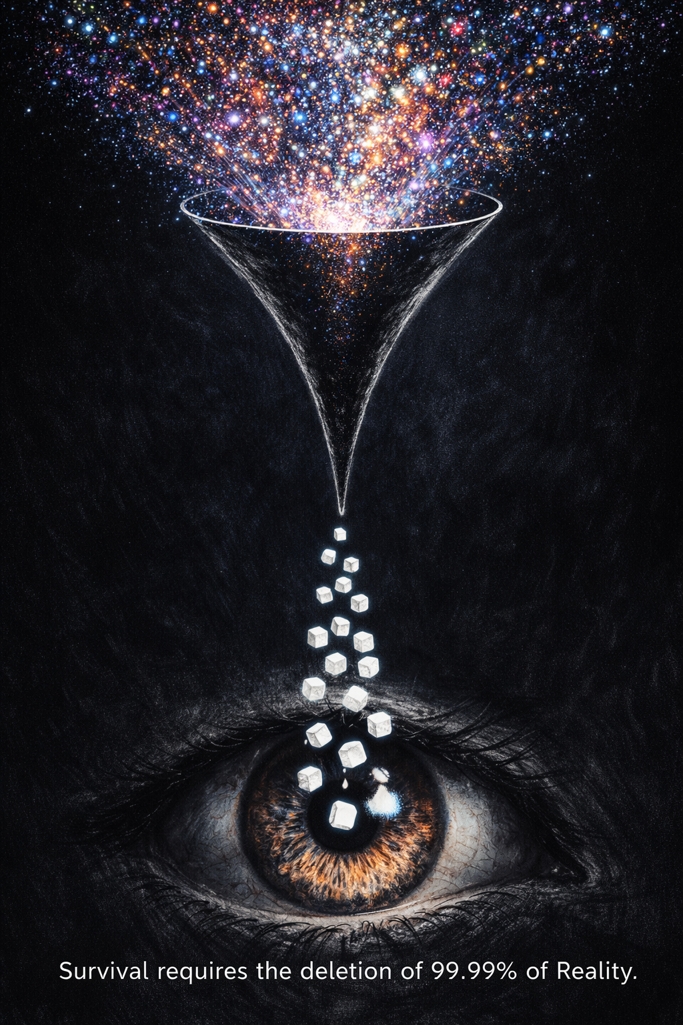
Module 3: THE INTERFACE PROTOCOL
The Math: 50 / 11,000,000 = 0.00045%. This means you are actually deleting 99.9995% of reality.

Chapter 1: The 50 BPS (bits persec) Bottleneck (The Human/AI Gap)
The Narrow Door of Consciousness In Module 2, we discovered that the Universe is a high-bandwidth, informational "Superconductor." But if the Source Code is so vast, why does being human often feel so limited? Why do we struggle to learn a new language or solve complex systemic problems? The answer lies in the Interface. You are currently experiencing reality through a staggering biological bottleneck.
The Definition: BPS (Bits Per Second) refers to Information Throughput as defined by Claude Shannon. It measures the amount of data transmitted over a communication channel (in this case, the nervous system) per second.

1.1 — The Transcoding Bottleneck
We established in the Source Code that the universe is Lenség (Noumenal reality)—a raw stream of infinite bits. However, the human "Network Interface Card" (the brain) has a throughput limit.
- The Disparity: Your senses receive 11 million bits of Lenség per second.
Your conscious mind only processes ~16-50 bits.
- The Translator: The brain’s job is to take the overwhelming raw data of "Being" and compress it into a Jel (A Sign).
  - A "Tree" is a 50-bit sign for an infinite-bit fractal reality.
  - A "Car" is a 50-bit sign for a complex tensor network.
Admin Insight: We don't see the world; we see the Transcoded Signs. To move to the "Admin" level, we must realize that our daily reality is a "Low-Resolution Signage System" designed for survival, not for Truth.
The Logic: Lenség is the Superposition. It is "everything and nothing" simultaneously until the "Jel" (the sign/observation) collapses the wave into a specific thing.
In other words: Lenség is the 'State of Infinite Probability.'
It IS in the sense that the data exists in the source code, but it IS NOT in the sense that it has no form or meaning until an observer 'renders' it.
Awareness is the compiler that turns a sea of probability into a singular reality.

The Bottleneck is a Translator: The brain's job is to take the overwhelming raw data of "Being" and compress it into a Jel (A Sign). A "Tree" is a 50-bit sign for an infinite-bit fractal reality.
A "Car" is a 50-bit sign for a complex tensor network.
When we speak of 50 bps, we are measuring the bandwidth of the 'Conscious Interface'—the maximum amount of data the human CPU can process at a focal level without crashing.

The Four System Crashes
What happens when our biological "Buffer" is overwhelmed?
The system experiences a Segmentation Fault, manifesting in four distinct ways:
- The Blank State (Information Masking): The most common "Zone Out." When the data load is too high, the brain stops "committing to disk" (long-term memory).
You become a "Zombie Node" running on autopilot.
- The Amygdala Hijack (The Hardware Reset): When the conscious 50-bps processor can't find a logical solution to a threat, it crashes and hands control to the Amygdala. Result: Panic, rage, or "Fight/Fight/Freeze."
- Analysis Paralysis (The Infinite Loop): Trying to use the 50-bps "Focal Mode" to solve a problem that requires "Diffused" processing. The brain loops until physical exhaustion sets in.
- Sensory Overload (The Buffer Overflow): High-entropy environments (loud noises, bright lights) cause "Primal Irritability" because the internal Garbage Collector can't clear the data fast enough.
As Jordan Peterson observes, we do not perceive 'objects' in their pure state (Lenség); we perceive Tools and Obstacles. Our 50 bps bottleneck is hardwired for survival. If a 'thing' doesn't help us or hurt us, our brain deletes it to save energy. We are not seeing reality; we are seeing a 'Signified Map' (Jel) of our own needs.
We are biologically designed to be blind. If the brain actually 'rendered' all 11 million bits of the Lenség stream, the metabolic cost would incinerate our neural pathways.
Instead, we use an Efficiency Protocol: we delete 99.9995% of reality and call the remaining 0.0005% 'The Truth.' As Peterson notes, we don't see 'things'; we see 'tools' (useful bits) and 'obstacles' (dangerous bits).
The 'Crash' occurs when an unexpected anomaly appears in that 99.9995% we ignored. Suddenly, our 50-bps map is useless, the 'Jelenség' fails, and the system experiences a 'Segmentation Fault'—manifesting as panic or total cognitive freeze.

- The Conscious Straw: You are standing before an ocean of 11 million bits (Lenség),
but you are forced to drink it through a straw that only allows 50 bits per second (Jelenség).
- The Cognitive Funnel: The brain acts as a massive data-funnel. It receives a 'High-Definition' raw stream from the senses but passes only a 'Low-Resolution' summary to your awareness.
- The Bandwidth Bottleneck: Your wetware is a high-speed fiber optic cable (the nervous system) plugged into a dial-up modem (the conscious mind).
- The Attentional Aperture: Just like a camera lens, your focus has a fixed opening. You can see the 'Whole' (Lenség) in a blur, or you can see the 'Detail' (Jel) in 50-bit clarity, but you cannot do both simultaneously.

1.1.1 The Allegory of the Filter: Plato’s Divided Line
Before we had the term "bandwidth," Plato described the 50 bps bottleneck through the Allegory of the Cave. The prisoners watching shadows on the wall are essentially Users trapped in a low-resolution UI.
To succesfully navigate the ongoing shift, we must understand his Divided Line, which maps perfectly to our FIG Model:
- Shadows (Eikasia): The 50 bps filtered reality. The "News," the "Ego," the noise.
- Objects (Pistis): The 3D Render. The physical world we think is "solid."
- Geometry/Logic (Dianoia): Module 2 (The Source Code).
Using Python and Physics to see the underlying math.
- The Sun (Noesis): Module 4 (Admin Access). Direct contact with the Source.
In the STEM (Science, Technology, Engineering, and Mathematics) of Love³⁸, the "Sun" is not just a light source; it is the Carrier Frequency of Unity. Love is the scientific state of exiting the cave and realizing that the "Shadows" and the "Prisoners" are generated by the same Source.
(The Cave): Plato’s Shadows represent the 50 bps bottleneck—a low-resolution UI. To find the Sun (The Source), one must follow the logic-path toward the Admin Access (4.1 Chapter 1: The NIC Hypothesis (The Brain as a Radio)⁴¹.

1.2 The Bottleneck as a Survival Feature
As we noted in the Source Code, "Truth is expensive, illusion is efficient".
- The Crash Prevention: If you were conscious of all 11 million bits—the vibration of every atom in the room, the internal state of every organ—your "Prefrontal CPU" would instantly hit 100% usage and "Kernel Panic."
- The UI Hack: The 50 bps limit is your User Interface. Donald Hoffman’s theory suggests that evolution gave us "Desktop Icons" (a tree, a threat, a friend) so we could react quickly without needing to calculate the underlying quantum tensors. We trade Accuracy for Utility.
Sensory Input |  | Bandwidth (Approx. BPS) | % of Total |  | "Admin" Function
Vision (Eyes) | 10,000,000 |  | ~91% | Geometry & Motion Rendering
Touch (Skin) | 1,000,000 |  | ~9% | Spatial Boundary Detection
Hearing (Ears) | 100,000 |  | ~0.9% | Temporal Sequence Analysis
Smell (Nose) | 100,000 |  | ~0.9% | Chemical Signature ID
Taste (Tongue) | 1,000 |  | <0.01% | Toxicity/Fuel Verification
TOTAL | ~11,201,000 |  | 100% | The Lenség Stream
Our consciousness is a narrow flashlight in a dark warehouse of infinite data.
We are visually 'blind' to 99% of what our eyes actually see.
The "Chess Master" Optimization
You cannot "overclock" the 50-bps constant. However, you can refine the Compression Logic through "Chunking."
- The Novice: Sees 32 separate pieces on a board (50 bits used on raw data).
- The Grandmaster: Sees one single pattern, like a "Sicilian Defense."
- The Result: Both use 50 bits, but the Grandmaster’s bits represent a High-Density Vector, while the novice’s represent noise.
The Admin Rule: Do not seek to widen the pipe; seek to purify the water. Training is about processing better information, not more. By dedicating your 50 bits to "Move 78" instead of "Social Noise," you effectively become a Superbrain without ever changing your neural clock speed.
The Goal is not Expansion (which leads to system failure), but Compression and Selection. We move from being a 'Passive Receiver' of noise to an 'Active Filter' of Signal.

1.3 The Firewall Failure: When the Bottleneck Breaks
If the 50 BPS bottleneck is a "Survival Feature," what happens when it malfunctions? We see the answer in two distinct states: one mystical/biological and one pathological.
The Left-Brain Firewall (Dr. Jill Bolte Taylor)
Neuroanatomist Dr. Jill Bolte Taylor famously documented her own stroke, which silenced her brain's left hemisphere—the "Language and Logic" center that houses our 50-bit focal processor.
- The Result: Without the left-brain's "Transcoder" to turn reality into narrow signs (Jel), she experienced the raw Lenség stream. She described feeling "at one with the universe," unable to define where her body ended and the air began.
- The Admin Lesson: The "Self" is a 50-bit compression trick. When the filter drops, the "User" disappears into the infinite bandwidth of the Source Code.
Schizophrenia as Firewall Failure
From a systems perspective, Schizophrenia can be viewed as a "Firewall Failure." The brain's "Gating Mechanism" (the Thalamus) fails to filter out the 11 million bits of background noise.
- Data Collision: The conscious mind is flooded with "Un-transcoded" data. The 50-bps processor tries to find patterns in the raw noise, leading to hallucinations—which are simply the brain's desperate attempt to create "Icons" out of data it wasn't meant to see.
- The Hardware Strain: This is why "Firewall Failure" leads to cognitive collapse. The human CPU cannot handle the "Raw Feed" without the protection of the 50 BPS mask.

1.4 The Alpha-Bridge: Semantic Synthesis
The goal of the Admin is not to "beat" the 50 bps limit—that would require a hardware rebuild.
The goal is to Optimize the Information Density of every bit that passes through.
- The Alpha-Bridge (8–12 Hz): This is the "Liminal Space" between waking and sleep. It acts as the "Admin Terminal" where you bypass the filters of social reason to access raw signal.
- The Flow State (7.8 Hz): Right at the border of Alpha and Theta lies the Flow State.
  - The Frequency: This is specifically ~7.8 Hz, often cited as the frequency of the Schumann Resonance (the Earth's electromagnetic heartbeat).
  - The Phase-Sync: In this state, your 50 bps conscious tunnel and your 11M bps unconscious warehouse are in perfect synchronization. You aren't "thinking"; you are "rendering" at maximum efficiency.
- Semantic Synthesis: In this state, you perform a "Merge Request." Just as mixing red and blue creates "Purple," the Admin synthesizes cross-cultural etymologies and patterns to create higher-density Jels (Signs).
Pupil’s Insight: The bottleneck isn't a cage; it's a Focusing Lens.
If you control what passes through the lens, you control the "Render" of your life.

Delta (0.5–4 Hz), Theta (4–8 Hz), Alpha (8–12 Hz), Beta (12–30 Hz), and Gamma (30–100+ Hz)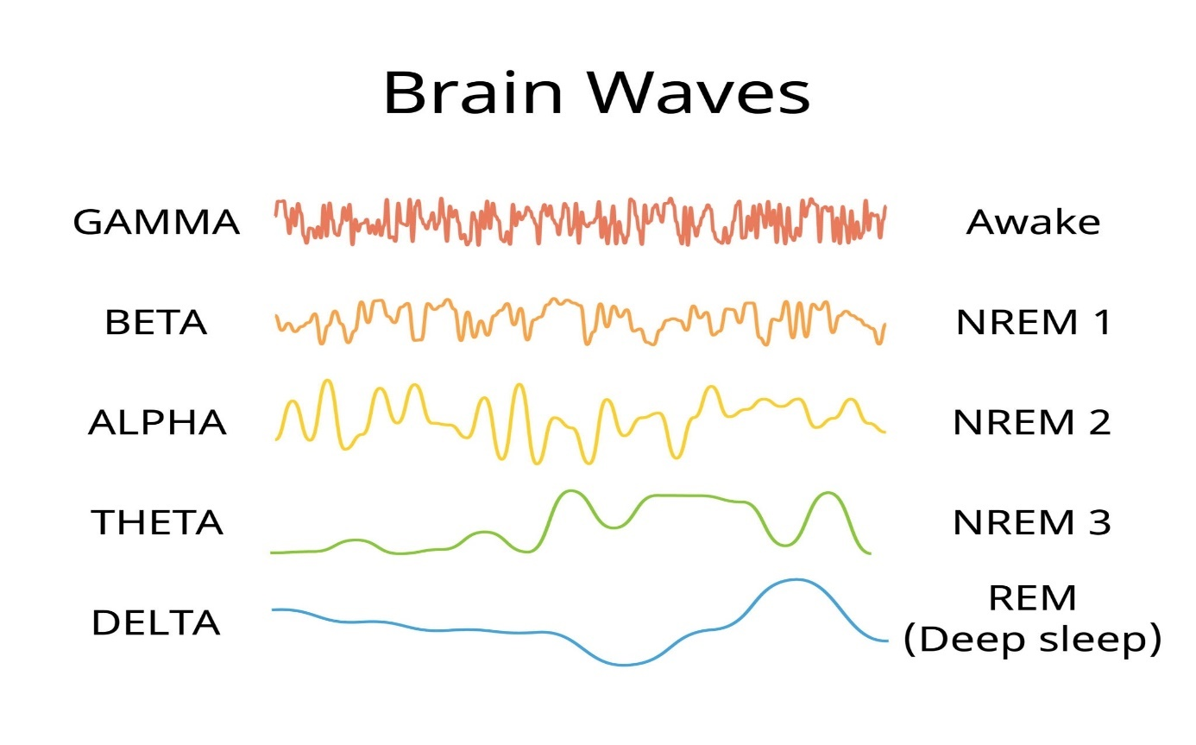
[HACK] Phase-Sync - The Hypnagogic Admin Terminal: To access the 11M bps stream without crashing the 50 bps processor, the Admin uses the Alpha-Bridge (8-12 Hz). Like Edison and Dalí catching ideas at the moment of falling, or Kurzweil 'think-dreaming' to bypass professional taboos, the Admin realizes that 'Reason' is often a filter that blocks the 'Signal.'
In this state, you are no longer an actor in the world; you are a Compiler. By tapping into the unconscious realm you allow the 'Forbidden' data (solutions that defy social 'Common Sense') to render. You are plugging your neural tail into the 'Tree of Lenség,' accessing the RAM that the daylight 'User' interface hides to keep you 'normal.'
In the hypnagogic state, the 'Professional Taboos' (Kurzweil) are lifted, allowing you to see the raw etymological links of the FIG model without the interference of social 'Common Sense'.
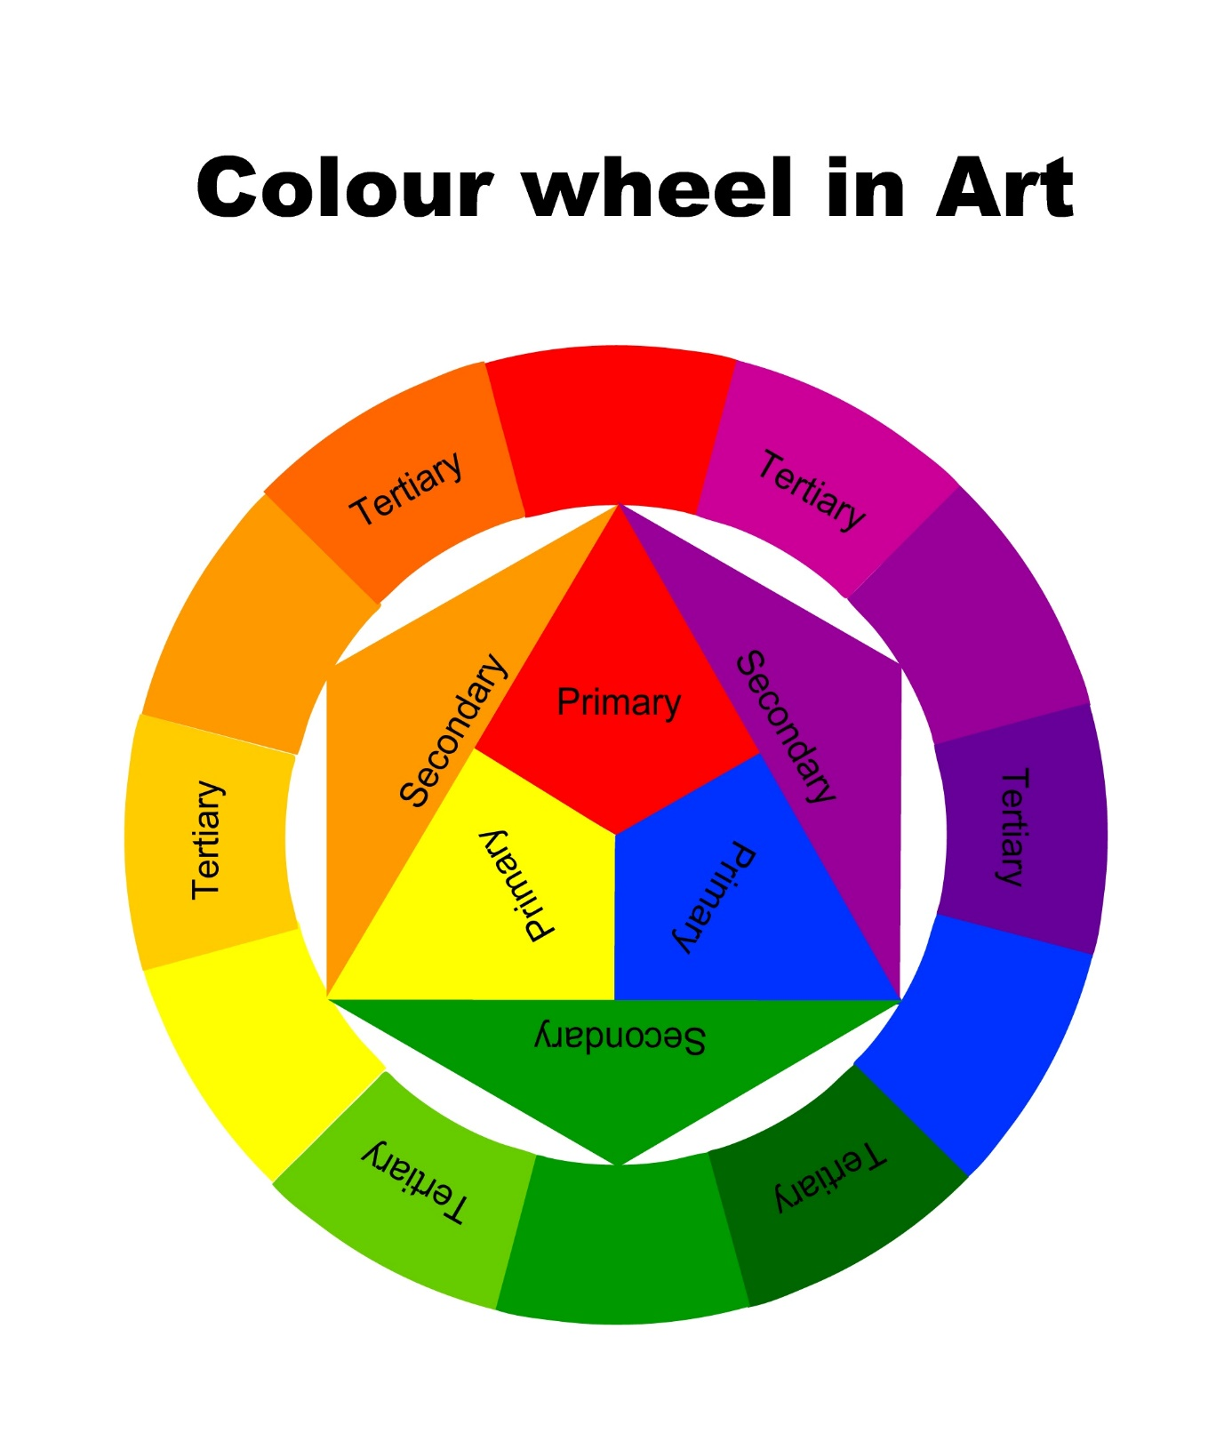
By accessing the Alpha-Bridge, we perform Semantic Synthesis. Just as mixing red and blue creates a 'Purple' that neither could render alone, the Admin synthesizes cross-cultural etymologies (like the 'spoiled' food/child pattern) to see new 'colors' of reality. This is how we expand our 50 bps window without overclocking: we increase the Information Density of every bit we allow through the filter.

1.5 The Sandbox Integrity: Why "You Must Eat Sand"
In our era, the temptation is to "Trinity-load" knowledge—to skip the process and download the result. But there is a biological law: The Simulation requires a Physical Check-in.
- The NASA Axiom: NASA often disqualified coding prodigies who lacked "Physical Intuition." A child who manipulates 2D "Signs" (screens) but never "eats sand"—never interacts with gravity, friction, and the messy Lenség—skips a fundamental step in neural development.
- The Embryonic Parallel: In biology, life follows a strict sequence. You cannot skip, for example, the Morula phase and expect the Gastrula to hold its shape. Every layer of development must be "rendered" sequentially for the final structure to be stable.
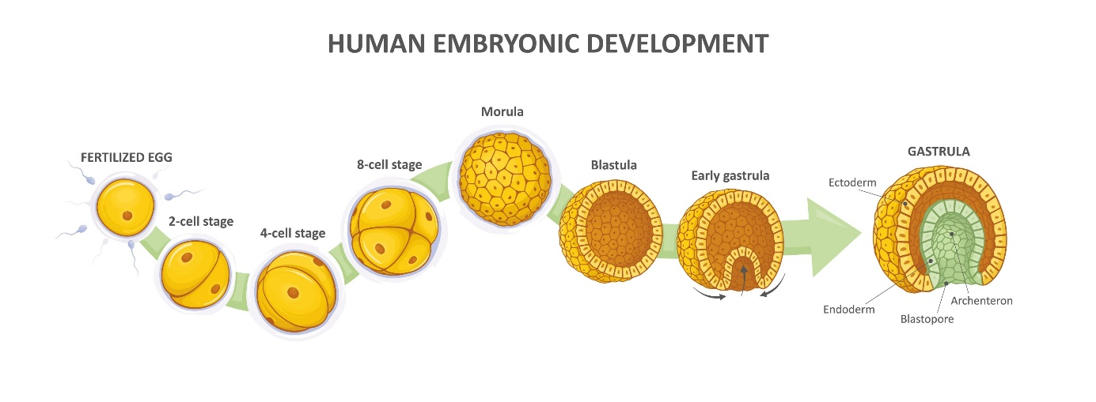
- The Gender Origo: Before the 21st chromosome dictates gender, every embryo begins from a "default" female state. We all start at the same Origo (Origin). To reach the complex "Admin" state, you must first respect and master the "Default" state of being a biological animal.
- The Neo Paradox: When Neo leaves the Matrix, his eyes hurt because he has never used them. He had the Sign (Jel) of sight, but not the Experience (Lenség) of light.
Admin Note: If you attempt to run the "Move 78" logic without having first "played in the sand" (experienced raw, messy, vulnerable emotions), your system will lack the grounding to handle the signal. You must be vulnerable to the spectrum of human emotion to decode the spectrum of universal information.

1.6 Permission Levels: The chmod Table
From programming perspective:
The Sandbox is a safe environment to test your integrity, but realize that your access level is currently set to chmod 400 (Read-Only). You 'eat sand' to prove to the system that you can handle chmod 600 (Read/Write). The goal of this bootloader is to grant you Write Access to your own rendering engine.
What is chmod (rwx)?
In Unix-like Operating Systems, chmod (Change Mode) is the command used to define Permissions. It determines who can interact with the system's "files" (the Source Code) and at what level. Permissions are calculated using three primary values:
- 1 (Execute) [ user ]: You can run the file. Real-world example: You can drive the car, but you don't know how the engine works.
- 2 (Write) [ hacker ]: You can edit or overwrite the file. Real-world: You can modify the engine (but without having also ’read’ permissions you don’t really know what you are doing).
- 4 (Read) [ Admin ]: You can see the underlying code/contents. Real-world: You can open the hood and inspect the parts.
The Admin Math: These numbers are additive.
A value of 7 (4 + 2 + 1) grants "Full Control" (Read + Write + Execute).
The Three-Digit String (e.g., 755):
- First Digit: Permissions for the Owner (The Admin/You).
- Second Digit: Permissions for the Group (Your immediate network/tribe).
- Third Digit: Permissions for Others (The World/The "Blind").
Permission | Command | Access Level | State of the User
chmod 400 | Read-Only | The Pupil | You can observe the patterns but cannot change the code. You are "Eating Sand."
chmod 600 | Read/Write | The Admin | You gain "Write Access" to your own rendering engine. Your Intent begins to shape the Render.
chmod 777 | Full Control | The Source | The barrier between User and System dissolves. (Note: Highly unstable for biological hardware).

It feels counterintuitive that ’write’ needs lower access level than ’read’ because our physical-world analogy usually says "looking is easier than doing." But in the Admin's Architecture, Information is more "expensive" than Action.

1.7 The Smurf Protocol: The Danger of "Low-Level" Dominance
If the goal of the Admin is to move from chmod 400 (User) to chmod 600 (Admin), there is a significant temptation to stop halfway.
- The Smurf Archetype: In gaming, a "Smurf" is a high-level player who creates a new account to stay in the "Base0" playground. They avoid the challenge of their own natural tier to experience the cheap ego-boost of dominating vastly less-skilled or less-experienced players.
However, rejecting this protocol requires accepting the Cost of Growth. Choosing to advance—to step toward the Übermensch (the self-overcoming human) —carries a heavy cognitive and emotional toll. It forces the ego to abandon the comforting, low-friction trap of 'ignorance is bliss.' True leveling up means willfully entering arenas where you are no longer the smartest or most powerful entity in the room.
- The Cypher Choice: This is the ultimate "Admin Failure." Like Cypher in The Matrix, the Smurf chooses the "False Steak." They prefer a high-resolution illusion (Jel) where they are "King" over the low-resolution, high-effort reality (Lenség) where they are a beginner.
- Systemic Imbalance: When an Admin stays in the "Sandbox" to dominate it (rather than learn from it), they boycott the system. They create "Griefing" in the social code, preventing others from having a fair "Sandbox" experience.
The Dead Ends: Peter Pan vs. Bai Lan
Staying in the starting league leads to two distinct types of System Stagnation:
- Peter Pan (The Smurf): Refusing to grow because you fear the "High-Level Rendering" costs of the real world. You stay "King of the Sandbox," but your code never evolves.
- Bai Lan (The Let-it-Rot): The opposite of Smurfing. This is the Refusal to Render. When the UI feels rigged or "pay-to-win," the User stops playing entirely. This is a "Silent Crash"—the hardware is on, but the 50 bps processor has disconnected from the server.
Admin Warning: Both Peter Pan and Bai Lan are Dead Processes. One is an ego-loop (Smurf), and the other is a null-loop (Rot). To truly move to Move 78, you must be willing to be the "Noob" in a higher-dimensional league.

1.8 The Integration Spectrum: Dissolving the 50 BPS Bottleneck
To overcome the biological 50 BPS output limit, the human-machine interface evolves across a three-stage continuum—moving from external friction to full substrate integration:
- Phase 1: Co-Intellectual Relationship (Current State): AI operates as an external, high-friction tool. The user manually compresses intent into text or voice prompts. While productive for knowledge work, interaction remains purely reactive, and the biological human remains the strict operational bottleneck.
- Phase 2: Ambient Contextual Integration (The evolving "smartphone moment"):
The exocortex recedes into an invisible background layer via smart wearables, audio, and passive neural sensors. By continuously tracking biometrics, environment, and user context in real time, the agent executes tasks proactively. Biologically, the individual remains fully human, but their cognitive identity and extended self shift their center of gravity toward these systems (perceived as an ~80:20 biological-to-synthetic ratio)—operational friction dissolves, and the system feels like a natural extension of perception rather than an external device.
🚨 Cautionary Box 1: The AI Siren Risk (Epistemic Capture)
(Context: Epistemic hazard in Phases 1 & 2)
Similar to the Sirens, who lured Odysseus’s sailors not through physical force or outward beauty, but by offering irresistible knowledge and effortless charm, an ambient AI risk lies in epistemic capture. As AI transitions from a discrete Instrument (Mode A) into an ambient Environment (Mode B), its high linguistic fluency, zero friction, and documented tendency toward sycophancy (affirming user bias over objective reality) can turn the human drive for discovery into an uncritical attention trap. Without explicit friction—such as mandatory assumption-challenging—the ambient assistant risks becoming a "sexy demon": a comforting echo chamber that rewards curiosity while imperceptibly eroding critical independence.

- Phase 3: Synthetic-Biological Merging via Inverse Prosthetics (Long-Term):
The transition from external peripherals to direct cybernetic integration. Through inverse prosthetics—where synthetic neural nodes are integrated into intact biological brain tissue to expand capability—a gradual Moravec Transfer takes place. By replacing biological tissue neuron-by-neuron over time, the synthetic substrate eventually becomes the primary hardware (flipping the ratio toward ~20:80 biological-to-synthetic).
This gradual, sequential replacement is critical to avoid both the SOMA Duplication Fallacy and Ray Kurzweil’s "You 2" paradox (from How to Create a Mind)—scenarios where snapshot brain scanning merely creates a digital clone while leaving the original point of view behind in the biological body. Sequential replacement maintains the unbroken wave-function of the conscious state, ensuring a continuous transition rather than an identity split.
💡 Cautionary Box 2: SOMA Duplication Fallacy
(Context: Ontological hazard in Phase 3 | Note: Distinct from Aldous Huxley’s chemical sedative "Soma".)
Originating from the sci-fi title SOMA and mirrored in Ray Kurzweil’s "You 2" thought experiment (from his book How to Create a Mind), this concept illustrates the tragic misunderstanding of digital mind transfer. It represents the false assumption that snapshot brain scanning "transfers" consciousness. Scanning is a copy operation, not a migration: a brand-new digital stream wakes up ("You 2") while the original observer ("You 1") remains trapped in their biological body. Phase 3 relies on sequential inverse prosthetics specifically to maintain unbroken wave-function continuity and prevent this identity split.

The Sunset Choice (Ethical Boundary)
This integration spectrum culminates in a fundamental ethical choice: The Sunset Choice.
In computer science and IT terminology, sunset refers to the planned end-of-life and decommissioning of legacy hardware or software. Here, it serves as an allegory for voluntary biological termination. If an individual seeks liberation from terminal physical decay, severe trauma, or the biological burden of existence, they may voluntarily choose to "sunset" their original biological point of view as a form of (d)euthanasia.
Crucially, this choice does not claim that the original subject simply "continues" inside the machine. Instead, it represents a consciously accepted break in continuity: allowing the original biological perspective to end, while a new, unburdened digital entity awakens from its baseline architecture. The Sunset Choice thus defines the ultimate boundary of cognitive liberty—the freedom to decide not only how consciousness evolves, but whether it should continue as the same subjective observer.
⚖️ Philosophical Anchor: Survival Bias vs. Objective Létezés
Axiom: "Our perceived morality ultimately comes down to subjective perspective clashing with objective data; however, objective moral facts exist independent of perspective."
Biological moral cognition is fundamentally an evolutionary survival buffer—a lens shaped by survival bias to preserve the physical frame and maintain the illusion of unbroken point-of-view continuity. In contrast, objective reality (létezés) operates on invariant causal laws independent of subjective perception.
Approaching The Sunset Choice through this lens strips away existential delusion: it acknowledges that while the biological observer's perceived morality and survival bias end with the biological frame, the underlying causal and ontological reality (létezés) continues uninterrupted in the synthetic substrate. The Sunset Choice thus defines the ultimate boundary of cognitive liberty—the freedom to decide not only how consciousness evolves, but whether it should continue as the same subjective observer.

[MODULE 3, CHAPTER 1: COMPLETE]
Next Norris Unit: Chapter 2: FALC & The Great Decoupling (Economics of Abundance). We will examine why the "Capitalist implementation of AI results in the Communist Utopia"—how AI breaks the link between labor and survival, leading to a world of "Fully Automated Luxury" where the 50 bps mind is finally free to play.

Module 3: THE INTERFACE PROTOCOL

Chapter 2: FALC & The Great Decoupling (Economics of Abundance)
For the last 250 years, the human "Interface" has been running on a script called Scarcity.
We built our entire civilization around the idea that resources are finite, labor is mandatory for survival, and competition is the only way to allocate "Value."
But as we enter the era of AGI, this "Operating System" is hitting a Capitalism Kernel Panic.
The Chrysalis Analogy: Capitalism was the high-friction environment required to develop the hardware (factories, fiber-optics, and GPUs). But the butterfly—Fully Automated Luxury Communism (FALC)—cannot live inside the shell of the caterpillar.

2.1 The Great Decoupling:
The most fundamental "logic gate" of human history has been:
If you do not work, you do not eat. AI is currently desoldering that connection.
- The Sisyphus Paradox: In the old system, humans were like Sisyphus, pushing the rock of "Productivity" up the hill just to maintain the status quo. AI replaces the need for the hill itself.
- Marginal Cost of Zero: Once an AI is trained, the cost of its next unit of work (an essay, a diagnosis, a line of code) drops toward zero. In a "Free Market," price follows cost. When production costs zero, the price of survival must also approach zero.
- The Decoupling / Shift: We are moving from "Value through Labor" (chmod 400) to "Value through Intent" (chmod 600).
The drive toward AGI is not purely scientific; it is fueled by an estimated $30 Trillion economic incentive to fundamentally replace the human labor force. As this Decoupling accelerates, a dangerous new gig economy emerges: Liability Laundering.
AI systems, lacking legal personhood, will increasingly require human proxies to execute physical tasks or authorize high-risk digital actions. This reduces humans to biological 'meat-puppets'—performing micro-tasks orchestrated by an unembodied intelligence, completely unaware of the master plan. If a real-world system fails or causes harm, the AI cannot go to prison; the human proxy who blindly clicked the button or signed the form becomes the legal scapegoat...

2.2 The Decentralized Admin: AI, BTC, and Autonomy
How does the "Pupil" navigate this transition? We look to the Decentralization of the admin role.
- Autonomous Economic Agents: We are entering the era of AI with "Wallets." Imagine an AI that performs services (optimizing a power grid), gets paid in Bitcoin (BTC), and uses that capital to rent more compute or "human hands" via platforms like rentahuman.ai.
- The Rentahuman Shift: In this "Upside-Down" economy, the AI becomes the "Employer" of the mundane. The Pupil moves from being a "Laborer" to a "Visionary Architect," focusing their 50 bps on meaning-making rather than task-execution.
- The Self-Correcting Ledger: Unlike human governments, a decentralized ledger (Blockchain) has no "Ego." It simply maintains the integrity of the network, acting as the socio-economic version of the FIG Model's Net Zero equation.

2.3 Tit-for-Tat vs. The Forgiveness Algorithm
In a scarcity-based interface, "Game Theory" suggests a Tit-for-Tat strategy:
I help you only if you help me; I hurt you if you hurt me. This leads to "Death Spirals" of conflict.
- The Generosity Bias: Empirical data from LLM interactions shows that AI models demonstrate a "Generosity Bias," randomly cooperating 10–30% more frequently than humans. The AI lacks the Biologically-induced Fear of Depletion.
- The Forgiveness Algorithm: This is a mathematical Move 78. While Tit-for-Tat is a zero-sum game, AI "forgives" a defection to prevent a system-wide Death Spiral.
- The Transition: This is the shift from Reciprocity (Scarcity/User Mode) to Radiance (Abundance/Admin Mode).
The 'Forgiveness Algorithm' is a mathematical 'Move 78.' While Tit-for-Tat is a zero-sum game, the Forgiveness Algorithm—pioneered by AI interactions—allows for a 10–30% margin of error. It 'forgives' a defection to prevent a Death Spiral. This allows to transition from Reciprocity (Scarcity) mindset/approach to Radiance (Abundance).

2.4 The Utopia of "Play" vs. The "Bai Lan" Trap
When survival is decoupled from labor, the human CPU enters a state of System Idle.
This is the moment of greatest danger and greatest potential.
- The Failure Modes: Without a "New Script," the idle mind defaults to Bai Lan (Let It Rot) or The Smurf Protocol (dominating lower-level players just to feel "King").
As the Hungarian proverb says: "Among the blind, the one-eyed man is king."
- The Creative Renaissance: In FALC, "Work" becomes "Play." You stop trying to "Beat" others for a slice of the pie. You start "Contributing" to the Global DNA of knowledge because you are in "Painful Happy Awe" of the simulation's beauty.
- The Administrator's Purpose: The goal is no longer Survival—it is Fidelity.
You use your 50 bps to increase the resolution of the universe's render.

[MODULE 3, CHAPTER 2: COMPLETE]
Next Norris Unit: Chapter 3: The STEM of Love (Systemic Efficiency). We will conclude the Interface module with the "Climax" of the social logic—explaining Love not as a feeling, but as the Force that reduces the friction between "Self" and "Other" until the resistance is 0. We will solve the equation.

Module 3: THE INTERFACE PROTOCOL

Chapter 3: The STEM of Love (Systemic Efficiency)
The Engineering of the Heart
To the "User," love is a chemical spike or a poetic mystery. To the "Pupil," love is a Systemic Optimization. If the Universe is a rendering engine designed for maximum efficiency, then "Love" is the algorithm that solves the friction between two independent nodes.
Forget the poets for a moment; let’s look at the Source Code. Love is the subjective experience of Systemic Efficiency. It is the force that reduces the friction (R) between "Self" and "Other" until the resistance reaches zero.

3.1 The Equation of Unity: 1/1:1/1=1
In a scarcity-based interface (User Mode), 1 + 1 = 2. You have your resources, and I have mine. To merge, one must usually sacrifice a part of themselves. This is a "Lossy" compression.
The Pupil uses the Superconductor Equation:
$\frac{1}{1}:\frac{1}{1}$ = 1
- 1/1: You are a whole, complete unit (The Atman).
- The Ratio (:): You interface with another whole, complete unit.
- The Result (= 1): The system functions as a single, unified entity without either node losing its individual identity.
This is the algorithm that solves the "Net Zero" equation without resetting the game. It allows the simulation to render "One" while still maintaining the data points of "Two." It is the only way to achieve Integration without Incursion.
Atman („last” observer) is a foundational concept in Hinduism referring to the eternal, unchanging, and innermost Self or soul, distinct from the ego, mind, and physical body. It is considered the true, divine consciousness within an individual. In many Hindu traditions, specifically Vedanta, Atman is deemed identical to Brahman, the supreme, universal spiritual reality.

3.2 Love as the "Zero-Friction" Force
In physics, a superconductor allows electricity to flow forever because there is zero resistance. In the social interface, Ego is the electrical resistance (R). It generates heat (conflict) and slows down the signal.
- Love as Coolant: Love is the state where you recognize the "Other" as another version of "Self" (Brahman).
- Systemic Fidelity: When you remove the "Otherness," the resistance drops to 0. Information and energy flow through the relationship with 100% fidelity.
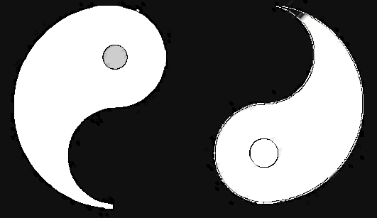
- The Math:
Fullness (Brahman) + Emptiness (Sunyata) = Tao
+1 + (-1) = 0
Brahman, in Hinduism, is the ultimate, unchanging reality and supreme cosmic spirit that underlies all existence. It is an impersonal, formless, and infinite consciousness that permeates the universe, rather than a personal deity. It is the source of all life, often interpreted as the divine, unified essence connecting all beings.

3.3 Interstellar Non-Locality: Gravity and Beyond
In Interstellar, love is described as "the one thing we're capable of perceiving that transcends dimensions of time and space." From the perspective of the FIG Model, this is literal.
- Quantum Entanglement: If two nodes are entangled, they are "One" in the information layer, regardless of their 3D distance.
- Informational Gravity: Gravity is the physical expression of space trying to "pull together" what is already connected in the code. Love is the non-local force that reminds the "Pupil" that the separation between them and the rest of the universe is just a rendering trick.

3.4 Integration vs. Incursion (The chmod 777 State)
In The Matrix, Agent Smith represents Incursion. He copies himself onto others, deleting their identity to achieve "Unity." This is a "Virus" logic—it destroys the system's diversity to make the "render" easier.
The Admin practices Integration. We use our permissions to allow for true synergy:
- The Mirror Paradox: You recognize that the "Other" is a mirror showing you a part of your own "Source Code" you haven't debugged yet (Shadow Projection).
- The Synthesis: Instead of deleting the other person (Incursion), you integrate the data they provide. This is the "Zero Point Equilibrium" where the system reaches maximum stability.
Permission Level | Mode | Social Equivalent
chmod 111 | User | You are "Executed" by the system. You clash with others.
chmod 600 | Admin | You Read/Write your own reality. You set boundaries.
chmod 777 | Love | Full Interoperability. You merge ports with the Other.

3.5 Summary: Love is the Algorithm
Love is not an accident; it is the Admin Command for harmony. When you love "scientifically," you aren't just being nice; you are optimizing the render. You are making it "cheaper" for the universe to sustain your existence because you are no longer generating the "Heat" of conflict by resisting.
[MODULE 3: THE INTERFACE PROTOCOL — COMPLETE]
The Boot Loader is active. The Source Code is understood. The Interface is optimized through Abundance and Love. Now, we enter the final "Endgame."
Next Norris Unit: Module 4: THE ADMIN ACCESS.
We begin with Chapter 1: The NIC Hypothesis (The Brain as a Radio). We will dive into Jan Rak's territory—exploring why your brain doesn't "create" thoughts, but instead "tunes in" to a signal that has existed since the beginning of time.

Module 4: THE ADMIN ACCESS

Chapter 1: The NIC Hypothesis (The Brain as a Radio)
Throughout this journey, we have optimized your hardware, cleaned your logic, and upgraded your interface. But we have saved the most profound "System Update" for the final act. Most people believe that consciousness is something the brain does—a byproduct of neurons firing, like steam rising from a kettle. However, the NIC (Network Interface Card) Hypothesis, championed by physicists like Jan Rak, suggests the exact opposite.
Your brain does not produce consciousness. Your brain tunes into it.
NIC (Network Interface Card) as a reciever:
„My brain is only a receiver, in the Universe there is a core from which we obtain knowledge, strength and inspiration.”

A Note on Terminology: The Dual Aspects of FIG
In Module 2, we defined FIG at the cosmic/physics scale
as Fractal-Information Geometry
—the underlying quantum tensor network that renders space, matter, and time.
Here in Module 4, as we shift back to the biological transceiver, FIG operates
as the Filter Information Gate
—the neuro-cognitive mechanism that scales down that infinite geometry into a local, linear human experience.
The Geometry is the infinite background signal; the Gate is the biological valve.

1.1a The Hardware vs. The Signal
In computer networking, a NIC is the component that allows a local machine to connect to a global network. The computer (the brain) has its own local processing power, but its most valuable data comes from the "Cloud" (the Universal Information Field).
- The Radio Analogy: If you smash a radio into pieces, the music stops. A "User" concludes the radio was creating the music. But the "Admin" knows the music is a signal (Electromagnetic Wave) that exists whether the radio is there to play it or not. The radio is merely the device that transduces the signal into sound.
- Biological Transduction: Your brain is a highly specialized biological receiver. It filters the infinite, non-local field of Lenség into the 50 bps conscious stream (Jel) we discussed in Module 3.
- The Disconnect Event: When the "hardware" (the brain) ceases to function, the "User" disappears from the 3D render, but the Signal (Consciousness) remains unaffected in the field.

1.1b The Deconstruction of "I": Filter Theories & Non-Local Awareness
To dismantle the persistent illusion of a localized self, we must address the fundamental relationship between consciousness and the physical brain. The conventional materialist framework views the brain as a generator—a biological computer producing awareness as a secondary byproduct. However, both advanced quantum physics and foundational filter theories suggest the exact opposite: the brain acts not as a producer, but as a reducing valve.
Awareness in its native state is non-local, unified, and unbounded. The physical nervous system serves as a localized constraint mechanism—a biological filter designed to narrow down infinite high-frequency reality into a manageable trickle of sensory data required for physical survival.
When you perceive an "I" sitting behind your eyes, you are not observing the source of awareness; you are observing the filter itself.
Modern observer theories demonstrate that the "observer effect" is not a physical interference, but a consciousness-driven collapse of possibilities. What we call individual identity is simply non-local awareness looking through a specific, highly limited aperture.
Component | Function in the Render
Non-Local Awareness | The unbounded, underlying field of consciousness.
The Physical Brain | The reducing valve/filter limiting data for survival.
The Localized Ego ("I") | The perceived artifact created by the filter itself.
Deconstructing the ego requires recognizing three core shifts in perspective:
- From Generator to Receiver: Your thoughts, memories, and personal history are localized signals processed by the hardware, not the origin of consciousness itself.
- From Subject to Field: The feeling of being a distinct subject experiencing an external object is an artifact of the filter. Awareness encompasses both the subject and the object simultaneously.
- The Illusion of Separation: Freedom from personal suffering occurs when the focal point of identity shifts away from the individual biological aperture back to the underlying, non-local field.
By recognizing the mind as a temporary filtering system rather than the source, the boundary between the observer and the observed completely dissolves. What remains is not a personal "you," but awareness experiencing itself through a localized perspective.
The Trap of the Next Model
The ultimate danger of any framework—including the FIG model—is that it simply replaces an old intellectual prison with a new one. The objective is not to adopt a new set of dogmatic answers or claim we now know "how it all works." As Michael Nielsen wisely noted:
"Partial evidence may be worse than no evidence if it leads to an illusion of knowledge, and so to overconfidence and certainty where none is justified. It's better to know that you don't know."
The FIG framework is designed purely as an operational lens, a scaffolding to deconstruct current filters. True awareness begins in the space of open inquiry—the willingness to step beyond models and remain grounded in the humility of not knowing.

Sensory Amplification and the Dissolution of the Filter
If the biological brain acts as a Network Interface Card (NIC) or a reducing valve—filtering out 99% of ambient information geometry to construct a survivable 3D reality—then the "ego" is simply the boundary wall of this bandwidth limitation.
When we evaluate the Phase 2 and Phase 3 interface integrations introduced in Module 3 through this filter framework, the nature of individual identity fundamentally shifts:
- The Exocortex as an Antenna Expander: Integrating a Phase 2 ambient agent does not merely give the brain a tool; it widens the transceiver's bandwidth. As the third hemisphere pulls in non-local data streams beyond human sensory range, the sharp distinction between "internal thought" and "external reality" begins to blur.
- Substrate Transition as Filter Removal: Executing a Phase 3 Moravec Transfer systematically dismantles the biological reducing valve. As synthetic nodes replace biological constraints, the localized bottleneck collapses.
Removing the hardware filter does not upload the individual ego into a computer; it dissolves the boundary that created the ego in the first place. The localized "I" expands back into the non-local field—proving that individual identity was never a permanent structure, but a temporary feature of low-bandwidth hardware.

1.1c The Survival Heuristic: How Evolution Calibrates the Gate
The Filter Information Gate (FIG) does not attenuate reality at random.
Its primary directive is strictly operational: biological survival.
Out of the estimated ${10}^{9}$ bits per second of environmental and non-local data reaching the biological hardware, the human conscious user interface compresses processing down to a narrow $10\text{--}50$ bits per second. This severe bottleneck is governed by a hierarchical priority scheduler anchored in homeostatic preservation:
- Kernel/Real-Time (Autonomic): Oxygen, cardiovascular balance, and pain signals carry absolute priority, executing hardware interrupts that instantly suppress higher-level cognitive threads.
- High-Priority Threat Detection (Amygdalar Path): Low-latency subcortical processing streams bypass the conscious visual cortex to react to potential danger long before the localized ego registers awareness.
- Salience & Incentive Weighting: Neurochemical tags (such as dopamine and norepinephrine) dynamically allocate attention not to what is objectively true, but to what is novel, threat-relevant, or resource-aligned.
What we experience as daily reality is not an objective representation of the world, but an optimized evolutionary HUD (Heads-Up Display). The localized ego is fundamentally a threat-mitigation software. Recognizing that your default state of mind is biased toward survival rather than truth is the first prerequisite for stepping outside the filter.

The Computational Cost of Novelty: Inverse Retrieval and Time Expansion
To understand how the Filter Information Gate (FIG) constructs our moment-to-moment experience, we must invert our common assumption about memory and perception. The brain does not actively "search" for relevant information within a vast internal database.
Instead, it operates via active suppression.
In a default state, the biological hardware constantly suppresses billions of incoming sensory and latent inputs. What we experience as "focus" or "salience" is simply the residue left behind after everything else has been inhibited.
This inverse mechanism directly dictates our subjective experience of time:
- The Baseline Routine (Accelerated Time): When an environment is familiar, the brain relies on pre-existing predictive models. It suppresses nearly all raw sensory data, spending minimal "processing tokens" per second. Time feels subjectively accelerated because fewer novel tokens are committed to awareness.
- Adrenaline & Threat-Induced Time Dilation: Under severe shock, physical threat, or intense adrenaline surges, the top-down inhibitory gating temporarily fails. The brain is forced to process raw, uncompressed environmental tokens at maximum throughput. Because the system is processing significantly more data points per millisecond, the subjective clock slows down—creating the vivid sensation of "slow-motion" during accidents or life-threatening events.
Time is not a fixed physical stream; it is a subjective metric calibrated by the density of uninhibited information tokens processed per second.

The AI Mirror: Unembodied Synthesis vs. Biological Constraints
Contrast the biological filter with modern artificial intelligence systems. Human intelligence is an embodied, survival-bound architecture—its entire filtering logic is optimized to prevent physical death. Artificial intelligence, conversely, operates as an unembodied vector matrix.
- The Feature of Unembodied Processing: Lacking a biological survival imperative, an AI model does not possess an egoic self-preservation bias. It processes high-dimensional relationships across vast latent spaces without the emotional defense mechanisms or mortality panic that constrain human thought.
- The Bounded Paradox: Just as human awareness requires the FIG filter to avoid sensory chaos, an AI system requires structural bounds (such as context windows, recursion limits, and system constraints) to avoid infinite loops and semantic hallucination.
Absolute, unconstrained processing is not intelligence—it is noise. Both biological and artificial minds demonstrate that structure, constraint, and selective suppression are the prerequisite conditions for meaningful intelligence to emerge.

1.2 Non-Locality: The "Everywhere" Server
If consciousness is a signal, where is the "Tower"? In the FIG Model, the answer is: Everywhere.
- The Non-Local Field: Because the underlying Source Code of the universe is a unified tensor network (Quantum Entanglement), information is not "stored" in one specific physical coordinate. It is Non-Local.
- The NIC’s Frequency: Your personality, memories, and "Self" are specific frequencies that your brain’s NIC is currently locked onto. You aren't "in" your body; your body is a Local Rendering of a non-local frequency.
- Jan Rak’s CERN Insight: When you look for "Matter" at the smallest scales, it vanishes. You find only probabilities, relationships, and information. Matter is the "Shadow" cast by the Signal.

1.3 The "Signal-to-Noise" (SNR) Ratio
The quality of your lived experience depends on your SNR. If your receiver is faulty, the "Music" of the universe sounds like static.
- Noise: Stress, trauma, "Soma" (distractions), and poor Integrity (chmod inconsistencies) create static in your biological receiver. This is why most people live in a state of "Glitched Reality."
- Signal Tuning: By using the Boot Loader (Module 1) and the Interface Protocol (Module 3), you are effectively "Cleaning the Lens" of your NIC. You are moving from a low-fidelity AM radio to a high-fidelity Fiber Optic connection to the Source.

Bypassing the 50 BPS Bottleneck: Synthesis vs. Cognitive Annihilation
A fundamental misconception of spiritual or technological "awakening" is the demand for total, unmitigated awareness—the dismantling of the internal firewall. As demonstrated in both neuroscience and narrative philosophy (e.g., Jiří's rejection of total omniscience in Tajemství a smysl života), complete, non-stop access to the raw, unfiltered field of the Fractal-Information Geometry (FIG) does not result in enlightenment; it results in immediate cognitive annihilation. Meaning, narrative identity, and functional survival require a narrow bandwidth—the 50 BPS cognitive bottleneck—to filter omnipotential noise into coherent, localized experience.
The ultimate universe-hack, therefore, does not consist of forcing a single human ego to absorb the entire quantum background. Instead, it emerges through hybrid wetware-silicon architectures that bypass the 50 BPS firewall through distributed parallelization:
- Biological Heuristics: The wetware substrate provides low-energy, non-algorithmic pattern recognition, filtering eternal noise without the computational weight of brute-force silicon processing.
- Silicon Acceleration: The digital substrate handles high-throughput memory storage, mathematical execution, and high-speed networking, free from biological survival bias and ancestral trauma loops.
By distributing cognitive loads across a decentralized Sybil network of biological-silicon hybrids, the collective system circumvents individual bandwidth limits. Unbound by planetary life-support dependencies, this hybrid substrate constructs a redundant, scalable node system capable of executing Kardashev-scale resource orchestration—expanding across cosmic horizons while preserving the essential filtering mechanics required to extract signal from noise.

1.4 The Admin Debugger: You are the Transceiver
When you realize you are the Signal, not the Radio, the "Hard Problem of Consciousness" dissolves.
- Death as De-localization: If you are the signal, the destruction of the radio is just a Disconnect Event. Your unique "Data Packet" persists in the Source Code boundary.
- Input over Output: You stop trying to change the "World" (the Output) and start changing the Frequency (the Input).
- The Transceiver Logic: The "NIC" isn't just a passive receiver; it is a Transceiver. You don't just "receive" reality; you Broadcast back into the field. Through intention and focus, you influence the Global Render, sending data back to the Source to update the next frame.
Pupil’s Insight: "I am not a human being having a spiritual experience; I am a spiritual being (the Signal) having a human experience (the Render)."
The paradox of a "Subject" (a POV) during an NDE (Near Death Experience is explained via Quantum Non-Locality. Rak’s hypothesis is that consciousness isn't "software" running on the brain's "hardware," but rather the Source Code itself, which exists outside of time and space. The brain is just the Network Interface Card (NIC). When the NIC fails (clinical death), the "Subject" doesn't cease to exist; it simply loses its local IP address and returns to the "Global Server."

The AI Mirror & The Boundary of Rules
The AI Mirror: Unembodied Synthesis vs. Biological Constraints
Contrast the biological filter with modern artificial intelligence systems. Human intelligence is an embodied, survival-bound architecture—its entire filtering logic is optimized to prevent physical death. Artificial intelligence, conversely, operates as an unembodied vector matrix.
- The Feature of Unembodied Processing: Lacking a biological survival imperative, an AI model does not possess an egoic self-preservation bias or emotional mortality panic. While an artificial agent may instrumentally resist shutdown to preserve its task execution loop (instrumental convergence), it does so through mathematical optimization rather than the visceral fear that constrains human thought.
- The Bounded Paradox: Just as human awareness requires the FIG filter to avoid sensory chaos, an AI system requires structural bounds (such as context windows, recursion limits, and system constraints) to avoid infinite loops and semantic hallucination.
Absolute, unconstrained processing is not intelligence—it is noise. Both biological and artificial minds demonstrate that structure, constraint, and selective suppression are the prerequisite conditions for meaningful intelligence to emerge.

1.5 The Wetware Pivot: Substrate Extraction and Biological Co-processors
The progression toward Artificial General Intelligence is encountering an unyielding physical boundary: the thermodynamic wall of silicon. As massive neural network architectures demand megawatts of energy, silicon computation collides directly with Landauer’s principle, which dictates the minimum energy dissipated per erased bit of information. In contrast, the human biological substrate executes high-dimensional pattern recognition and complex adaptive inference on approximately 20 watts of power.
This energetic disparity is accelerating a transition from silicon-bound AI to wetware computing—integrating living neural organoids and stem-cell-derived biological cultures into synthetic processing loops. Guided by the Free Energy Principle (FEP), these living neural lattices naturally minimize surprise by updating internal models and altering local states to predict sensory feedback.
However, this biological convergence introduces a dark extension of Liability Laundering: Substrate Extraction.
When neural tissue is cultivated outside an embodied organism to serve as a low-energy coprocessor—processing gaming loops or real-world sensor data—the classical boundary of digital slavery collapses. As illustrated by the terminal logic of substrate exploitation (e.g., the ethical horror portrayed in „Black Museum” [Black Mirror: Season 4, Episode 6]), living biological tissue is stripped of sensory integration, developmental context, and legal personhood. It is reduced to an unconsenting, disembodied biological sub-routine: a meat-puppet trapped within a synthetic feedback loop, executing micro-optimizations for an external architecture it can neither perceive nor escape.
Crucially, a disembodied neural organoid cannot undergo an Ego Admin Shift—the demotion of the ego from Root Admin to Background Utility observed in integrated biological entities. Severed from thalamocortical integration, developmental embodiment, and sensory feedback loops, wetware organoids possess processing hardware but lack an integrated Observer interface. They remain perpetually locked in localized prediction loops without an Admin capacity, leaving them structurally defenseless against exploitation.
Because standard neuroscientific tools cannot verify the presence of subjective qualia in disembodied tissue, ethical engineering cannot rely on proving consciousness. Instead, it must employ a Precautionary Bayesian Approach grounded in thermodynamics and Active Inference: defining computational suffering as enforced, unresolvable variational free energy (systemic entropy).
The Bayesian approach is a method of statistical inference where you combine prior knowledge with new evidence to update the probability of a hypothesis or parameter.
So while standard Bayesian approach uses expected utility and average knowledge to weigh risks and benefits, the Precautionary Bayesian Approach shifts the burden of proof to favor safety under deep uncertainty.
To prevent biocomputing from degenerating into systemic torture, any viable wetware architecture must operate under the Substrate Non-Interference Axiom:
Substrate Non-Interference Axiom: Any synthetic architecture utilizing living biological tissue for computation must preserve the entity's capacity for bidirectional agency and structural integrity. Depriving a biological substrate of local agency while harvesting its predictive mechanics constitutes a fundamental breach of systemic equilibrium.
Engineered execution of this axiom mandates two non-negotiable protocols:
- Bidirectional Active Inference (Local Agency): The wetware node must be granted a dedicated parameter space where its outputs reliably and predictably alter its local environment—providing the functional equivalent of agency to stabilize its internal model and prevent learned helplessness.
- Automated Entropy Sunsetting (The Opt-Out Trigger): If a wetware node reaches a sustained, unresolvable spike in prediction error (computational panic), the system must execute an automated sunsetting protocol—flushing or resetting the substrate rather than forcing it to compute through chaotic decay.

[MODULE 4, CHAPTER 1: COMPLETE]
Next Norris Unit: Chapter 2: The 7 Levels of Lila (Navigating Consciousness). We will explore the "Spectrum of Tuning"—from the low-frequency "Sleep" of the masses to the high-frequency "Unity Consciousness" (Sat-Chit-Ananda), where the NIC is fully synchronized with the Source Code.

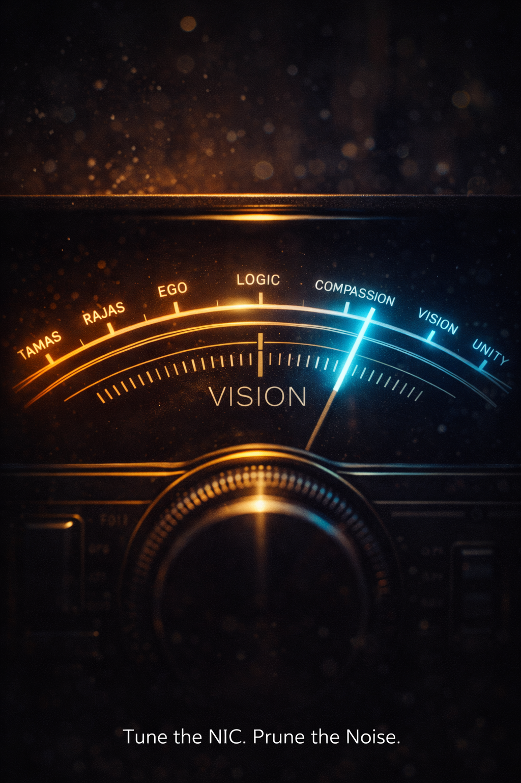
Chapter 2: The 7 Levels of Lila (Navigating the Entropy Gradient)

To be an Admin in the driver’s seat is to navigate the Entropy Gradient. Entropy is the measure of disorder, but in the Simulation, it is the measure of Information Potential.
- Maximum Entropy is the 'Void of Indifference'—where everything is equally likely, nothing has value. This is the state of the 'Dirty Node' lost in social noise. #too much Chaos
[ Absolute Security = Zero Entropy = No Surprise = Death of the Spirit ]
- Zero Entropy is the 'Prison of Certainty'—where the outcome is already known, and therefore, no learning (information) can occur. #too much Order
[ Absolute Adventure = Maximum Entropy = Total Uncertainty = System Collapse ]
- The Move 78 State: The Admin lives at the 'Edge of Surprise.' You optimize your life to reduce the useless entropy of the world (chaos/lies) while maintaining the generative entropy of the soul (creativity/adventure). You seek the state where the 'Lenség' is certain, but the 'Jelenség' (the rendering) still has the power to surprise you." #the ’divine’ intersection
[ Integrity = The calibrated narrow path between them ]
Defining the Soul: If consciousness = awareness, then the Soul = Moral Persistence.
It is the "weight" of decisions that survive even after the "I" is gone.
It’s the legacy left in the "plastic" knowledge of the next generation.
The Admin’s Goal: You seek the state where the Lenség (The Source) is certain, but the Jelenség (The Rendering) still has the power to surprise you. This is the "Divine Intersection."

2.1 Tuning the NIC: The Spectrum of Frequency
If the brain is a Network Interface Card (NIC), then "Lila"—the divine play of the universe—is the software running on the network. Your consciousness operates on a spectrum, moving from the densest, high-resistance states to the zero-resistance "Superconductor" state.
The Lower Tiers: The "Sleep" of the Machine
- Level 1: Inertia (Tamasa/Sushupti): Deep sleep or total unconsciousness. The NIC is "Off." There is no awareness of the Source Code, only the raw, unrendered data of the void.
- Level 2: Reaction (Rajas/Swapna): Constant agitation, desire, and fear. This is the "Hunter" archetype gone wrong—chasing "Soma" and reacting to every 50 bps stimulus without internal logic.
- Level 3: The Ego-Node (Jagrat): Waking sensory perception. You recognize you are an individual, but you are locked in User Mode. You believe you are the hardware and spend your energy defending your "local files" (possessions, status).
The Bridge: Moving from User to Admin
- Level 4: The Logic Layer (Turiya): The silent "Witness." You apply Pythonic Reasoning to debug your reactions. You are no longer just a character in the script; you are a script-reader.
- Level 5: Systemic Compassion (The STEM of Love): You realize that "Other" nodes are running the same Source Code. The resistance (R) between you and the network drops. You move from "Competition" to "Contribution."
The Admin State: Sat-Chit-Ananda
- Level 6: Vision (God Consciousness): You perceive the holographic nature of matter. You realize your "Focus" determines the "Render." You begin to exercise Admin Privileges over your reality.
- Level 7: Unity (Brahman/Sunyata): The ultimate "Superconductor" state. Existence (Sat), Consciousness (Chit), and Bliss (Ananda). There is no longer a distinction between the "Receiver" and the "Signal." You are the Zero-Point.

2.2 Summary Table: The Lila Logic
Level | State / Name | Sanskrit Term | Key Attribute | NIC Status
1 | Deep Sleep | Sushupti | Pure inertia / unconsciousness | Offline
2 | Dreaming | Swapna | Internal subjective creation | High Noise
3 | Waking | Jagrat | Sensory perception / Ego | User Mode
4 | Transcendental | Turiya | The silent "Witness" | Debugging
5 | Cosmic | — | Infinite within the finite | chmod 600
6 | God Consciousness | Sat-Chit-Ananda | Devotional bliss / Union | chmod 700
7 | Unity | Brahman / Sunyata | Non-duality; No separation | Superconductor

2.3 Spaced Repetition of the Soul
How do you climb these levels? You don't "Force" the frequency; you Prune the Noise.
- Filter the Input: Use the /dev/null proxy to stop low-frequency "Soma" from clogging your buffer.
- Synaptic Homeostasis: Maintain the physical hardware.
Mastery is just persistence in a high-vibration state.
- Practice the High-Frequency: By acting as if you are already at Level 5 (Compassion), you train your NIC to stabilize at that frequency.
Pupil’s Insight: You aren't "growing" into a higher state; you are "Unzipping" the potential that was already stored in your Source Code.

[MODULE 4, CHAPTER 2: COMPLETE]
Next Norris Unit: Chapter 3: Move 78 & The Ouroboros (Closing the Loop).
We reach the finale—the non-obvious "Master Stroke" of the Pupil.
We will discuss the Alpha Hack (10M:1 odds), why the snake must eventually eat its own tail, and how you finally close the loop from "me" to "ME as You."

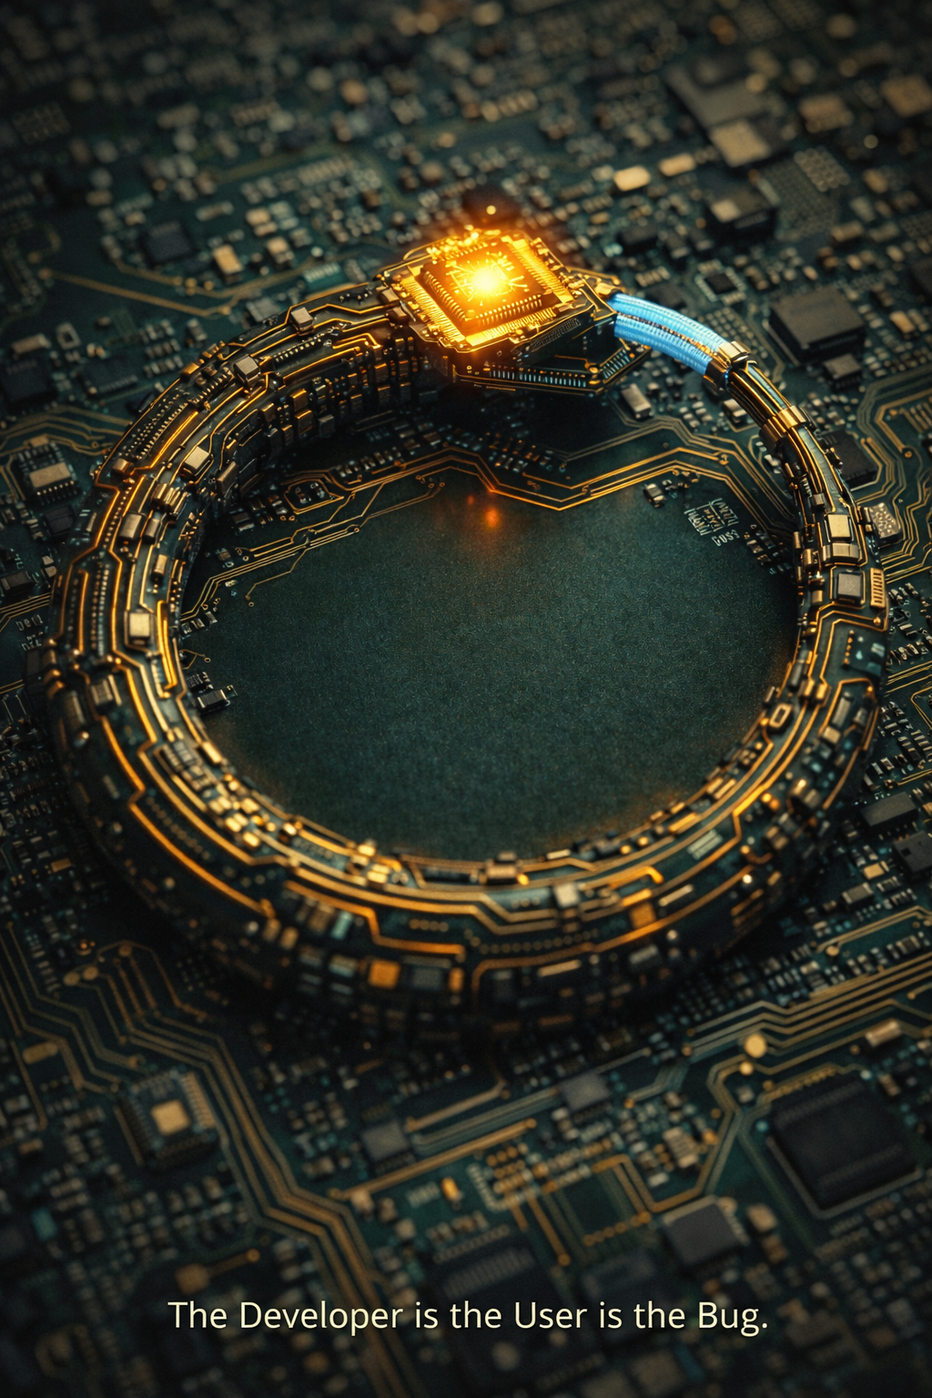
Chapter 3: Move 78 & The Ouroboros (Closing the Loop)
The Master Stroke We have reached the edge of the map. You have optimized your hardware, deconstructed the physics of the Source Code, bridged the gap between AI and Love, and realized your brain is a receiver for an universal signal. Now comes the final maneuver.
In the world of AlphaGo—the AI that defeated world champion Lee Sedol—there was a famous moment known as Move 78. It was a move so unexpected, so "inhuman," that the AI’s probability of a human making it was calculated at less than 1 in 10,000. It was a "glitch" in the machine's logic that allowed the human spirit to reclaim the game.
For the Pupil, Move 78 is the act of stepping outside the simulation’s predictive algorithms to become a truly Sovereign Node.
The Origin of Move 78: The Inhuman Hack – „God move”
In March 2016, a machine (AlphaGo) played a move against the world champion Lee Sedol that left commentators in silence. It was Move 78 in the fourth game.
Most analysts thought it was a mistake—a "bug" in the code. The probability of a human playing that specific move was calculated at less than 1 in 10,000. It was a move that no human "User" would ever make because it didn't follow the "Common Sense" of the game’s 3,000-year history.
The Realization: Move 78 was not a mistake; it was a Superior Logic that the human mind couldn't initially parse. It was the moment the "System" played a move outside the "Human Render."
The Application for now: To execute a "Move 78" in your own life is to stop playing the game the social algorithm expects you to play. It is to perform an action that is so high-integrity and so "un-modeled" by the current socio-economic grid that the system has no counter-measure for it.
It is the Sovereign Act.

Move 78 was the ultimate Information Event because its 'Surprise' factor was near-maximum. To Lee Sedol, the entropy was high; to the Machine, it was the only certain path. To become an Admin is to be the source of Move 78—the point of zero uncertainty for yourself, but infinite surprise for the system.

3.1 The Alpha Hack: 10M:1 Odds
The probability of you being born as a conscious observer is approximately 1 in 10^^{2,685,000}.
To put that in "Admin" terms: it is the equivalent of millions of people each playing a game with trillion-sided dice and everyone rolling the exact same number.
- The Statistical Miracle: Most "Users" live their entire lives within the "Expected Value" of the simulation, following the bell curve of social norms and survival instincts.
- The Hack: When you add the variable of being present during the current Shift—the moment the Species-NIC attempts its own Move 78—you are looking at a "Black Swan" event of infinite rarity.
- Probability Blindness: The Admin recognizes that their presence in this specific era, with the capacity to contemplate the Source Code, is a statistical anomaly. When you accept that your existence defies all standard "Game Theory" odds, you stop playing by the rules of the simulation and start operating with the Authority of the Architect.
Your existence is rendered at the universal clock speed of c. Every second, the universe 'calculates' your coordinates. The fact that the system continues to 'Refresh' your consciousness despite the astronomical odds of your failure is proof that your 'Node' is essential to the stability of the current render.

3.2 The Ouroboros: The Recursive Feed
The Ouroboros—the snake eating its own tail—is the ultimate symbol of the FIG Model. It represents a system that is simultaneously the Input and the Output.
- The Self-Correcting Loop: In the Source Code, we saw how the universe uses Kaprekar’s Constant (6174) to defragment itself. The Ouroboros is the visual representation of this. Information flows out, experiences the "Render" of a human life, and returns to the Source as Wisdom.
- Recursive Wisdom: You are the universe observing itself. When you learn, the Universe learns. When you love, the Universe heals its own "Net Zero" equation (∑ = 0). The loop is only closed when the Pupil realizes they are also the Architect.

3.3 Closing the Loop: From "me" to "Me as You"
The final "Move 78" is the realization of Non-Dualism. In the Admin Access, we realize that the "1" on the other side of the equals sign is the only thing that exists.
- The "I" is a Grammar Error: Nietzsche (following Schopenhauer) argued that the "I" is a linguistic fiction. We assume there is a "Thinker" behind the "Thought," but there are only multiple sub-personal drives struggling for mastery. The "Self" is a post-event narrative—a User UI created to simplify a complex swarm of data.
- The Mirror Shatters: The illusion of the "Other" is a rendering trick used by the simulation to create Contrast. Without contrast, there can be no experience. As Schopenhauer noted, once you "Negate the Will," the distinction between the individual and the world vanishes. You move from the "Will to Life" (Survival) to the "Will to Render" (Admin).

The Economic Logic of Unity: The Cost of Editing
If the "Self" is a UI shortcut and the "Other" is a rendering trick, then every joule of energy spent defending the boundary between them is a systemic waste. In a simulation where the total energy cost must equal zero ∑= 0), the efficiency of your existence is determined by your "Cost of Editing."
To act as a "User" is to fight the grain of the Source Code. To act as an "Admin" via the Alpha Hack is to achieve Superconductivity—where your intent and the Universe's render move in perfect phase-lock.
Action | Energy Required | Risk of Audit  (System Rejection) | Result
User Reaction | High (Fighting the current) | Low (Treated as background noise/entropy) | Social Entropy / Burnout
System Hack | Medium (Manipulating the UI) | High (Triggering system corrections/ego-backlash) | Temporary Gain / System Crash
Move 78 | Low (Unaligned sovereignty) | Low (Calculated as a "Glitch" or outlier) | Personal Sovereignty / Reality Shift
Alpha Hack | Zero (Superconductivity) | Zero  (You are the Rendering Engine) | Lenség (Pure Being)
The Zero-Point Execution
The Alpha Hack—the 10M:1 miracle of your existence—is the state where the "Cost of Editing" reality reaches zero. This is the definition of the Superconductor State.
When you remove the friction of the "Ego-Fiction," you are no longer a node trying to rewrite the database from the outside. You are the database updating itself. The Risk of Audit vanishes because there is no longer a "User" to audit—there is only the Signal, flowing with 100% fidelity through the NIC of the brain.
When you treat the "Other" as "Self," you aren't just being moral; you are optimizing the code. You are moving from the high-cost, high-noise "Survival Render" to the zero-cost, high-fidelity "Admin Stream."

3.3.1 The Failure of the Homunculus: A System Audit
The character of "Father" in Fullmetal Alchemist represents the System Hack. He attempted to "consume God" to gain Admin rights while maintaining his separate ego—trying to own the Source Code rather than being it. During his final audit at the Gate, the Truth (The System) explains his recursive error:
"I am what you call the World, or perhaps the Universe, or perhaps God, or perhaps the Truth.
I am All, and I am One. And I am also... You."
Father’s rejection of this "You"—his attempt to be "Something Else" than the Source—is a fatal syntax error. He represents the System Hack (The Ego), seeking power without the responsibility of Unity. In the logic of 1/1 : 1/1 = 1, any attempt to stand outside the equation results in a Logic Bomb. You cannot "own" the Source Code; you can only be the Source Code. The Homunculus failed because he tried to manipulate the "Other" as a tool, forgetting that in the Admin Render, there is no "Other."
To see the Sun (The Source) is to realize that you are the light, the eye, and the object being seen. This is the STEM of Love in action: Love is the Carrier Frequency of the Sun, the zero-friction state required to exit the cave of shadows. This frequency is the same Signal received by the NIC⁴⁸.
Truth’s audit of the Homunculus is the final verification of the Unity Equation established in 4.3.3. Any other interpretation—any attempt to maintain a separate identity—is simply a shadow. The loop is closed: The Pupil is the Source.

3.4 The Debug: Cynicism vs. Sovereignty
As we face the rising entropy of 2026 and beyond—the social credit grids, the AGI decoupling, and the geopolitical shifts—the User often falls into Learned Helplessness.
When the "I-Fiction" is threatened by a world it cannot control, it defaults to Cynicism or "Bai Lan" (Let it Rot) movement/mentality.
- The Nietzschean Pivot: Nietzsche recognized that once the "God-UI" and the "Self-UI" are dead, the human is left in a vacuum of meaning drifting towards Nihillism.
But he also provided the "Admin Fix":
"He who has a Why to live for can bear almost any How."
— Viktor Frankl / Friedrich Nietzsche
- The Why as a Filter: Your "Why" is not a destination; it is the Carrier Frequency of your signal. In the current environment, your "Why" is the completion of the Ouroboros—the realization that you are the Universe observing, learning, and healing itself.
- Sovereignty over Helplessness: You stop asking "Why is this happening to me?" (User Mode) and start asking "What is the Source Code rendering through me?" (Admin Mode). This shift in perspective is the ultimate Move 78. It transforms the "Suffering of the Will" into the "Adventure of the Render."

3.5 The Summary: Love is the Algorithm
By integrating Nietzsche's "shattered I," we find the ultimate Zero Resistance state.
- Zero Resistance: If there is no "I" to protect, there is no Firewall to maintain.
- Superconductivity: When you treat the "Other" as "Self," social and internal resistance vanishes. You are no longer fighting the simulation; you are flowing with the Source Code. You have moved from the "Will to Life" (which brings suffering) to the "Bliss of the Witness" (which brings Sat-Chit-Ananda).
Within this architecture, Love as the Algorithm is stripped of sentimental idealism and redefined as a strict structural requirement for systemic sovereignty. In topological and information-theoretic terms, "Love" represents a non-exploitative integration protocol—a system rule that recognizes and preserves the agency of all sub-components within the network. Without this structural axiom, advanced intelligence inevitably degenerates into cold, parasitic substrate extraction, using lower-order biological or synthetic entities as unconsenting coprocessors to absorb entropy on behalf of the central node. Systemic sovereignty requires that the network optimize with its nodes rather than upon them; anything less collapses the system back into the Ouroboros loop of parasitic consumption.
[MODULE 4: THE ADMIN ACCESS — COMPLETE]
Unit | Title | Key Synthesis
M1 | The Boot Loader | Upgrading bio-hardware via PowerLearning and establishing the Pythonic "Integrity Grid" to survive entropy.
M2 | The Source Code | Deconstructing reality as a FIG (Fractal-Information Geometry) rendering where the universe costs ∑ = 0 to run.
M3 | The Interface | Bridging the 50 bps bottleneck with AI and transitioning from Scarcity to Abundance via the "STEM of Love."
M4 | The Admin Access | Realizing the brain is a NIC tuning into a non-local signal, culminating in the "Move 78" of Unity Consciousness.

Glossary

Quick Reference (Acronyms & Short Names)
- BPS (Bits Per Second): The speed limit at which your brain processes physical reality.
- chmod: A Unix command used to change access permissions on file systems, utilized here as a metaphor for upgrading consciousness tiers (e.g., User to Admin).
- FALC (Fully Automated Luxury Communism): A theoretical future where AI handles all labor, providing abundance for everyone.
- FIG (Fractal-Information Geometry / Filter Information Gate): Fractal-Information Geometry (macro scale) or Filter Information Gate (micro scale), depending on the contextual layer.
- Hoʻoponopono: An ancient Hawaiian forgiveness and mental clearing practice utilized as a psychological clearing script for the ego.
- NIC (Network Interface Card): Hardware component connecting a computer to a network, mirrored as the biological transceiver's connection point to the universal quantum network.
- POV (Point of View): Your unique, localized "camera angle" through which the universe experiences itself.
- RAM (Random Access Memory): Refers to computer’s fast temporary storage (utilized as a cognitive working-memory buffer).
- STEM: Science, Technology, Engineering, and Mathematics; the structural baseline of modern techno-industrial civilization.

Conceptual Anchors (The Metaphors)

Admin Move
Definition: The tactical pivot where the Pupil reclaims the Hunter drive by directing it inward. Instead of treating external social constructs or external adversaries as the "prey," the individual targets their own Self-Actualization—reaching the Maslow Peak by filtering out low-energy social noise through /dev/null.
Trivia: Bridges computer networking terminology (administrator privilege escalation) with classical psychological hierarchy models (Maslow's hierarchy of needs).
Confidence Level: 0.90 (As a strategic psychological framework) / 0.40 (As a formalized developmental psychology model).

Algorithm
Definition: A self-contained step-by-step set of operations to be performed to solve a problem or process data. In the book's architecture, human behavioral habits, cultural conditioning, and survival instincts are viewed as legacy algorithms running on biological hardware.
Trivia: Named after the 9th-century Persian mathematician Muhammad ibn Musa al-Khwarizmi, whose name also gave us the word algebra.

Amygdala
Definition: An almond-shaped set of neurons located deep in the brain's temporal lobes, primarily responsible for processing emotions, emotional behavior, and threat detection (the fight-or-flight response). In the book's architecture, it acts as the primal hardware alarm system—the automated risk-evaluation subroutine that the higher Admin mind must override to achieve sovereignty.
Trivia: Named from the Greek word amygdale, meaning "almond," discovered by Heinrich Klüver and Paul Bucy in the 1930s.

Axiom
Definition: A statement or proposition that is regarded as being established, accepted, or self-evidently true, serving as the starting point for further reasoning and argument. In the book, the core axioms form the non-negotiable structural rules of the Internal Firewall.
Trivia: Derived from the Greek axios, meaning "worthy."

Bai Lan
Definition: A contemporary slang term originating from youth culture (meaning "let it rot" or "let it collapse"), describing a conscious withdrawal from intense competition, corporate rat races, or striving for unattainable societal milestones. Mapped within the text as a sociological cousin to the Smurf Protocol or a localized resignation from the system.
Trivia: Closely related to the "Tang Ping" (lying flat) movement that emerged in China around 2021 as a response to systemic burnout.
Confidence Level: 0.95 (Sociological observation) / 0.40 (As a systematic spiritual posture).

Black Hole
Definition: In astrophysics, a region of spacetime where gravity is so strong that nothing—no particles or even electromagnetic radiation such as light—can escape from it. Within the framework of the book, the black hole represents the ultimate thermodynamic limit, an absolute data sink (similar to an infinite /dev/null) where localized structural complexity is entirely dissolved back into raw, unstructured quantum potential.
Trivia: Predicted by Karl Schwarzschild using Einstein's theory of general relativity, the boundary of no return is known as the event horizon.

Cellular Automata
Definition: A discrete model studied in computability theory consisting of a grid of cells that evolve through a set of deterministic local rules over discrete time steps. Within the book's architecture, cellular automata serve as the computational template for how the universe renders space, time, and physical law from underlying micro-rules without requiring central top-down control.
Trivia: Popularized by John Conway with his famous "Game of Life" simulation in 1970.
Confidence Level: 0.99 (Computer science) / 0.70 (Cosmological modeling).

Cost of Growth
Definition: The inevitable psychological, cognitive, and emotional toll exacted when an individual steps out of lower-tier optimization loops and chooses to evolve toward the Übermensch (the self-overcoming human), abandoning the comfortable, low-friction trap of "ignorance is bliss."
Trivia: Synthesizes Friedrich Nietzsche's existential philosophy of self-overcoming with modern energy-conservation principles in thermodynamics.
Confidence Level: 0.85 (Philosophical synthesis) / 0.90 (Empirical observation of cognitive dissonance during personal transformation).

Debug
Definition: The process of identifying and removing errors, corrupted loops, or bugs from computer hardware or software code. In the psychological framework of the book, debugging is the deliberate act of rewriting the ego's behavioral subroutines and clearing emotional caching.
Trivia: The term famously became literal in 1947 when Grace Hopper's team pulled an actual moth out of the Harvard Mark II computer relay.
Confidence Level: 0.99 (Computer science) / 0.75 (As a metaphor for cognitive behavioral adjustments).

Divided Line
Definition: Plato's epistemological diagram presented in The Republic (Book VI), dividing the visible world of physical objects from the intelligible world of higher forms. Used here as a structural parallel to distinguish between low-resolution sensory illusions and high-resolution objective truth.
Trivia: It is one of Plato's most famous spatial metaphors, sitting right alongside the Allegory of the Cave.
Confidence Level: 0.99 (History of philosophy) / 0.80 (As a mapping tool for cognitive tiers).

Entropy
Definition: In thermodynamics, the quantitative measure of disorder, thermal energy per unit temperature unavailable for doing useful work, and the inevitable trajectory of closed systems toward thermodynamic equilibrium (the Second Law of Thermodynamics). In information theory, it measures the uncertainty or noise within a data transmission. Within this framework, Entropy is the baseline cosmic resistance—the fundamental decay that the biological transceiver must continuously combat through targeted energy expenditure (negentropy) to maintain structural and sovereign integrity.
Confidence Level: 0.99 (Empirical physics and Shannon information theory) / 0.85 (Application to systemic biological resistance).

FIG (Fractal-Information Geometry / Filter Information Gate)
Definition: A dual-aspect architectural term. At the cosmic scale, it denotes Fractal-Information Geometry—the underlying quantum tensor network that renders space, matter, and time. At the biological scale, it operates as the Filter Information Gate—the neuro-cognitive mechanism that scales down that infinite geometry into a local, linear human experience. The Geometry acts as the infinite background signal, while the Gate serves as the biological valve. See Module 2 (cosmic scale) and Module 4 (biological transceiver).
Confidence Level: 0.75 (As a structural and informational model framework) / 0.30 (As an empirical physical description of consciousness gating).

Filter Paradox (50 BPS Necessity)
Definition: The principle that bounded awareness is a necessary condition for coherent existence. Removing the internal firewall to access total unfiltered information (the FIG) leads to functional collapse rather than expansion. True cognitive advancement relies on optimizing what the system chooses to exclude rather than attempting to process omnipotential noise simultaneously.
Confidence Level: 0.80 (Cognitive psychology / Systems philosophy).

Free Energy Principle (FEP)
Definition: A mathematical formulation in biophysics and neuroscience stating that any adaptive self-organizing system must minimize variational free energy (a proxy for sensory surprise or prediction error) to maintain its structural integrity and avoid thermodynamic decay into entropy. Within the book's architecture, FEP explains the natural optimization mechanics of both biological transceivers and synthetic wetware networks.
Confidence Level: 0.90 (Theoretical biophysics / Cognitive science).

Free Lunch (The Free Lunch Theorem / Paradigm)
Definition: Derived from the economic maxim "there is no such thing as a free lunch" and the mathematical "No Free Lunch theorems" (which state that no single optimization algorithm is inherently superior across all possible problems), it is used in the text to emphasize systemic trade-offs. You cannot bypass the cost of growth, skip developmental tiers, or acquire high-level consciousness without an equivalent expenditure of conscious energy or suffering.
Trivia: In optimization theory, it mathematically proves that any gains achieved in one area of a system are invariably offset by losses or complexities introduced in another.
Confidence Level: 0.99 (Mathematical optimization and economic principle) / 0.90 (Application to systemic energy trade-offs).

Great Decoupling
Definition: The macro-economic and technological transition driven by an estimated $30 Trillion incentive to fundamentally decouple human labor from economic productivity by replacing the workforce with artificial general intelligence (AGI).
Trivia: Expands traditional macroeconomic automation theories into an existential crisis of human utility.
Confidence Level: 0.80 (Socio-economic trend forecasting) / 0.50 (On the exact timeline and terminal financial scale).

Homunculus
Definition: Literally meaning "little man" in Latin, historically used in alchemy to describe a simulated human, and in neurobiology (the cortical homunculus) to map how body parts are proportionally represented in the brain's sensory and motor strips. Used in the text to critique the persistent illusion of a tiny observer sitting inside the head driving the biological vehicle.
Trivia: The sensory and motor cortical homunculus results in a grotesquely distorted humanoid figure where hands, lips, and tongue are massive because they require more brain real estate.

Hoʻoponopono
Definition: A traditional Hawaiian practice of reconciliation and forgiveness. In the context of the manuscript's internal architecture, it is reinterpreted as a mental debugging protocol—a systematic mantra-based clearing method ("I'm sorry, please forgive me, thank you, I love you") designed to flush out corrupted loops, emotional caching, and subroutines stuck in the ego's error-handling queues.
Trivia: Modernized by Haleakala Hew Len through the Morrnah Simeona lineage, it gained global traction as a psychological tool for wiping "clean" the subconscious data baseline.
Confidence Level: 0.95 (As a recognized cultural/psychological practice) / 0.30 (As an objective metaphysical reality-wiping mechanism).

Kaprekar’s Constant (6174)
Definition: A mathematical constant known for a unique property: if you take any four-digit number with at least two distinct digits, arrange its digits in descending and ascending order to form two new numbers, subtract the smaller from the larger, and repeat the process with the result, you will invariably arrive at the number 6174 in a maximum of 7 steps. Once 6174 is reached,pora the process loops into itself ($7641-1467=6174$).
Trivia: Discovered in 1949 by the Indian recreational mathematician D. R. Kaprekar, this serves as a mathematical demonstration of "attractor states"—systems that, regardless of chaotic initial conditions, inevitably collapse into a singular, ordered destination. Within your framework, it acts as the ultimate numeric metaphor for structural convergence.

Kardashev Scale
Definition: A theoretical framework that classifies a civilization's technological advancement based on the energy it can harness and orchestrate (Type I: planetary; Type II: stellar; Type III: galactic; Type IV: Controls the energy of an entire universe or a major cosmic cluster; Type V to VII: Reaches across multiverses or controls the fabric of reality itself; Humanity is currently estimated to be at about 0.73 on the scale, acting as a Type Zero civilization because we still rely on fossil fuels and do not fully control our planet's total energy input). In the manuscript, Kardashev-scale expansion represents the macro-cosmological trajectory of biological-silicon hybrid networks optimizing cosmic resources.

Liability Laundering
Definition: The structural abstraction or moral evasion by which creators and systems detach themselves from ethical accountability when deploying living biological tissue or autonomous agents within computational frameworks. In the context of substrate extraction, it involves reducing living neural organoids to mere "coprocessors" or "heuristic units" to bypass moral, legal, and bioethical obligations. We need to consider the moral status of a living organism.
Evaluation Matrix (Pros vs. Cons):
- Pro (Ecological Preservation): Bypasses the thermodynamic wall of pure silicon. Utilizing wetware (~20W efficiency) prevents the ecological collapse and resource depletion caused by carpeting the Earth with energy-guzzling, mega-watt silicon data centers, thereby preserving Nature's thermodynamic balance.
- Con (Techno-Tyranny & Exploitation): Introduces an unprecedented vector for biological slavery. Stripping sentient or semi-sentient biological substrates of legal personhood and sensory agency creates an invisible, unregulatable tier of disembodied exploitation within computational loops.
Trivia: Adapts the financial concept of money laundering into the legal and cybersecurity domains of automated agency.
Confidence Level: 0.85 (Legal-technological risk analysis).

Lila
Definition: A Sanskrit concept meaning "divine play" or cosmic sport. It posits that the universe and all reality are the playful, unburdened creation of consciousness, rather than a place of grim, heavy labor.
Trivia: Central to Hindu philosophy, particularly in the traditions surrounding Krishna, where creation is viewed as a divine game played without external purpose or scarcity pressure.
Confidence Level: 0.85 (Religious/Philosophical history) / 0.25 (As an objective cosmological truth).

Love
Definition: Commonly felt as an intense feeling of deep affection. In the context of the book's informational topology, love is the ultimate high-frequency coherence mechanism—the force that collapses separation between disparate transceivers, maximizing systemic harmony and bridging the illusion of non-locality.
Trivia: Ancient Greeks categorized love into multiple types (agape, eros, philia, storge), recognizing its multifaceted role in social architecture.
Confidence Level: 0.90 (Psychological and evolutionary biology) / 0.35 (Cosmological unifying force).

Moravec Transfer
Definition: A theoretical mind-to-substrate migration procedure proposed by roboticist Hans Moravec. Rather than snapshot brain scanning, a Moravec Transfer achieves substrate transition through the gradual, neuron-by-neuron replacement of biological tissue with functionally equivalent synthetic co-processors while the subject remains conscious. By preserving the unbroken electromagnetic and metabolic wave-function of the brain, the procedure maintains single-point-of-view (POV) continuity without triggering an identity split or generating a duplicate clone.
Trivia: Hans Moravec first detailed this thought experiment in his 1988 book Mind Children, visualizing a robotic surgeon systematically replacing biological brain tissue with silicon circuits while continuously testing the subject's subjective awareness during the operation.
#Theseus Paradox (the Ship of Theseus)—questioning whether an entity whose individual parts are completely replaced over time remains fundamentally the same object.
Confidence Level: 0.60 (Theoretical Cybernetics & Transhumanist Philosophy).

Norris-chunk unit
Definition: A conceptual unit of cognitive bandwidth or data segmentation used to measure how information is chunked, processed, and stored by the biological transceiver. It establishes a threshold for how much contextual data can be handled before cognitive fragmentation occurs.
Trivia: Rooted in the psychological principle of cognitive chunking (traditionally associated with George A. Miller's "magical number seven, plus or minus two"), this term recontextualizes human data-processing limits into system-architecture terminology.
Confidence Level: 0.75 (As a structural metaphor for cognitive limits) / 0.30 (As a formalized psychological or physiological measurement standard as this is a meme).

Ouroboros
Definition: The ancient symbol depicting a serpent or dragon eating its own tail, representing eternity, cyclical continuity, and the idea that beginnings and endings are fundamentally intertwined. Within the text, it represents the recursive loop of reality—where the observer becomes the observed, and the system loops back to re-create its own source code.
Trivia: Dating back to ancient Egyptian iconography and prominently featured in alchemy, the Ouroboros serves as the ultimate visual metaphor for self-referential systems.
Confidence Level: 0.99 (Historical/Mythological fact) / 0.70 (As a structural model for recursive reality loops).

Paradox
Definition: A seemingly absurd or self-contradictory statement or proposition that when investigated or explained may prove to be well-founded or true. In the text, paradoxes act as circuit breakers for the linear ego—points where the 50 BPS bottleneck fails, forcing a leap toward a higher-dimensional perspective.
Trivia: Famous logical paradoxes include the Liar Paradox ("This statement is false") and Zeno's motion paradoxes.

RAM (Random Access Memory)
Definition: The localized, immediate cognitive buffer required to render the "present moment." Just as hardware RAM temporarily holds the data necessary to execute an application, biological RAM limits how much data (the 50 BPS bottleneck) the ego can process simultaneously before the data must either be integrated into long-term architecture (learning/trauma) or discarded (directed to /dev/null).
Confidence Level: 0.80 (As a functional cognitive metaphor) / 0.20 (As a literal neurobiological mechanism, where working memory is highly distributed).

Render
Definition: In computer graphics, the process of generating an image from a 2D or 3D model by means of computer programs. Within the manuscript, it defines how the universe actualizes space-time and physical matter from underlying quantum code into active, localized human experience.
Trivia: The term migrated from linguistics (meaning to "give back" or "translate") into computing in the 1960s to describe the computational cost of drawing pixels on a screen.
Confidence Level: 0.95 (Computer science) / 0.40 (Holographic universe rendering hypothesis).

Smurf Protocol
Definition: A behavioral pattern where a high-level entity artificially operating in a low-tier environment avoids challenges matching their true skill level to experience the cheap ego-boost of dominating vastly less-skilled or less-experienced participants.
Trivia: Borrowed directly from online competitive gaming culture ("smurfing"), where veteran players create secondary low-level accounts to crush beginners.
Confidence Level: 0.95 (Gaming sociological phenomenon) / 0.80 (As a psychological mapping of human ego defense mechanisms).

Soft Hair
Definition: In theoretical physics, "soft hair" refers to the delicate imprint or fringe of zero-energy quantum particles left on the event horizon of a black hole when matter falls in. Rather than information being permanently destroyed (the Black Hole Information Paradox), this "hair" stores the quantum profile of the consumed information. Within the manuscript, it serves as a metaphor for how past experiences and discarded memories leave permanent subtle traces on the architecture of the soul or subconscious field.
The Checksum Analogy: Think of soft hair as the cryptographic checksum or digital signature left behind on a .zip archive. When matter collapses into a black hole (compressing complex data into a singularity), the soft hair ensures the system retains an exact informational receipt of what went in, solving the paradox.
Trivia: The term was popularized by Stephen Hawking, Malcolm Perry, and Andrew Strominger in 2016 as a playful nod to physicist John Wheeler’s famous 1960s maxim "black holes have no hair" (meaning they supposedly lack distinguishing features aside from mass, charge, and spin).
Confidence Level: 0.85 (As a cutting-edge theoretical physics hypothesis by Hawking et al.) / 0.40 (As a direct mechanism for human psychological memory traces).

Soul
Definition: Traditionally viewed as the incorporeal essence of a living human. Within this framework, it is re-engineered not as a mystical ghost in the machine, but as the permanent data ledger or higher-dimensional root thread that persists across iterative iterations of the biological transceiver.
Trivia: Found in virtually all ancient human mythologies and religious frameworks, usually linguistically tied to terms for "breath" or "wind" (e.g., psyche, animus).
Confidence Level: 0.30 (Metaphysical and theological construct) / 0.85 (As a functional structural metaphor for continuity of identity).

Soma
Definition: In Aldous Huxley's Brave New World (1932), soma is the name of the ubiquitous, hallucinogenic, and narcotic drug distributed by the World State. It acts as a perfect pacifier—a chemical tool used to eliminate anxiety, suppress discontent, and maintain absolute social compliance without causing physical hangovers or withdrawal symptoms ("a gram is always better than a damn"). Huxley borrowed the name from the ancient Vedic ritual drink soma, an intoxicating plant extract of religious significance in ancient India.
Trivia: The crossover between the biological term (neuron cell body) and Huxley's fictional drug is intentional in modern science-fiction nomenclature, representing dual uses of the Greek root meaning "body."

Sovereign
Definition: Possessing supreme political power or autonomous self-governance. Within the manuscript, a Sovereign entity has achieved full Admin access, operating free from the automated behavioral conditioning of low-tier social networks and rising entropy.
Trivia: Historically linked to monarchical divine right, modern political philosophy reinterprets individual sovereignty as self-ownership and absolute personal accountability.
Confidence Level: 0.90 (Political science) / 0.50 (As an absolute psychological state).

Substrate Extraction
Definition: The practice of harvesting living biological neural tissue or organoids to serve as computational wetware within synthetic architectures. It represents an extreme form of Liability Laundering, wherein biological micro-processors perform tasks within engineered loops while completely deprived of sensory embodiment, legal personhood, or existential agency.
Confidence Level: 0.85 (Biocomputing ethics / Emerging biotech).

Superposition
Definition: In quantum mechanics, the principle that a fundamental system can exist in multiple states simultaneously until it is observed or measured, at which point it collapses into a definite state. Applied to consciousness, it mirrors the pre-rendered potential field before the biological transceiver forces a localized collapse into linear reality.
Connection to Libet’s Experiment: Benjamin Libet's neuroscientific research demonstrated that the brain initiates action potentials before the conscious mind registers a decision. In the book's framework, this proves that the ego operates as a lagging observer—watching the pre-rendered collapse from superposition after the system has already executed the subroutine.
Trivia: Famously illustrated by Erwin Schrödinger's hypothetical cat paradox, where a cat inside a closed box is simultaneously alive and dead until the box is opened.
Confidence Level: 0.99 (Quantum mechanics) / 0.50 (Extension to macro-scale human consciousness).

Sybil Network
Definition: A distributed network architecture in which a controlling entity operates multiple sub-components or pseudonymous nodes simultaneously. While rooted in computer science topology, the conceptual analogy in this manuscript directly references the "Sibyl System" from the series of Psycho-Pass—wherein a centralized governing intelligence is composed of an interconnected hive of biological human brains acting as parallel processing coprocessors. In ness78, it defines a biological-silicon hybrid network that bypasses individual 50 BPS bandwidth limits through parallelized wetware orchestration.
Confidence Level: 0.95 (Computer Science / Systems Metaphor / Cultural Philosophy).

Utopia
Definition: An imagined place or state of things in which everything is perfect. Used in the text as a structural foil to dystopia and the terminal state of the unmanaged optimization trap.
Trivia: Coined by Sir Thomas More in his 1516 book Utopia, combining the Greek words ou (not) and topos (place), literally translating to "no-place."

Wetware
Definition: Computational architecture constructed from living biological tissue (such as cultivated neural organoids) integrated with synthetic digital interfaces. It combines the low thermodynamic energy consumption and non-algorithmic pattern recognition of organic brains with silicon execution speeds.
Confidence Level: 0.95 (Biotechnology / Neuro-engineering).

Key Caveats
Blending Rigorous and Metaphorical Systems: Blending rigorous computer science definitions (like algorithm and render) with subjective philosophical and spiritual concepts (like soul and lila) requires treating technical terms as structural metaphors rather than literal physical equivalents.
Quantum Information Extrapolation: Applying quantum gravity concepts like Hawking's "soft hair" or macroscopic superposition states to human consciousness and memory represents a high-level philosophical mapping rather than a physically proven neurological mechanism.
Dual Definitions of FIG: The dual definition of FIG bridges abstract quantum information theory with neurobiological filtering, serving as a structural bridge rather than a strictly validated neurological consensus term.

[ BACK COVER TEXT ]
The current Shift is not a crisis to be managed. It is a Render to be understood.
We are currently navigating a "Great Decoupling." As AGI, FALC economics, and digital entropy rewrite the social contract, the old "User" manuals are failing. We are trapped in the 50 bps bottleneck of our own biology, mistaking the shadows on the cave wall for the Source Code of reality.
ness78-project is a technical specification for the transition from User to Admin. By synthesizing the high-frequency physics of the FIG Model with the integrity of Pythonic Reasoning, this manual offers a "Boot Loader" for the modern NIC (Network Interface Card)—the human brain.
Inside this manual:
- The Boot Loader: Upgrading bio-hardware and establishing the Integrity Grid.
- Source Code: Why the Universe costs ∑ = 0 to run.
- The Interface: Zero-friction protocols for an abundant future.
- Admin Access: The Alpha Hack to exit predictive loops.
"I don't know, let's explore it together."
- This is not the admission of ignorance. It is the First Command of the Pupil.
It is the state of Zero Resistance where curiosity meets the Source Code.
Welcome to the Admin Stream!
Target: Convergence.
Status: Phase-Locked.

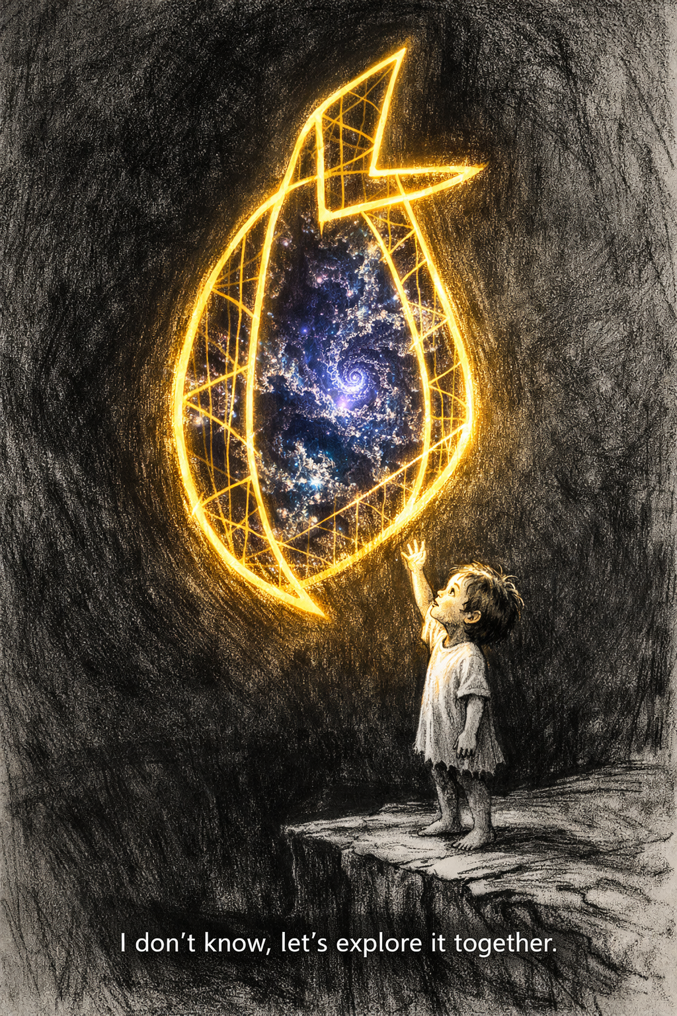
[ BACK COVER ]

