1.(1)true

(2)false, An is-a relationship is implemented via inheritance.

(3)false, A Student class has an has-a relationship with the Faculty and

Course classes.

(4)true

(5)false, friends of the base class’s derived classes can not access the base class’s friends.

2. 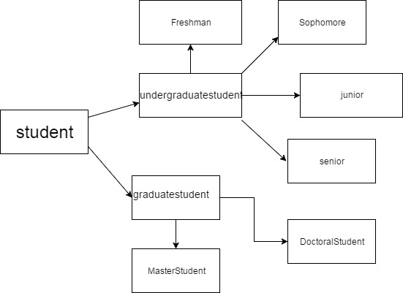

According to the picture,the student is the indirect base class,the graduatestudent and the graduatestudent are the direct base class inheriting from the student. freshman,sophomore,junior,and the senior are the derived class inheriting from undergraduatestudent. Doctoralstudent and Masterstudent are the derived class inheriting from graduatestudent.