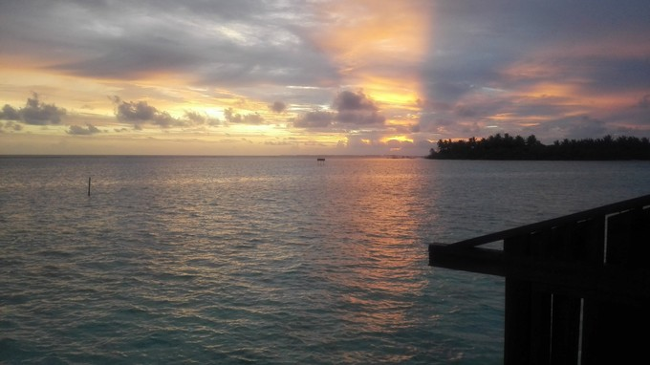

We are using three sources for this scenario:

1-The data of the districts and districts divisions of Lima city, in pure GEOJson(provided by https://www.urbania.pe)

2-The data of the land value of each sub-district, in JSON Format(provided by https://www.urbania.pe)

3-Foursquare API to locate the nearby hotels, REST services (provided by Foursquare)

**DATA**

HotelCorp is a global company in constant worldwide expansion. Currently, it wants to expand their operations to Latin America. First at all, they want to build a new luxury hotel in Lima, Peru. This hotel must be built in the most wealthy zone of Lima and must be far from others hotels(to be really exclusive). The question to answer: Where is the best place to build the new luxury hotel?

**INTRODUCTION**

**E-mail: xxxxxx@163.com**

**Telephone: (+86)134-000-000-000**

**M&M Consulting Services**

**375 Boadalban Road**

**Ephrata, PA 12345**

**(177) 377-4777**

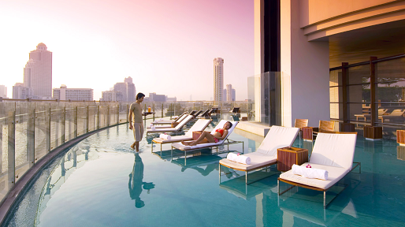

There are two important points in the solution to this problem. First is the analysis of the value land and next the analysis of nearby hotels. We will use the geodata to draw the map, marking an initial spot where the most wealthy zone is located(Figure 1). This will be a important point for the next step. Next, we will locate the nearby hotels(ignoring hostels and other cheap places), cluster them and draw the clusters in the map. This will allow HotelCorp to know how far they are from others hotels and choose the best place for the new building. The cluster analysis is done with k-means. The next step is to evaluate the second most wealthy zone. This provide us with a comparison point.

**METHODOLOGY**

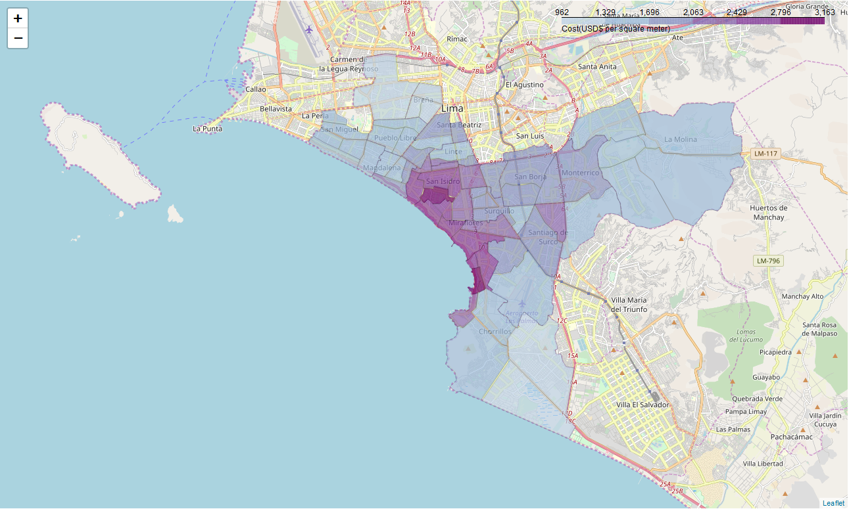

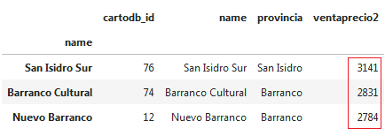

**RESULTS**

Figure 2 : Top three zones in Lima($ per squared meter)

Figure 1 : Land value in Lima

After the analysis, we found the best districts for the hotel are San Isidro district and Barranco, but San Isidro is slightly wealthy than Barranco. Also, Barranco is mostly an touristic zone and have many hostels, and this is not a desired location. Based on the results the best place for the new hotel is San Isidro Sur zone, in the San Isidro district(Figure 3).

**DISCUSSION**

Based on the results, San Isidro Sur zone is the most wealthy and is pretty far from other hotels. It is possible that some hotel data is missing from Foursquare, because it is not popular in Peru. Other map systems like Google Maps maybe can provide better information. It is also important to mention that although a zone is recommended, currently there is not possible way to predict the exact hotel location, because there is no data about parks or detailed commercial zone information. Also, it was not possible to query the rating data of the venues, limiting the scope of comparison between hotels.

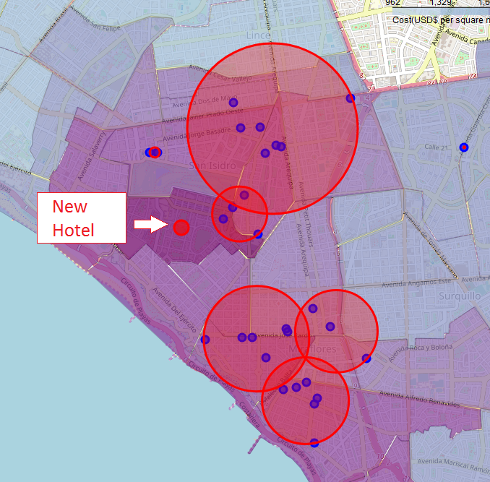

In this report we analyzed the land cost of Lima’s districts and the available hotels location data for the determination of the best location for the new luxury hotel of HotelCorp. We recommend that besides the points analyzed in this report, HotelCorp reviews the local district information like taxes, and construction regulations.

**CONCLUSION**

Figure 3 : The recommended location for the luxury hotel