mRNA Viewer

Capstone Project Proposal

**Melissa Mayberry – Spring 2016**

Specifications

The mRNA Viewer will be a program written in C# used for exploring the features of mRNA and, if time permits, genes. NCBI has a graphical sequence viewer, but this does not include mRNA features (such as CDS, UTRs, etc.) and it can be confusing for individuals who are new to the NCBI databases.

The sequence and feature data will first be pulled from the NCBI's Entreaz databases (<http://www.ncbi.nlm.nih.gov/>) from user input into the application. The functions will be made to mimic the Entreaz eUtils of Biopython in that it will be able to search and parse the requested pages. The viewer itself will include a visual representation of the sequence with accurately located and sized labeled sections (likely displayed with color) identifying the features. The visual representation will have some sort of navigation (drag and/or zoom) to accommodate long sequences. The features will also be listed as text beside the image; when this text is clicked, the feature will be pointed to on the image with the name of the feature and its location. It may potentially also include either a description or link to an external source which explains what the feature is.

The viewer will be able to search for a new mRNA or gene after the first results have been displayed. Additionally, the results will include links which will trigger a new search for either the mRNA made from the gene currently being examined, or the gene which made the mRNA currently being examined.

Rough Mockup & Sequence of Events

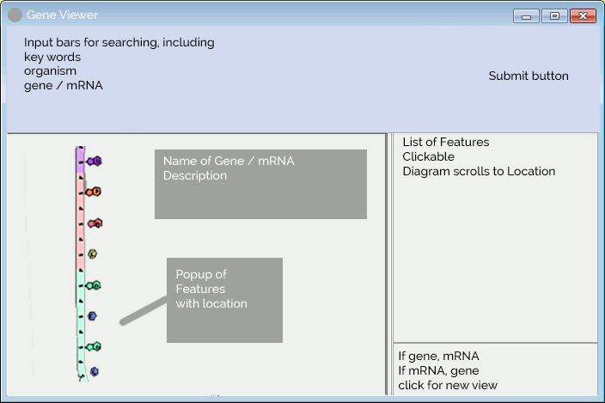

1. Search functions (possibly have the option to return page in XML format)
   1. be able to (at least) specify key words and organism
2. Parse functions
3. Basic form layout (illustrated above)
4. (possibly) Display multiple results to pick from
5. Display list of features
6. Display graphical representation of search results
   1. features should be distinguishable from each other
   2. zoom and/or scroll navigation
      1. (possibly) viewable sequence when sufficiently zoomed in
7. Examine feature details (at least including location) via selecting from feature list and/or graphic
8. (possibly) allow the view of genes in addition to mRNA