IE University
School of Science and Technology


Streamlining Real Estate Investment processes in Madrid
Mayer N. Attie
Bachelor in Data & Business Analytics

Supervised by:
Prof. José Antonio García Escandón

Date: 20/03/2026

Abstract
This thesis presents a system that automates the real estate investment analysis pipeline for Madrid. It collects property listings from four of Spain’s largest portals (Idealista, Redpiso, Fotocasa, Pisos.com) through APIs and web scraping, normalizes them into a unified database, and applies a Gradient Boosting regression model to predict market prices. It also integrates official notary closing price data from the Colegio General del Notariado for 55 Madrid postal codes, allowing direct comparison between what sellers ask and what buyers actually pay. A separate financial module lets users evaluate Fix and Flip investment opportunities by computing IRR, MOIC, ROE, and gross margin from monthly equity cash flows with leverage. An analytics dashboard then ties everything together, comparing asking prices against closing prices and ML predictions across Madrid’s 21 districts to surface where the best opportunities are. The Gradient Boosting model, selected after comparing four algorithms on 4,425 listings, achieves an R-squared of 0.88 on five-fold cross-validation. No existing system, academic or commercial, combines multi-source scraping, ML valuation, notary transaction data, financial modeling, and opportunity analytics in a single deployed platform for the Spanish market. The system runs in production with multi-user authentication and was reviewed by five real estate professionals from Argentina and Spain.

Keywords: real estate, machine learning, property valuation, web scraping, investment analysis, Madrid, gradient boosting, fix and flip, automated valuation model

Abstract 2
Literature Review 5
Methodology 19
Exploratory data analysis 21
Machine learning valuation model 32
Financial analysis model 34
Analytics dashboard 36
Results and discussion 37
Conclusions and future work 40
References 41
Appendix: Frontend screenshots 42

Literature Review

Information Asymmetry in Real Estate Investment
In most markets, not all participants have access to the same information — and this imbalance has consequences. George Akerlof (1970) was the first to formalize this problem in his landmark paper "The Market for Lemons," demonstrating that when sellers know more about a product's quality than buyers do, markets break down. In his model, buyers (unable to distinguish good cars from bad ones) offer only average prices, which drives high-quality sellers out of the market entirely. The result is not just unfairness between parties; it is a systematic deterioration of market efficiency. Akerlof's work earned the 2001 Nobel Prize in Economics and established information asymmetry as one of the central problems in modern economics. Grossman and Stiglitz (1980) extended this logic further, arguing that perfectly efficient markets are theoretically impossible: if prices already reflected all available information, no one would spend resources acquiring it, which means the information would never get incorporated in the first place. Information costs, in other words, create persistent and exploitable inefficiencies.

Real estate is one of the most acute examples of this phenomenon in practice. Unlike publicly traded assets, where prices are observable in real time, transaction histories are disclosed, and arbitrage is possible, private real estate markets are structurally opaque. Each property is unique, transactions are infrequent, and pricing data is rarely standardized or publicly accessible. Broxterman and Zhou (2022), in the most comprehensive recent review of information frictions in real estate, conclude that real property "never trades with full information" and that "even small information costs can have large consequences." This is not a temporary market imperfection waiting to be corrected, it’s a structural feature of the asset class.

The empirical evidence on the cost of this asymmetry is direct. Levitt and Syverson (2008) found that real estate agents selling their own homes — rather than acting as agents for clients — achieved prices 3.7% higher and held their properties 9.5 days longer, a measurable advantage attributable purely to superior information. Garmaise and Moskowitz (2004) showed that buyers respond to information uncertainty by limiting geographic scope, effectively constraining their investment universe to markets they know personally. Chinco and Mayer (2016) documented that out-of-town buyers in residential markets earned roughly 5% per year lower capital gains than local buyers purchasing simultaneously in the same location — a direct and recurring penalty for lacking local market intelligence.

The implications for small and mid-size real estate funds are significant. These investors typically operate without the data infrastructure of large institutional players, relying instead on broker relationships, personal networks, and manual analysis. The JLL Global Real Estate Transparency Index (2024) notes that highly transparent markets attract over 80% of global direct real estate investment — meaning that markets with higher information friction, like private residential markets in Southern Europe, carry a structural disadvantage. In this context, any tool that systematically reduces information costs does not merely improve operational efficiency. It directly addresses one of the most well-documented sources of value destruction in private real estate investment.

PropTech: Evolution, Promise, and Market Gaps
The application of technology to real estate (broadly termed PropTech) has grown from a niche category into a global industry. Andrew Baum (2017) proposed the most widely adopted framework for understanding this evolution, identifying three distinct waves. PropTech 1.0 (1980s–2000) brought desktop tools for property professionals: database platforms like CoStar and financial modeling software like ARGUS. PropTech 2.0 (2008–2015) was driven by mobile and the sharing economy, producing platforms like Airbnb and WeWork that redefined how space is used. PropTech 3.0 (2015–present) is defined by artificial intelligence, machine learning, and big data. Ttechnologies that do not just digitize existing processes but fundamentally change how decisions are made. Braesemann and Baum (2020), analyzing over 7,000 PropTech firms globally, found that data analytics sits at the core of this third wave, connecting valuation, transaction, and management tools into an increasingly integrated ecosystem.

The numbers reflect the pace of this shift. The European PropTech market was valued at approximately $10.8 billion in 2024, projected to reach $50.7 billion by 2033. Spain has been a particularly active market within this ecosystem. With nearly 700 PropTech startups, Spain ranks third in Europe, concentrating activity in Madrid and Barcelona. The PwC/ULI Emerging Trends in Real Estate Europe report (2025) ranked Madrid second among European cities for investment attractiveness, only behind London, reinforcing the city's position as a relevant and growing market for real estate technology.

Despite this growth, technology adoption in real estate has been deeply uneven. Ullah, Sepasgozar, and Wang (2018), in a systematic review of smart real estate technology, found that almost a third of the global real estate industry (valued at over $11 trillion) is still managed on spreadsheets. The JLL Global Real Estate Technology Survey (2025), covering 1,500+ senior decision-makers, found that while 88% of large institutional investors are piloting AI, only 5% had achieved their AI goals, with over half citing compatibility issues with existing infrastructure. This gap between adoption intent and actual implementation is even more pronounced for smaller players, who lack dedicated technology teams and procurement budgets.

The competitive landscape makes the segmentation concrete. At the consumer end, platforms like Idealista and Fotocasa have built powerful property portals with millions of listings and basic filtering tools. Useful for individual buyers but not designed for systematic investment screening or financial analysis. At the institutional end, platforms like CBRE's AI suite and JLL's enterprise analytics tools serve organizations with large internal teams and significant technology budgets. In the valuation space, PriceHubble offers AI-driven automated valuation models across 11 European countries, serving primarily banks and agencies, with Spain not among its core active markets. What is absent from this landscape is a tool designed for the operational reality of a mid-size fund: one that aggregates deal flow from multiple sources, structures it automatically, applies a valuation model calibrated to a specific local market, and connects directly to investment analysis. The tools exist for each individual piece. Portals for listings, valuation APIs for price estimates, Excel for financial models. But they remain disconnected, forcing analysts to move data manually between systems.

This is the gap the present work addresses. Not the absence of PropTech broadly, but the absence of an integrated pipeline for a specific and underserved segment: private real estate funds operating in markets like Madrid, where deal flow arrives through informal channels, local market knowledge is the primary competitive advantage, and the analytical process remains largely manual.

Deal Flow Management: From Manual Process to Structured Extraction
For a private real estate fund, deal flow is the raw material of the business. Every investment starts with a property reaching the desk of an analyst. Through an email, a WhatsApp message, a listing from a portal, or a tip passed along in a meeting. The quality and speed of what happens next determines whether the fund captures the opportunity or misses it. Yet despite the stakes, this process remains overwhelmingly manual at most small and mid-size funds. Understanding why this is a problem, and what it costs, is essential context for the system this thesis proposes, which focuses on automating the extraction and structuring of deal flow from property portals as a first and foundational layer of this pipeline.

The typical deal flow pipeline at a private fund today looks roughly like this: a property arrives through one of multiple informal channels, an analyst reads through it, manually extracts the key features price, size, location, condition, copies them into a spreadsheet, and then begins the actual analysis. If ten deals arrive in a day, the analyst spends a disproportionate share of their time on the extraction step, not the evaluation step. This is not a trivial inefficiency. Research on knowledge work more broadly has consistently found that data preparation dominates analytical time. The CrowdFlower Data Science Report (2016), surveying data professionals across industries, found that between 50% and 80% of working time is consumed by collecting and structuring data rather than analyzing it. The Anaconda State of Data Science Report (2020), covering over 2,400 respondents globally, confirmed that data preparation alone accounts for 45% of a data scientist's day. While these figures come from data science contexts rather than real estate specifically, they reflect a general pattern that applies directly to any analyst whose input data arrives in unstructured or inconsistent formats, which is precisely the situation in private real estate deal flow.

The cost compounds in two ways. First, there is the direct time cost: hours spent copying data are hours not spent evaluating deals. Second, and more consequentially, there is the opportunity cost of deals that simply do not get evaluated because there is no capacity to process them. A fund receiving fifty listings a week through informal channels, with a team of two or three analysts, will inevitably develop informal filters. Ignoring certain sources, skipping deals that require more extraction work, defaulting to familiar formats. These shortcuts are rational responses to capacity constraints, but they introduce systematic bias into what gets analyzed and what does not. Hazeem and AlBurshaid (2024), studying data fragmentation in real estate specifically, establish that scattered and inconsistent property data directly hinders investment decision-making.

The solution is not new in principle. The Extract, Transform, Load (ETL) pattern. Collecting data from heterogeneous sources, normalizing it into a consistent schema, and loading it into a structured database. What is relatively new is its application to real estate deal flow specifically. Private equity and venture capital have already made this transition. EQT Group's Motherbrain platform, launched in 2016, scans over 50 million companies across 50+ data sources using machine learning to identify investment opportunities. A direct parallel to what automated deal flow management could achieve in real estate. The World Economic Forum (2025) notes that AI-powered deal sourcing in private equity can evaluate 195 companies in the time a human analyst reviews one. The real estate industry has been slower to adopt these approaches, in part because property data is more heterogeneous and geographically specific than company data, and in part because the sector has historically lagged in technology adoption.

For the Madrid residential market specifically, the data fragmentation problem is acute. Listings appear across multiple portals, with different field structures, different levels of completeness, and significant overlap. Beyond portals, deals also arrive through channels that produce no structured data at all: broker emails, WhatsApp forwards, and PDF attachments. Each of these sources presents a different extraction challenge. This thesis focuses on the portal layer, the most systematic and scalable entry point. Integrating unstructured communication channels such as email and messaging platforms represents a natural and high-value extension of this pipeline, and is identified as a priority area for future work. The result of the portal-focused pipeline proposed here is that deal flow from the most active listing sources in Madrid is automatically extracted, normalized into a consistent schema, and made immediately available for valuation and financial analysis, replacing the manual extraction step for the most volume-intensive part of the deal flow process.

Automated Valuation Models: State of the Art and Limitations
The question of how to estimate the value of a property given its characteristics has a long academic history. The foundational framework is the hedonic pricing model, formalized by Sherwin Rosen in his 1974 paper "Hedonic Prices and Implicit Markets," published in the Journal of Political Economy. Rosen's core insight was that a property's price is not a single number but a bundle, an implicit sum of the values of its individual attributes: location, size, number of rooms, condition, floor level, proximity to amenities. By decomposing observed transaction prices into these components, hedonic models allow researchers and practitioners to estimate the marginal contribution of each characteristic to overall value. For decades, this approach, implemented through linear regression, was the standard method for property valuation at scale.

The limitation of linear hedonic models is also well-documented. They assume that the relationship between each attribute and price is constant across the entire market, which rarely holds in practice. The value of an extra square meter is not the same in a penthouse in Salamanca as it is in a ground-floor apartment in Vallecas. Location effects interact with structural characteristics in ways that a linear model cannot capture. Rosen himself noted that the hedonic price function should be non-linear, but the computational tools to implement that non-linearity at scale were not available in 1974. Machine learning methods have changed this.

Over the past decade, a consistent body of research has demonstrated that ensemble methods, particularly gradient boosting and random forest, outperform linear hedonic regression for property price prediction across a wide range of markets and datasets. The mechanism is straightforward: decision trees partition the feature space recursively, capturing non-linear relationships and interactions between variables without requiring the researcher to specify them in advance. Random forests aggregate many trees to reduce variance. Gradient boosting builds trees sequentially, with each new tree correcting the errors of the previous ensemble. XGBoost, introduced by Chen and Guestrin (2016) in one of the most cited machine learning papers, is an optimized implementation of gradient boosting with built-in regularization that has become the benchmark method for structured data prediction tasks.

The evidence from Spanish housing data is particularly relevant here. Baldominos, Blanco, Moreno, Iturrarte, Bernandez, and Afonso (2018), in a study using Idealista listings from Madrid's Salamanca district, found that ensemble methods based on regression trees consistently outperformed other approaches for identifying mispriced properties. Rico-Juan and Taltavull de La Paz (2021), analyzing the Alicante housing market, found that random forest achieved prediction error below 2%, substantially outperforming hedonic regression, though they noted that hedonic models remain more interpretable for understanding which attributes drive price. Mora-Garcia, Cespedes-Lopez, and Perez-Sanchez (2022), testing six algorithms on nearly 40,000 georeferenced properties in Alicante, found that boosting algorithms (GBR, XGBoost, and LightGBM) consistently outperformed bagging methods in generalization accuracy. Taken together, these papers establish a clear empirical consensus for Spanish residential markets: ensemble methods are the appropriate modeling choice for property price prediction, and gradient boosting variants perform best.

Model performance is evaluated using a standard set of regression metrics that appear consistently across this literature. R2 measures the proportion of price variance explained by the model. Mean Absolute Error (MAE) expresses the average prediction error in absolute terms, interpretable directly in euros. Root Mean Squared Error (RMSE) penalizes large errors more heavily than MAE, making it sensitive to outliers. Mean Absolute Percentage Error (MAPE) normalizes error by the actual price, useful for comparing performance across different price ranges. Cross-validation, typically with five or ten folds, estimates how well the model generalizes to unseen data by training and testing on different partitions of the dataset. This thesis uses all four metrics to evaluate model performance, following the approach established in the literature.

Automated Valuation Models have known limitations that are worth acknowledging directly. Kok, Koponen, and Martinez-Barbosa (2017), studying U.S. multifamily commercial real estate, found that even well-trained AVMs carry an average absolute error of approximately 9%. Acceptable for screening purposes but not a substitute for professional appraisal in final investment decisions. Bergadano et al. (2019) identified three core weaknesses in AVM approaches: data scarcity in private or thin markets, the geographic dependence of feature importance, and the difficulty of generalizing a model trained on one market segment to another. These limitations do not undermine the utility of the approach; they define its appropriate scope. For investment workflows focused on screening and prioritizing deal flow rather than replacing professional appraisal, an AVM that reduces the search space and flags potentially mispriced properties provides clear and well-documented value.

Financial Modeling for Real Estate Investment
Identifying a potentially undervalued property is only the first step in an investment decision. The second and ultimately more consequential step is evaluating whether that property represents a financially attractive opportunity given a specific investment strategy. This requires translating raw property data and valuation estimates into the metrics that drive actual investment decisions: returns, margins, and risk-adjusted yields. The financial models used for this purpose are well-established in both academic literature and industry practice, and understanding their logic is essential context for the system this thesis proposes.

The Internal Rate of Return (IRR) is the primary metric for evaluating active real estate investment strategies. Formally, IRR is the discount rate at which the net present value of all cash flows, acquisition costs, renovation expenditure, financing costs, and exit proceeds, equals zero. Geltner, Miller, Clayton, and Eichholtz, in Commercial Real Estate Analysis and Investments (the standard academic reference in real estate finance), establish IRR as the foundational measure for comparing investments with different time horizons, capital structures, and cash flow profiles. For fix-and-flip projects measured in months rather than years, IRR is calculated from monthly cash flows and annualized, making it particularly sensitive to project duration. A shorter hold period with the same profit produces a higher IRR, which is why speed of execution matters as much as margin in renovation-based strategies. Complementary metrics include Return on Equity (ROE), which measures profit relative to capital invested, and Equity Multiple (EM/MOIC), which expresses total cash returned as a multiple of equity deployed. This thesis focuses on the fix-and-flip strategy, implementing a financial model that evaluates investment opportunities through IRR, ROE, and MOIC.

For rental and income-producing strategies, the relevant framework shifts to capitalization rates and yield-based metrics. The capitalization rate (net operating income divided by property value) is the standard measure of income return in real estate, functioning as the inverse of a price-to-earnings ratio in equity markets. Chervachidze, Costello, and Wheaton (2009) establish that cap rates are driven by a combination of property fundamentals, macroeconomic conditions, and available financing, making them sensitive to both local market dynamics and broader credit conditions. Yield on Cost (net operating income divided by total project cost including renovation) is the relevant metric for value-add rental strategies, where the investor creates income yield through capital expenditure rather than simply acquiring existing cash flow. While the academic foundation for rental-based financial modeling is well established, the implementation of a cap rate and yield-based evaluation module is identified as a priority extension of this work, left for future development.

Madrid's housing market provides a particularly compelling context for fix-and-flip investment. The city's housing stock is among the oldest in Western Europe. According to Idealista and Catastro data, approximately 67% of Madrid's residential properties were built before 1980, prior to any modern energy efficiency or habitability standards. BBVA Research (2024) documents that new construction permits in Madrid have remained below pre-pandemic levels, with demand substantially outpacing supply. The Ayuntamiento de Madrid reports that nearly 98% of consolidated urban land in the city center is already occupied, and heritage protection regulations in districts like Centro, Salamanca, and Chamberi effectively prohibit demolition and new development. When new construction is structurally constrained and existing stock is aging, renovation becomes the primary mechanism for value creation. CaixaBank Research (2024) estimates Madrid's housing imbalance at 0.42, meaning the city is building less than half the housing its demographic growth requires, sustaining upward pressure on sale prices that underpins the return assumptions in renovation-based investment.

The problem with how these models are used in practice is not their analytical validity but their disconnection from data. At most small and mid-size funds, financial models live in Excel spreadsheets that are manually populated for each deal. An analyst who wants to evaluate a listing must extract the property data, look up comparable transactions separately, build or populate a model, and then interpret the output. A process that can take hours per property even for an experienced analyst. Beyond time, the deeper problem is scalability: a manual Excel-based process simply cannot keep pace with a systematic deal flow pipeline. Del Giudice et al. (2019), proposing an integrated real estate investment evaluation framework, argue that connecting data inputs directly to financial models is not merely a convenience but a prerequisite for consistent, comparable, and scalable investment analysis.

This is the final link in the chain this thesis proposes to close. Automated deal flow extraction provides structured property data. The valuation model provides a market price estimate. The financial model, taking those inputs directly, produces the IRR, ROE, and MOIC figures that allow an investor to evaluate a fix-and-flip opportunity in seconds rather than hours. Each component has academic and industry precedent. What is novel is their integration into a single pipeline, designed specifically for the operational reality of active real estate investment in Madrid.

The Gap This Work Addresses
The five sections of this literature review build a single cumulative argument. Private real estate markets are structurally information-asymmetric, and that asymmetry has measurable costs. PropTech has grown to address this problem, but its solutions serve consumers and large institutions, leaving mid-size funds and active investors operating deal-by-deal without integrated tooling. The operational cost of this gap is concrete: analysts spend the majority of their time structuring data rather than analyzing it, financial models live in disconnected spreadsheets, and the number of opportunities that can be seriously evaluated is constrained by manual capacity rather than analytical judgment.

The technical foundations to close this gap are well-validated. Automated data extraction through ETL pipelines is an established approach. Ensemble-based valuation models consistently outperform traditional hedonic regression on Spanish residential data. IRR-based financial modeling for fix-and-flip investment is the industry standard, with direct applicability to Madrid's renovation-driven market.

What this thesis proposes is their integration: a single automated pipeline that takes deal flow from Madrid's property portals, structures it, values it against a locally calibrated ML model, and evaluates it through a financial framework, with minimal intervention at any step. The integration is the gap and closing it is the contribution of this work.

Methodology

Research approach
This thesis follows an iterative development. Database schema first, then data collection, then ML, then financial modeling, then analytics, then authentication and deployment. Each component was tested against production data before moving to the next.

Technology selection
Layer | Technology
Backend | FastAPI (Python), Uvicorn, SQLAlchemy + Alembic
Database | PostgreSQL 16 (ACID, upsert, UUID PKs)
Frontend | Next.js 14, Tailwind CSS, Recharts
ML | scikit-learn, XGBoost, joblib, numpy-financial
Deployment | Railway (Docker + managed Postgres), Vercel (CDN)
Table 1. Technology stack.
The backend is a single FastAPI service. The system is deployed on Railway (backend Docker container with managed PostgreSQL) and Vercel (frontend), both auto-deploying from the main GitHub branch.

Data sources
Source | Method | Auth | Volume | Key fields
Idealista API | REST (OAuth2) | Client ID + Secret | ~500/cycle | All structured: price, size, rooms, floor, amenities, condition
Idealista HTML | Firecrawl (JS render) | API key | ~15,000 | Regex-parsed: price, size, rooms, condition
Redpiso | JSON API | None | ~1,300 | Structured: price, size, rooms, district, broker
Fotocasa | Firecrawl (JS render) | API key | ~9,000 | Regex-parsed: price, size, rooms, condition
Pisos.com | Firecrawl (JS render) | API key | ~10,500 | Regex-parsed: price, size, rooms, district
Notary | ArcGIS FeatureServer | None | 55 postcodes x9 | Avg price/sqm, avg price, transactions, construction type
Table 2. Data sources.

Data collection pipeline
The system scrapes four of Spain’s largest property portals, selected for their coverage of Madrid’s residential market and the feasibility of automated access. Data enters through three scraping strategies. The Idealista API provides structured JSON via OAuth2, rate-limited to 100 requests per month. Redpiso exposes a public JSON endpoint with no authentication. Fotocasa and Pisos.com render content through JavaScript, so the system uses Firecrawl to render pages in headless browsers and parses the returned markdown with regex. Idealista is also scraped via Firecrawl as a complement to the rate-limited API.
Before storage, every listing goes through normalization. District normalization maps approximately 150 barrio name variants to Madrid’s 21 canonical districts, using exact lookup first, then partial matching. Postal code extraction uses a regex for five-digit codes starting with 28, with a fallback dictionary mapping 131 barrio names to their postal codes.
Each listing must pass four quality checks: it needs a URL, an asking price, a size in square meters, and a valid Madrid district. Listings missing any of these are dropped. After each scrape batch, newly inserted deals automatically receive ML predictions, stored with model_version=“auto” to distinguish them from manual predictions.
Notary closing price data is collected from the Colegio General del Notariado’s public API, which provides postal-code-level transaction statistics. The system scrapes all nine filter combinations (3 construction types x 3 property classes) for postal codes 28001 through 28055.

Exploratory data analysis
Before building the valuation model, we examined the dataset to understand what we're working with: how much data we have, where the gaps are, and which features actually carry pricing information. The findings in this section directly informed the feature engineering and preprocessing decisions in the next chapter.

Dataset overview
The system collected 4,432 property listings across all 21 administrative districts of Madrid from four of the largest Spanish portals.
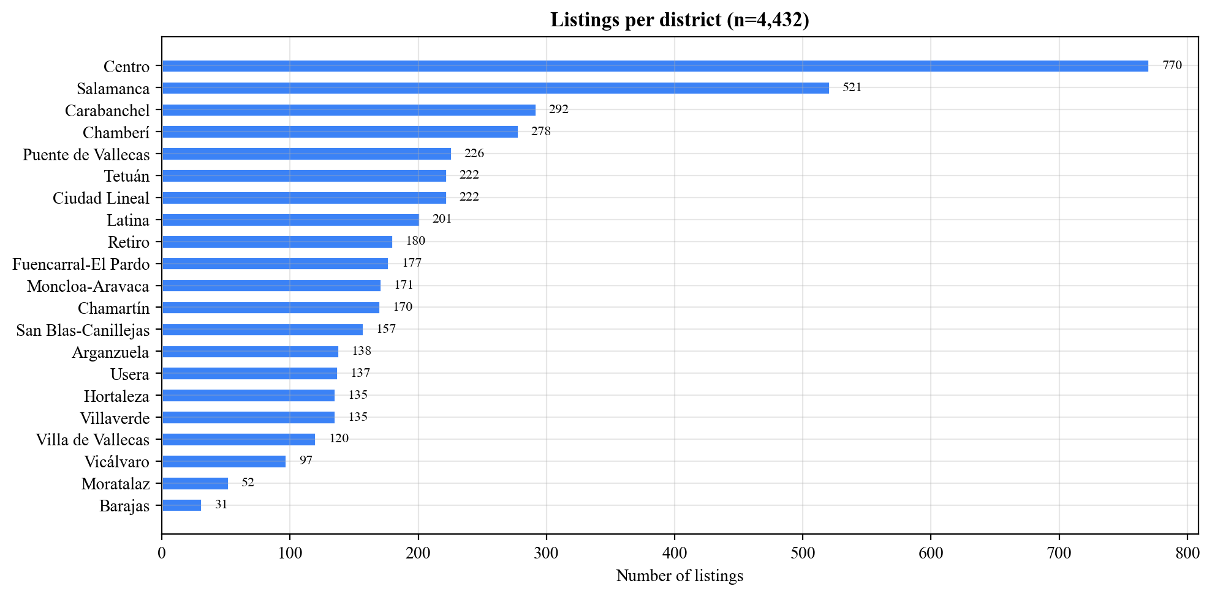
Figure 1. Listings per district.
Centro and Salamanca together account for roughly 30 percent of all listings, which tracks with their position as Madrid's most active residential markets. Peripheral districts like Moratalaz and Barajas have the fewest, likely reflecting both lower market activity and sparser portal coverage.
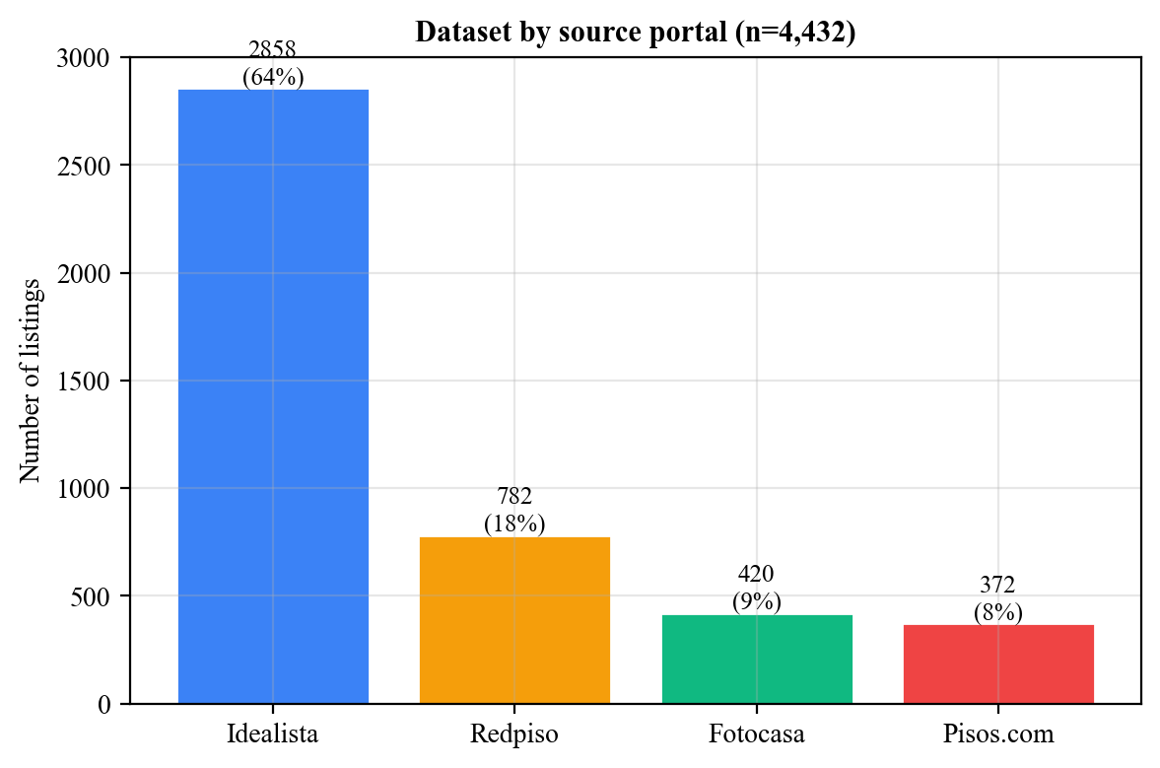
Figure 2. Dataset by source portal.
Idealista contributes 64% of the dataset, followed by Redpiso (18%), Fotocasa (10%), and Pisos.com (8%). This matters because each portal provides different levels of detail.

Field completeness and data quality
Not all portals provide the same fields. The heatmap below breaks down coverage of the fields most relevant to price prediction, by source.
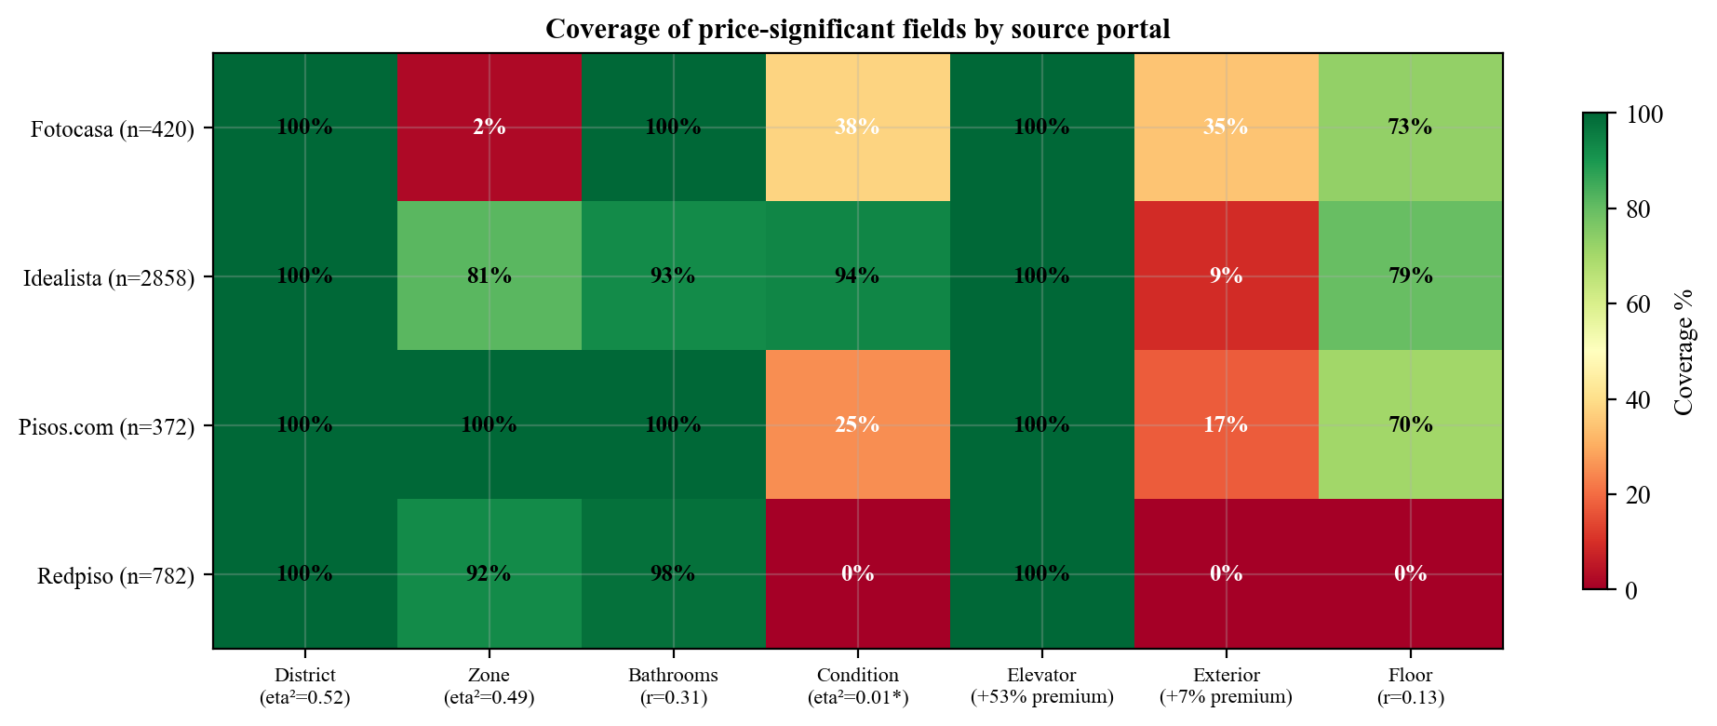
Figure 3. Coverage of price-significant fields by source.
Idealista is the most complete source across the board. Redpiso has zero condition data because their API simply does not include it, and this alone accounts for most of the condition gap in the dataset. Fotocasa and Pisos.com have partial coverage from Firecrawl parsing.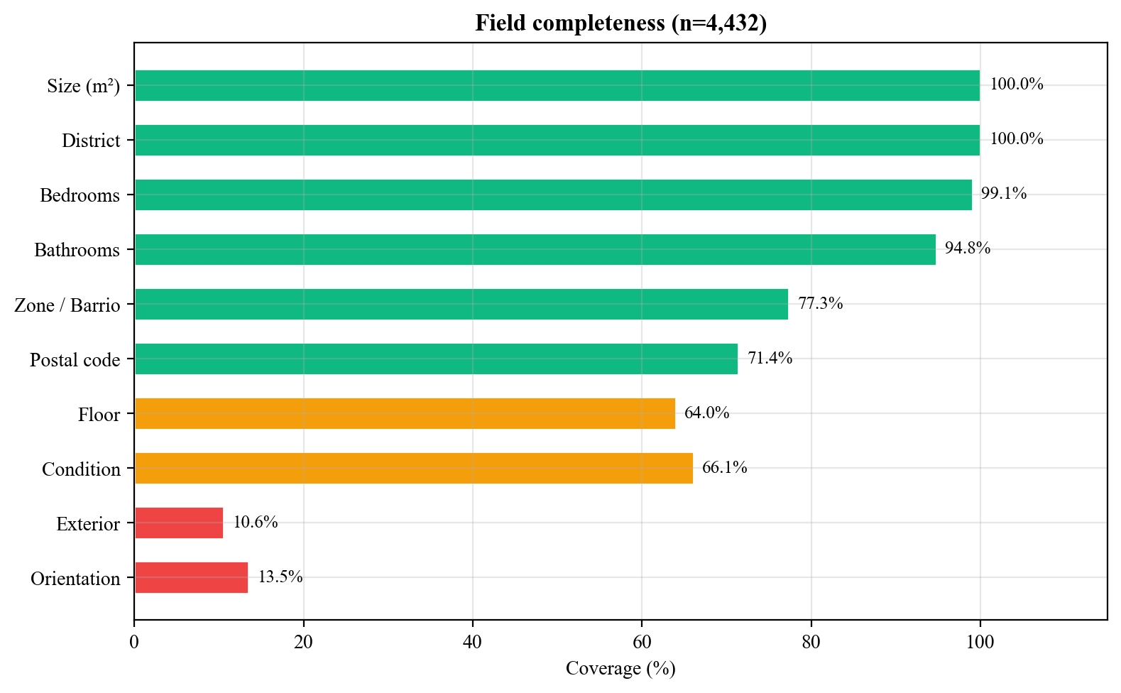
Figure 4. Field completeness.
Size and district are at 100% because the quality filter requires them. Condition sits at 66%, with the gap coming mainly from Redpiso. Orientation and exterior remain low at 14% and 11% respectively, limited by what the portals expose on their listing pages.

Price distribution and target transformation
Property prices follow a right-skewed distribution with a skewness of 4.59. The median asking price per square meter is 5,385 EUR, while the mean is 9,168 EUR, pulled up by luxury listings in Salamanca and Chamberí.
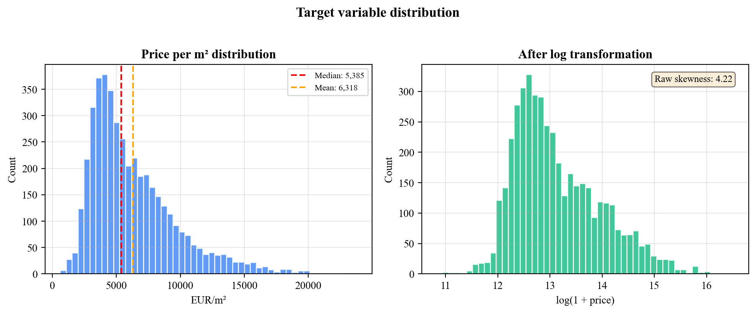
Figure 5. Price distribution before and after log transformation.
Applying log(1 + price) compresses the right tail and produces a more symmetric distribution, which improves training stability for tree-based models by suppressing extreme values in the target variable.
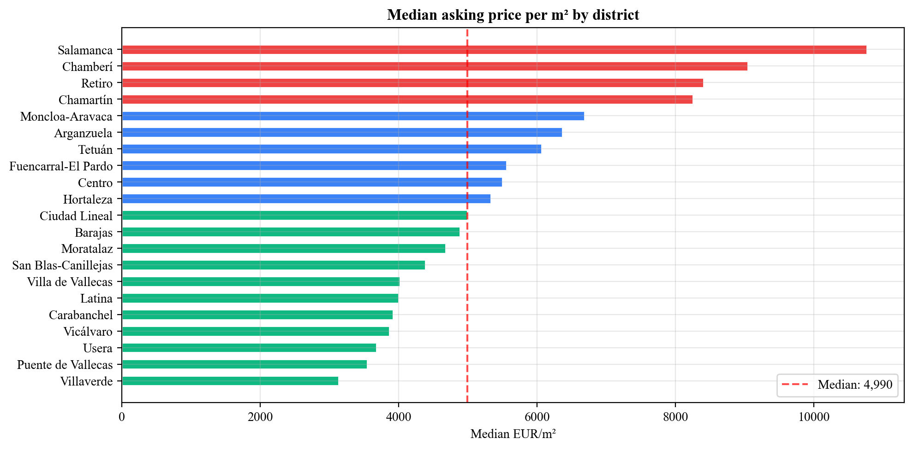
Figure 6. Median price per sqm by district.
The price range across Madrid is wide. Salamanca sits at 10,767 EUR/sqm, 3.4 times higher than Villaverde at 3,135 EUR/sqm. This confirms that location is likely the dominant factor in pricing, which the correlation analysis below quantifies.

Feature correlations with price per square meter
To measure which features carry the most pricing signal, we computed two types of statistics against price per square meter. For numeric features (size, bedrooms, bathrooms, floor), we used the Pearson correlation coefficient (r), which measures the strength and direction of a linear relationship between two continuous variables. A value of +1 means perfect positive correlation, -1 means perfect negative, and 0 means no linear relationship. For categorical features (district, condition), we used eta-squared, which measures the proportion of total variance in price that is explained by group membership. An eta-squared of 0.50 means that knowing which group a property belongs to explains half the price
Feature | Type | Metric | Value
District | Categorical (21) | eta-squared | 0.52
Zone / barrio | Categorical (239) | eta-squared | 0.49
Bathrooms | Numeric | Pearson r | +0.31
Size (sqm) | Numeric | Pearson r | +0.14
Floor | Numeric | Pearson r | +0.13
Bedrooms | Numeric | Pearson r | -0.01
Condition | Categorical (3) | eta-squared | 0.006

Table 4. Feature correlations with price per square meter.

District and zone each explain about half the price variance on their own. They overlap because zone is nested within district, but zone adds real granularity: it is not the same to find an opportunity in Almagro as in Gaztambide, even though both are in Chamberí.
Bathrooms is the strongest numeric predictor. Bedrooms, on the other hand, has essentially zero correlation with price per square meter. This is not a data error. More bedrooms means a larger apartment, which means a higher total price, but the price per square meter is driven by location, not by how many rooms the floor plan has. A 2-bedroom and a 4-bedroom on the same street in Salamanca cost roughly the same per square meter; the 4-bedroom just has twice the total price because it has twice the area.
Condition appears nearly irrelevant in aggregate (eta-squared = 0.006), but this turns out to be misleading. The low score reflects the fact that eta-squared measures condition's effect in isolation, without accounting for location. Since renovation properties concentrate in expensive districts, their high absolute prices mask a real within-district discount that the model can capture by splitting on district first and condition second. The next section examines this in detail.

Condition analysis: class imbalance and Simpson’s paradox
Among deals with known condition, 73% are classified as "buen estado" (good), 18% as "a reformar" (needs renovation), and 8% as "obra nueva" (new construction). A third of the dataset (34%) has no condition data at all, almost entirely from Redpiso.
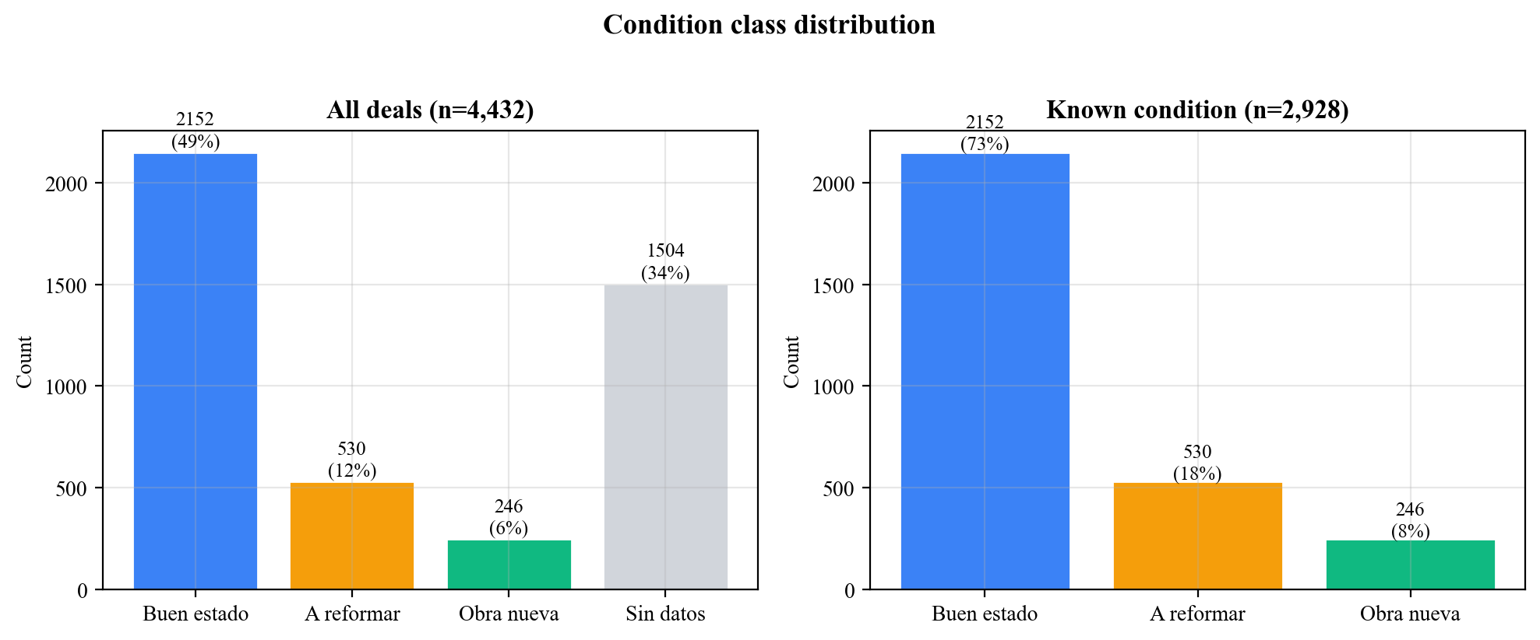
Figure 7. Condition class distribution.
The class imbalance means the model sees far more "good" examples than "renew" during training, which may limit its ability to learn renovation-specific pricing patterns. Looking at aggregate prices by condition, something counterintuitive appears:
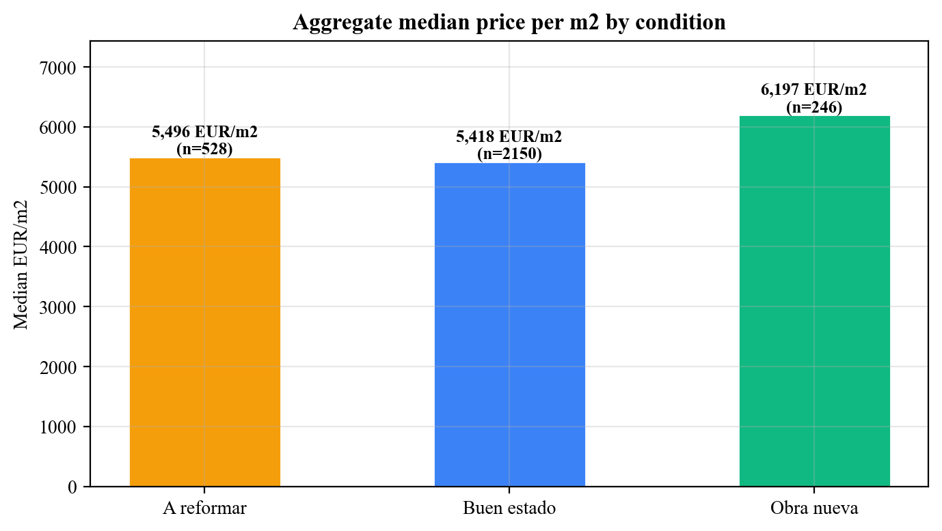
Figure 8. Aggregate median price per square meter by condition.
"A reformar" properties have a median of 5,496 EUR/sqm, slightly higher than "buen estado" at 5,418 EUR/sqm. Renovation candidates appear to be more expensive than finished apartments. But this is a Simpson's paradox. When we compare within each district, "a reformar" is cheaper in 15 out of 20 districts that have enough data:
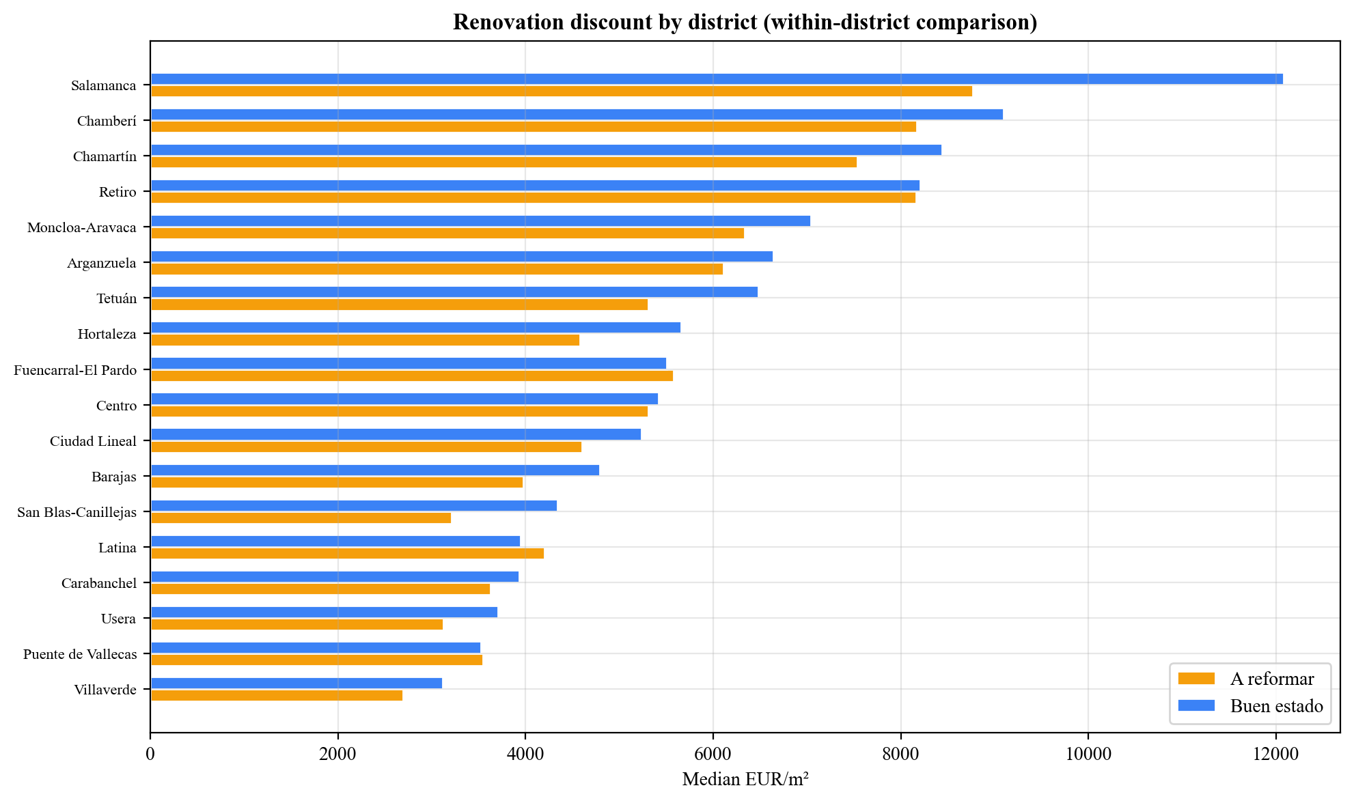
Figure 9. Within-district comparison of median price per sqm.
In Salamanca, the renovation discount is 25%. In Chamberí, 12%. The aggregate numbers flip because expensive districts like Salamanca have a high concentration of "a reformar" listings, which pulls the overall renew median above the good median even though within every individual district renew is cheaper.
This finding has two implications. First, condition is a useful feature for the model, but only because tree-based models can split on district first and then on condition within each district, capturing the interaction. Second, the within-district price gap between renovation candidates and finished properties is real, which validates the Fix and Flip strategy.
Amenities and price premiums
Several property amenities show large aggregate price premiums: elevator (+53%), terrace (+50%), balcony (+60%), garage (+20%), storage room (+23%). These numbers come from comparing the median price per square meter of properties that have each feature against those that do not.
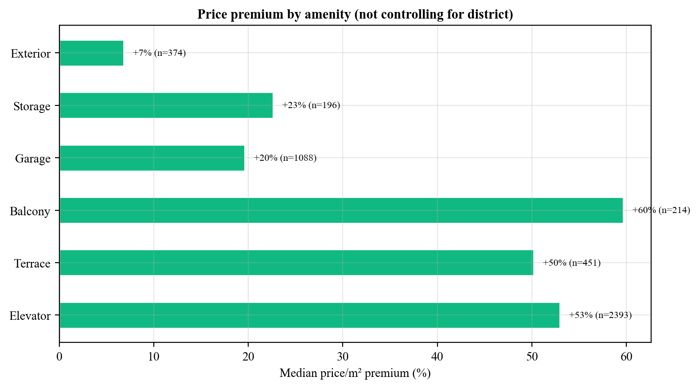
Figure 10. Price premium by amenity.
However, these premiums are heavily confounded with location. Expensive districts tend to have more buildings with elevators, more terraces, and more garages. The +53% elevator premium is largely the model seeing "this property is in Salamanca" rather than "this property has an elevator." When both district and elevator are included as features, the model may partially double-count the location effect.
The exterior/interior distinction is different. Exterior-facing properties show a +7% premium over interior ones, measured on the 469 deals where this data is available. This comparison is less confounded because exterior and interior units often exist in the same building, in the same district. That coefficient reflects a real difference in natural light and livability rather than a location artifact.
These observations informed the modeling decisions in the next chapter: all features were kept (the model can learn to weight them appropriately), but the confounding between amenities and district means feature importance scores from the trained model should be interpreted with caution.

Machine learning valuation model

Feature engineering
The model uses 14 features extracted from each deal: four numeric features: size in square meters; bedrooms; bathrooms; and floor. Six binary amenities: storage room; terrace; balcony; elevator; garage; and exterior (encoded as 0/1). Four categorical features: district (21 values); zone (barrio name); condition (good/renew/new development); and orientation. All one-hot encoded.
No price-derived features are used to prevent data leakage. Missing numerics default to zero. Missing categoricals produce their own one-hot column, which lets the model learn that “unknown condition” behaves differently from any known condition.

Preprocessing
Deals must have a non-null asking price and size. Deals with price per square meter below 500 or above 25,000 EUR are excluded as outliers (7 deals removed, leaving 4,425). Zone cardinality is reduced by mapping zones with fewer than 10 deals to an empty value. This does not remove any deals from the dataset; it only erases the zone label for those specific listings so that one-hot encoding does not create columns based on 2 or 3 examples. The result cuts the number of columns from 327 to 201. This was validated experimentally: the reduced version outperformed the full version on every model (see Experiments below). The target is log-transformed: y = log(1 + price). Features are scaled with StandardScaler. Data is split 85/15 with random_state=42.

Model comparison
Four models were trained on the same data with the same preprocessing:
Model | R-squared (test) | R-squared (CV) | CV std | MAE (€) | MAPE
Gradient Boosting | 0.853 | 0.883 | 0.019 | 167,418 | 21.7%
XGBoost | 0.839 | 0.881 | 0.021 | 170,375 | 21.6%
Random Forest | 0.838 | 0.849 | 0.018 | 180,624 | 24.7%
Linear Regression | 0.651 | 0.762 | 0.061 | 252,092 | 29.4%
Table 5. Model comparison on 4,425 deals. Gradient Boosting has the best R-squared.
Gradient Boosting was selected as the production model. Its hyperparameters: n_estimators=300, max_depth=5, learning_rate=0.05, subsample=0.8.

Experiments
Five configurations were tested to validate feature engineering decisions:
Experiment | Description | Best R-squared CV | Best MAE
A | Baseline (zone cleanup, all features) | 0.883 | 167,418
B | Drop zone + orientation | 0.860 | 176,211
C | B + impute missing condition as “good” | 0.858 | 180,846
C2 | B + impute missing condition as “segunda mano” | 0.860 | 177,632
D | B + target = price per sqm | 0.856* | 174,415
Table 6. Feature engineering experiments. All using Gradient Boosting.
*D’s CV is computed in price/sqm space and is not directly comparable.
Experiment A (baseline with zone cleanup) wins. Dropping zone costs 2.3 points of CV R-squared, confirming that barrio-level location carries real pricing information beyond the district. Imputing missing condition as “good” or “segunda mano” does not help; the model already handles the missing category through its own one-hot column. Predicting price per square meter instead of total price (D) shows competitive test metrics but unreliable CV scores.

Deployment and inference
At inference time, the system builds a single-row DataFrame from the deal’s features, one-hot encodes it, scales with StandardScaler, predicts in log space, and reverses the transform.
There are two prediction modes. The first is manual: the user selects specific deals on the Valuaciones page and triggers a batch prediction. The second is automatic: after each scrape cycle, the system runs the model on every newly inserted deal and stores the result with a flag (model_version='auto'). These automatic predictions are not visible on the Valuaciones page but feed into the analytics dashboard, where the ML spread chart uses them to compare predicted prices against asking prices.

Financial analysis model
The Fix and Flip financial module is a separate tool within the application. When a user identifies a potential renovation opportunity, either from the deals database or from their own source, they can run a financial analysis to see whether the numbers work.

Cash flow construction
Cash flows are modeled monthly from the equity investor’s perspective. At Month 0, the investor pays the equity portion of the purchase price (total minus mortgage) plus closing costs. During renovation months, outflows include the equity share of capex, operating expenses, property tax, and interest on both mortgage and capex debt. After renovation, only operating costs and interest continue. At exit, the investor receives the net sale price minus broker fee and repays all debt. All debt is interest-only during the hold, with principal repaid at exit.
The model takes 15 inputs grouped into four categories: property parameters (size, purchase price, exit price per sqm), renovation parameters (capex total, capex months, project months), operating costs (monthly opex, annual IBI, closing costs at 7.5% default, broker fee at 3.63% default), and financing (mortgage LTV, mortgage rate, capex debt amount and rate, tax rate). All financing inputs default to zero, so the model works with or without leverage.

Output metrics
- IRR is computed from the monthly cash flow array using numpy_financial.irr(), then annualized.
- MOIC: total cash returned / peak equity deployed.
- ROE: profit / maximum equity exposure.
- Gross margin: profit / total development cost.
- Max equity exposure: the peak negative cumulative cash flow. The most capital tied up at any point, which is a more honest denominator than initial equity because ongoing costs keep increasing the capital at risk.
The model supports two debt instruments: an acquisition mortgage (percentage of purchase via LTV) and capex debt (fixed amount for renovation). Each has its own interest rate. This reflects real conditions where acquisition and renovation financing often come from different sources. This provides more flexibility but it doesn't hurt. If a deal is leveraged once or twice the model would simply behave like a single-mortgage or an unleveraged model.

Analytics dashboard
The analytics dashboard answers one question: where should the next investment be?

Design and sections
Instead of showing raw statistics, every section compares data sources against each other to surface opportunities. Three layers of upside comparison form the backbone:
- Conservative upside: portal asking prices for “a reformar” properties against notary closing prices for “nueva” properties. Buy at asking, sell at what the market actually pays for new.
- Optimistic upside: asking prices for “a reformar” against asking prices for “buen estado.” Both from portals, so both inflated by the same seller bias.
- Market ceiling: notary closing prices for “segunda mano” against “nueva.” Both real transaction data, showing the structural price gap.
The dashboard also shows negotiation margins (asking vs closing spread by district, color-coded by severity), ML spread (where the model thinks properties are underpriced), condition distribution, a listing timeline, and portfolio-level KPIs from saved financial analyses. Each upside chart links directly to the deals page filtered by that district and condition.

Opportunity scoring
The system ranks districts by combining three signals: average entry price (lower is better), renovation upside (bigger gap is better), and ML spread (more undervalued is better). Each dimension is ranked 1 to 10, and the scores are averaged. The composite score identifies which districts offer the best combination of affordability, renovation potential, and model-predicted undervaluation.

Results and discussion

ML model performance
The production Gradient Boosting model, trained on 4,425 deals with zone cardinality reduction, achieves:
Metric | Value
R-squared (test) | 0.853
R-squared (5-fold CV) | 0.883
CV standard deviation | 0.019
MAE | 167,418 €
MAPE | 21.7%
Deals trained | 4,425

Table 7. Production model metrics.
The R-squared of 0.88 on cross-validation means the model explains most of the price variation from the property's physical characteristics and location. The 14 input features (4 numeric, 6 binary, 4 categorical) expand to 201 columns after one-hot encoding, with district and zone accounting for most of that expansion. The MAE of 167,000 EUR is roughly 20-30% of the typical property value (median ~500,000 EUR). That makes the model useful for screening and ranking, not for setting a final price. Several factors explain the remaining error: the model trains on asking prices which include seller noise; condition data is missing for 34% of deals; and features like building age, energy certification, and exact floor plan are not available from portal data.

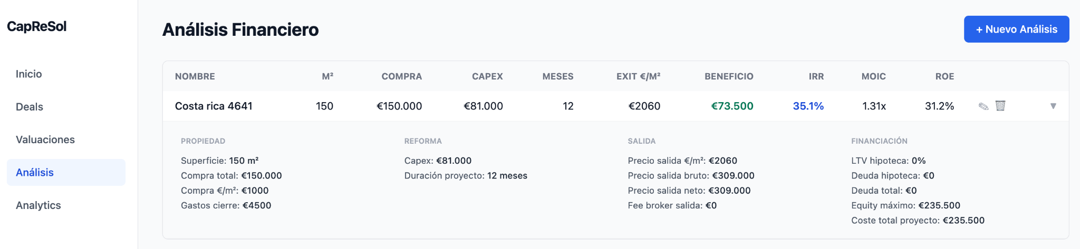
Financial analysis
Image 1. Financial Analysis Module. Costa Rica 4691 example.
The financial model has been tested with scenarios reflecting typical Madrid renovation projects. Users input property and renovation parameters, and the system computes monthly cash flows and return metrics. The screenshot above shows a representative analysis.

Analytics insights
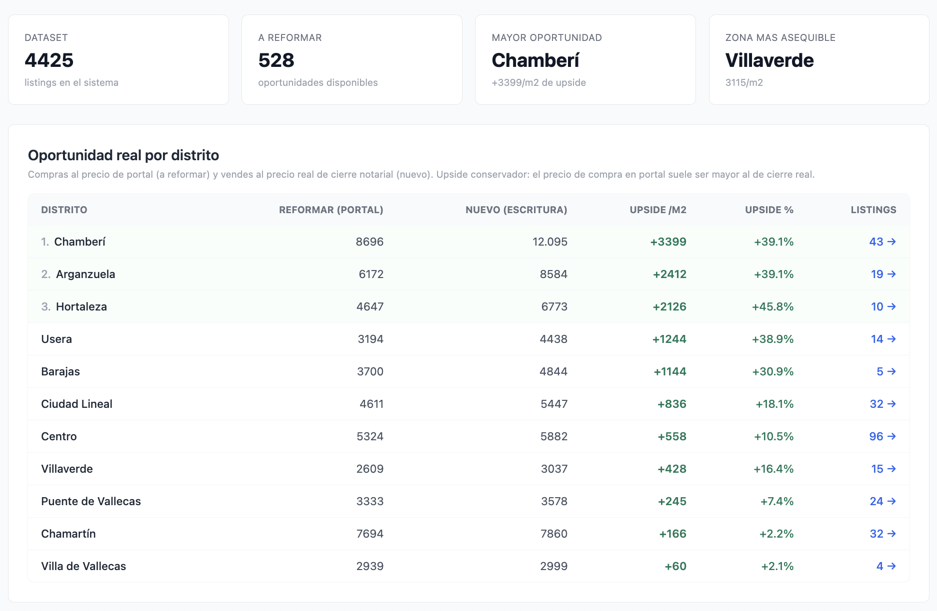
Image 2. Analytics page featuring KPIs and potential upside on renovation projects per district.
The analytics dashboard, when populated with both portal and notary data, surfaces district-level opportunities. The conservative upside chart identifies which districts have the largest gap between renovation asking prices and new-build closing prices. The negotiation margin section shows where sellers are most overpricing relative to what the market actually pays.

Professional feedback
Methodology: Three professionals with experience in real estate investment development, renovation and fund management were given access to the production system and asked to evaluate its utility.
# | Company | Role | Location | Experience
1 | AC Arqs | Founder & partner | Buenos Aires, Argentina | R.E. development, fix and flip, renovation projects.
2 | Chateau Partners | Executive Director | Madrid, Spain | R.E Private Equity. Investment fund.
3 | HORMIGAZ | Founder & Partner | Buenos Aires, Argentina | R.E development.

Table 8. Professional feedback participants.
Feedback was collected from two real estate professionals in Buenos Aires through a two-phase interview process designed to minimize bias. In the first phase, each participant was introduced to the system and given access credentials with minimal instructions on how to use it. No guidance was provided on what to focus on or what outcomes to expect. After a period of independent use, a second interview was conducted to gather their impressions across all modules, covering functionality, usability, terminology, and perceived market fit. Full transcripts are included in the Appendix.

Both reviewers identified the deals module as the most valuable component. One described it as a direct replacement for the hours his partner currently spends browsing portals manually, often without finding anything viable. The other reviewer also highlighted the deals module but wanted additional columns showing who publishes each listing and their contact information.
The financial analysis module was recognized as a practical time saver. One reviewer tested it with a real opportunity and got instant results that he estimated would have taken hours to compute manually. He suggested adding more granular phases to the construction timeline: permits, preliminary design, project execution, and exit. The ML valuation module was described as useful for a quick first impression but not accurate enough to be relied upon or considered a differentiator.
The analytics dashboard generated the most divided response. Both reviewers could see its potential for market-level price comparisons and benchmarking, but one found the tables confusing on first use. Mixed Spanish and English labels, unexplained acronyms, and unclear table structures meant he did not understand what the data was showing until it was explained to him. His recommendation was to reduce the number of tables and make the remaining ones self-explanatory with clearer titles and consistent language.
On business potential, the two professionals converged on the same conclusion from different angles. The renovation specialist identified three client types: investors focused on fix and flip, independent brokers with active portfolios, and first-time homebuyers looking for market orientation. He offered to pilot the system with his team if adapted to the Buenos Aires market. The developer took a more structural view: the real opportunity is in volume, not in niche tools for investment funds, which likely already have proprietary solutions. He suggested targeting large real estate agencies with many branches, where brokers could use the system to find opportunities published by competitors or by owners without intermediaries. He also proposed that if the platform reached enough retail users, the aggregated search behavior data, what people look for by zone, product type, and price range, would itself become a product that could be sold to agencies and funds as market intelligence.

Conclusions and future work

Summary
The thesis's main objective to build a system that consolidates the fragmented real estate investment workflow into a single application, was accomplished. Covering everything from deal sourcing to financial decision making. The motivation was concrete: investment professionals in Madrid as in Buenos Aires spend hours browsing multiple portals manually, estimate property values through intuition, and run financial projections in disconnected spreadsheets. The system was built to close that gap.
The result is a production application that collects and normalizes listings from four of Spain's largest property portals into a unified database of over 4,400 deals across all Madrid districts. A Gradient Boosting model predicts market prices with an R-squared of 0.88 on cross-validation. Official notary closing prices allow users to compare what sellers ask against what buyers actually pay. A Fix and Flip financial module computes key metrics. And an analytics dashboard ties it all together, surfacing district-level opportunities through three layers of price comparison and a composite scoring algorithm. The six objectives set in the introduction were met.
Finally, professional feedback from two real estate practitioners in Buenos Aires confirmed that the core functionality delivers immediate practical value. Both saw commercial potential but with different perspectives and one of them was open to conduct a pilot program in his work.

Limitations
The dataset contains 4,425 deals, which is small compared to institutional AVMs that train on millions of transactions. Condition data is missing for a third of listings because one of the four portals does not provide it in their API. The model predicts asking prices, not transaction prices, so seller-side noise sets a ceiling on accuracy. The R-squared of 0.88 on cross-validation indicates the model captures most of the price variation, but the MAE of 167,000 EUR represents roughly 20-30% of a typical property value in the dataset, which is too high for the model to be used as a standalone pricing tool. It works as a screening mechanism to rank and filter deals, but final valuations still require market comparables and professional judgment. Notary data is a single snapshot with no historical dimension. The Cap Rate model for rental strategies was not built. The system covers Madrid only. And the ML model has not been benchmarked against commercial AVMs, so there is no industry baseline to compare against.

Future work
In the near term, the priority is improving overall data quality from the scraper module. The analytics dashboard needs clearer terminology and fewer tables, as both professional reviewers flagged confusion with mixed-language labels and unexplained acronyms. The financial model would benefit from more granular construction phases as suggested in the feedback.

The next step is piloting. One reviewer offered to test the system with his team in Buenos Aires if adapted to that market. Adapting it requires new district-barrio mappings and portal configurations for Argentine portals, but no architectural changes. In parallel, finding an investment fund or large agency in Madrid to pilot the current version would generate the kind of usage data and feedback that drives meaningful iteration.
Beyond the pilot, several directions are possible. Expanding to other Spanish cities like Barcelona and Valencia. Adding scheduled scraping for automated data refresh. Implementing the Cap Rate model for rental strategies. And a longer-term direction: generation of documents, reports, market analyses, and intelligence products as new features, expanding the platform's role beyond search and analysis.

References
Baldominos, A., Saez, Y., & Quintana, D. (2018). Machine learning techniques for predicting housing prices: A review. Advances in Intelligent Systems and Computing, 584, 123-132.
BBVA Research. (2024). Spain housing market outlook 2024. BBVA Research Publications.
CBRE. (2024). Real estate investment market Spain 2024 report. CBRE Research.
European PropTech Report. (2025). PropTech in Europe: Companies, trends, and investment landscape. European PropTech Association.
Kok, N., Kopczuk, W., & Timmins, C. (2017). Big data in real estate: From manual appraisal to automated valuation models. Journal of Portfolio Management, 43(6), 202-211.
Maps PropTech API. (2025). PropTech adoption survey Spain 2025: Tech stack, barriers, and automation needs. Maps PropTech API Annual Report.
PwC. (2025). Tendencias del sector de tecnologia inmobiliaria en Espana 2025. PwC Spain Real Estate.
Rosen, S. (1974). Hedonic prices and implicit markets: Product differentiation in pure competition. Journal of Political Economy, 82(1), 34-55.
v7 Labs. (2026). AI in real estate: Key use cases, solutions, and challenges. Retrieved from v7labs.com/blog/best-ai-tools-for-real-estate

Appendix

Frontend screenshots

Image 3. Home page software.
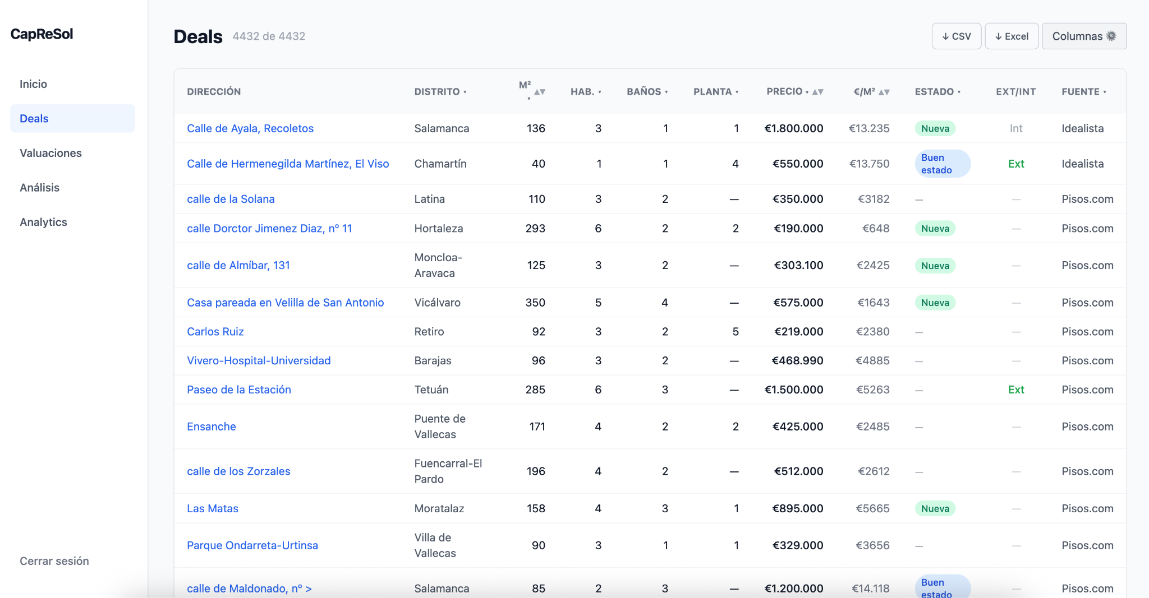
Image 4. Deals page software. Scraped deals structured.
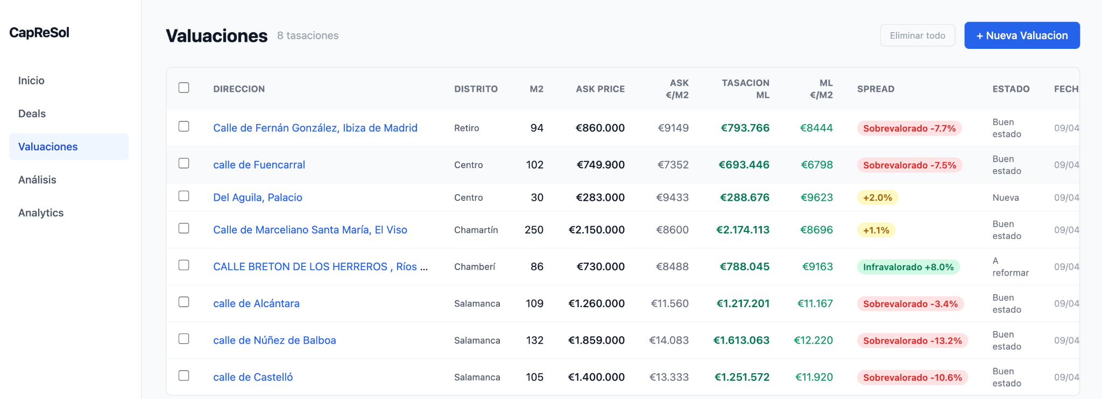
Image 5. Valuations page software. Machine Learning Module with predictions.
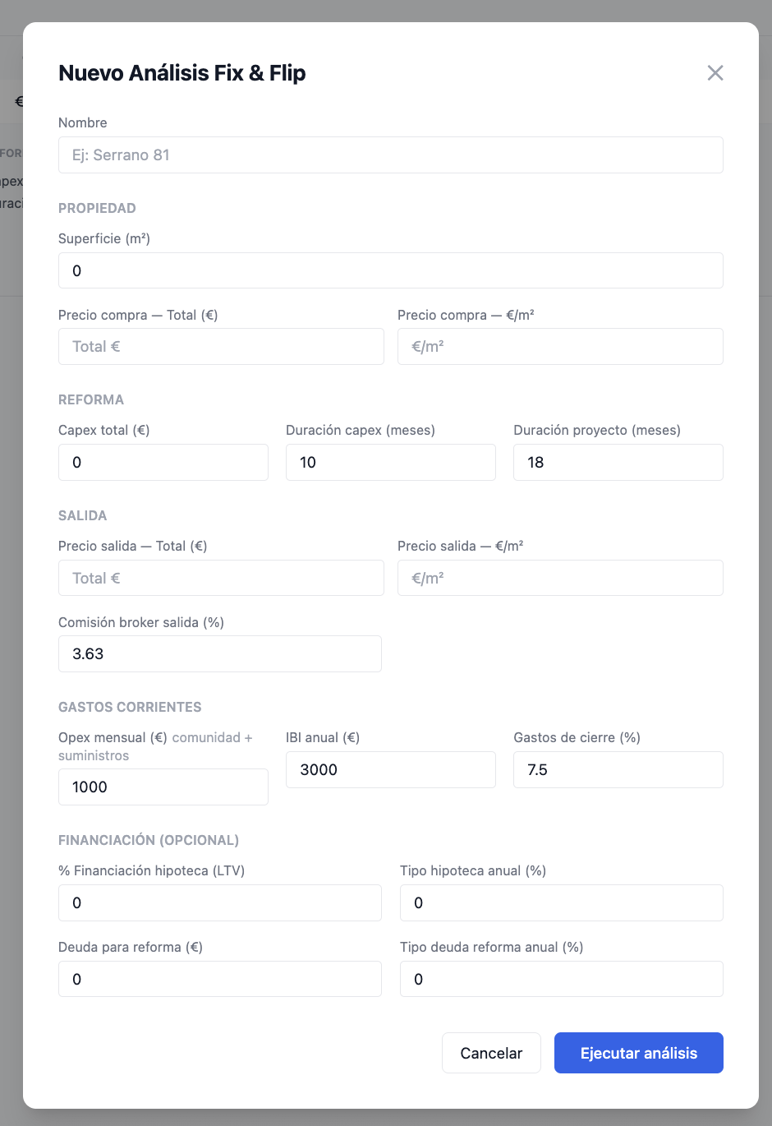
Image 6. Financial model inputs.
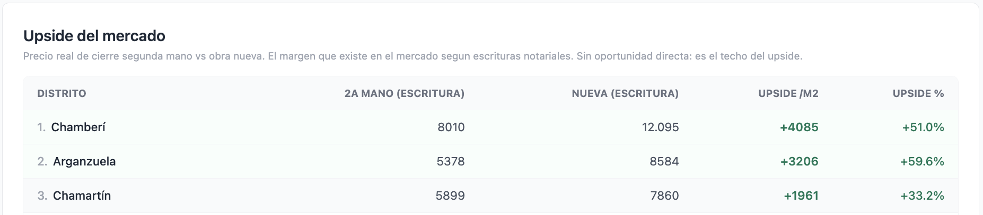
Image 7. Closing price comparison per district between ‘segunda mano’ vs ‘nueva’.
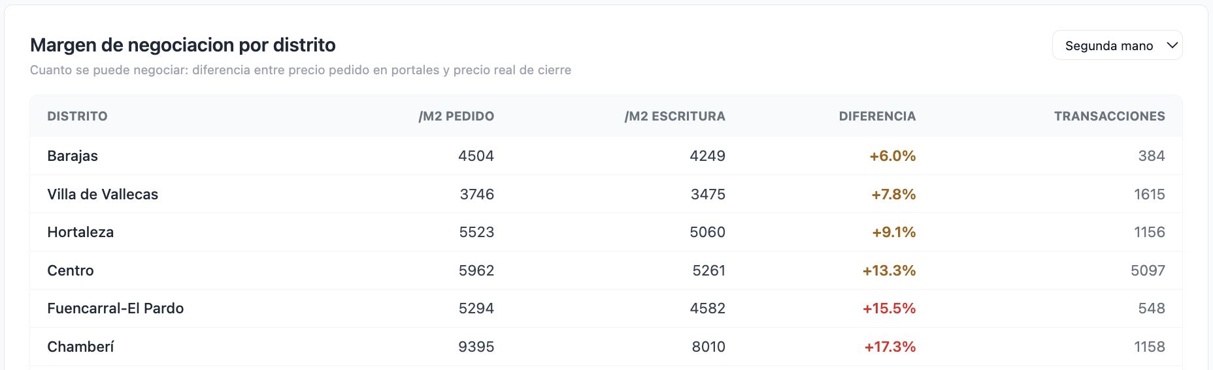
Image 8. Negotiation margin per district. Comparing average ask price vs average closing price per district.

Interview with Kevin Cuño - Founder at AC arqs.
First call: Introduce him to the project, and help him to access it. Via google meet, 13/03/2026. Second call: Feedback and sensations covering every aspect and every experience of the user. Via google meet, 7/04/2026.
Second interview Transcript: M(Mayer Attie), KC (Kevin Cuño).
- M: Hola Kevin como estás? Gracias por tu tiempo. Contame un poco qué sensaciones tuviste con la plataforma?
- KC: […] en líneas generales anduvo bien. Vamos módulo por módulo. Para empezar ‘deals’ funciona barbaro, saca mucha data super interesante, lo deja estructurado y se siente como va buscando oportunidades por internet, en el día a día del estudio acá vendría bárbaro. Hay muchas veces que lo tengo a Toro (partner), buscando horas y horas deptos para que no sirva nada al final. Por tema de números o lo que sea. Esta buenisimo que también tengas el link ahi rápido, cosa de que si realmente interesa puedas contactar rápido. Los datos que vas guardando me parecen bien, suelen ser los más importantes, de vez en cuando hay varios vacíos pero no molesta mucho. Segundo el módulo de valuaciones o tasaciones, está genial. Pero me sirven más los otros. Es un ‘chiche’ digamos. No muy certero pero si se mejora puede andar bien. De todas maneras no me parece un diferencial enorme. Para un pantallazo sirve. Después la parte de análisis financiero también está genial. Le agregaría varias capas, un desglose un poco más detallado en la parte de timings de obra. Incluiría, ‘trámites, ante proyecto, proyecto y salida’ esas serían las inflatables para mi. Hice la prueba con uno en Costa Rica que nos apareció y me dio unos números bárbaros que capaz hubiera tardado varias horas en sacar yo, o que tenía que agarrarlo a Toro para que los haga por mi. Más allá de que no sea 100% acertado ya un pantallazo rápido nos viene muy bien acá. Lo único es que pensaría en renombrar todo, eso está flojo. Lo vi más que nada en la parte de analiticas. No entiendo mucho las tablas. Son confusas, que es asking, portales, cierre, closing, los términos los tenes en español en inglés, y con siglas que yo no entiendo y estoy seguro que el inversor promedio acá en Buenos Aires tampoco. Con analiticas me paso eso, siento que capaz son super interesantes pero de primeras no las entendí.
- M: [Expliacion de analiticas y sus tablas]
- KC: Si… Son buenisimas para análisis más de mercado, comparativas, precios de salida promedio y eso genial, pero lo vi y no entendí nada. Recorrería varias y dejaría un par bien claras con nombres y títulos que puedan entender todos. Lo último en cuanto a estética no me fascina, pero entiendo que no era el objetivo de esto.
- M: Gracias, cualquier feedback viene increíble. Que opinas de que lo arme para el mercado de Buenos Aires así como está y lo prueben en el estudio 1 mes? A ver cómo se sienten después. Si sirve, si no, más feedback y cómo seguir iterando.
- KC: Olvidate, si lo haces para Buenos Aires lo uso si o si. Creo que a los chicos les va a encantar, y de cualquier manera te contamos lo que vaya más o menos para que lo cambies. Pero siento que puede quedar buenísimo con un par de cambios básicos.
- M: Espectacular. ¿Cómo ves el mercado para esta herramienta? ¿Le ves potencial? ¿Quiénes pueden ser clientes?
- KC: Me gusta, siento que tienes varios potenciales clientes. Con intereses muy diferentes. Por un lado, la gente como yo. Gente que está buscando todo el día, que hace fix and flip, que renueva mucho. Después los brokers independientes, que también tienen su cartera pero se la pasan buscando oportunidades en los portales, ya sea para llevarle a inversores o a cliente final. Después podrías servirle al que va a comprar su primera casa. Que no entiende mucho, y entre tu modulo de busqueda lo ayudas y despues con lo de analitica para hacerse una idea del mercado en general, va a pasar de saber cero a bastante en un segundo. De estos yo creo que los perfiles de inversor o el broker pagaron algún tipo de suscripción pero el resto dudo mucho…
- M: Gracias por todo. Estamos al habla.

Interview with Nelson Korenblum - Partner at HORMIGAZ.
First call: Introduce him to the project and its scope. Via whatsapp, 16/03/2026. Second call: discussion and feedback. Via whatsapp, 25/03/2026.
Second interview Transcript: M(Mayer Attie), NK (Nelson Korenblum).
- M: Hola Nelson ¿cómo andas? ¿Pudiste probar el sistema?
- NK: ¿Qué haces Mayer? Entré pero no sabía muy bien qué hacer. Iba tocando todos los botones. No me llevo muy bien con la tecnología. ¿Queres que lo repasemos juntos aca?
- M: Obvio, dejame compartir y te cuento. [screen sharing and going over the software with him]. Vamos uno a uno. (I explained every module one by one, making it run).
- NK: Ok bien, está muy bueno eh. Lo de la búsqueda de los portales es genial. Ahí podrías agregar un par de columnas más con información. Por ejemplo quien lo publica, y su contacto. Los otros módulos no me dicen mucho. El de analíticas capaz. Pero veo esto y pienso que el target de este tipo de cosas son inmobiliarias enormes. Hay que apuntar a una con muchas sucursales, muchas franquicias, agarrar la raíz y que lo implementen ahí. Esto para una inmobiliaria le vendría muy bien. Que usen esto para buscar oportunidades que publican otros, que publican sin intermediarios, y el broker que tenga una cartera bien activa vaya llamando a lo que le puede servir. O engancha a otra inmobiliaria para compartir comisiones, o agarra a otro sin inmobiliaria para llevarle a un potencial comprador u ofrecerle un mejor negocio. Me parece que ahí está lo bueno. A mi me da la impresión que los fondos de inversión o ese estilo ya deben tener sus herramientas.
- M: Entonces decis que el enfoque está en el volumen, no tanto en una solución más a la talla de fondos, o inversores en general.
- NK: Si, es decir siento que en el volumen de clientes y en las inmobiliarias grandes en general está lo bueno. Que le puede servir a un fondo seguro, pero el modelo de negocio está en atacar el volumen. Otra es que lo usan muchísimo usuarios, se vuelva el buscador por defecto y ahí se arma otra rama de negocio donde tenes la data de lo que buscan los clientes retail, los ayudas a encontrar porque tu herramienta es mejor, y de ahi con esa informacion podes tener analiticas para inmobiliarias y fondos a nivel macro de que busca la gente, en cuanto a producto, zona, y todo eso. El círculo se va cerrando y todos se alimentan de todo.
- M: Súper interesante eso. Muchísimas gracias Nelson. Un saludo.

