Mikhail Mayers

EE523

For tis problem, I began by creating a simple signal. I didn’t want anything fancy. I made a simple design that I could change later if needed. I Originally planned to create a random small sample every time, but I decided against that.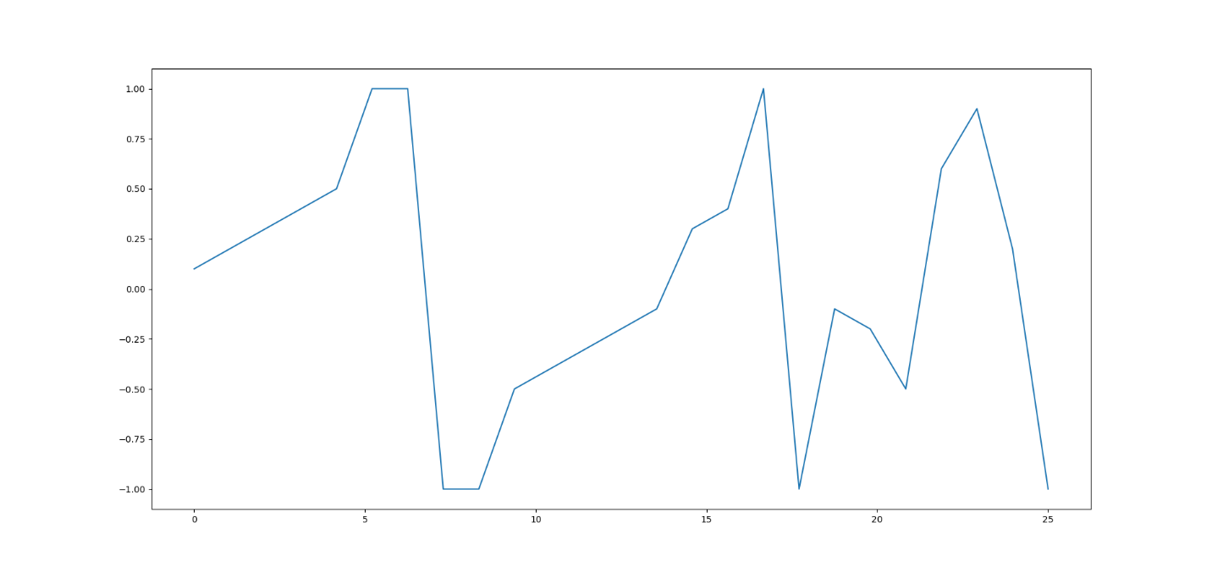

The average power of my small sample is 0.3944 V. For the next part, I did add the small signal to a noise free recording of 10,000 samples. This I did make random. I kept track of the locations of the small samples to compare with later, and only added the small 10 times.

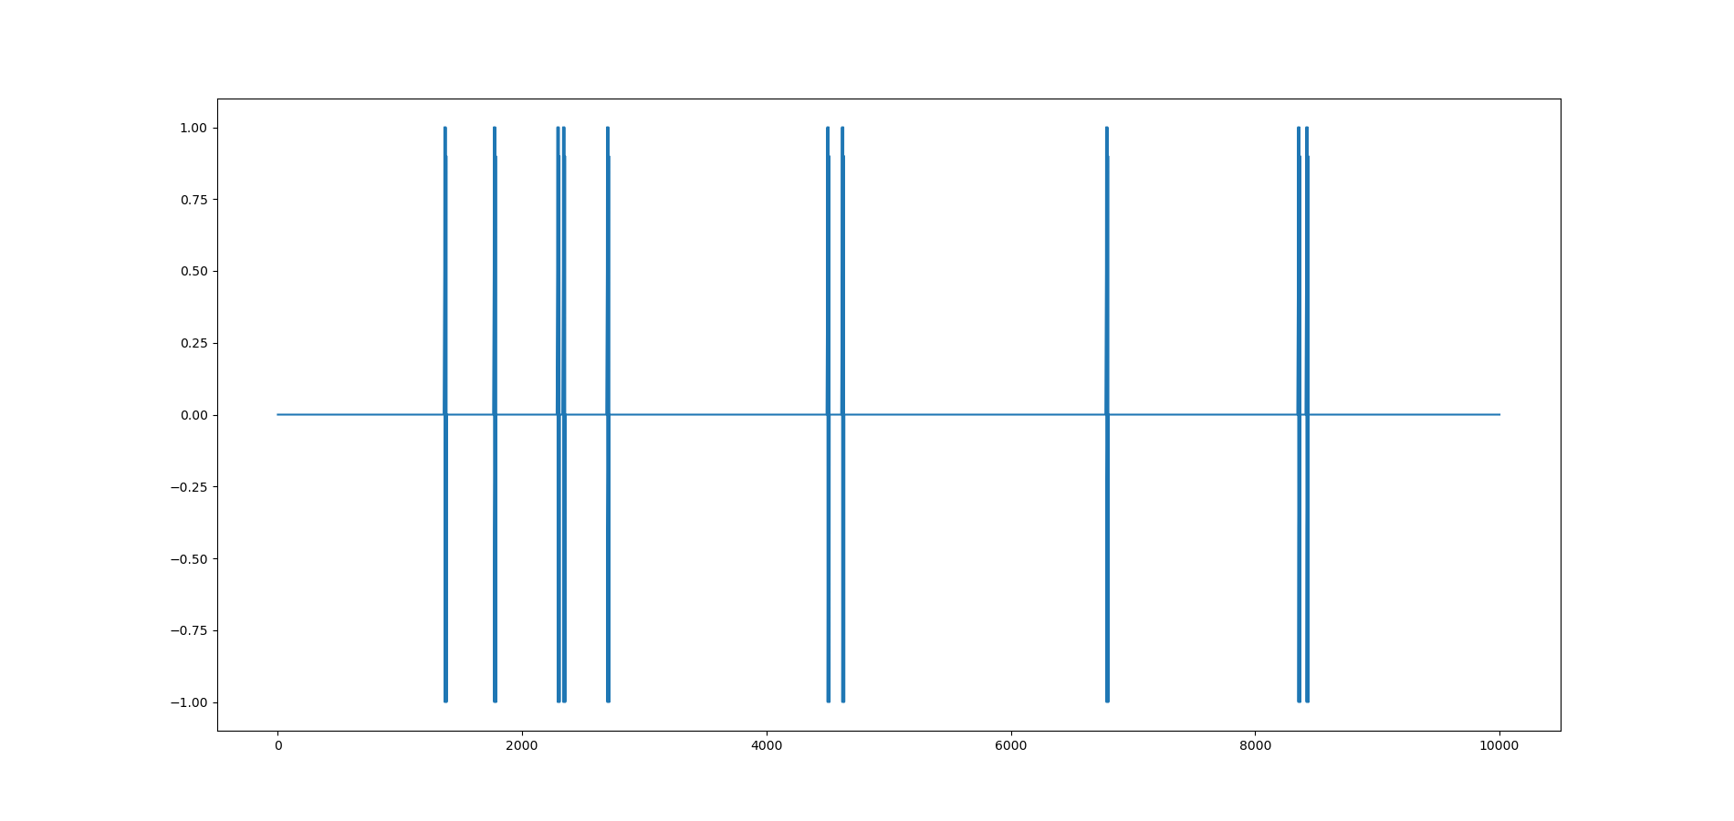

The noise I chose was gaussian noise. It should be uncorrelated because that is a property of gaussian noise. I did this simply by generating an array of normal points, with mean zero, and a variable standard deviation(sigma) so that I can control the SNR. My SNR was calculated by finding the ratio of the power of the clean signal noise over the power of the noise. If sigma was large, the SNR would be very low, and if sigma is small, the SNR would be high. My range was between SNR .01 – 10, or ~sigma 1 - .03. Below are graphs with less noise to full noise.

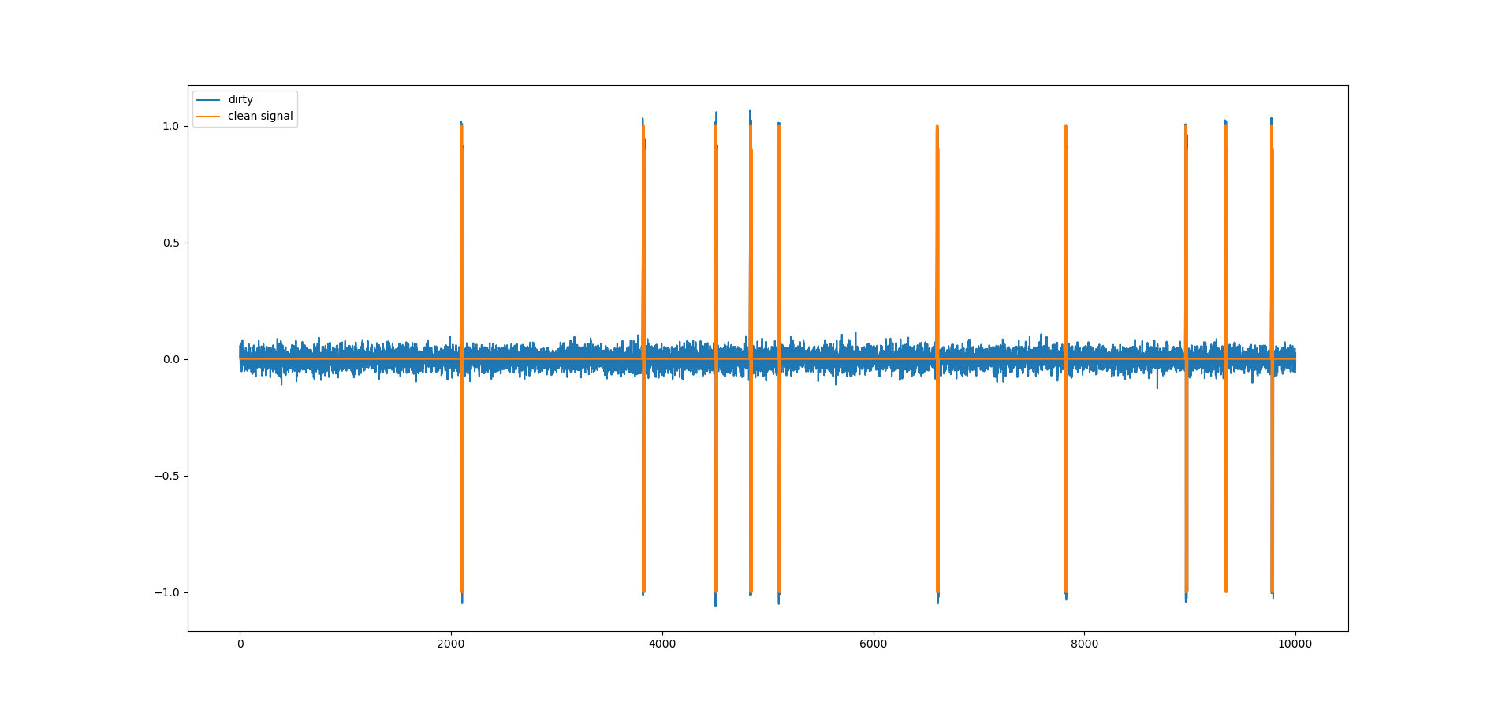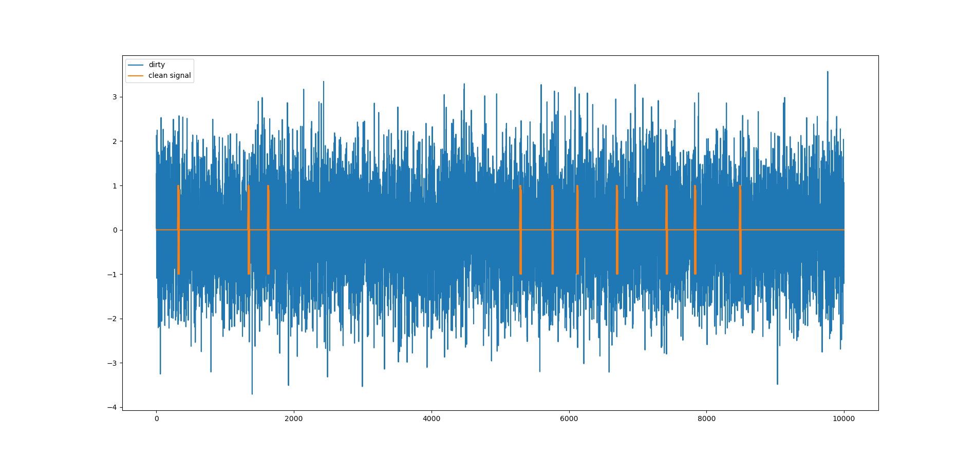

Because I wasn’t sure of the best way to pick prior probabilities, I assumed that every point was independent of the others. With this, I also assumed that I had an equal chance of their being a noise at any point, because I placed the small samples randomly throughout the signal, so pi_1 and pi_0 were both ½. As for my costs I started with an assumption of C_01(fp) > C_11(TP) and C_10(FN) > C_00(TN). I choose this arbitrarily at first with the differences only being 1, but as I tested with lower SNR, I found my PPV was getting very high, so I ended up increasing my number of FN to discriminate more. However, I still noticed problems with my threshold. As my SNR changed, my threshold did not, so I looked farther in the book in chapter 8(sorry for looking ahead) and used an equation found later. Which helped a lot. I tried to understand it as E, is the inner product of the small sample, and the Eta equation is the midpoint of the inner product of the small sample, which is the halfway point between the best-case scenario of the matched filter landing on itself and zero. That midpoint is then shifted by the log of the threshold, which is scaled by the amount of sigma. So, if sigma is larger, there’s more noise, so the midpoint needs to be increase more by the threshold.

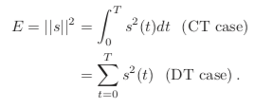

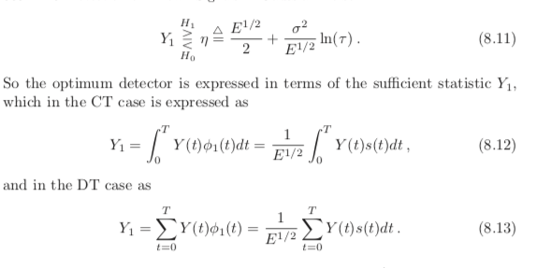

Besides from this equation change, I also increased the acceptance window. I was originally just trying to locate the signal at a single point, but this didn’t go well. So instead, I gave an acceptance window of 6 points on either side of the true point (13 points), which is about half the size of my sample. Although I always hit the correct points, I still always have a lot of false positives. Below I have low noise various amounts of FP:

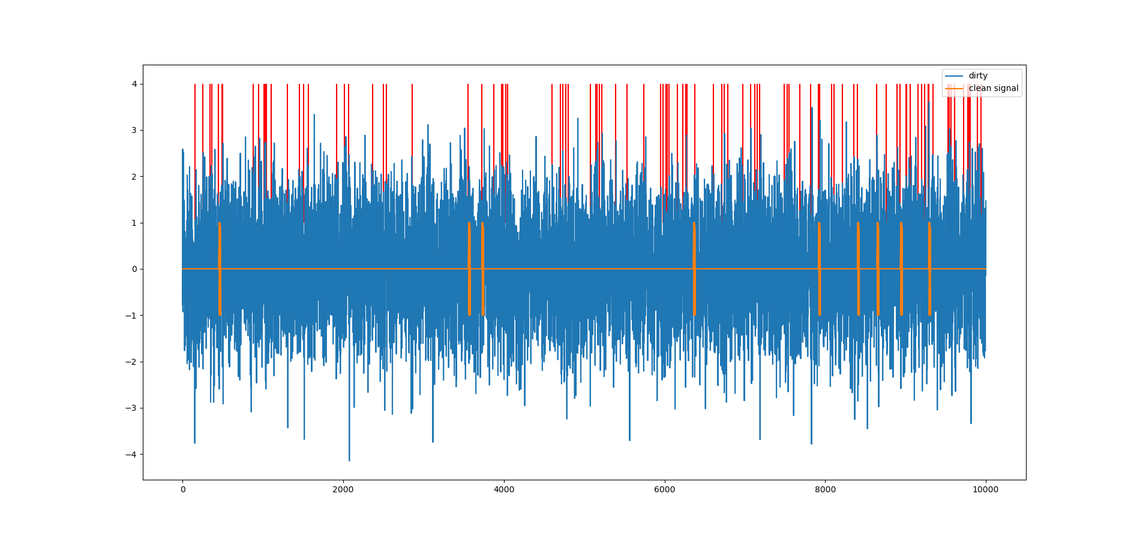

Sigma 1 / SNR .01

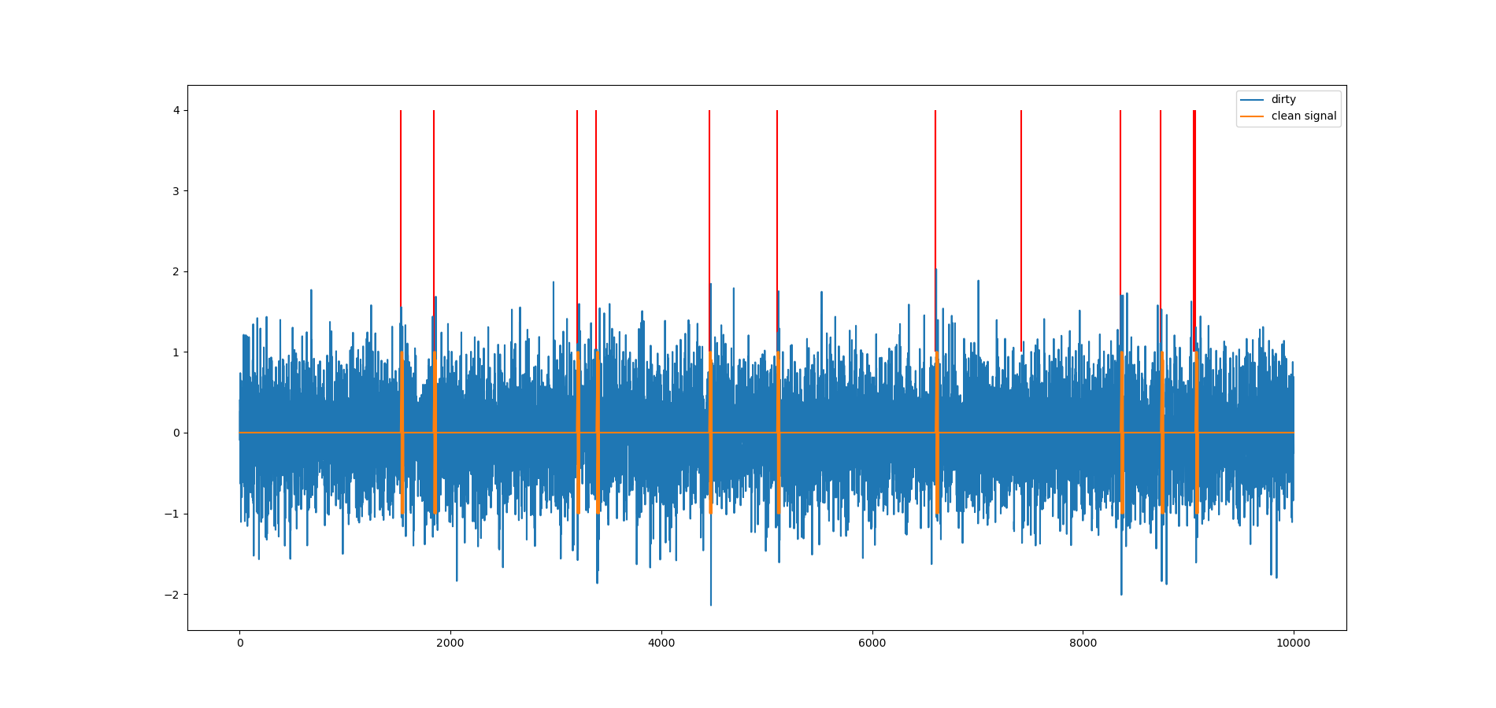 sigma .5/SNR .03

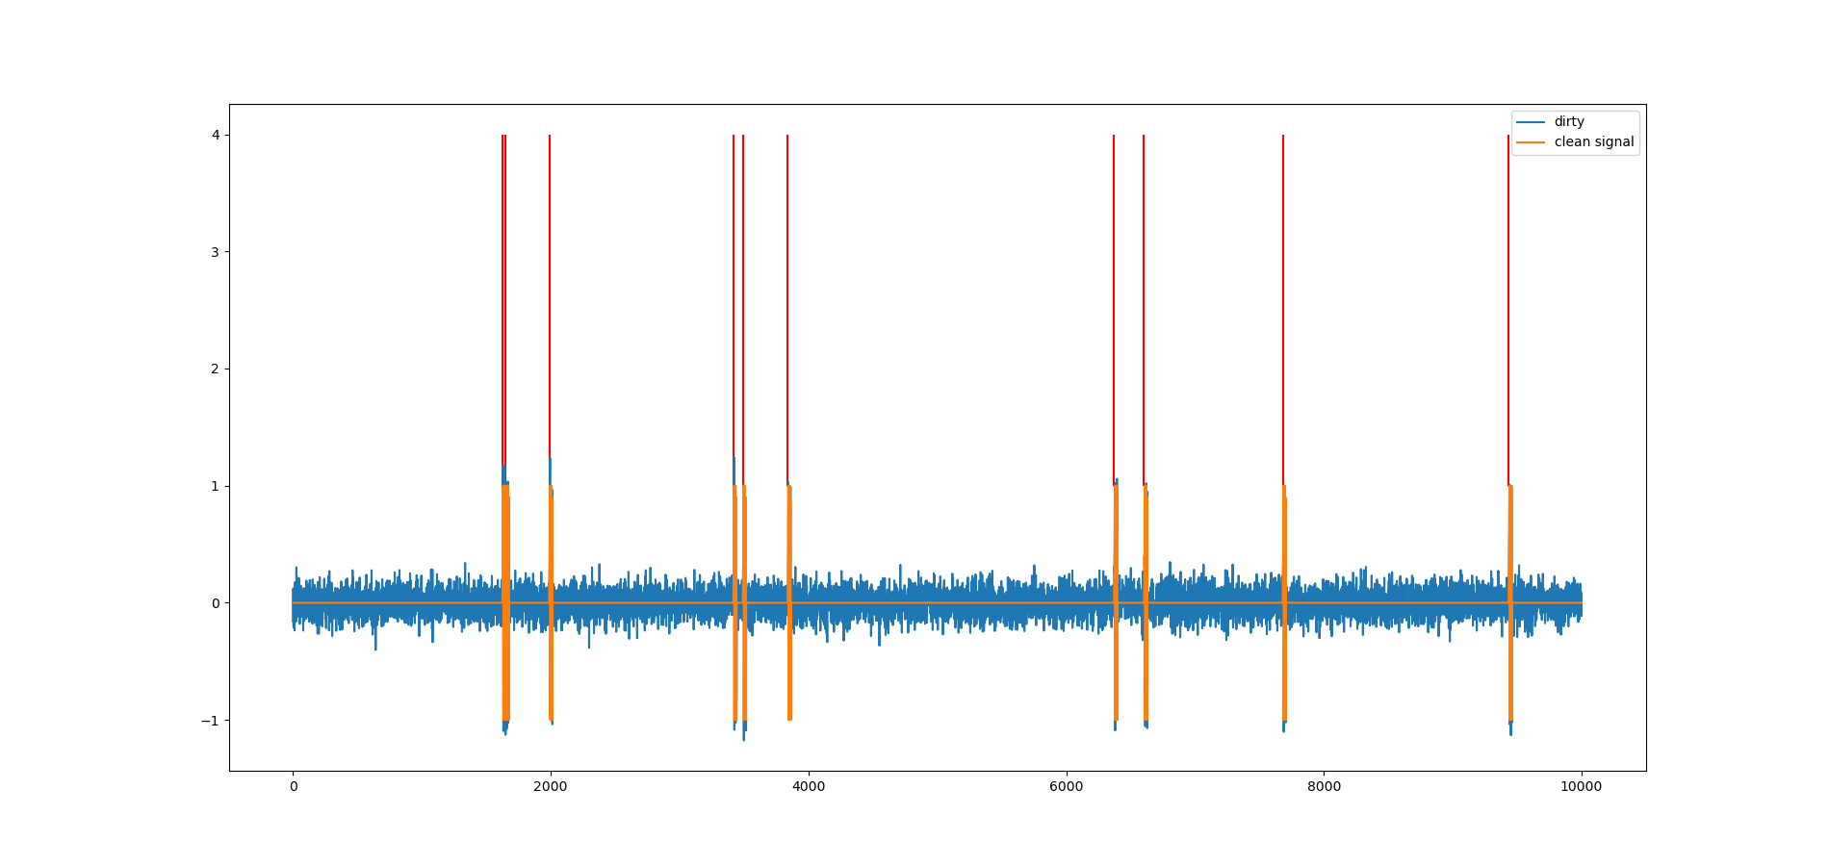

Sigma .1 /SNR 1

So, this leads to my SNR vs Bayes Risk Plot. I had a hard time figuring out how to plot Bayes Risk, but I ended up using the following equation:

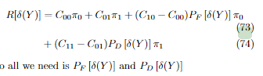

Where p_f was 1-PPV and p_d was the sensitivity. I ended up with.

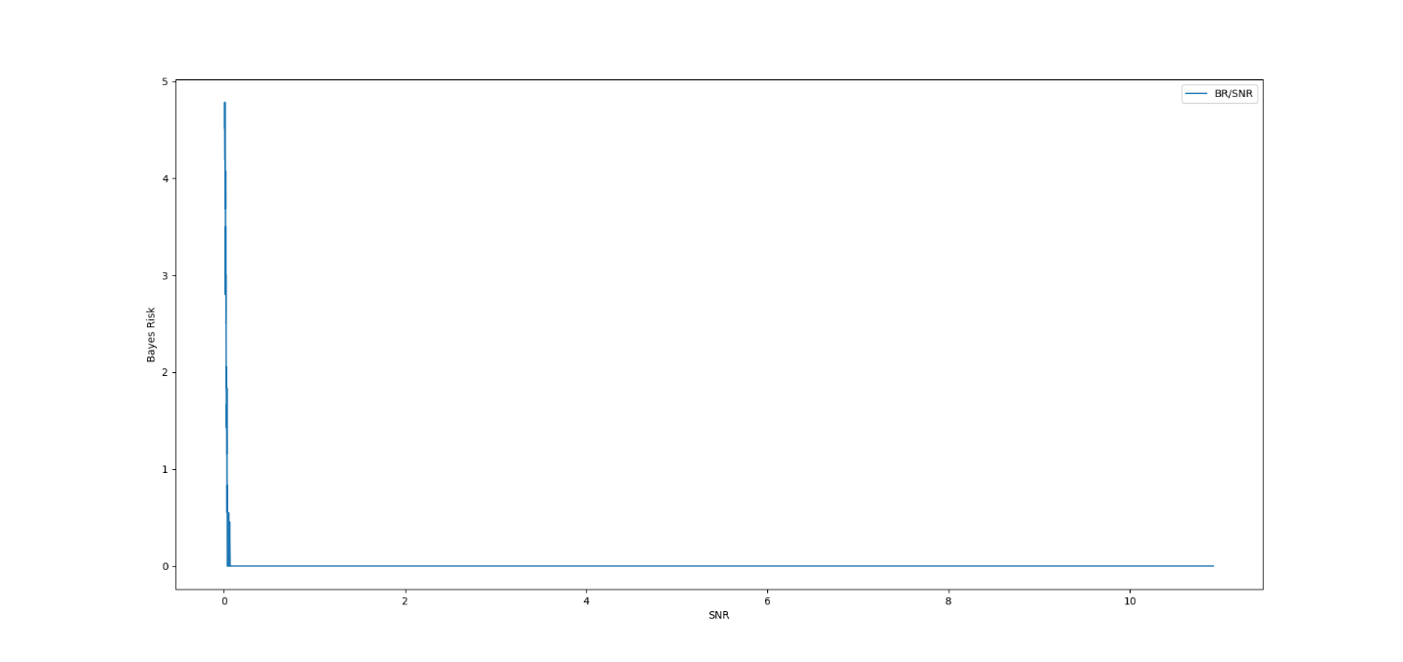

And this minimizes the risk, which at SNR of a high noise is zero, and at a low noise is ~5 which is most likely due to the high number of false positives. My output for SNR ranges from .01 – 10(points removed because it’s long):

|  |  |  |  |  |  |
| --- | --- | --- | --- | --- | --- |
| SNR | BR | Sens | Spec | PPV | NPV |
| 0.009926 | 4.618321 | 1 | 0.988 | 0.076336 | 1 |
| 0.020917 | 2.5 | 1 | 0.999 | 0.5 | 1 |
| 0.030775 | 1.667 | 1 | 1 | 0.66666 | 1 |
| 0.040221 | 1.15 | 1 | 1 | 0.76923 | 1 |
| 0.101887 | 0 | 1 | 1 | 1 | 1 |
| 2.020779 | 0 | 1 | 1 | 1 | 1 |
| 2.807558 | 0 | 1 | 1 | 1 | 1 |
| 4.001855 | 0 | 1 | 1 | 1 | 1 |
| 6.066556 | 0 | 1 | 1 | 1 | 1 |
| 10.97726 | 0 | 1 | 1 | 1 | 1 |

I didn’t get a chance to quantify the heuristic method. I tried, but I was working more on trying to understand this method and realized there was a lot more that I didn’t understand. I was having a hard time understanding how to implement Bayes Risk, which I eventually found in the notes and I discussed with what p_d and p_f could be with some classmates.

I learned a lot in this homework. A lot of the problems I was having involved the threshold, and how to control whether or not this was a hit. I understood the math in class, but I had a hard time using it with a range of values rather than just one, this is what forced me to read ahead. I also wasn’t sure on how to calculate bayes risk until I discussed with some people. The p_d and p_f values are what confused me the most. I didn’t know how to correctly relate them. I want to know if there’s a better way for this to work when the signal is very noisy.