

**SCHOOL OF ARTS AND SCIENCES**

**DEPARTMENT OF COMPUTER, INFORMATION SCIENCES AND MATHEMATICS**

**Church: ATTENDANCE MANAGEMENT SYSTEM FOR BLESSED HOPE CHRISTIAN FELLOWSHIP**

A Capstone Proposal

Presented to

the Faculty of the Department of Computer, Information Sciences and Mathematics

University of San Carlos

In Partial Fulfillment

of the Requirements for the SD 250 Research Method 2

**Prepared by:**

**Ma. Lyn Gamboa**

**Marichu Niere**

**Geneva Rivas**

**Raymond Jay Yorong**

September 2020

**INTRODUCTION**

**Rationale of the Study**

**Global**

**National**

**Local**

Today, even with the advanced change that the world is going through, various churches actually utilize manual record keeping frameworks. Each record begins with every member. Each record beginning with members' details and delicate financial details are kept manually are. A case study led at King'ong'o PCEA area at Nyeri demonstrates that churches are still in the simple world despite the pursuit of the word to digital heights.

The Blessed Hope Christian Fellowship Community is not just a religion but a personal relationship with Jesus to bring hope, love and inspiration. Their mission is to help live life to the full with Jesus, wherein they will guide in finding God given purpose and maximize potential only with Jesus. They are a family and they grow in Him. In, Blessed Hope Christian Fellowship Community they are one and not alone in whatever situation, they always want oneness. In achieving these, they come up to an idea of creating a system wherein, monitoring and managing their members would not be a hassle. Blessed Hope Christian Fellowship Community aims to give their members an easy way of acquiring information. Thus, they foresee that by creating a system that is exclusive for their church would give a great impact to their community. Also, it would always be a hassle storing information of their members using a spreadsheet, and the goal of their community is to monitor the progress of the church and its members through statistics in which if spreadsheet would only be a tool, it would consume a lot of time. As well as, spreading announcements through facebook is not an effective way since there is already a lot of information in facebook and some of the members neglect the important announcements the church is announcing. With that, by creating a web application would help them so that the oneness that their aiming is achievable.

**Statement of the Problem**

The Blessed Hope Christian Fellowship Community needs to launch an online system for them to operate and monitor people coming in and out of their church. The said church does not have clear monitoring of their growth. For the Pastor, as overseer of the church needs to see the progress of the church and to take care of the people as it is his purpose. They currently use Google sheets shared in Google drive to keep records and for the Pastor to monitor. It is not that reliable, efficient, and user-friendly because not all people are even familiar with Google drive. They also used Facebook Group Chats for them to communicate with each other which is a broad way of communicating.

Thus, this Church Management System is designed to make the organization a lot easier for them to operate, monitor, and manage their members. Redundancy of data will be prevented.

**General Objective**

The main objective of this study is to develop a running application that will solve and cater to the needs of our clients and to overcome the drawbacks of the existing system. This aims to give the church a more convenient, reliable, less hassle, and efficient online system for faster monitoring of its progress. The authorities of the church will use this system for the better performance of the work. The benefits are the following:

1. To create a comprehensive database that provides all the information of the members and can retrieve the information needed.
2. To make the system more user friendly and easy to use.
3. For the Pastor to manage and to see the church’s progress a lot easier
4. Make use of Information Technology to increase the efficiency and productivity.
5. To communicate with each other, watch and guide each other to grow.
6. To fulfill the mission and the vision of the church (*mission and vision should be stated in the rationale*).

**Significance of the Study**

This proposed solution is beneficial to the Blessed Hope Christian Fellowship community.

1. For the Pastor(admin), this system is helpful in monitoring the progress of the Church.
2. For the leaders, this system helps them to communicate and guide its members easily. They can disseminate more accurate information towards its members which help them save their time and efforts. They can also add new members.
3. For the members, this system helps them save their time and efforts by acquiring information and activities which will be shown automatically on their end.
4. For the whole community, this system is helpful for them to reach out to each other and be aware of the activities which are not time consuming.
5. For the future developers, who want to explore and enhance the study.

**Scope and Limitations**

This system is only limited for the Blessed Hope Christian Fellowship Community.

**DESIGN AND METHODOLOGY**

**Conceptual Framework**

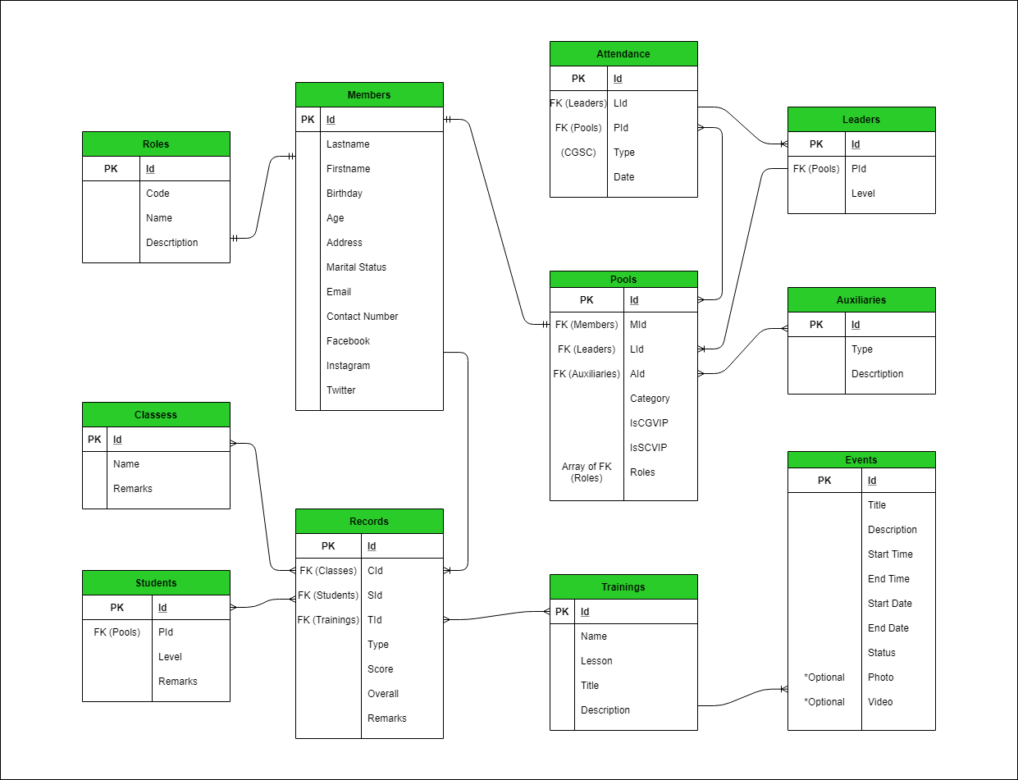

Fig 1.0 ERD