January 24, 2017

The Editor,
Langmuir, American Chemical Society

Dear Editor:

We are submitting the manuscript entitled, “Dynamics of a Camphoric Acid boat at the air-water interface” for publication in Langmuir. Studies on the self-propulsion of camphor particles on air-water interfaces go back several centuries and were relevant in establishing the fundamental concepts of surface tension and Marangoni force, which results from gradient in surface tension. Particles self-propelled by Marangoni forces find modern relevance in emerging topics of the non-equilibrium statistical mechanics of active matter, hydrodynamics of viscous Marangoni propulsion, chemo-mechanical transduction in biology, autonomous motion, self-assembly and reconfigurable actuation in soft matter physics. Several published studies (including in Langmuir) have reported three distinct propulsive modes for such Marangoni driven particulate systems: harmonic mode where the particle speed sinusoidally oscillates with time, a steady mode where the particle speed is constant (barring small fluctuations), and a relaxation oscillation mode where the particle remains at rest for an extended period with periodic jumps in position and speed.

In this work, we report a series of experiments on agarose gel tablets loaded with camphoric acid where we observe all the three modes in the same system during a single experimental run. We experimentally trace the source of these propulsive modes to the surface tension difference between camphoric acid and water. By controlling the air-water surface tension with metered dosage of Sodium Dodecyl Sulfate, a soluble surfactant, we show the three separately reported propulsive modes are part of a common description.

Thanking you on behalf of all authors.
Yours sincerely
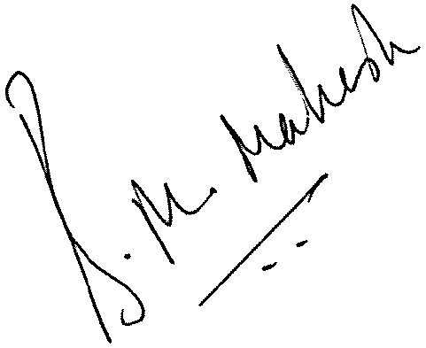

Mahesh M. Bandi

