Metadata Editor
in
Didactor

Technical Specification

Document: | MetaData Editor for Didactor
Version: | 0.5
Date: | 06.04.2005
Author: | H. Hangyi
History: | 0.1 Newly created
 | 0.2 Added some corrections and details after skype discussion
 | 0.3 Changed approach for form
 | 0.4 new valid button, duration field, first metalangstring present without clicking “+”, default values for metadefinitions
 | 0.5 Changed document to TS.

Table of contents
Defining Metadata Standards 2
Adding metadata to content 3
Example 1 3
Example 2 3
Functionality of the metadata editor 3
Showing the metadata form 5
Default values to the metadefinitions in a metastandard 7

List of figures
Figure 1: MetaData objectmodel 2
Figure 2: accessing the metadata editor: no tabs and link to metadata editor (MetaFormButton) 4
Figure 3: metadata editor (MetaForm) 5
Figure 4: Warning page for the metadata editor (MetaWarning) 6
Figure 5: default values metadefinitions in a metastandard (SettingDefaults) 7

Attachment: 05.04.06.MetaDataEditor.ppt contains all the screens of the Metadata editor

Defining Metadata Standards
The first step in adding metadata is to define a metadata standard. See the Metadata folder-icoon in the Didactor editors. A metadata standard consists of metadata definitions. A metadata definition can contain meta vocabularies. E.g. a standard is IEEE LOM, a definition is language, a vocabulary is ru, en, nl. See figure 1 for the object model of the MetaData application (the application and uml can be found in the /documents/application directory )

Metadefinitions consist of the following fields (and one relation):
- name
- description
- type = { multiple select (vocabulary), string (tekenreeks), date & time (datum/tijd) }
- maximum number of values
- used classname for handler which reads metadata values from the content (an example of such a handler is nl.didactor.metadata.handlers.Authors; not included in the sources) The handlers are called from nl.didactor.metadata.builders.MetaData
- values of the metadatavocabulary

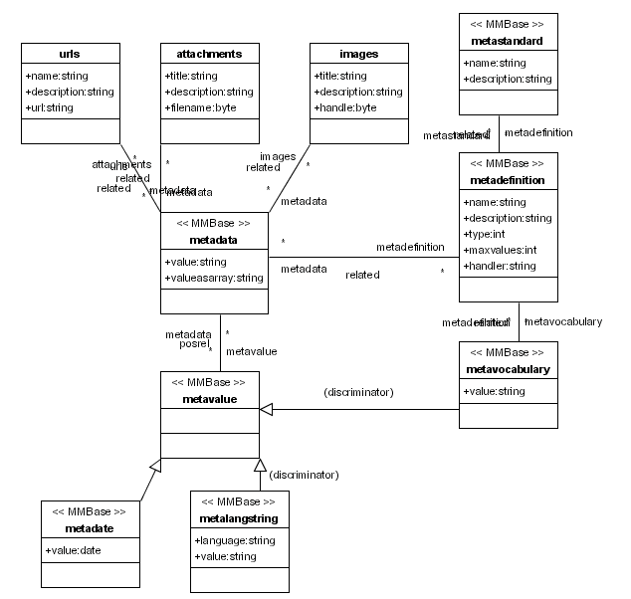
Figure 1: MetaData objectmodel

Adding metadata to content

In the present implementation it is possible to add metadata to educations, learnblocks and learnobjects, urls, attachments and images. The metadata is related to one of the following metavalue-types:
- metalangstring (Tekenreeks)
Editwizard: webapps\didactor\editwizards\data\list\metadatalangstring.xml
- metadate (datumtijd/duur)
Editwizard: webapps\didactor\editwizards\data\list\metadatadate.xml
- metavocabulary (Vocabulaire)
Editwizard: webapps\didactor\editwizards\data\list\vocabulary.xml

Two fields in the metadata.xml builder are used to improve search functionality:
- value - returns the related or generated metavalue as a String divided by spaces
The value field is filled when the Metadata object is saved, by the values in the underlying metavalues. This functionality is implemented by the extending the commit() function in the MetaData class for the metadata builder. Note: when changing a metavalue the metadata.value is not update automatically. So after each change in metavalue the related metadata should be saved.
- valueasarray - returns the related or generated metavalue as an array. The meaning of a metadata object depends on its relation to a metadefinition. (Not implemented at the moment)
To add metadata to an object, this object should be related to a metadata object, and this metadata object is (1) related to the metadatadefinition = programming language and (2) the metavalue = java

In the present implementation there is no connection between the definition of metadata standards and using the metadata standards to add metadata. All metadata standards present in the Didactor implementation are available to add metadata to objects.

Example 1
If Alexey is the author of the learnblock MMBase, the metadefinition.name = author, the learnblock.name = mmbase and the metadata related to the metadefinition and the learnblock has metadata.value = Alexey.

Example 2
Metadata for the learnblock MMBase uses programming language java.

metadatadefinition = programming language is related to:
metavalue1 = metavocabulary1 = java
metavalue2 = metavocabulary2 = perl
metavalue3 = metavocabulary3 = python
BTW metavocabulary extends metavalue

Functionality of the metadata editor
Since the editwizards cannot provide the functionality needed for adding and editing metadata, JSP-editors have to be build which have the needed functionality. Unfortunately the editwizards cannot include jsp-files, so the second tab in the editwizards “Metadata invoeren” is replaced by a button in the menu structure. See figure 2 (= MetaFormButton ).

This button has one of the following two colors:
- green (see media metavalid.gif) if the metadata is valid
- red (see media/metaerror.gif) if the metadata is invalid

The metadata of an object is valid if every metadata field matches:
- >= minvalue and <= maxvalue (only holds for checkboxes)
- and every metadata field with required >0 is non-empty
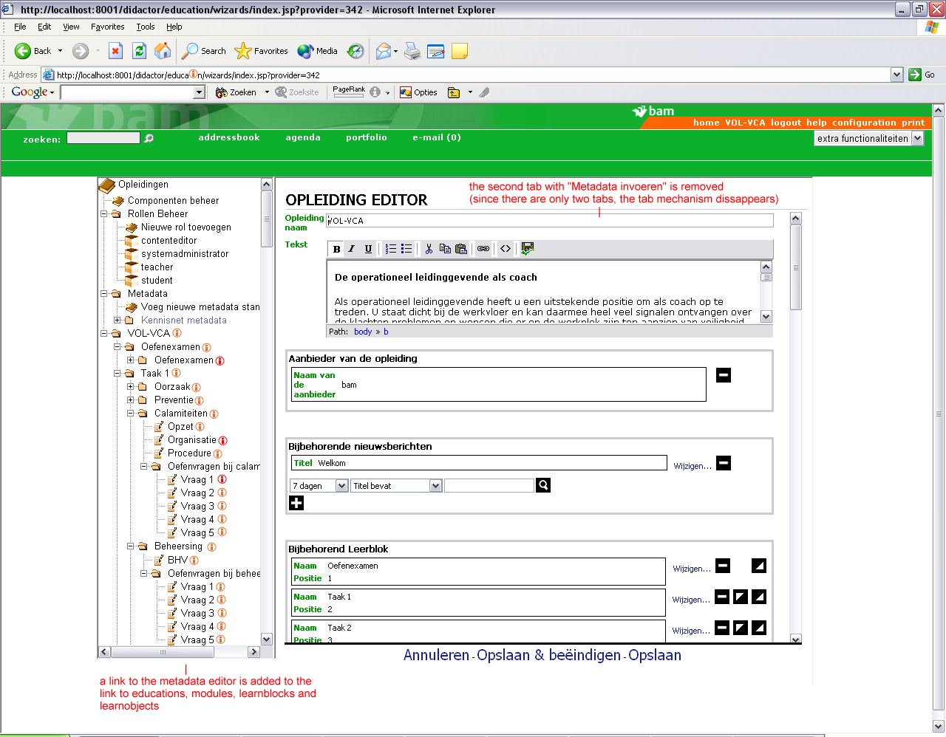
Figure 2: accessing the metadata editor: no tabs and link to metadata editor (MetaFormButton)

The metadata editor shows the following texts and formfields. See figure 3 (= MetaForm):

Field | Used as
metastandard.name | text
metastandard.description | text
metadefinition.name | text
metadefinition.description | text
metavocabulary.values | as checkboxes (if maxvalues >1) and as dropdown (if maxvalues ==1)
metadate.date | as dates
metalangstring.language | use fixed dropdown with “nl”, “en”, “fr”
metalangstring.value | as textbox

For duration see didactor3_duration.tif.

When a user fills out the metadata form and clicks on save the form is checked on:
- if all required fields are filled in
- if all minvalues and maxvalues for metadefinitions are met

If the entered metadata does not meet these criteria the user gets a pages with a warning and a list of metadatadefinitions, that have to be changed to make the metadata valid. The warning page contains a back button by which the user can go back to the page and fill out the required fields. See figure 4 (= MetaWarning)

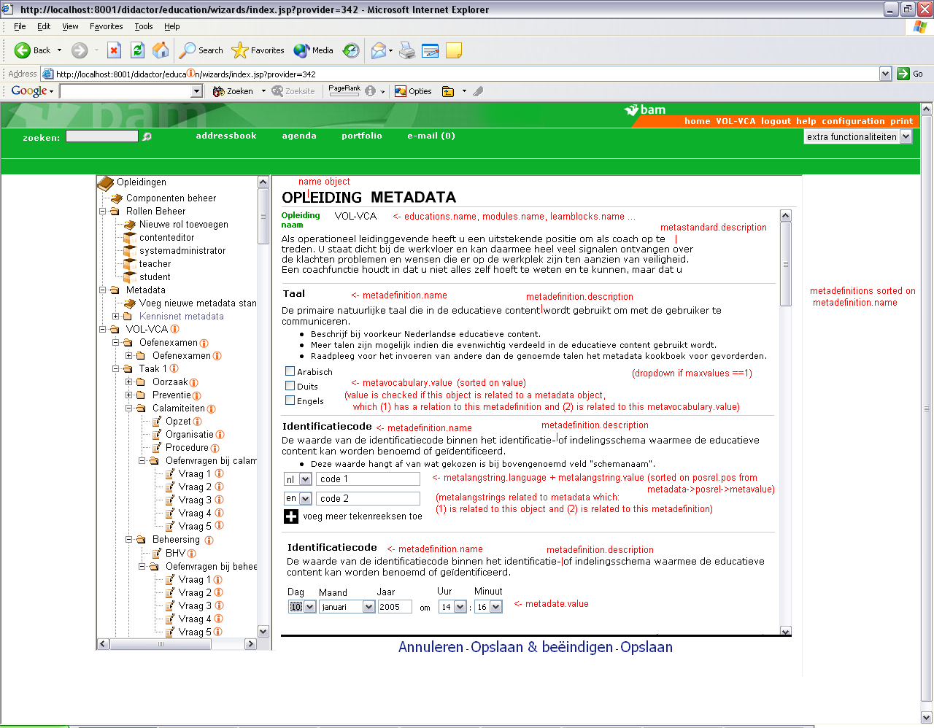
Figure 3: metadata editor (MetaForm)

The metalangstring is implemented as follows

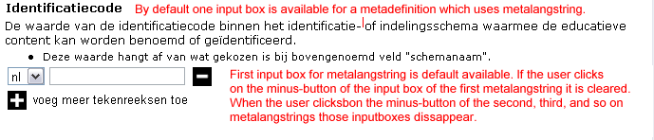

Showing the metadata form

When the form in figure 3 is selected for a certain object X it contains:

for every ( metadatadefinition Y in the metastandard ) {
the metadata Z of object X which is related to metadatadefinition Y
and the metavalues related to metadata Z
}

In the form the user can change the metadata Z for metadatadefinition Y for object X.
The possible values metadata Z can take depend on the metadatadefinition Y and Y's metavalues.

Processing the form:

Assume you are the user and the learnblock MMBase does not have any metadata:

1. you click on the metadata button for the learnblock MMBase
2. a form is displayed, with all the metadatadefinitions and possible checkboxes / dropdown for metavalues related to metadatadefinitions
3. you fill in the values of the metadatadefinitions and click the submit button
4. the template processes the input for the form
4.1 for each metadatadefinition Y for which input is entered a metadata Z is created
4.2.1. in case of a metadate or metalangstring: the input value is stored in the metavalue related to metadata Z
4.2.2 in case of a metavocabulary: the metadata Z is related to the metavalue that is selected by the user
4.3 metadata Z is related to (a) metadatadefinition Y and (b) the learnblock MMBase
4.4 after the metavalues are saved the value field in the metadata object is updated by saving the object

The metadata form is generic: so it does not matter for what object it is used.

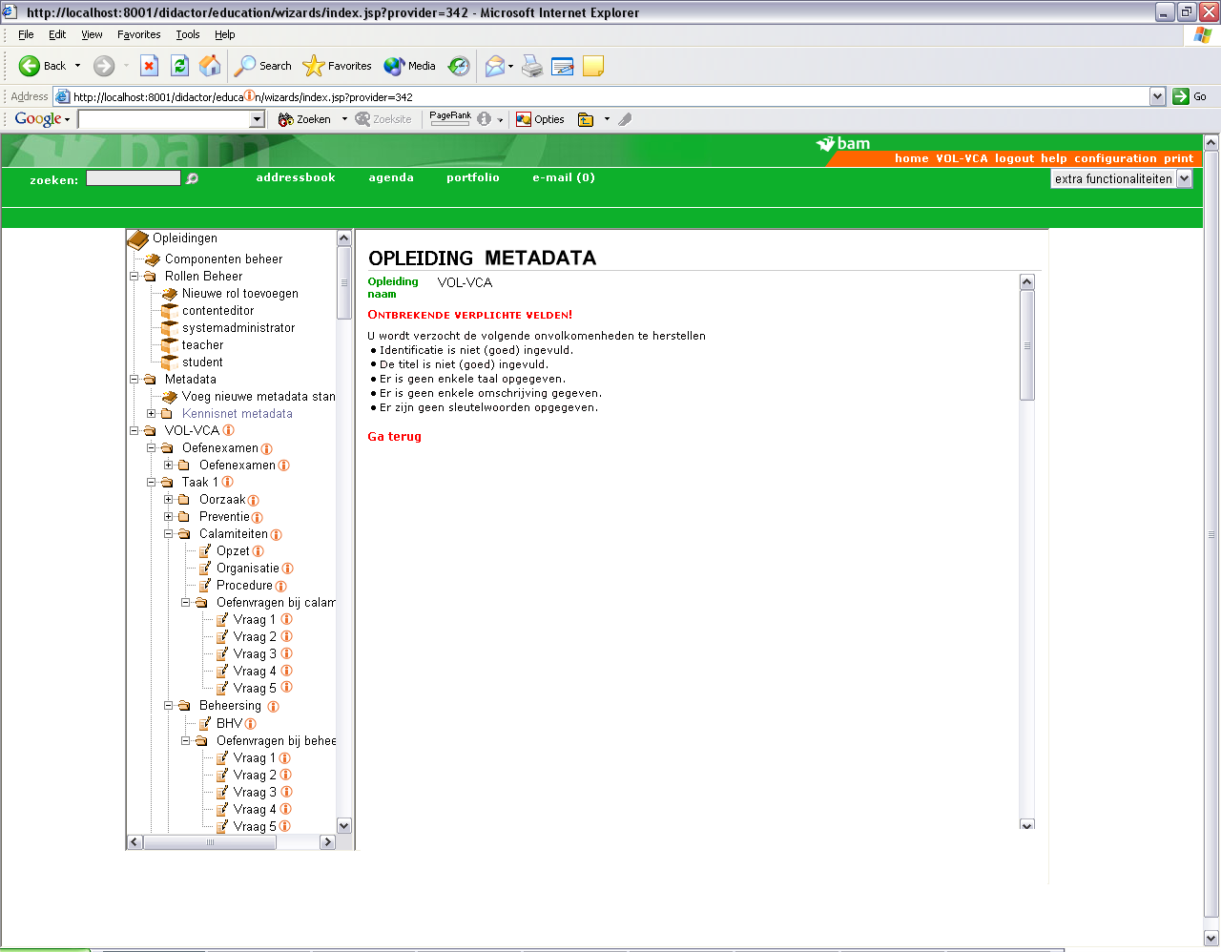
Figure 4: Warning page for the metadata editor (MetaWarning)

Default values to the metadefinitions in a metastandard

Adding default metadata values to a metastandard is done in much the same way as adding metadata to learnobjects. (see figure 5).

To this end the relation “metastandard -> related -> metadata” is used.

Note:
a. that for adding defaults to a metastandard only the metadefinitions for one (= the selected) metastandard is shown. With “Save” the metadata is added to the metastandard.
b. the form for default values is always valid, since is does not have to match the metastandard itself. So always show the metavalid.gif.

3. The default values for the metadataform for objects. So if no metadata is present for a metadatadefinition, check whether there is a default value related to the metastandard. If there is a default metadata show it in the metadataform.

Note: as a consequence, when the user opens the form of a learnobject, does nothing but only saves the form, the default metadata will be added to the form.

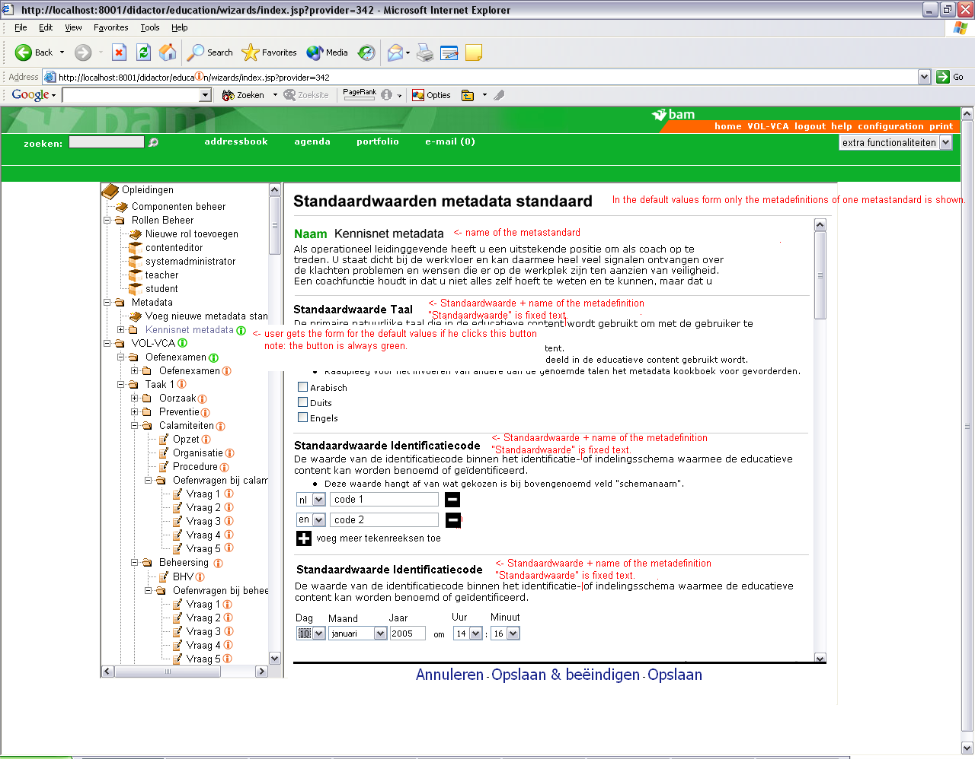
Figure 5: default values metadefinitions in a metastandard (SettingDefaults)

