

Data Model
of the
Central Events Database

Title | Data Model of the Central Events Database
Status | First version
Date | 11-9-2005
Authors | Henk Hangyi

Versions

Date | Version | Comments | Author
10-8-2005 | 0.1 | first version | Henk Hangyi
 | 0.2 | added ticket_office to inschrijvingen | Henk Hangyi
11-9-2005 | 0.3 | added overview of functionality | Henk Hangyi

TABLE OF CONTENT

1 Introduction 1
2 Functionality 2
3 Data Model of the CAD 3
4 Data files Imported into the CAD 7
Appendix I. Small introduction to UML object models 8

Introduction
This document describes the functionality and the data model of the Central Events Database (= nl: Centrale Activiteiten Database). Chapter 4 gives an overview of data files imported in the CAD.

Functionality
The CAD contains the following functionality.

 | Functionality | Example screen  (see the folder cad_screens) | Url
1 | Overview of all events | events.gif | events.jsp?p=agenda
2 | Listing of all events for editors. | ed_evenementen_evenementen.gif | /editors (click on Activiteiten and Beheer)
3 | Special editing page for events, by which editors can change the evenementen-partrel-evenementen | ed_evenementen_evenement.gif | Click in 2 on the title of an event
4 | Editing the parent evenement by the editwizard | event_in_ew.gif | Click in 3 on the “Overige onderdelen | Bewerk” link.
5 | Out-of-the-box functionality: the events in the default editors | event_in_myeditors.gif | /mmbase/edit/my_editors
6 | Editor page for booking tickets | ed_evenementen_subscribe.gif | Click in 2 on one of the tickets icons
7 | Visitor page for booking tickets | includes_events_subscribe.gif | events.jsp?p=agenda&e=70127&test=on and click on the “Aanmelden via internet | klik hier” link
8 | Statistics on work done by editors | ed_evenementen_userlist.gif | /editors (click on Overzicht redactie)
9 | commit() functionality for the evenement objects |  | nl.leocms.builders.ContentEvenement.java

The CAD is implemented by the following parts:

 | folder in NatMM:ROOT | Implemented functionality
1 | /events.jsp and includes | The overview of events for visitors
2 | /editors /evenementen | The overview of events for editors
3 | /WEB-INF /classes /nl /leocms /evenementen | The java classes used by the Struts framework
4 | /WEB-INF /struts-config.xml | The Struts action mapping for events

Data Model of the CAD
The data model of the CAD is shown in figure 1. See appendix I if you are unfamiliar with reading UML diagrams. Note that note all data types present in the Natuurmonumenten Objectcloud are listed in the diagram: the arrows at the left are relations with objects which are not relevant for the CAD, like pano’s, shorties, teasers, etc.

Some translations:
Dutch | English
medewerkers | employees
afdelingen | departments
evenement | event
evenement_type | events type
natuurgebieden | nature reserve
provincies | counties
vertrekpunt | starting point
extra_info | additional info
inschrijvingen | subscriptions
deelnemers | participants
deelnemers_categorie | participants group
inschrijvings_status | subscription status

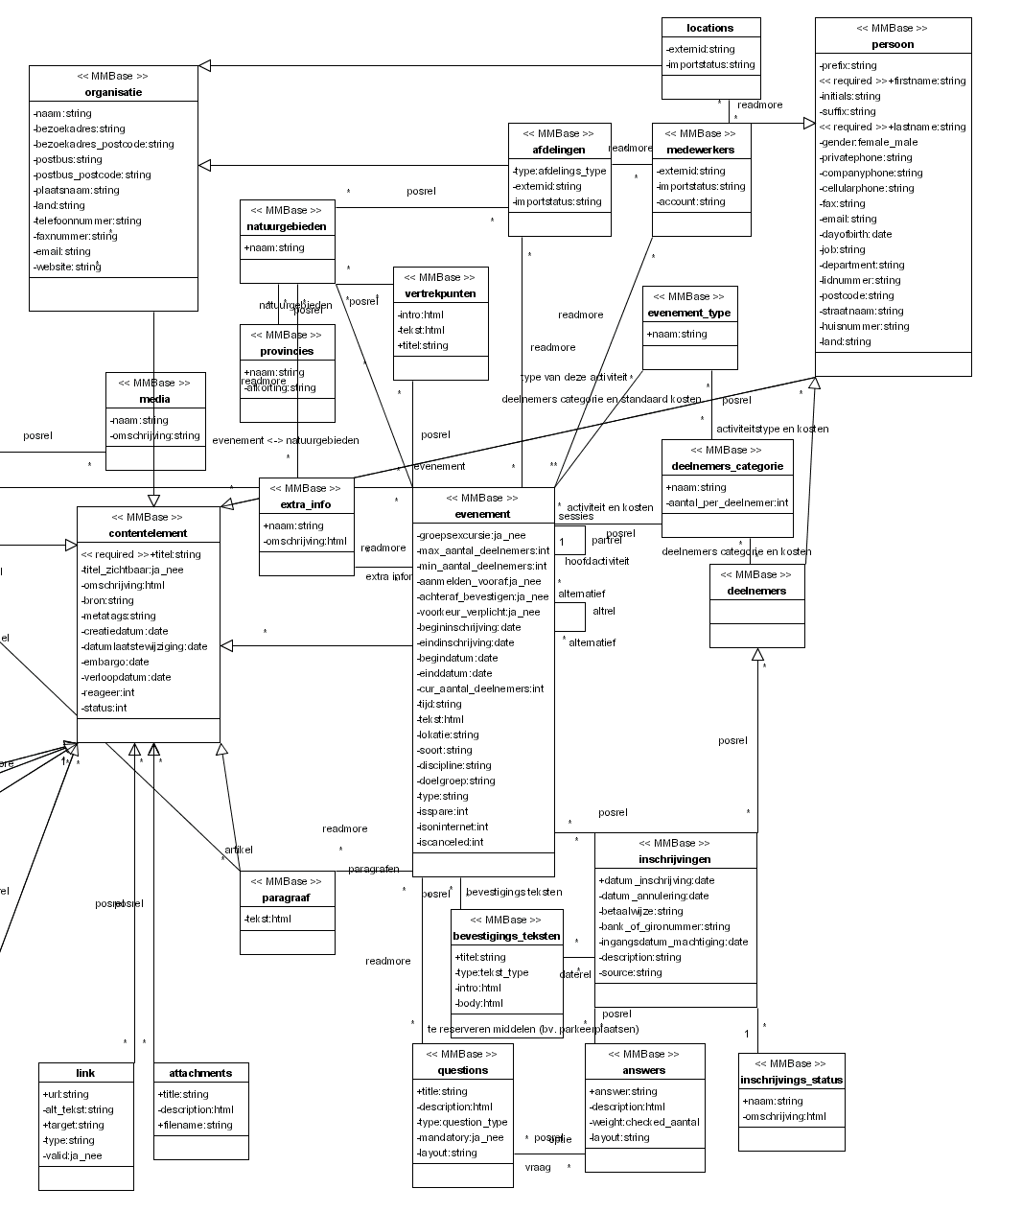
Figure 1: data model of the CAD

An example might clarify the data model:

deelnemers
titel | Jeanine vd Velden
initials
firstname | Jeanine
suffix | vd
lastname | Velden
bron | 3 | number of participants in this deelnemers_categorie
privatphone | 030-2938278
email | j@nd.nl
postcode | 3984AS
straatnaam | Sleedoorn
huisnummer | 2
plaatsnaam | Odijk
land
status | -1 | not used

Deelnemer “Jeanine vd Velden” is related to:

inschrijvingen
datum_inschrijving | 14-2-2005 13:12:44
description
source | Internet | how did the participant hear about this event
ticket_office | backoffice | how did the participant subscribe

Note: there are also other deelnemers related to inschrijving “14-2-2005 13:12:44”. These are the participants related to other deelnemers_categorieën booked at the same time.

Deelnemer “Jeanine vd Velden” is related to:

deelnemers_categorie
naam | Leden
aantal_per_deelnemer | 1

The relation between deelnemer “Jeanine vd Velden” and deelnemers_categorie “Leden” contains the costs (in cents):

posrel
pos | 800

Inschrijving “14-2-2005 13:12:44” is related to:

inschrijvings_status
naam | aangemeld
omschrijving | 1

Inschrijving “14-2-2005 13:12:44” is related to:

evenement
titel | Aalscholverexcursie
groepsexcursie | 0 | means false
bron | 5308 | id the event had in Sitemanager
min_aantal_deelnemers | 0
max_aantal_deelnemers | 25
cur_aantal_deelnemers | 25
aanmelden_vooraf | 1 | means true
achteraf_bevestigen | 1 | email notification, means true
begindatum | 1-6-2002 13:30
einddatum | 1-6-2002 16:30
tekst | Naardermeer, het oudste Natuurmonument, staat bekend om haar broedende aalscholvers. Tijdens de vaartocht bezoekt u de vogelobservatiehut bij de aalscholverkolonie. Ook maakt u kennis met het afwisselende landschap van dit gebied.<Br /><Br />
lokatie | ,41285, | The provincies this event is related to in comma seperated list
soort | parent
isspare | false
isoninternet | true
iscanceled | false

Evenement “Aalscholverexcursie” is related to:

- natuurgebieden: Naardermeer
- extra_info: for example “Neem warme kleding en/of regenkleding mee”
- evenement: all evenement with field soort is “child” that are the other dates at which this event takes place

Data files Imported into the CAD
The following datafiles are imported into the CAD on a dialy basis.

File | Contains | Generated by | Contact person
lrsddl.txt | memberid,  zipcode of members | ledenregistratie systeem | Albert de Weerd A.deWeerd@Natuurmonumenten.nl
mbexport.csv | account, emailaddresses of employees | Exchange Server | Gerard ter Haar G.terHaar@Natuurmonumenten.nl
beauexport.csv | other info about employees | Beaufort | Astrid de Beer A.deBeer@Natuurmonumenten.nl
orgschemaexport.csv | departments | Beaufort | Astrid de Beer A.deBeer@Natuurmonumenten.nl
nmv_vrijwilligers.csv | volunteers | Vrijwilligers Database (VDB) | Willemijn Prast W.Prast@Natuurmonumenten.nl

- Small introduction to UML object models

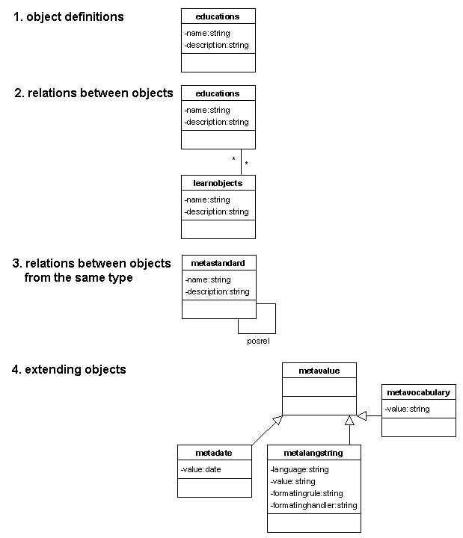
Figure 1: the basic concepts in an UML object model

- The blocks in an UML object model are the definition of an object or class. The class educations in figure 2 has two fields name and description
- Objects can be related to other objects. Educations in figure 2 can be related to zero or more learnobjects. Relations are objects themselves and can contain fields and functionality.
- An object may have a relation with an object of the same type. In figure 2 metastandards can be related to other metastandards. This makes it possible to create trees of metastandards.
- The fields and functionality of an object can be used as a starting point for another object. Metavalues in figure 2, are extended to metadates, metalangstrings and metavocabularies each containing their specific additions to the fields and functionality of metavalue.

