

Data Model
of the
Central Events Database

Title | Data Model of the Central Events Database
Status | First version
Date | 11-9-2005
Authors | Henk Hangyi

Versions

Date | Version | Comments | Author
10-8-2005 | 0.1 | first version | Henk Hangyi
 | 0.2 | added ticket_office to inschrijvingen | Henk Hangyi
11-9-2005 | 0.3 | added overview of functionality | Henk Hangyi
15-3-2006 | 0.4 | added description group excursion model | Henk Hangyi

TABLE OF CONTENT

1 Introduction 1
2 Functionality 2
3 Data Model of the CAD 3
4 Group excursions 8
5 Data files Imported into the CAD 9
Appendix I. Small introduction to UML object models 10

Introduction
This document describes the functionality and the data model of the Central Events Database (= nl: Centrale Activiteiten Database). Chapter 5 gives an overview of data files imported in the CAD.

Functionality
The CAD contains the following functionality.

 | Functionality | Example screen  (see the folder cad_screens) | Url
1 | Overview of all events | events.gif | events.jsp?p=agenda
2 | Listing of all events for editors. | ed_evenementen_evenementen.gif | /editors (click on Activiteiten and Beheer)
3 | Special editing page for events, by which editors can change the evenementen-partrel-evenementen | ed_evenementen_evenement.gif | Click in 2 on the title of an event
4 | Editing the parent evenement by the editwizard | event_in_ew.gif | Click in 3 on the “Overige onderdelen | Bewerk” link.
5 | Out-of-the-box functionality: the events in the default editors | event_in_myeditors.gif | /mmbase/edit/my_editors
6 | Editor page for booking tickets | ed_evenementen_subscribe.gif | Click in 2 on one of the tickets icons
7 | Visitor page for booking tickets | includes_events_subscribe.gif | events.jsp?p=agenda&e=70127&test=on and click on the “Aanmelden via internet | klik hier” link
8 | Record of work done by each user | ed_evenementen_userlist.gif | /editors (click on “overzicht redactie”)
9 | Record of work done on each event | ed_evenementen_relatedusers.gif | Click in 2 on the people icon.
10 | Statistics on events | ed_evenementen_stats.gif | /editors (click on “statistieken”)
11 | commit() functionality for the evenement and inschrijvingen objects |  | nl.leocms.builders.ContentEvenement.java and ContentInschrijving.java
12 | fuctionality to send notification emails to users and visitors |  | nl.leocms.evenementen.EventNotifier.java

The CAD is implemented by the following parts:

 | folder in NatMM:ROOT | Implemented functionality
1 | /natmm/events.jsp and includes | The overview of events for visitors
2 | /editors /evenementen | The overview of events for editors
3 | /WEB-INF /classes /nl /leocms /evenementen | The java classes used by the Struts framework
4 | /WEB-INF /struts-config.xml | The Struts action mapping for events
5 | /natmm/rss | rss feed for the events

Data Model of the CAD
The data model of the CAD is shown in figure 1. See appendix I if you are unfamiliar with reading UML diagrams. Note that not all data types present in the Natuurmonumenten Objectcloud are listed in the diagram: the arrows at the left are relations with objects which are not relevant for the CAD, like pano’s, shorties, teasers, etc.

Some translations:
Dutch | English
medewerkers | employees
afdelingen | departments
evenement | event
evenement_type | events type
natuurgebieden | nature reserve
provincies | counties
vertrekpunt | starting point
extra_info | additional info
inschrijvingen | subscriptions
deelnemers | participants
deelnemers_categorie | participants type
inschrijvings_status | subscription status
inschrijvings_categorie | subscription type

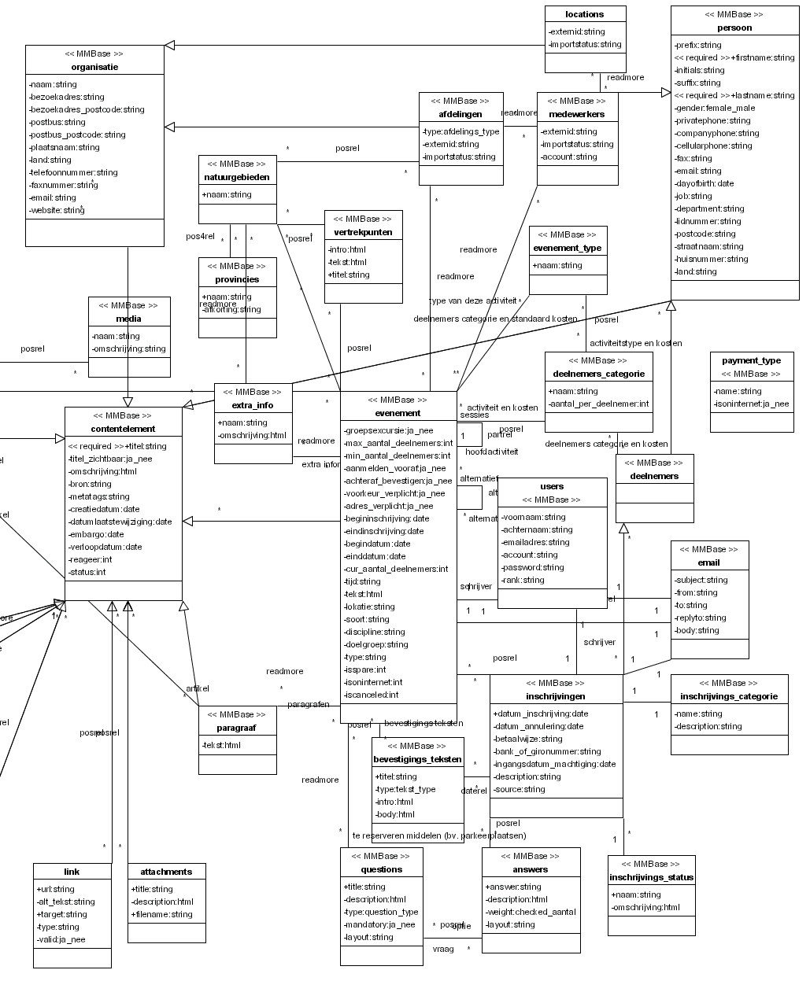
Figure 1: data model of the CAD

An example might clarify the data model:

deelnemers
titel | Jeanine vd Velden
initials
firstname | Jeanine
suffix | vd
lastname | Velden
bron | 3 | number of participants in this deelnemers_categorie
privatphone | 030-2938278
email | j@nd.nl
postcode | 3984AS
straatnaam | Sleedoorn
huisnummer | 2
plaatsnaam | Odijk
land
status | -1 | not used

Deelnemer “Jeanine vd Velden” is related to:

inschrijvingen
datum_inschrijving | 14-2-2005 13:12:44
description
source | Internet | how did the participant hear about this event
ticket_office | backoffice | how did the participant subscribe
users | ,12341, | comma seperated list of users who worked on this inschrijving

Note: there are also other deelnemers related to inschrijving “14-2-2005 13:12:44”. These are the participants related to other deelnemers_categorieën booked at the same time.

Deelnemer “Jeanine vd Velden” is related to:

deelnemers_categorie
naam | Leden
aantal_per_deelnemer | 1

The relation between deelnemer “Jeanine vd Velden” and deelnemers_categorie “Leden” contains the costs (in cents):

posrel
pos | 800

Inschrijving “14-2-2005 13:12:44” is related to:

inschrijvings_status
naam | aangemeld
omschrijving | 1

Inschrijving “14-2-2005 13:12:44” is related to:

evenement
titel | Aalscholverexcursie
groepsexcursie | 0 | means false
bron | 5308 | id the event had in Sitemanager
min_aantal_deelnemers | 0
max_aantal_deelnemers | 25
cur_aantal_deelnemers | 25
aanmelden_vooraf | 1 | See option_lists/ aanmelden_vooraf.xml  0 – not necessary  1 – yes, both backoffice and website  2 - yes, only by third party  3 – yes, only by phone  4 – yes, only be responsible deparment (sponsor event)
addres_verplicht | true | the address fields street, housnumber and city are mandatory
achteraf_bevestigen | 1 | email notification, means true
begindatum | 1-6-2002 13:30
einddatum | 1-6-2002 16:30
tekst | Naardermeer, het oudste Natuurmonument, staat bekend om haar broedende aalscholvers. Tijdens de vaartocht bezoekt u de vogelobservatiehut bij de aalscholverkolonie. Ook maakt u kennis met het afwisselende landschap van dit gebied.<Br /><Br />
lokatie | ,41285, | The provincies this event is related to in comma seperated list
soort | parent
isspare | false
isoninternet | true
iscanceled | false

Evenement “Aalscholverexcursie” is related to:

- natuurgebieden: Naardermeer
- extra_info: for example “Neem warme kleding en/of regenkleding mee”
- evenement: all evenement with field soort is “child” that are the other dates at which this event takes place

Note about payment_type
The payment_type is only related to a pagina (= page). By adding the payment_type to an pagina that uses the events.jsp template, the visitor on the website can choice to pay with this payment_type instead of “cash”.

Group excursions
The group excursions differ from regular events in the way the subscriptions are treated. The differences are:
- An event that is related to the deelnemers_categorie with the alias group_excursion are group excursions.
- For a group excursion one subscription makes the event fully booked. The posrel.pos field between the event and the group_excursion object is the price.
- The user can add a related medewerker (= employee) to this subscription
- The user can add inschrijvings_categorie (= subscription_type) to this subscription
- The user can add a bevestigings_tekst (= confirmation_text) to this subscription. In the posrel.pos field between evenement and bevestigings_tekst a different price can be specified.
- The confirmation email and confirmation letter for group excursions is different than for regular events.

Note: the event.groeps_excursie field is not used. After rethinking the group excursion implementation it turned out that it was more efficient to implement group excursions as events with a specific deelnemers categorie.

Data files Imported into the CAD
The following datafiles are imported into the CAD on a dialy basis.

File | Contains | Generated by | Contact person
lrscad | memberid,  zipcode, housenumber and name of members | ledenregistratie systeem | Albert de Weerd A.deWeerd@Natuurmonumenten.nl
mbexport.csv | account, emailaddresses of employees | Exchange Server | Gerard ter Haar G.terHaar@Natuurmonumenten.nl
beauexport.csv | other info about employees | Beaufort | Astrid de Beer A.deBeer@Natuurmonumenten.nl
orgschemaexport.csv | departments | Beaufort | Astrid de Beer A.deBeer@Natuurmonumenten.nl
nmv_vrijwilligers.csv | volunteers | Vrijwilligers Database (VDB) | Willemijn Prast W.Prast@Natuurmonumenten.nl
lrspos | Dutch zipcode, streetnames and housenumbers | TPG | Albert de Weerd A.deWeerd@Natuurmonumenten.nl

- Small introduction to UML object models

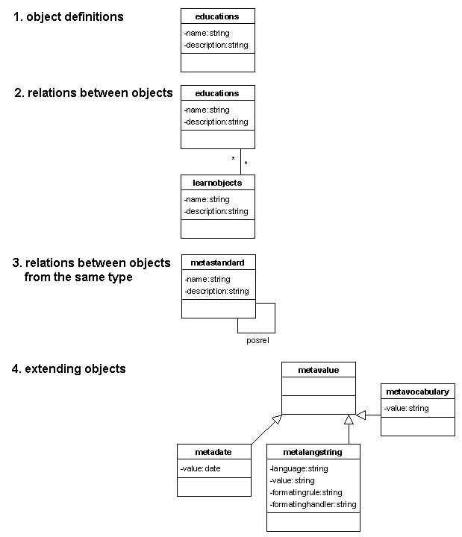
Figure 1: the basic concepts in an UML object model

- The blocks in an UML object model are the definition of an object or class. The class educations in figure 2 has two fields name and description
- Objects can be related to other objects. Educations in figure 2 can be related to zero or more learnobjects. Relations are objects themselves and can contain fields and functionality.
- An object may have a relation with an object of the same type. In figure 2 metastandards can be related to other metastandards. This makes it possible to create trees of metastandards.
- The fields and functionality of an object can be used as a starting point for another object. Metavalues in figure 2, are extended to metadates, metalangstrings and metavocabularies each containing their specific additions to the fields and functionality of metavalue.

