Product overview

MMBase Intranet

Author: | Henk Hangyi (MMatch)
Date: | January 6, 2006
Version: | 1.2
Status: | Final

Version | Description | Date
1.0 | Newly created | November 18, 2005
1.1 | Added educations component | December 15, 2005
1.2 | Added objectmodel for all components | January 6, 2006

MMatch (www.mmatch.nl) offers consultancy on the open source content management system MMBase. Since 2001, MMatch carried out a number of successful MMBase projects. Websites: medium and large scale websites, like netwerk.tv, nimbas.com, and roczeeland.nl; E-commerce: integrated shopping cart solutions for muziekcentrum.nl and webwinkel.natuurmonumenten.nl; Intranet: internal websites for Natuurmonumenten and the broadcasting companies VARA and VPRO; Courses: MMBase-courses both for management and developers.
1. Introduction
The MMBase Intranet has originally been build for the broadcasting company VARA, but is now also in use at the VPRO and Natuurmonumenten. It has been build on top of the open source content management system MMBase (see http://www.mmbase.org). The MMBase Intranet is also open source available.

2. Website structure
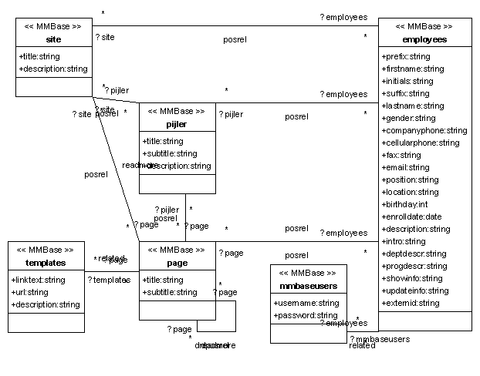

3. Overview of functionality
The following table gives an overview of the functionality in the MMBase Intranet.

4. System requirements
Perhaps the most important characteristic of MMBase is that it is platform independent. This means that the choice for an operating system is free (e.g. Linux, Unix, Windows), as is the choice for a database (e.g. Informix, DB2, MSSQL, MySQL, PostgreSQL, Oracle) or any J2EE compliant application server (Tomcat, JBoss, Orion).

4.a. Authentication
It is possible to connect the Intranet to an Active Directory or LDAP for authentication of visitors. It is possible to enable/disable parts of the Intranet for groups of visitors.

4.b. Statistics
The MMBase Intranet provides statistics on pageviews.

Component | Objectmodel | Description
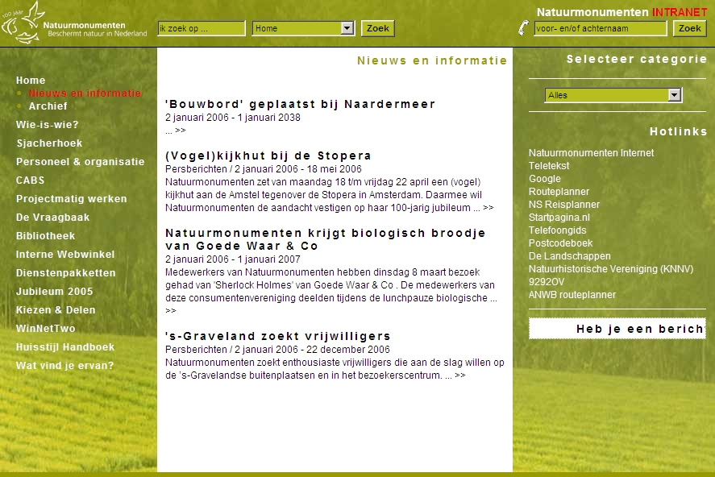 | 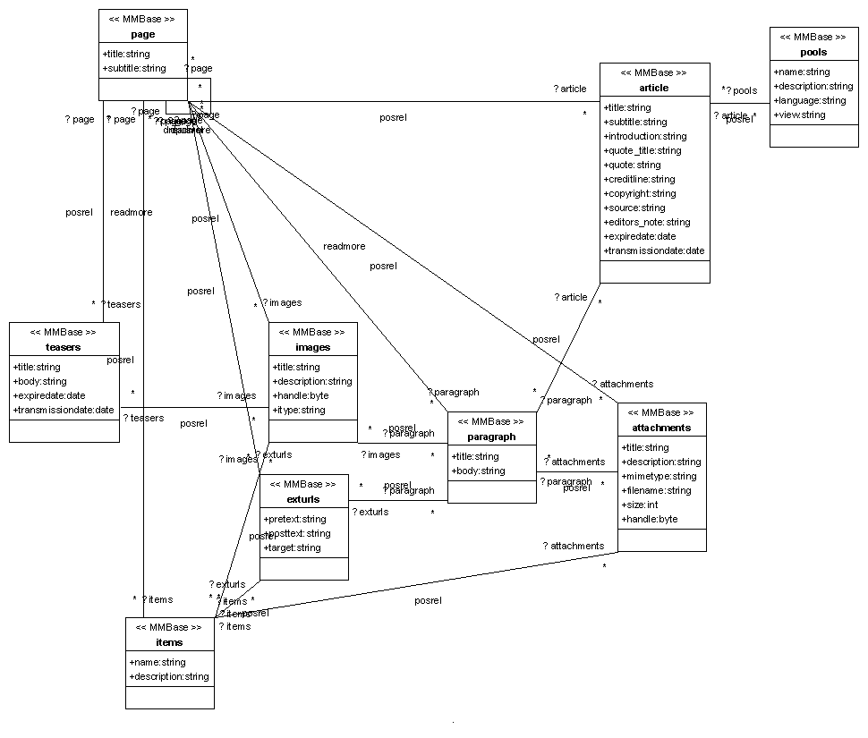 | Homepage (homepage.jsp)  With overview of news, hotlinks and a tickertape. Giving quick access to the main functionality of the Intranet.
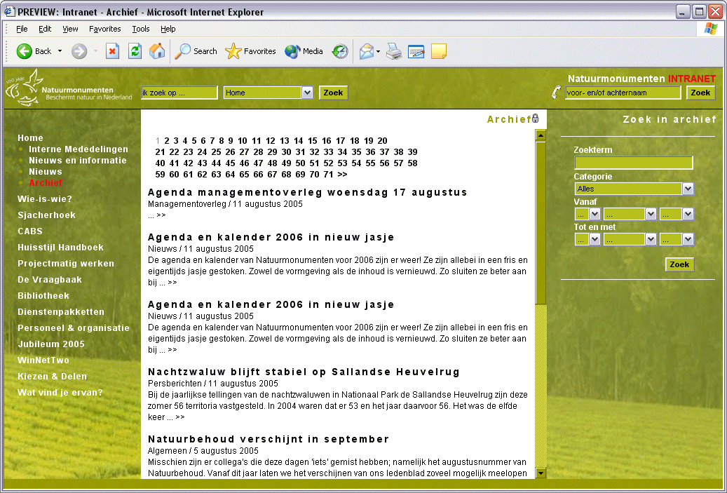 | 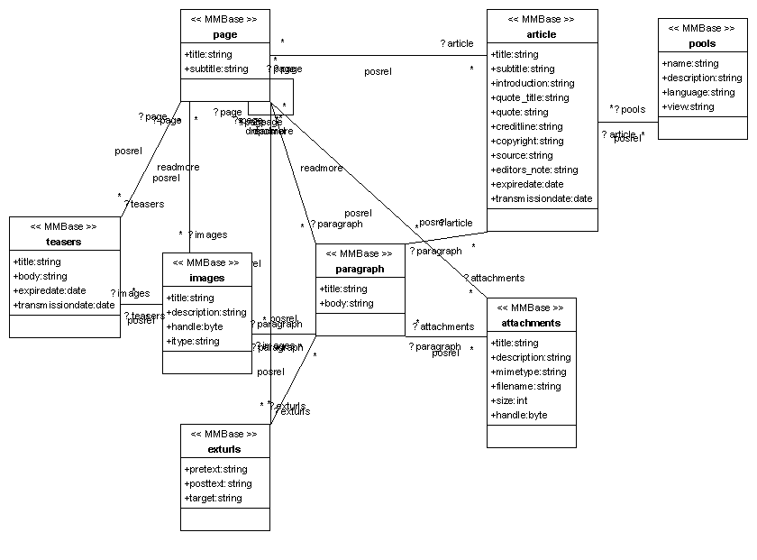 | News and archive (info.jsp)  News articles including a searchable archive.
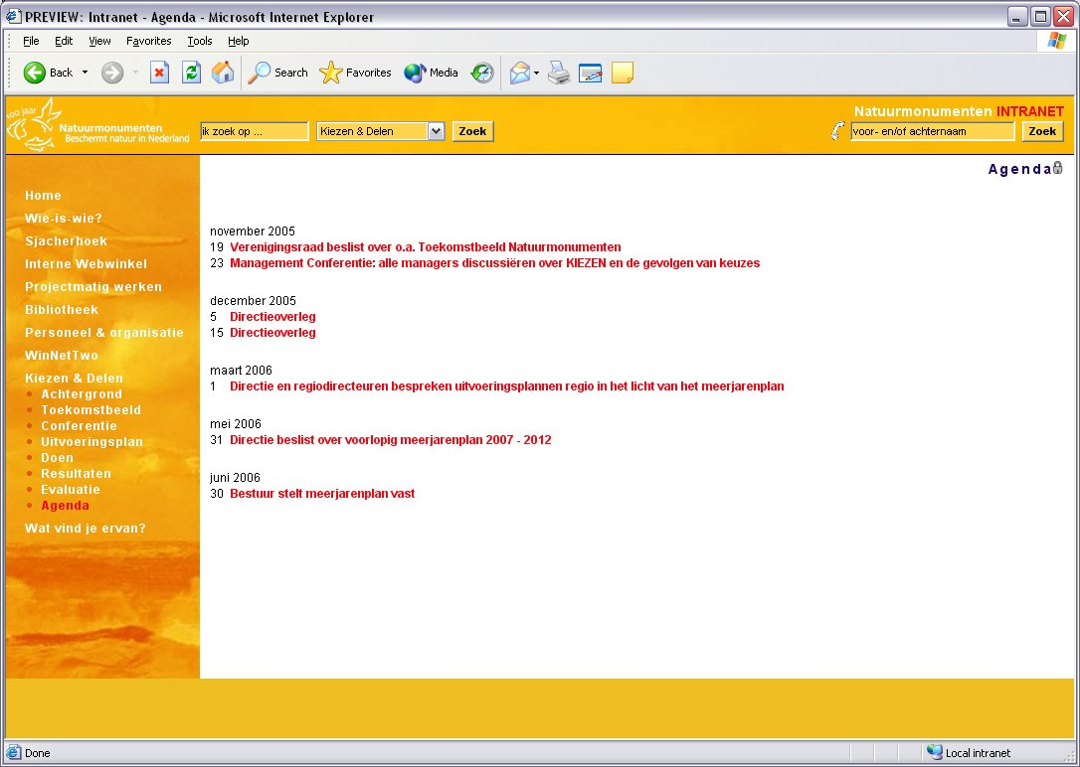 | Same objectmodel as News and archive | Agenda (calendar.jsp)  Possibility to show events which might be of interest for different groups of employees
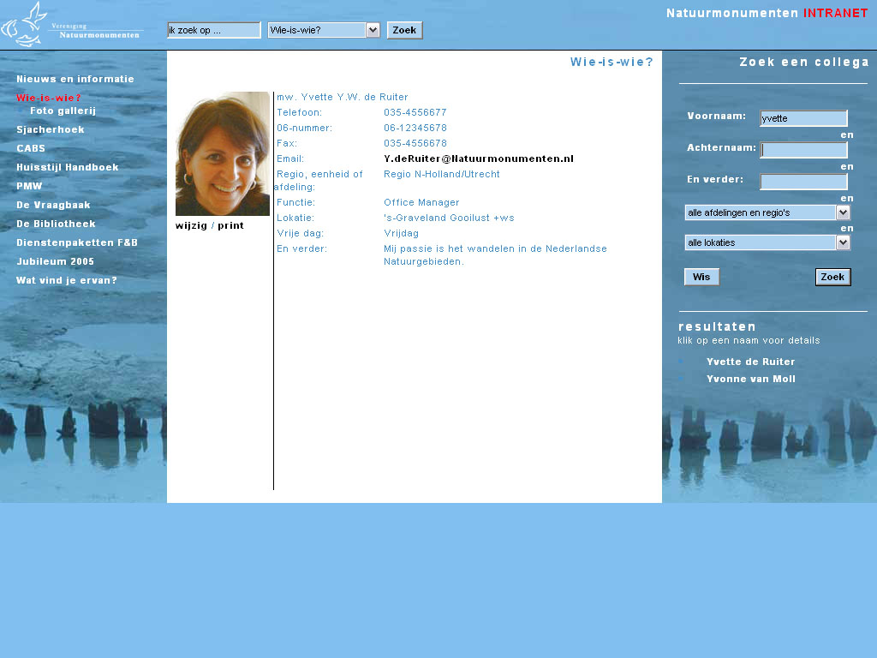 | 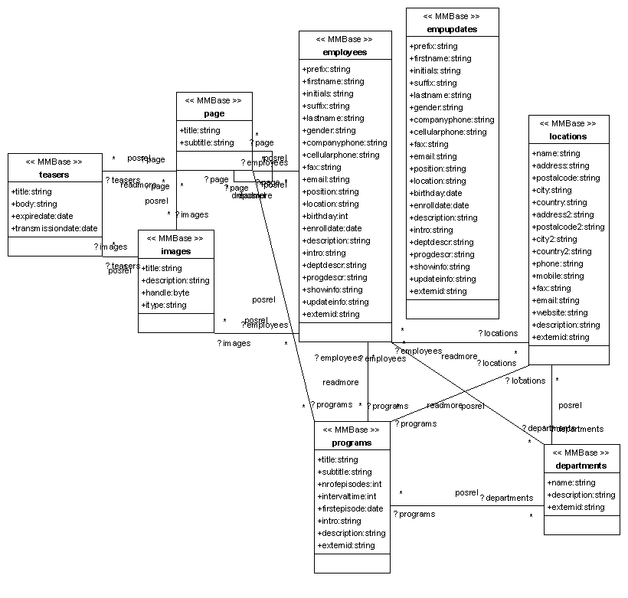 | Who-is-who (smoelenboek.jsp)  Overview of all employees in the organization. Personal profiles of employees can be imported automatically from existing databases, but can also be maintained manually.
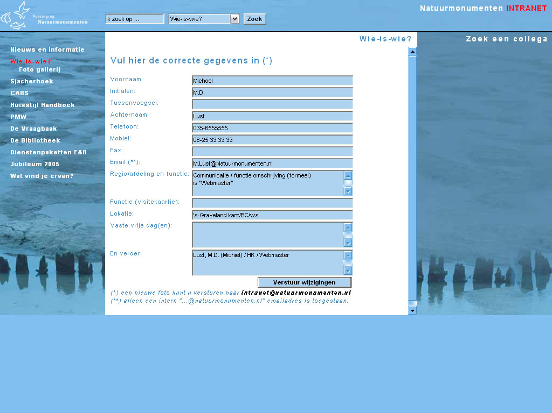 | Same objectmodel as Who-is-who | Employees update (smoelenboek.jsp)  Employees can online update their personal information. The update information is send by email to the departments, that take care of updating the personal profiles of employees.
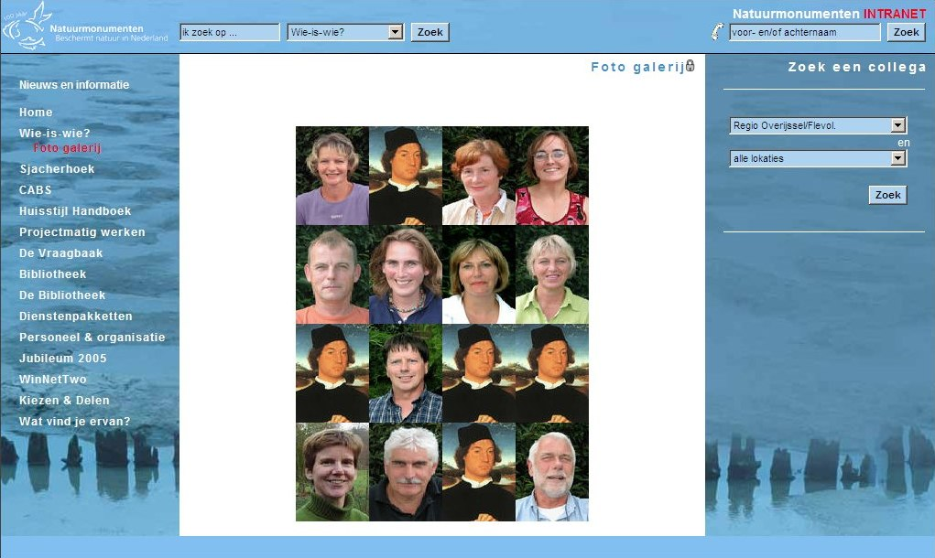 | Same objectmodel as Who-is-who | Departements and locations (thumbs.jsp)  Overview of employees from a department or location.
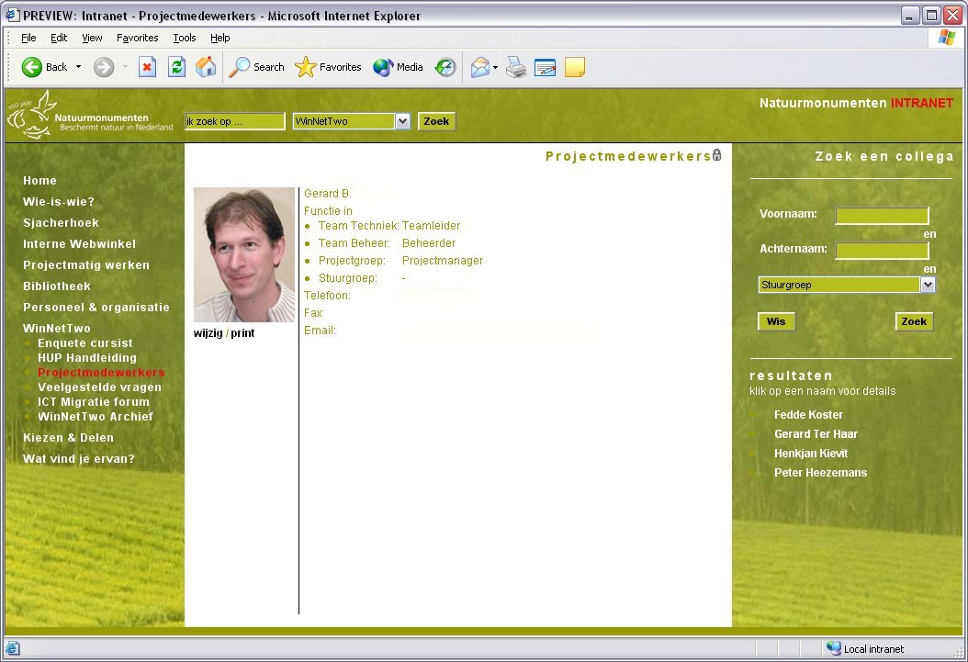 | Same objectmodel as Who-is-who (departments and locations are not used) | Project teams(smoelenboek.jsp)  Shows the teams and team-members of a project.
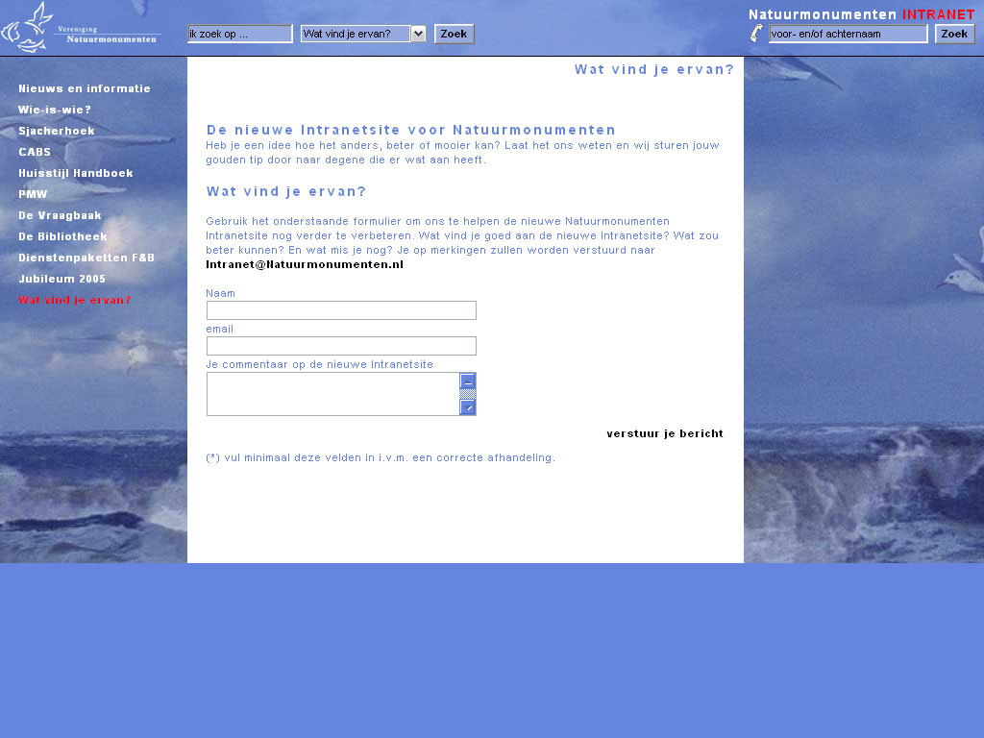 | 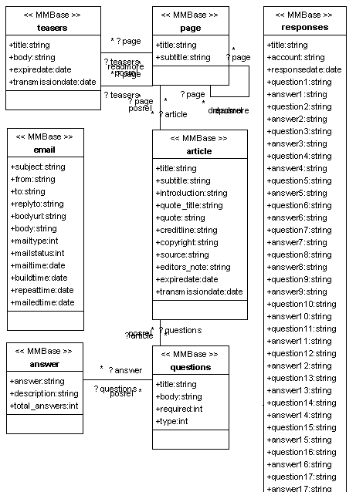 | Email forms (formulier.jsp)  Email forms can be created when and where needed.
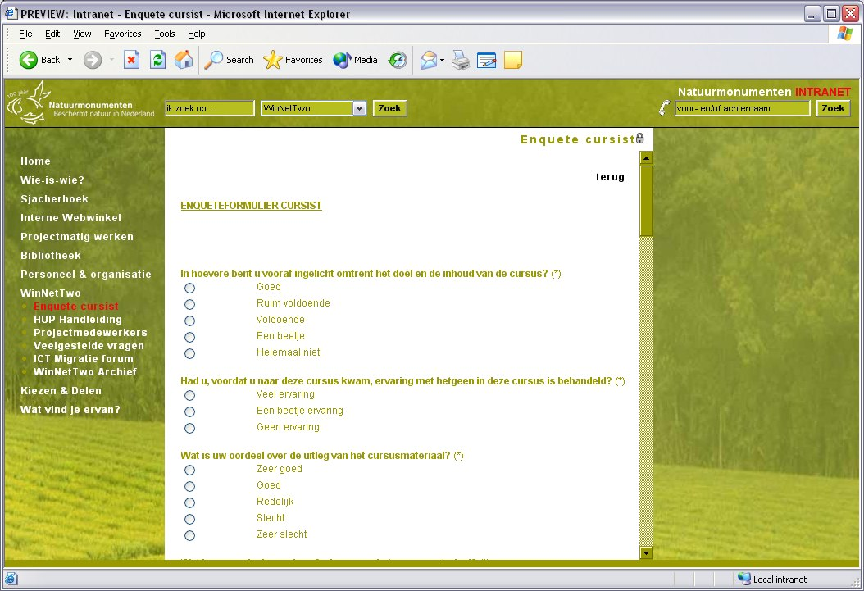 | Same objectmodel as Email forms. The answers object is used to save the filled out questionnaires and can be used for analyses by external statistical tools. | Online questionnaires (formulier.jsp)  Learn the opinion of employees by using online questionnaires
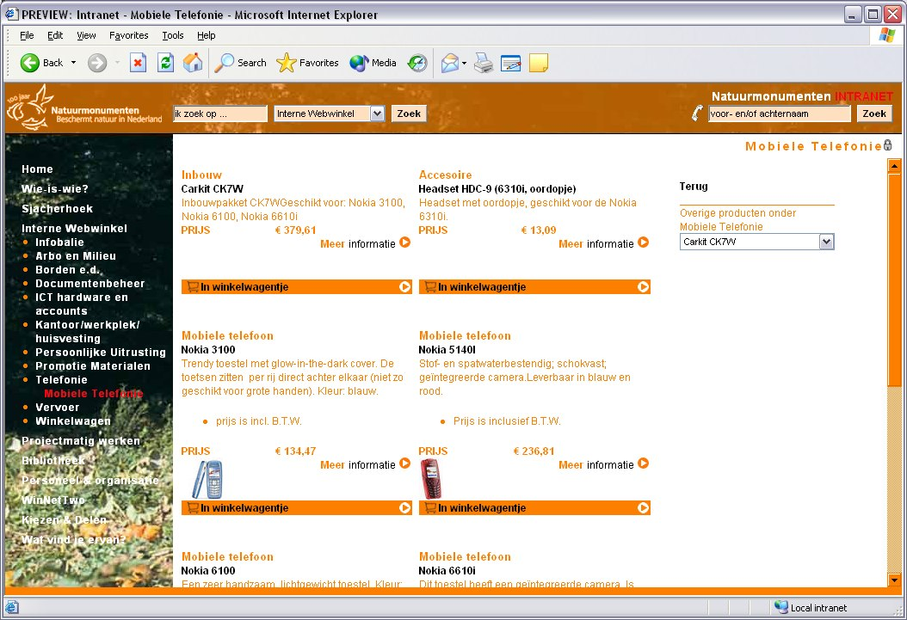 | 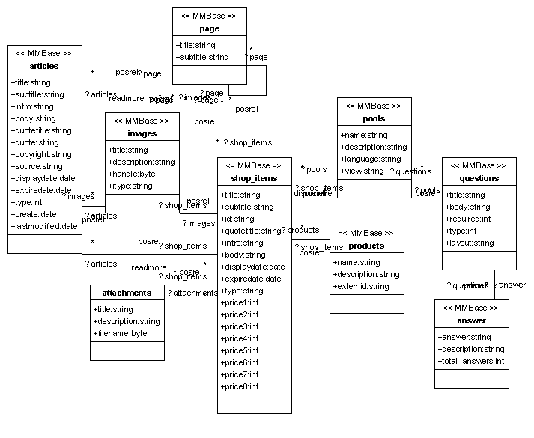 | Webshop (shop_items.jsp)  A webshop gives an overview of goods available. It can greatly improve the efficiency of internal supplies.
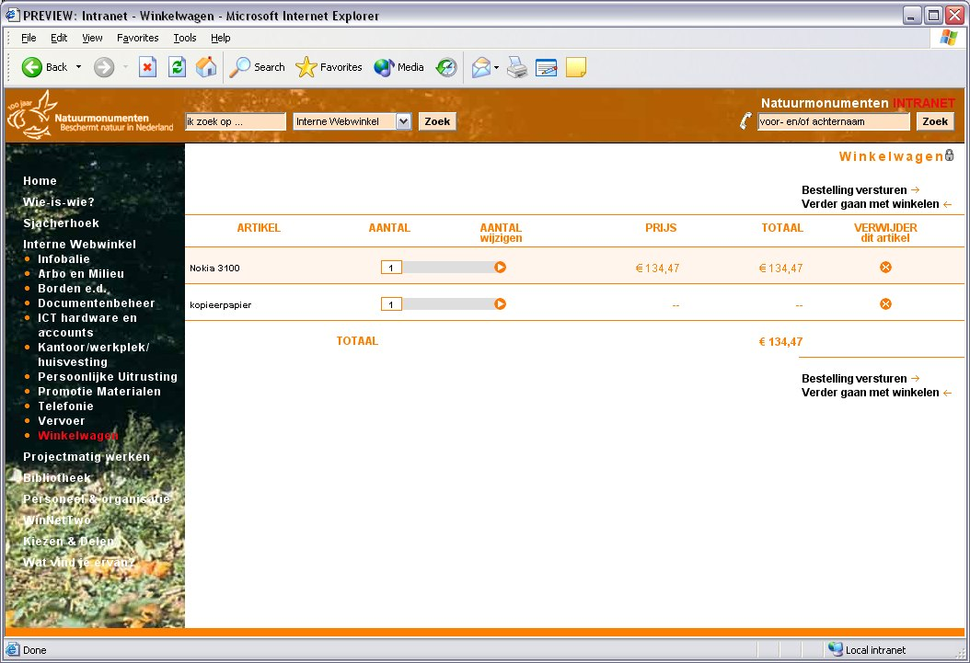 | Same objectmodel as Webshop | Shopping cart (shoppingcart.jsp)  The items ordered are send as email requests to different departments.
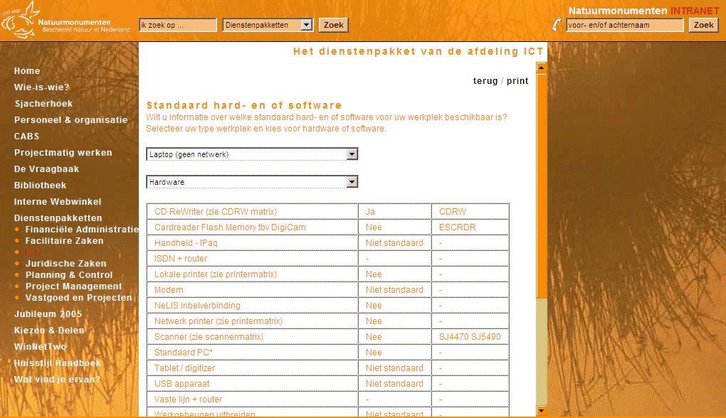 | 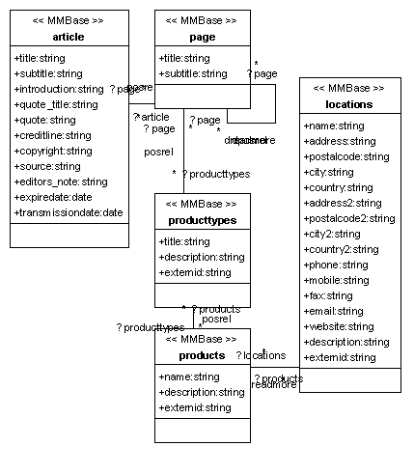 | Service level overview (producttypes.jsp)  Overview of terms and conditions on the products supplied by departments. Categorized by product type and location.
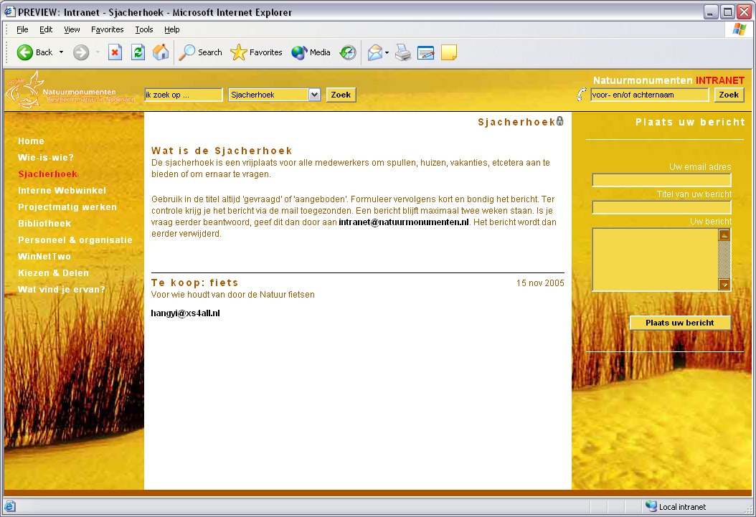 | 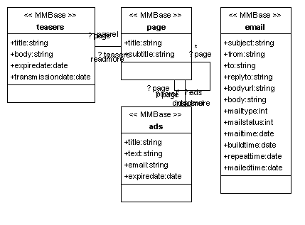 | Bulletin board (prikbord.jsp)  Employees can place their advertisements on the bulletin board.
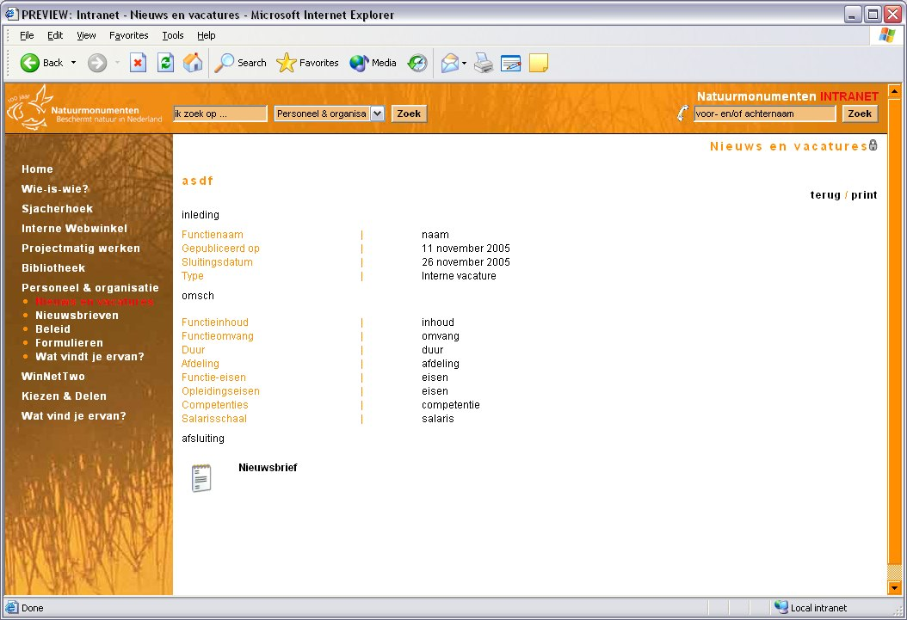 | 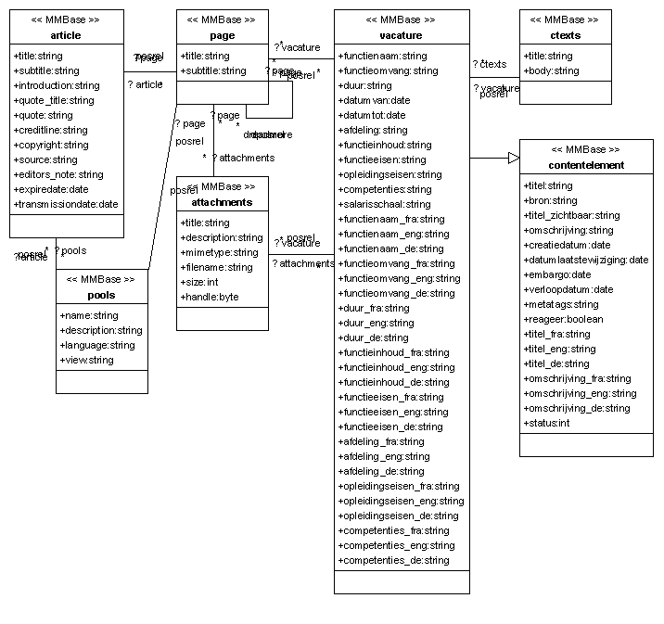 | Vacancies (vacature_info.jsp)  Overview of vacant job-positions
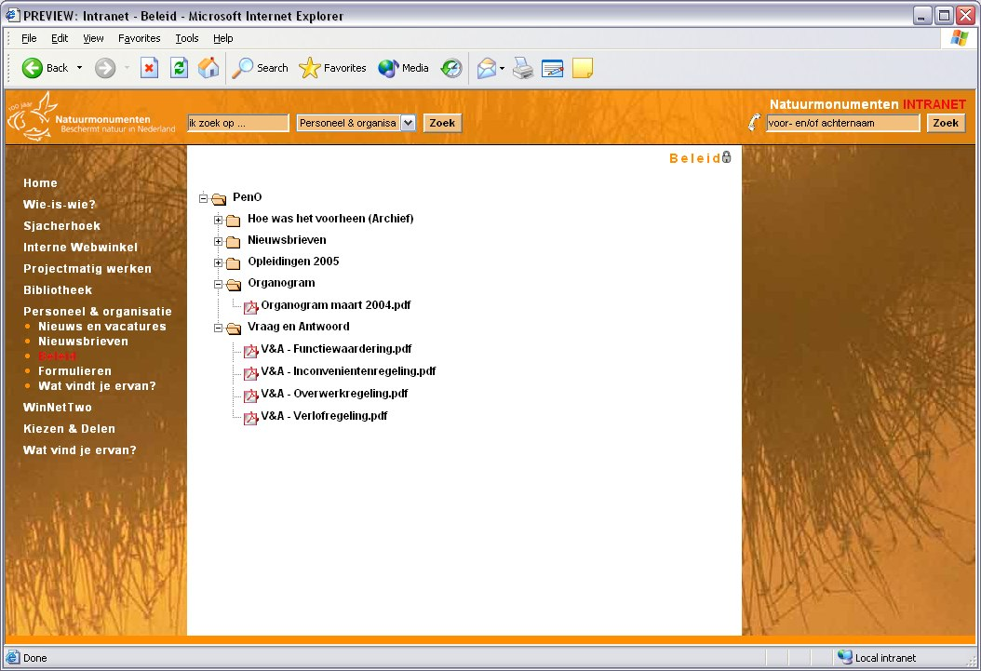 | 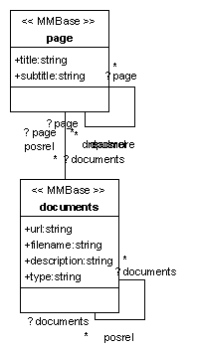 | Automatic upload of files from disc (documents.jsp)  Folders containing files that are important for everybody can be uploaded to the Intranet automatically
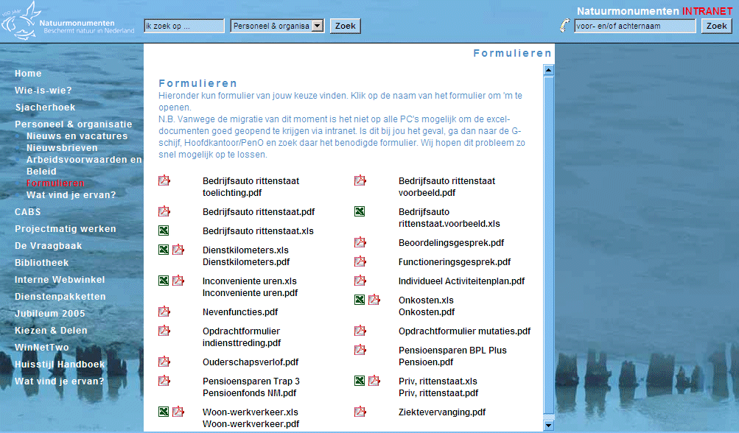 | Same objectmodel as Automatic upload of files from disc | Overview of documents (doc_page.jsp)
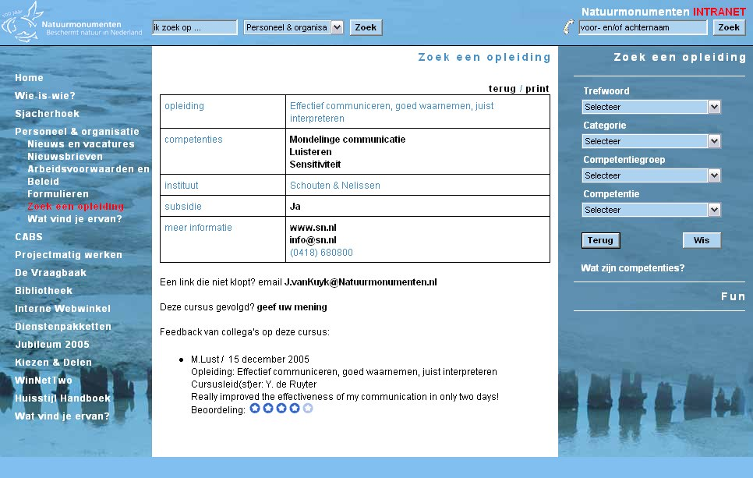 | 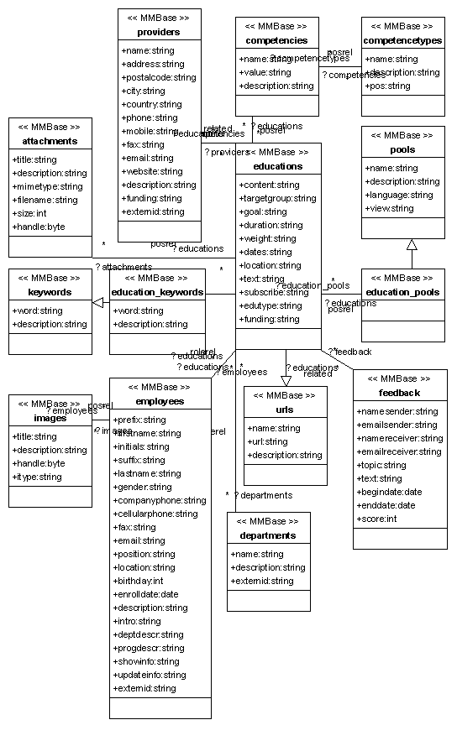 | Overview of educations (educations.jsp)  Search for educations on the bases of keywords, categories, providers and competencies. Employees have the possibility to give feedback on educations they attended.
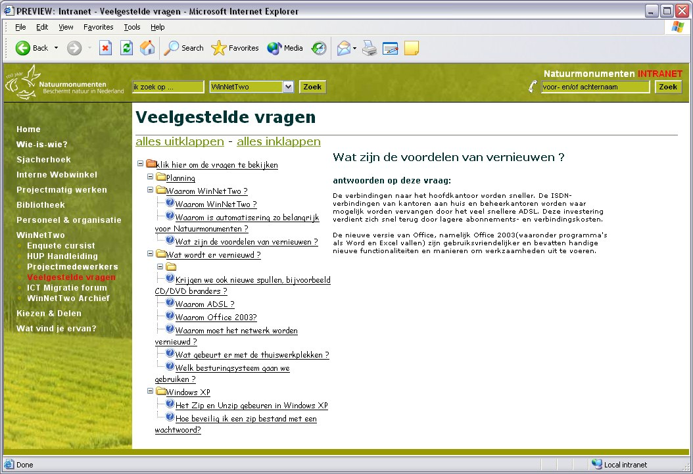 | 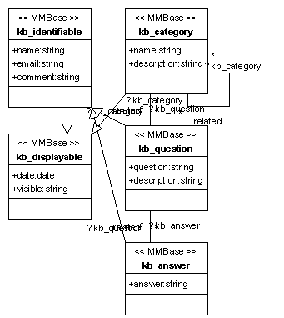 | Frequently asked questions (kbase)  Quick access for employees to information relevant on a certain topic.
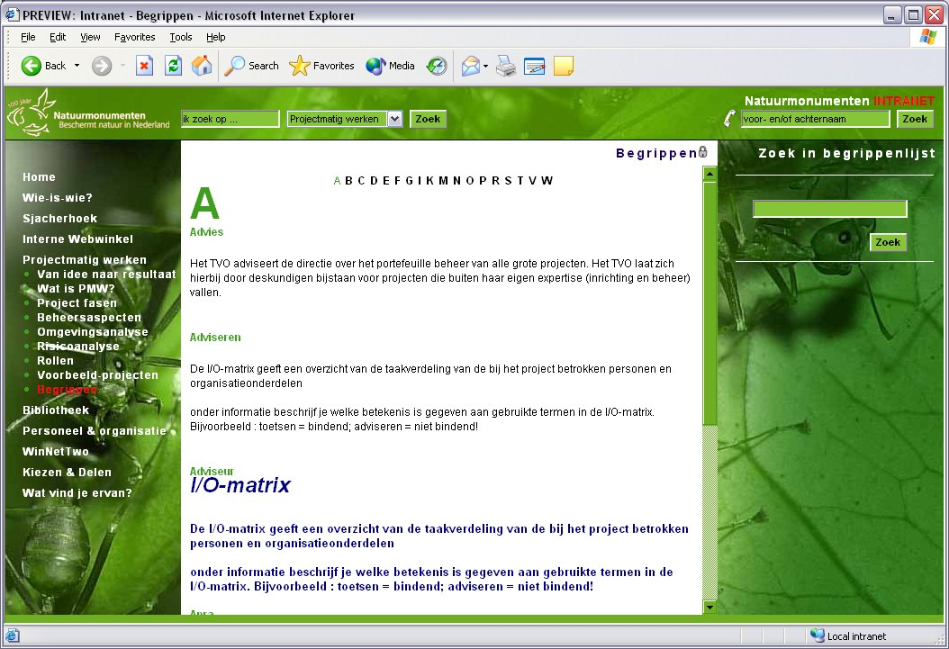 | 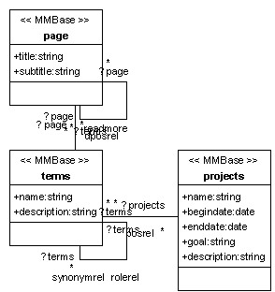 | ABC (terms.jsp)  A great relief for fields using a lot of terminology e.g. in project management
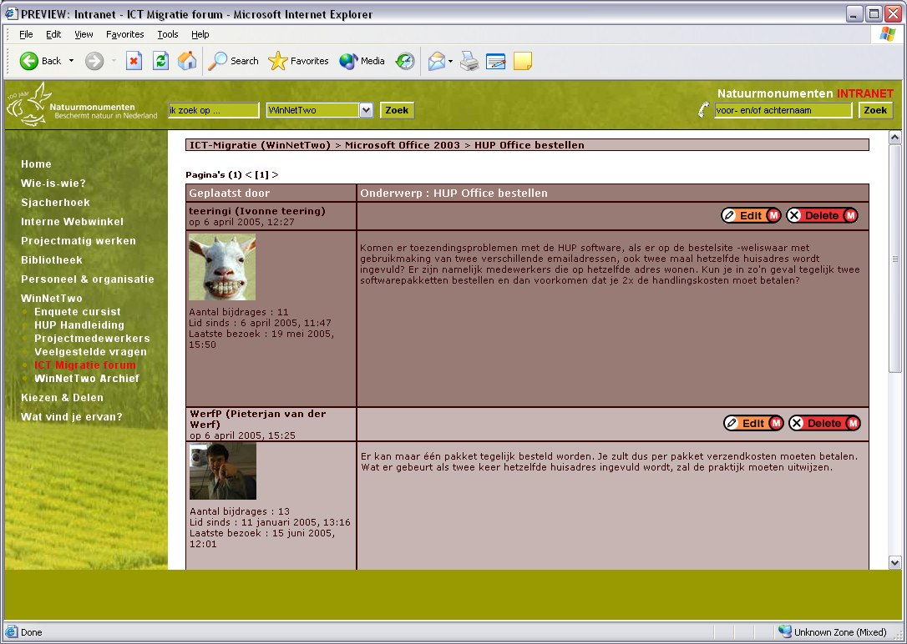 | 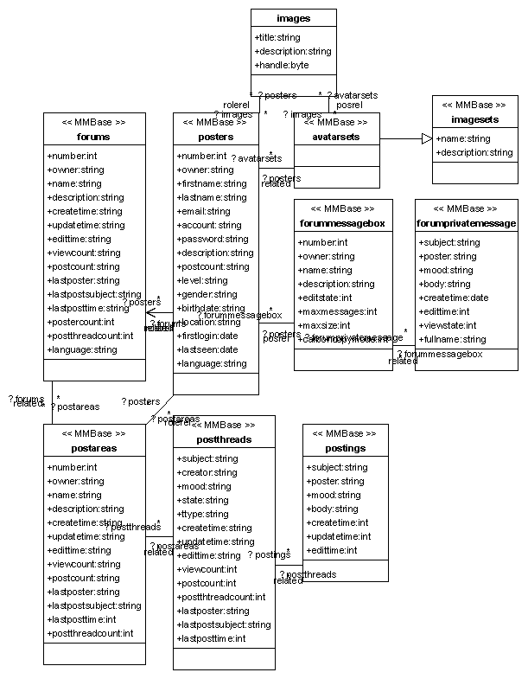 | Forum (mmbob)  Employees can discuss on topics which are of importance for the organization
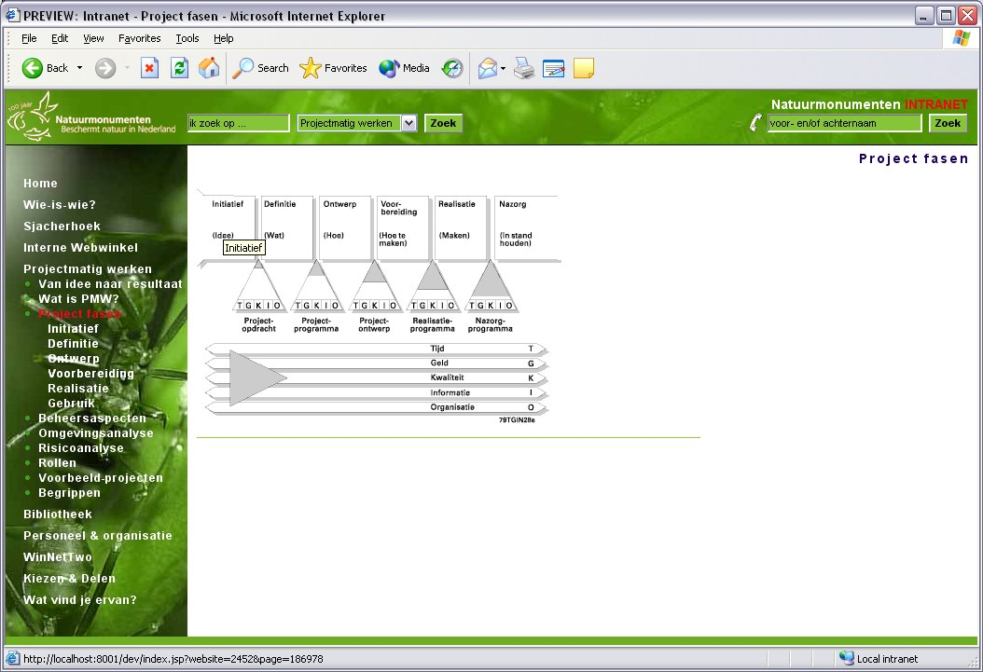 | 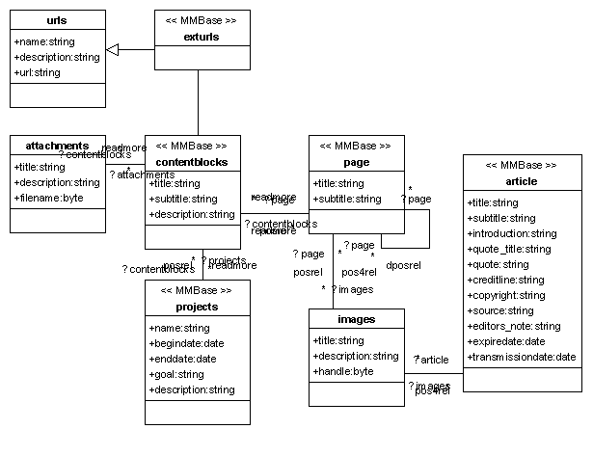 | Clickable images (ipoverview.jsp)  Images say more than thousand words; clickable maps can provide insight into issues that are otherwise difficult to grasp
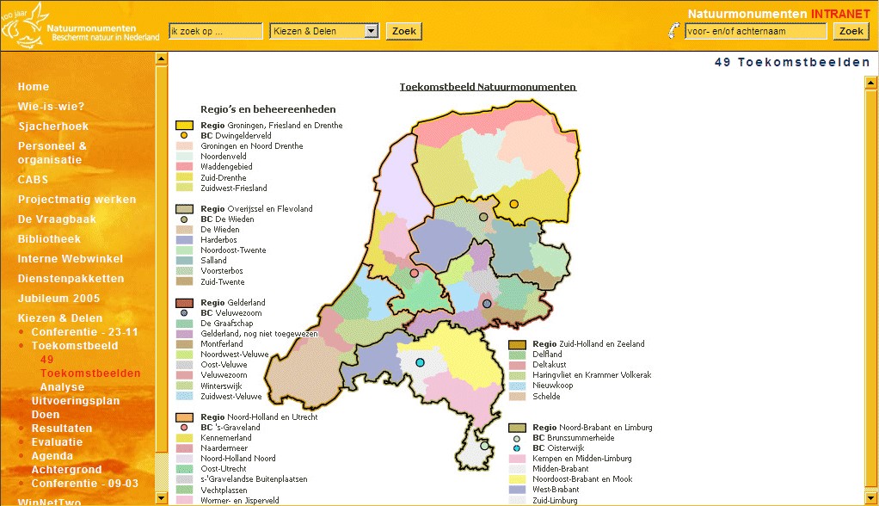 | Same objectmodel as clickable images (contentblocks are not used) | Advanced clickable images (ippolygon.jsp)  More advanced clickable images are possible. However the clickable areas on such an advanced clickable map can not be edited by the editors.
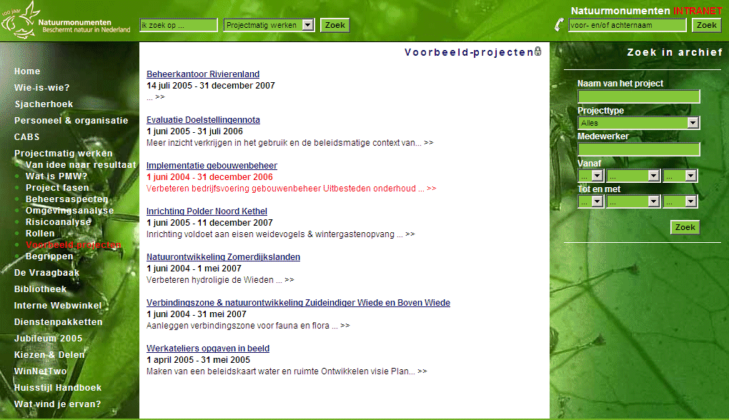 | 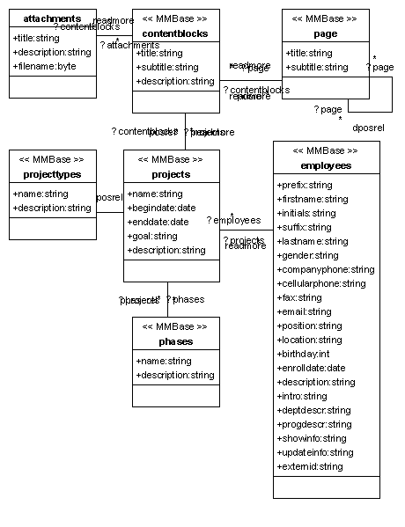 | Project archive (archive.jsp)  Gives an overview of past and present projects.
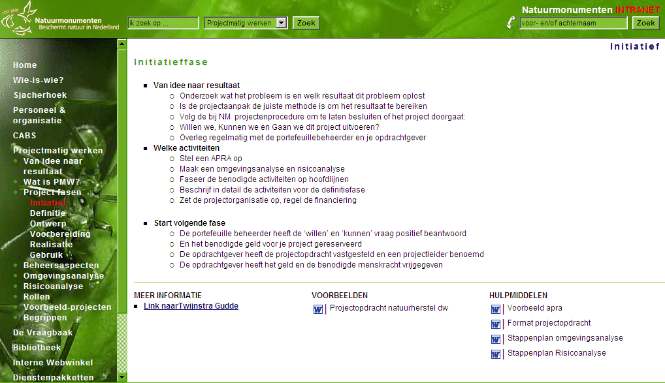 | Same objectmodel as clickable images | Project phaseoverview (phaseoverview.jsp)  Article (layout in bullited way) with content blocks

