vpro-wizards
author: Ernst Bunders

actions and handlers
There are a number of available actions. An action is in fact a bean that contains the fields that are relevant for the supported action. The type of an action (must extend nl.vpro.redactie.action.Action) determines to what handler the action bean is mapped. Handlers all extend nl.vpro.redactie.handler.Handler. The mapping of actions to handlers is done in nl.vpro.redactie.WizardService. The weak part of the system is that all supported actions and handlers are hardcoded. This is un-spring like and should be fixed.
In a given editor page you can define any number of actions (see section action mapping). Action beans are processed in a specific order: first the node actions are processed, and then the relation actions.
This section shows the available action handlers and the attributes you can set on them.

class | description | parameters
CreateNodeHandler | this handler creates a node of given type. first all the fields are set on it, than all the datefields. currently one file can be uploaded for each create node action, so nodes with more file fields than one have a problem.  Errors caused by setting these values result in a FieldError instance in the resultContainer.Errors map.  if an id is given than the newly created node is mapped to it in the idMap that is accessible for subsequent actions.  they usually allow pointing to this map with attributes like 'sourceRef=[id]'
  id (string) | to this id the new node is mapped in the idMap
  file (string)
  fields (string)
  dateFields (string)
UpdateNodeHandler | updates a given node.  Errors caused by setting these values result in a FieldError instance in the resultContainer.Errors map.  When id is set the node is set in the idMap
  *number(string)
  id(string)
  fields(map)
  dateFields(map)
  file(MultipartFile)
DeleteNodeHandler | a very simple action that deletes a node. if the node is a relation, a cache flush hint of type 'relation' is added to the resultContainer, and otherwise a hint of type 'node'
  *number(string) | a node number or alias
CreateRelationHandler | creates a new relation from a given source node to a given destination node with a given role. source and destination can be given as either a specific node number of as a reference to a previously mapped node.  all the values in the fields map will be set on the new node. date or file fields are not supported. Errors caused by setting these values result in a FieldError instance in the resultContainer.Errors map.  With sortfield you can set a sorting value on the relation (think: posrel: pos). When the role is posrel this fields defaults to pos. for other relations (specializations of posrel) you can set the field to use. the field must be of type number.  With sortPosition you can determine if the new relation should be added to the begin of the sorted list or the end.
  source
  referSource
  destination
  referDestination
  role | default: related
  fields(map)
  sortField(string) | then name of the sorting field in the relation
  sortPosition(string) [begin|end]
CheckRelationHandler | creates a new relation of given type. If olddestination is set, than the old relation node is deleted.  With this action it is not possible to set fields on the created relation!
  fields[olddestination]
  *fields[newdestination]
  *fields[relationtype]
  *fields[source]
CreateCheckboxRelationHandler | is the same as CreateRelationHandler. The only difference is that the action bean has a boolean 'relate' field. if it is not set this does noting. You can use this to create a certain relation with a checkbox.  This is the base class for UpdateCheckboxRelationHandler
  source (string)
  referSource(string)
  destination (string)
  referDestination (string)
  role (string) | default: related
  fields (map)
  create (boolean)
UpdateCheckboxRelationHandler | (extends  CreateCheckboxRelationHandler)  This handler is essentially a toggle for setting and removing a relation between two nodes.  if the boolean 'relate' is set on the action bean a check is made if a relation exists of given role to given source and destination. if it is not there it is created. if 'relate' is not set, then the relation is removed if it exists. | same as (CreateCheckboxRelationAction)
PosrelSortHandler | This handler moves a node that is connected to another node with a posrel one position up or down, depending on the dirction paramter value.
  *number(string) | the node you want to move up or down
  *direction(string) | [up|down]
  *containerNode(string) | node that the node you want to move is related to (with the posrel)
CreateTrackHandler | vpro and perhaps 3voor12 specific action to create a (cd) track
UpdateTrackHandler | vpro and perhaps 3voor12 specific action to update a (cd) track

action mapping
this section explains how to use the form to action bean mapping performed by spring.
TODO

automatic cache flushing
This section explains how automatic cache flushing works and how you can extend it fit your needs.
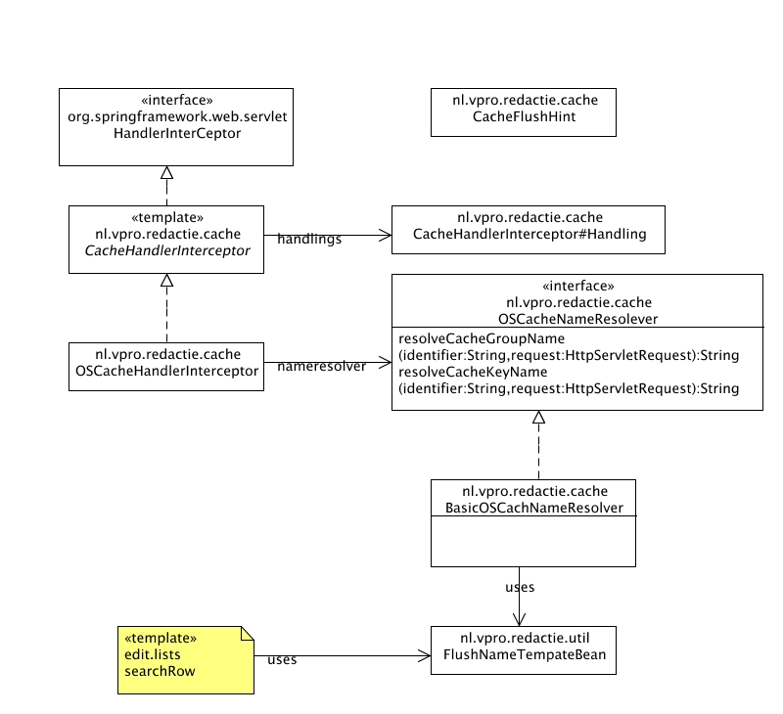

overview
The cache flush mechanism is in place to allow for automatic flushing of certain caches when certain events occur. It is designed to be flexible and expandable. How and when caches are flushed is entirely up to you.
The WizardsService class and all the Handler specializations will create cache flush hints when certain actions are executed that might call for cache flushes. These are added to the request. The processing of these cache flush hints is done by a Spring interceptor, that comes into action after the WizadService is done, and all actions are processed. By subclassing the CacheHandlerInterceptor you can easily map Handling instances to cache flush hint types (see below).
The values given to the flushname parameter is arbitrary, and will probably be handled by your specialization of CachHandlerInterceptor.
OSCacheHandlerInterceptor assumes you want to flush (oscache) cache groups and thus assumes that the flushname parameter contains a number of cache group names, separated by comma. It knows a few tricks that will be explained later.
The OSCacheHandlerInterceptor takes an OSCacheNameResolver instance that it uses to resolve 'real' cache names from values given with the cachename parameter. This allows you to process the cachegroup identifiers and add some runtime information like servername as prefix or so. You can create your own application specific one and inject it with spring, Though threre is a default one that will handle dynode number resolving (see below). It is recommended to extend from this one.

Cache Flush Hints
The vpro-wizard WizardService and it's Handler classes add cache flush hint instances (nl.vpro.redactie.cache.CacheFlushHint) to the request. there are currently three types: 'request', 'node' and 'relation'. A request type hint is added for each request. it has no extra data.
A node type hint is added when a node is created, deleted or modified. it's extra data is the node number.
A relation type hint is added when a relation was created, deleted or modified. It's extra data is the source number, destination number and relation node number.

CacheHandlerInterceptor
This is the abstract base class for handling cache flush hints. It is designed along the lines of the 'template' design pattern. You can subclass it and in the constructor add Handling instances to the 'handlings' collection. It is convenient to create the Handlings anonymously. The handlings are mapped to cache hint types.
After the actions are all precessed, the CacheHanderInterceptor comes into action and does the following:
- fetch the collection of cache flush hints from the request.
- for each hint, iterate over all it's handlings, and execute the ones that match the type of the current hint.
When creating a new cache flush mechanism, it is best to subclass this class.

OSCacheHandlingInterceptor
The OSCacheHandlingInterceptor is there to handle oscache cache flushes. It only flushes cache groups. It allows you to do several interesting things with the flushname parameter values. In short: you can specify what cache groups to flush for what cache flush hint types, and there is a simple template mechanism to substitute place holders with specific node numbers to support dynamic cache group name creation.

cache flushing hint types
There are three types of cache flushing hints, and you can determine what hint types flush which groups for a request. By prefixing a comma separated cache group indicators with node: these groups will be flushed in the case of one or more flush hints of type node. The same applies to relation:.
If you want to flush groups on flush hint type request (there is always one, regardless of what happened) simply omit node: or relation:. You can combine node: and relation: though.
examples:
group1,group2
will flush these groups no matter what
node:group1 relation:group2,group3
will flush group1 in case of a node change, and group2 and group3 in case of a relation event.

dynamic cache group indicators
The BasicOSCacheNameResolver helps you to create dynamic cache group names. This system works with a very simple template format that is resolved during runtime.
It is common to create cache groups with node numbers in them, like 'programs_[nodenr]' (i.e: programs_12344). So if you have a list with nodes of some type, and each row calls a wizard, you want 'flushname' to contain the node number of that row. The list:searchrow tag will help you with this. Templates inside the flushname value are resolved and the node number is appended to the template. The template stays in place, because the flushname value is communicated between wizards through the session, so when you come back to the list later you need it again. In this case the previously appended node number will be cleared out of it, and for each row a new value will be created with the node number of that row.
There are two possible template formats:
'pages_[page]'
where the value between [] is the type of the node you want to insert. When a list lists node of the given type, it will create a value like:
'pages_[page:7349]
The node number is appended.
Sometimes you want to reach a parent node of the node in the list, but you don't know it beforehand. An example is when you list all recent news articles, and you want to flush a cache group that is related to a specific category each news article is related to. to do this you can use a template like:
'pages_[page.insrel.categories]
Now the nodenumber will be resolved as the first node of type categories found along the given path, where the page node of the row in the list is the start node. The format is not flexible. it can contain exactly three steps and a role is required. Constrains and sort order are not supported.
Finally the tempates are stripped out of the flushname values by BasicOSCachNameResolver, so remember to call super when you extend this class to create you own cache name resolver.

