Lab 2: Agile Backlog Creation & Sprint Simulation in Jira
Software Engineering Lab | Lab 2 | PES1UG24CS561 | 2026-10-07

Aim
To translate the Lab 1 sports-tournament requirements into Jira epics and user stories, prioritize and estimate the work, simulate two Scrum sprints, and review the resulting progress.

Procedure
Scenario: Problem Statement #54, Local Sports Tournament & Bracket Manager. Project: Local Sports Tournament & Bracket Manager (key LSTBM), a Jira company-managed Scrum project. Three epics group the five functional and two non-functional requirements. Seven user stories use the As a / I want / So that format and include acceptance criteria. Story estimates use Fibonacci values 3 and 5, and work was planned across two seven-day Jira sprint timeboxes. The board's current navigation did not expose the handout's Reports > Burndown Chart page; the included burndown is therefore calculated transparently from Jira's sprint-report estimates and issue status-change history.

Task 1: Create the Scrum project, epics, and user stories
Command(s) used:
Jira project: LSTBM - Local Sports Tournament & Bracket Manager
Epics: LSTBM-1 Team Registration and Bracket Setup; LSTBM-2 Match Operations and Secure Scoring; LSTBM-3 Standings and Tournament Publication

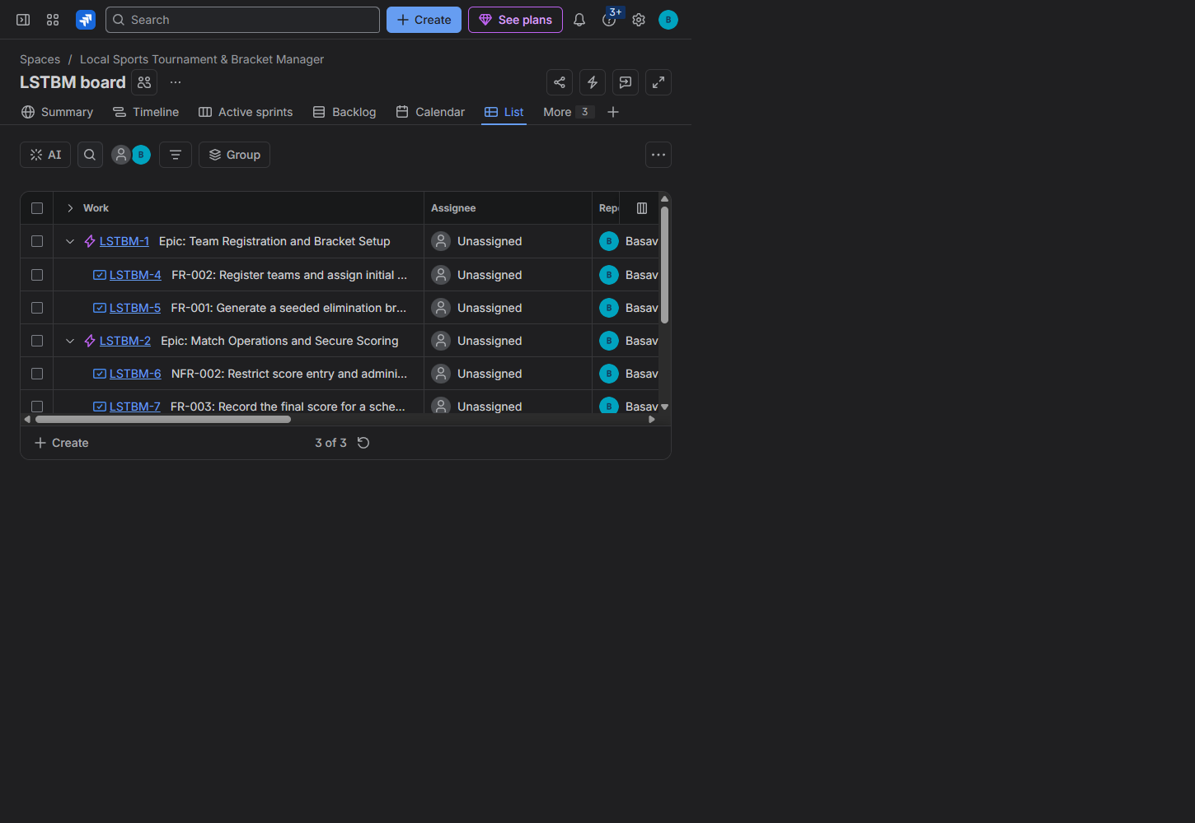
Observation: I created three Jira epics and linked seven stories to them, covering each of the five functional and two non-functional requirements from Lab 1 Problem 54. The stories follow the user-goal format and include acceptance criteria. I grouped team registration and bracket setup together, kept match operations and access control together, and placed standings performance and publication under the final epic.

Task 2: Prioritize stories and assign Fibonacci story points
Command(s) used:
Priorities: High for FR-001, FR-002, FR-003, FR-005, NFR-001, and NFR-002; Medium for FR-004.
Fibonacci estimates: 3 or 5 points per story, stored in Jira's configured Story Points field (customfield_10037).

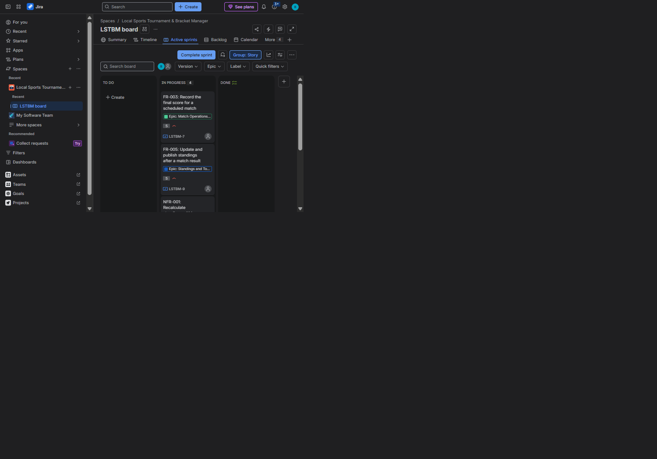
Observation: I gave the core tournament flows, access control, published standings, and the 200 ms response target High priority; the tiebreaker is Medium because it is needed for a subset of results. Each story is estimated at 3 or 5 points, reflecting the smaller configuration/authorization work and the more involved bracket, scoring, and standings behaviors. The Jira board uses the actual Story Points field, so these values contribute to sprint estimates.

Task 3: Plan and complete Sprint 1
Command(s) used:
Sprint 1 goal: register ranked teams, generate a valid bracket, and protect scoring access.
Planned stories: LSTBM-4 (3 points), LSTBM-5 (5 points), and LSTBM-6 (3 points).
Timebox: 2026-10-07 through 2026-10-14 (7 days).

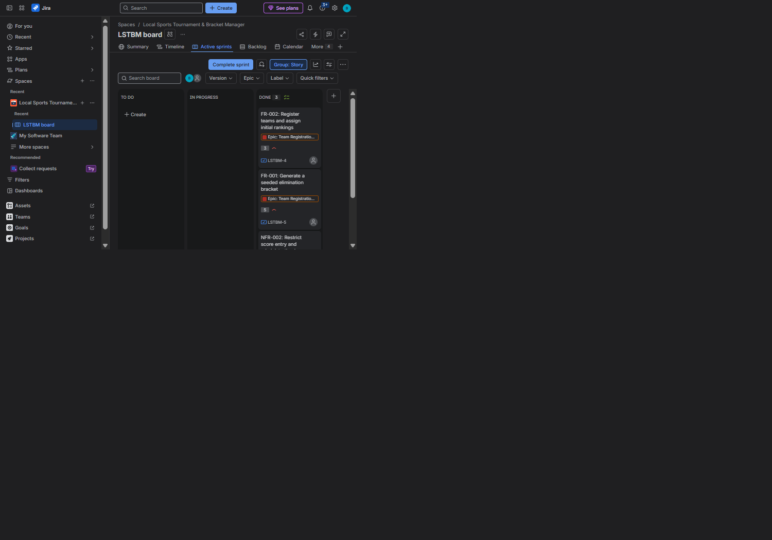
Observation: I planned three high-priority stories totaling 11 points, moved them through To Do and In Progress, and completed all three in Jira. The sprint report records 11 of 11 points completed and no unfinished issues. The board screenshot shows the stories in the Done column.

Task 4: Plan and complete Sprint 2
Command(s) used:
Sprint 2 goal: record match scores, resolve ties, and publish responsive standings.
Planned stories: LSTBM-7 (5 points), LSTBM-8 (3 points), LSTBM-9 (5 points), and LSTBM-10 (3 points).
Timebox: 2026-10-07 through 2026-10-14 (7 days).

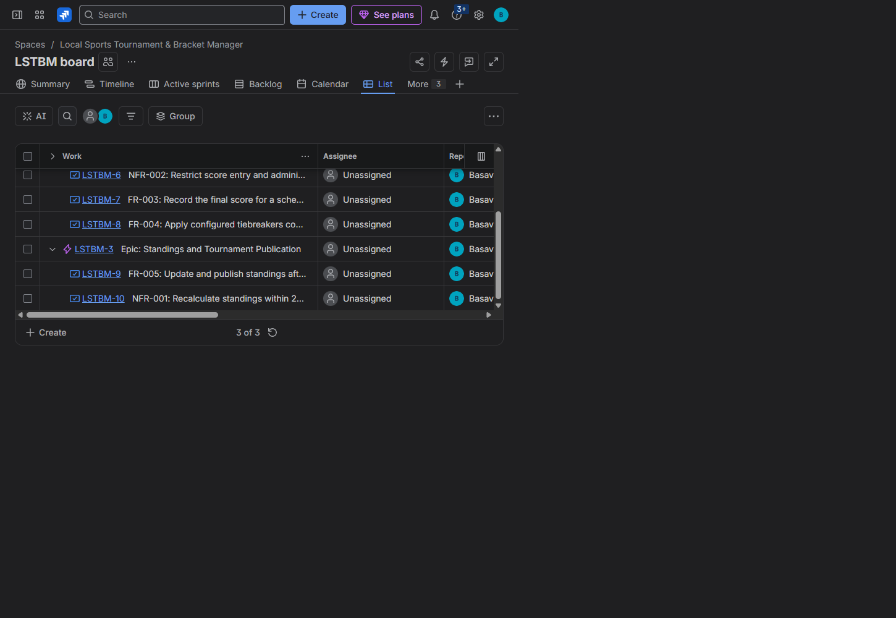
Observation: I planned four stories totaling 16 points, including score recording, tiebreaker handling, standings publication, and the 200 ms recalculation target. I first moved the stories to In Progress and then marked them Done. Jira's sprint report confirms all 16 points completed with no remaining issues; the issue list also shows the finished stories beneath their parent epics.

Task 5: Review the Jira-history-based sprint burndown
Command(s) used:
Source data: Jira Sprint Report API and each story's Jira changelog.
Calculation: start at the sprint's total estimated points; subtract each story's points at its recorded transition to Done; compare with the linear seven-day guideline.

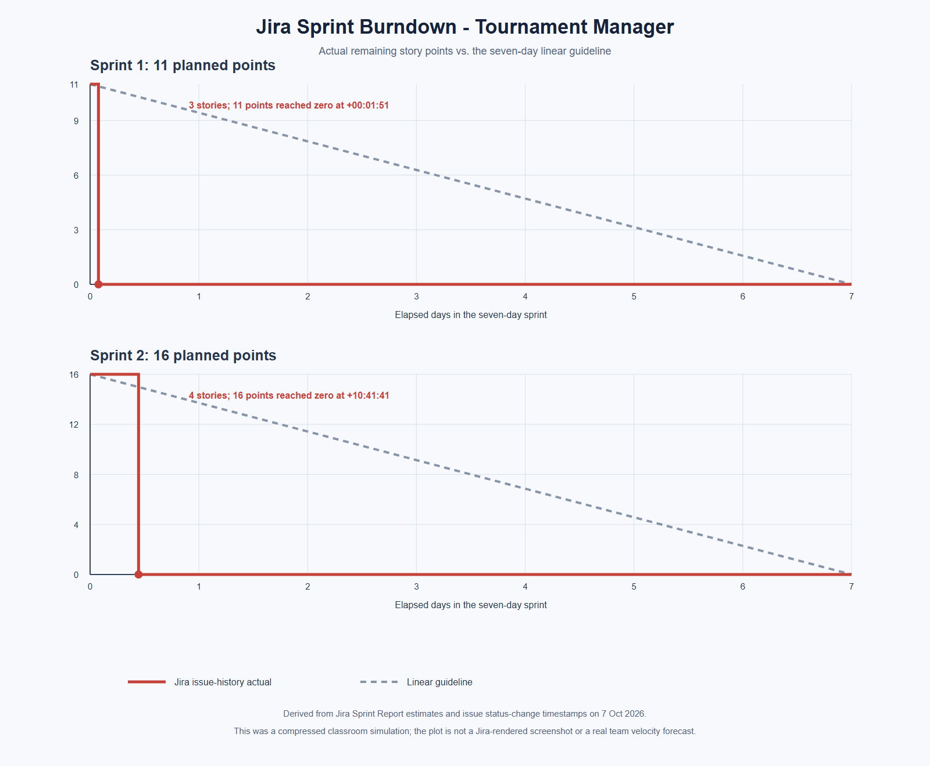
Observation: The Jira sprint-report totals are 11 of 11 points for Sprint 1 and 16 of 16 for Sprint 2. The issue histories show the final Sprint 1 story completed about 1 minute 51 seconds after its sprint start and the final Sprint 2 story about 10 hours 42 minutes after its start; remaining work then stays at zero. These are compressed lab simulations, not evidence of a team's real seven-day delivery velocity. The chart is explicitly derived from Jira's recorded estimates and transitions because the current Jira navigation did not provide the handout's Burndown Chart screen.

Task 6: Reflection
Observation: The estimates gave a useful relative ranking, but I cannot claim they matched actual engineering effort because the sprint exercise simulated status changes rather than implementing and timing the features. The backlog was prioritized around the tournament's core flows and security, with tiebreakers at Medium; dependencies could still be used to refine the order within the High-priority group. Both planned sets finished in Jira, but the rapid and same-day transitions make these runs unsuitable for forecasting a real team's capacity. The burndown confirms all planned points were completed and also shows why future sprints should be estimated from a real delivery history with progress recorded throughout the timebox.

Conclusion
I created a Jira Scrum backlog for all seven Lab 1 requirements, connected each story to an epic, assigned priorities and Fibonacci estimates, and completed two seven-day sprint simulations. Jira records 27 of 27 planned story points completed across the two sprints. The reflection and chart distinguish this classroom simulation from a real velocity measurement.

