

CREDIT CARD PROJECT REPORT:



AUTHORS

Group 47: Ramy Ktllama, Duco van Den Bos, Amandine Aabdaoui, Mylène Brown-Coleman

WHAT IS THE PROBLEM YOU ARE SOLVING?

In the late 1960s IBM scientist Hans Peter Luhn created an algorithm called; the Luhn algorithm or the Luhn formula, also known as the “mod 10” algorithm. The algorithm validates a variety of identification numbers, like credit card numbers, IMEI numbers etc., with the use of a simple checksum formula. The algorithm itself was not designed against hostile acts, but rather for protecting against accidental errors.

For our assignment we have to make a program based on The Luhn algorithm that can detect whether a provided number is a valid credit card number, following these set of rules;

1. Double every second digit from right to left.

a. If doubling of a digit results in a two-digit number add up the two digits to get a single-digit number.

1. Add all single-digit numbers from Step 1.
2. Add all digits in the odd places from right to left in the card number.
3. Sum the results from Step 2 and Step 3.
4. If the result in Step 4 is divisible by 10, the card number is correct. Otherwise, the number is invalid.

We are allowed to make our own assumptions of what is permitted, but we have to assume that the computer will generate numbers randomly or that a user will be entering a number of only a few digits. If the provided input is not permitted, how will our algorithm handle such cases? We specify this in a second, more sophisticated version of our algorithm.

HOW HAVE YOU TACKLED THE PROBLEM?

We chose an algorithm that was based on the solution strategy; “Divide the problem into several sub-problems”. This strategy was chosen because the assignment wants us to follow a set of rules, which are by themselves sub problems, i.e. rule 1 wants to double every second digit from right to left.

If doubling of a digit results in a two-digit number, add up the two digits to get a single-digit number. In order to carry out this step, we reasoned backwards by solving these rules first, so that the bigger problem was easier to solve. In addition to this, we exclusion boundaries for the edge cases of a null input or an invalid credit card number length. Then, we used inclusion boundaries for checking the even and odd indices within our number lists, from right to left. By combining these approaches, we had reduced the complexity of the problem, hence why the problem was easier to solve.

For the documentation we used GitHub which provides a Web-based graphical interface with useful features like, management tools for projects. This platform allowed us to clarify tasks, track stages of work progress, add or delete files and edit each other’s work, all from one repository.

For the implementation of our program we used PyCharm which is an integrated development environment created by the company JetBrains. PyCharm is really convenient since it allowed us to work from a dynamic workspace connected to our Git, where we could create files and directly push it to our individual branches on GitHub.

Concerning the flowchart, we used Lucid Chart, an online diagram software. Last but not least, for the video presentation we used googled Drive and Zoom. We created a PowerPoint in Google Drive, which we presented via a zoom call and recorded it. Then, we uploaded the recording onto YouTube.

WHICH PROBLEMS HAVE YOU ENCOUNTERED IN SOLVING THE PROBLEM?

The first problems we had encountered were some technical issues, setting up GitHub and Python. These were the following:

1. Installing git on everyone’s computer and installing Python on everyone’s computer.
2. Learning the GitHub workflow commands.
3. Different operating systems e.g. MacOS and Windows 10 use gitbash differently.
4. Setting up PyCharm to use git version control integration settings within it.
5. Merging pseudocode from different team members perspectives.
6. Trying to understand the algorithm task at hand.
7. Programming bugs due to lack of understanding of Python data type conversion.

HOW HAVE YOU SOLVED THOSE PROBLEMS?

* Sliced integer list problem:
  + - This was solved via Mylène and Amandine having a zoom call to debug the issue #10 together. We ran the code and discovered that it still compiled but it didn’t give the correct output for credit card number validation. Then, we used print statements throughout the different methods of the code to find which line had the problem.
    - After, awhile we realised that the issue was in the for loops for each method that loops over the list from left to right.
    - It became apparent to us that from the basic code that we previously had; we were slicing over a list of strings.
    - We changed the slicing within the loop to slice over a list of integers instead of a list of strings.

* The input conversion:
  + - Previously, you could only input numbers with space because otherwise it would only add one element to the list instead of the full credit card number.
    - This caused the splitting of the elements in the list into different types to break. To fix this she had to convert the list into a map of integers, instead of a map of strings.
    - Then this would be converted into a list of integers
* Zoom call for installing git and creating GitHub accounts:

o This is when Mylène helped everyone install git on their computers and clone the GitHub repository for the project.

* Understanding git commands and workflow:

o Video links YouTube tutorials and GitHub site, this was sent to everyone by Mylène to help them learn the GitHub workflow and the commands to use.

* Setting up PyCharm:

o There were more zoom calls as a group where Mylène helped people set it up on their computers.

* Understanding the assignment task:

o Doing our own individual research of Luhn’s algorithm and then having a meeting to discuss how we should sophisticate the algorithm to our style.

* Pseudocode code merging:

o We pushed each person’s version to their GitHub branch and then those individuals had a meeting about what they’d want to keep, and git rid of.

HOW DID YOU SPLIT THE TASKS?

* We assigned issues to each other on GitHub and created milestones within each issue so that they can get done by specific deadlines.
* Graphical user interface, application, Teams

  Description automatically generatedWe created a project board on GitHub where we’ve created issues and for each issue, we gave a description. Then, eventually a labelled and assigned those to everyone.

SPECIFY WHO DID WHAT.

* So, to keep track of the progress we were making with each issue, we used a project board within GitHub.
* Mylène gave everyone who had an account viewing and editing rights to everything. Then, we allocated everyone issues within the project board.
* Mmbc2008 is Mylène’s username, Amandine’s username is ama1998, Duco’s is bosduco and Ramy’s is Ramskovic.
* Here you can see a link to the issue board which tasks where assigned to which username within the project board we created in GitHub: https://github.com/mmbc2008/CreditCard/projects/3

* Within the project board you can also look at all of the issues we created individually. We started creating our issues on September 24th and carried on from that date creating more.
* All of the issues in the screenshot images below show all of the allocated issues according to username, label and milestone.
* The labels that we used were the following:

o Documentation: This would be for pdf files and diagrams to explain the algorithm and report.

* + Enhancement: This was for the improvement of certain parts of the documents and code by other team members
  + Application setup: All downloading of applications and software would come under this category
  + Bug: This is for programming errors
  + Question: This is for questions about other people’s code and different requirements that we didn’t understand.

HOW MUCH TIME HAVE YOU SPENT ON SOLVING THE PROBLEM?

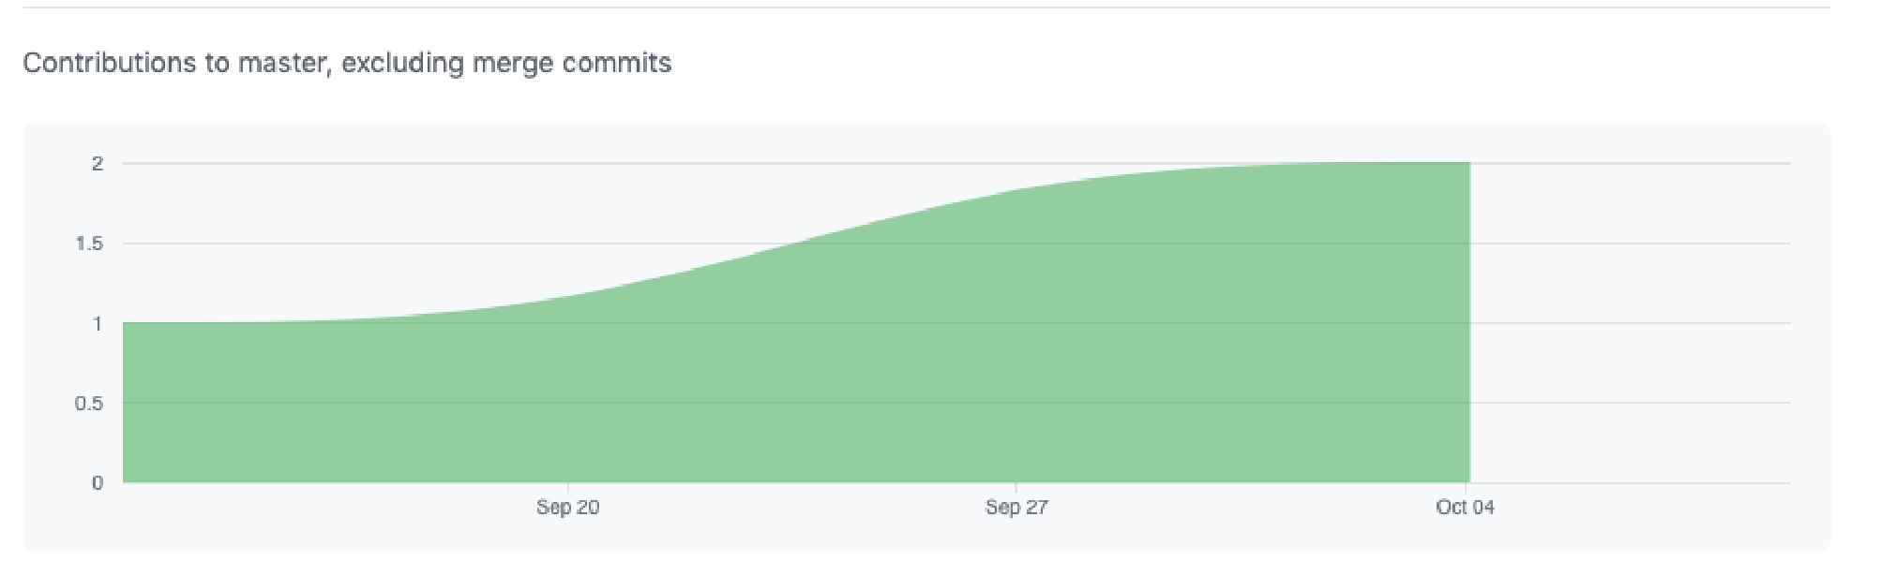

* As previously stated, we started allocating issues on GitHub to one another at around the 24th of September and finished around October 9th.
* This graph shows the trend of our contributions to our master branch over time:
* This means in total the programming part of our project took 10 days.
* 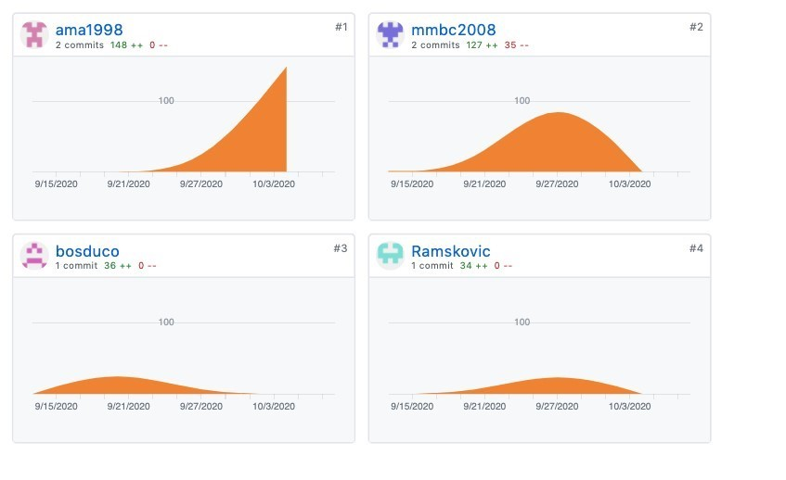Below shows the amount of commits to our master branch between each member’s GitHub account.

* As shown in the four graphs on the left we can see how each team member has contributed to the project over time. All group members have managed to finish completing their tasks before the fake deadline that was created by Mylène in GitHub.
* The video for our project is linked in the README.md page on our GitHub repository.