BeebPET

PET BASIC for the BBC Computer.

Developed using a Model B, thus keyboard routines tailored to the Model B keyboard.

There are two versions:

Low version - only uses normal RAM giving BASIC 7167 bytes free.

High version - also uses 16KB of Sideway RAM giving BASIC 19414 bytes free.

Character Sets

The high version allows the alternative character set to be selected by use of the following command:

POKE 59468,14

To return to normal character set enter:

POKE 59468,12

Filing System

Acorn DFS is assumed to be the filing system, so normal Acorn filenames are used with LOAD and SAVE.

Filing handling is not supported, i.e. OPEN, CLOSE etc.

Model B Keyboard (normal character set)

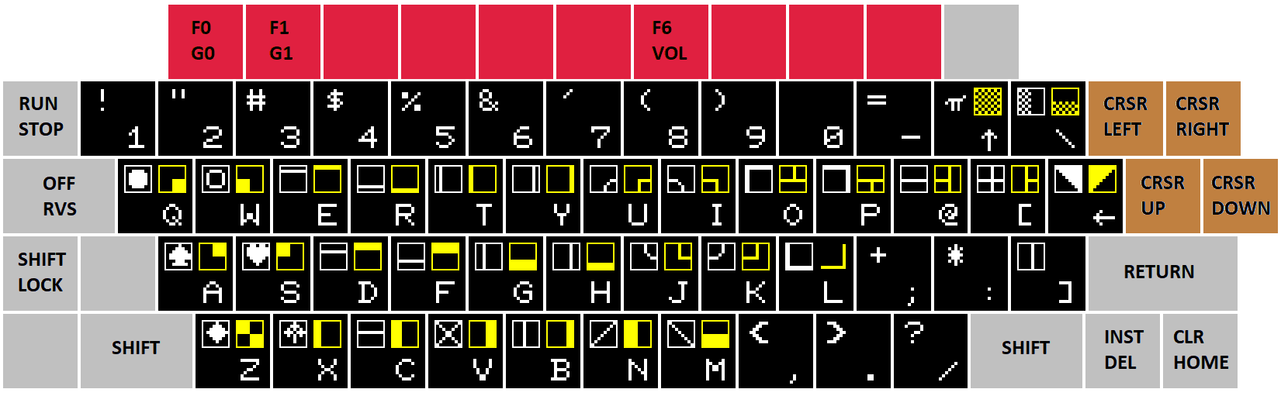

Function keys:

G0 (F0) Select graphics characters 0 (those in white).
G1 (F1) Select graphics characters 1 (those in yellow).
VOL (F6) Adjust sound volume.
Model B Keyboard (alternative character set)

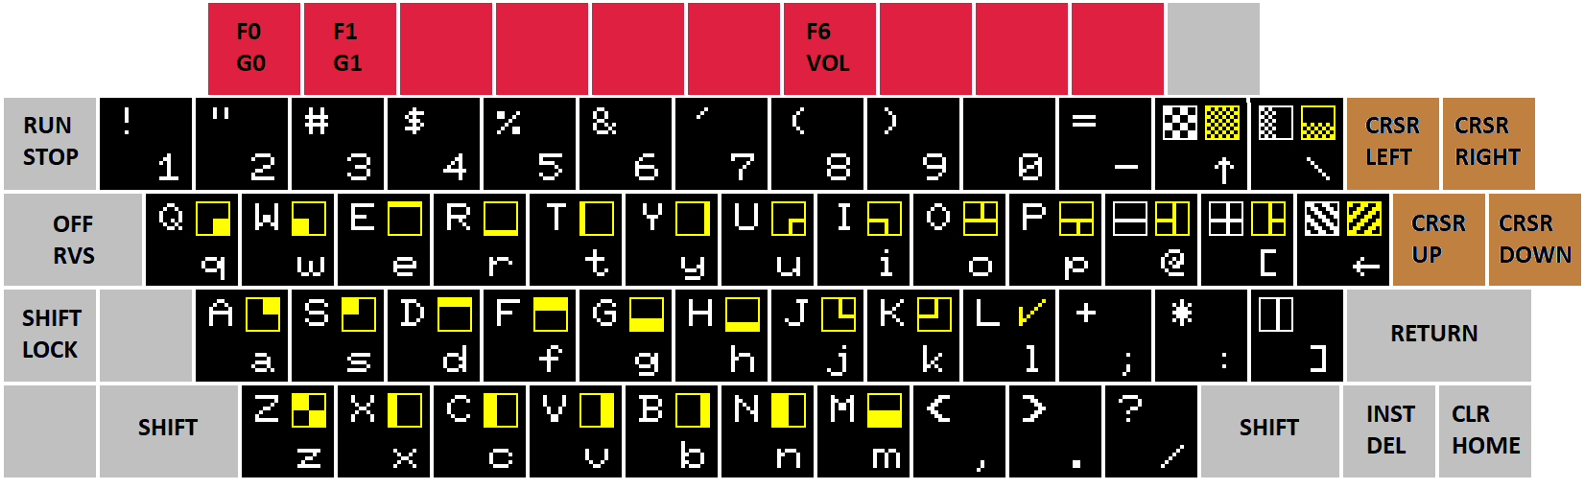

Function keys:

G0 (F0) Select graphics characters 0 (those in white).
G1 (F1) Select graphics characters 1 (those in yellow).
VOL (F6) Adjust sound volume.

