VORTRAC User’s Guide
Vortex Objective Radar Tracking And Circulation



Wen-Chau Lee, Paul Harasti, Michael Bell
and Lisa Mauger
University Corporation for Atmospheric Research
Boulder, Colorado

Version 1.0
August 2007

Table of Contents

- VORTRAC Basics……………………………………………...1
  - Operational Quickstart Guide
  - VORTRAC Overview
  - Computer Hardware & Software Requirements
  - Required Files and Formats
- VORTRAC Operation………………………………………….4
  - VORTRAC Display
  - Modifying the Configuration
  - Starting, Stopping & Restarting
  - Saving Products & Trials
- Algorithm Components...……………………………………..12
  - GBVTD
  - GBVTD-Simplex
  - Choose Center
  - HVVP
  - Quality Control Methodology
  - Uncertainty Calculation
- Technical Information………………………………………...16
  - XML Configuration
  - Formats for Output Products
    - ASI files
    - Vortex Data XML Products
    - Simplex Data XML Products
    - Pressure List XML File
    - HVVP Results Text File
    - Log files
  - Troubleshooting
  - Building VORTRAC
  - References

1. VORTRAC Basics

A. Operational Quickstart Guide

1. To run the program, click on the VORTRAC icon. On Linux, the icon should be configured to launch the binary executable on the target analysis machine. On Mac, the program is compiled as an stand-alone application. You will be presented with the VORTRAC Display described in Sec. 2B.

2. To initiate a new run, click on the ‘New’ icon in the upper-left corner. Alternatively, select ‘File->New’ from the drop-down menu at the top of the display (top of screen on Mac). The display will change to reflect the configuration information you have just selected.
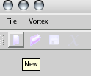
Figure 1. ‘New’ Icon

3. Configure the run by pressing CTRL-F. Alternatively, select ‘Vortex->Configuration’ from the drop-down menu.

4. Configure the Vortex information.
a. Input the storm name.
b. Input the initial position.
c. Input the initial motion as a heading (degrees clockwise from north) and speed (meters/second)
d. Select a time for the initial position and motion. The default is the current time.

e. Change the working directory if desired. The working directory stores all of the output from the current analysis. It will create the directory if it does not exist.

5. Configure the Radar information.
a. Select ‘Radar Configuration’ from the left menu.
b. Select a radar from the drop-down menu. This will change the location and altitude of the radar automatically.
c. It should not be necessary to change the radar format, radar data directory, or analysis times for real-time operation. Start and End times default to the current time plus 3 days.
d. Click the ‘Apply’ button to accept your changes.

6. Initiate the analysis with the ‘Run’ button. The status log and progress bar should begin to indicate that analysis is proceeding. If the Status Light turns red, see Sec. 4D for troubleshooting.

B. VORTRAC Overview

The Vortex Objective Radar Tracking and Circulation software is a collection of radar algorithms designed to provide real-time information about hurricane location and structure from a single Doppler radar. These algorithms are written in C++ and combined with a graphical user interface (GUI) that allows the user to control the software operation and display critical storm parameters for use in an operational environment. The primary display shows a timeline of estimated central surface pressure and the radius of maximum wind (RMW) that updates as new radar volumes are processed. Additional information about the radar data and program operation is also displayed to the user, including a constant altitude plan-position indicator (CAPPI), maximum velocity, storm signal, status light, operation log, and progress bar. This development was funded under a grant from the NOAA Joint Hurricane Testbed program from 2005 – 2007.

C. Computer Hardware & Software Requirements

The program has been designed to be cross-platform, and has been tested on Linux and Macintosh computers. Windows operation is possible, but has not been tested. The underlying graphics and utility package is Qt, developed by Trolltech Inc, and is needed for compilation. Precompiled binaries should work on other machines without the Qt libraries. Using the default configuration, the program can complete an analysis volume in under 5 minutes on tested machines including a PowerMac G5 running at 2.5 GHz and Linux machines running at greater than 2.2 GHz. RAM. Usage depends on the length of the run, but is recommended to be at least 1 GB. The CAPPI size largely determines the length of an analysis time. If the running time exceeds the radar update time, the CAPPI size could be reduced until the desired run-time is achieved.

D. Required Files and Formats

The program requires a few auxiliary XML files and image icons to run properly. The icons are in the ‘images’ subdirectory. The necessary XML files are ‘vortrac_default*.xml’ and ‘vortrac_radarlist.xml’. A separate configuration XML file is needed for each analysis, which can be created from the default or copied from a previous run.
VORTRAC requires at minimum a NEXRAD level II radar data stream from either a real-time LDM feed or archived NCDC data to display pressure deficit and RMW trends. For absolute pressure estimates, a surface pressure stream containing environmental pressure measurements is also required. In both cases, a specified data directory is checked continuously for new files while the program is operating. The population of the data directories must be performed by an external script or program such as LDM.

i. Radar Data – VORTRAC currently supports Level II WSR-88D radar data. This is distributed in two different binary formats: the ‘LDM’ format which has the blocks compressed internally via bzip2, which is available in real-time, or in an archived format available from the National Climatic Data Center (‘NCDC’ format) for historical cases. The user must select the format from a drop-down list prior to initiating analysis. Details on the level II format can be obtained from NCDC at http://www.ncdc.noaa.gov/oa/radar/leveliidoc.html

ii. Pressure Data – There are two implemented formats for the incoming anchor pressure data, AWIPS and H*Wind. The former is a dump of AWIPS data in a formatted ascii file. The format is ‘e15.9,2x,f5.2,f7.2,2x,f6.1,2x,a’, with the variables being unix time (seconds since Jan-01-1970 00 UTC), latitude, longitude, surface pressure, and station name. The latter format is a dump from the H*Wind database maintained by NOAA/HRD. This comma-delimited format is only used in research mode.
2. VORTRAC Operation

B. VORTRAC Display

The VORTRAC display is designed to provide a streamlined interface for the user to quickly determine trends in central pressure and radius of maximum wind, adjust configuration parameters, and display diagnostics to ensure proper program operation. The primary display is shown in Figure 2.

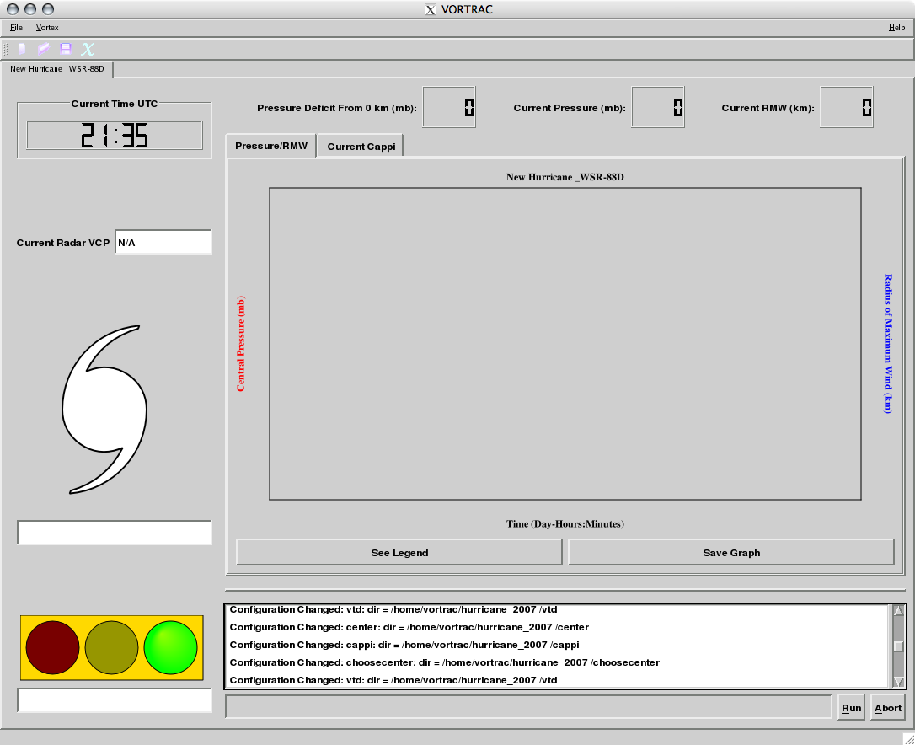
Figure 2. VORTRAC Primary Display

The display is composed of three main areas:
i. The Configuration Bar at the top of the display, including File and Vortex configuration options.
ii. The Analysis Display in the central panel, consisting of three LED-like displays of current storm information and a tabbed panel containing a Pressure/RMW graph and Current Cappi display.
iii. The Status Display, consisting of the current UTC time, radar volume coverage pattern (VCP), Storm Signal, Status Signal, status log, progress bar, and Run and Abort buttons.
Each of these areas is described in detail below.

i. Configuration Bar. This controls file and run operations and provides access to the configuration menu. Note that shortcuts are slightly different on the Mac.

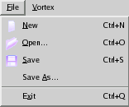
Figure 3. File Menu

a. File Menu (Alt+F)
1. New (icon; Ctrl+N): Start a new configuration from the default XML
2. Open (icon; Ctrl+O): Open a previously saved configuration file
3. Save (icon; Ctrl+S): Save the current configuration
4. Save as: Save the current configuration to a different file
5. Exit (icon; Ctrl+Q): Quit VORTRAC

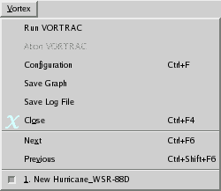
Figure 4. Vortex Menu

b. Vortex Menu (Alt+V)
1. Run Vortrac (Button): Begin an analysis
2. Configuration (Ctrl+F): Open the configuration dialog
3. Save Graph: Save the current Pressure/RMW graph
4. Save Log File: Save the current log file to a separate file (log is automatically saved to autolog.log periodically)
5. Close (Icon; Ctrl+F4): Close the current configuration
6. Next (Ctrl+F6): Move to the next analysis tab (right)
7. Previous (Ctrl+Shift+F6): Move to the previous analysis tab (left)
8. Active analysis tab and descriptor: Switch directly between multiple simultaneous analyses.

ii. Analysis Display

The primary display is the Pressure/RMW graph in the Analysis display. It shows the trace of central surface pressure (red) and RMW (blue) that updates in real-time after the analysis of each new radar volume. The other display tab is the Current Cappi, showing the most recent radar Doppler velocity on the lowest Cappi level, along with some diagnostic information.

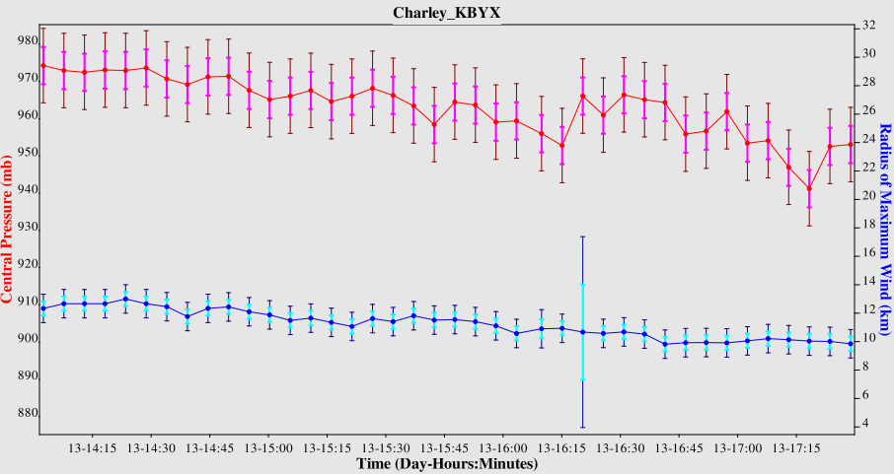
Figure 5. Pressure/RMW Display.

a. Pressure/RMW Display: The graph shows a double-Y axis with central surface pressure on the left, and RMW on the right, against Time. The title of the graph is the name of the hurricane. Each radar volume is represented by a point with thick and thin uncertainty bars representing the 1 and 2 sigma levels respectively. A pop-up window showing the legend for the graph (Fig. 6) can be obtained by clicking the left button below the graph. Numerical values of pressure deficit from the outermost analysis ring, central pressure, and RMW for the current volume are displayed above the graph. The graph can be saved to a Portable Network Graphics (PNG) file at any time by the right button below the graph. Putting the cursor over a particular datapoint brings up a pop-up menu with the time and numerical value of the pressure or RMW estimate. It is important to note that there is inherent variability in the estimates due to both the technique and high sampling rate of the WSR-88D data (~6 minutes). The user should view temporary ‘spikes’ with caution, but be aware of longer period trends in the graph.
If the anchor pressure data stream is gone, the program will still attempt to compute the central pressure using 1013 mb as the anchor. However, this may introduce biases in some storms. An alternative display can be invoked from the Graphics configuration that graphs the deficit instead of the absolute central pressure, which may be more useful.

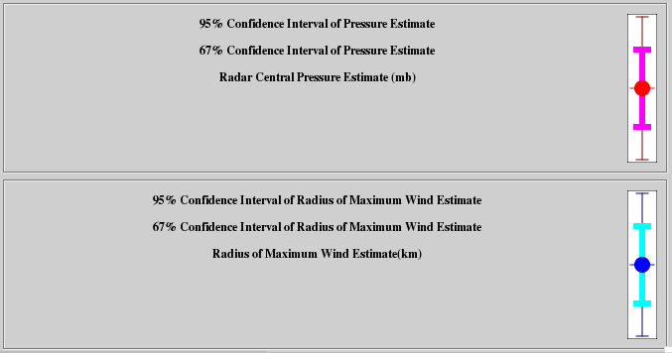
Figure 6. Pressure/RMW Legend

b. Current Cappi Display: Clicking on the right tab at the top of the graph switches to the Cappi display. This is a colored pixel map showing the quality-controlled Doppler velocities from the current radar volume at the lowest grid level. On the left side there are two numeric displays indicating the maximum approaching and receding velocities found in the Cappi. The color scale is set to plus/minus the largest of these values. The initial Cappi contains only the velocity information, but it is updated following the completion of the Simplex center search and Choosecenter operations. After a center is selected, it is denoted by an ‘X’ in the display. This ‘X’ should be roughly between the velocity couplet near the zero Doppler velocity contour. Surrounding the center location are two gray circles indicating the minimum and maximum Simplex search radii. These should bracket the maximum velocities observed in the display. If the annulus defined by the rings is too narrow or shifted inside or outside the area of maximum velocities, they should be updated immediately using the Configuration dialog. A third white circle is also displayed, indicating the edge of the VTD analysis. Internal checks prohibit analysis where the velocities cover less than 180 degrees of the storm or geometric occurs near the radar, but the program will attempt to analyze data out to this radii. A value of 80 km is typical, but could be extended in some circumstances with excellent radar coverage.

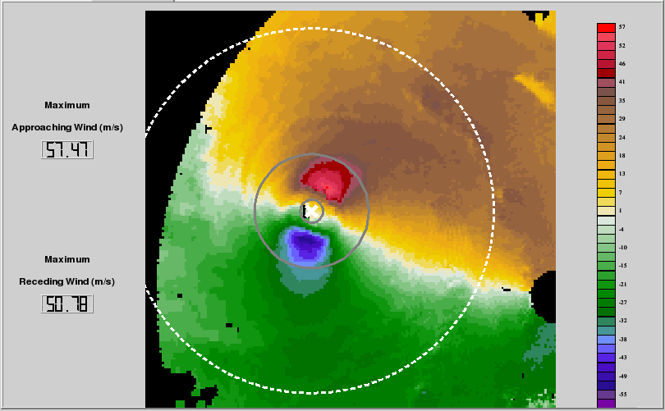
Figure 7. Current Cappi Display from Hurricane Charley 13 Aug. 2004, 14Z, Key West radar (KBYX)

iii. Status Display

This area contains additional information for the user to determine the quality of the analysis and display potential meteorological warnings for rapidly changing storms. The radar volume coverage pattern (VCP) is displayed on the left side of the display so that changes in the scanning strategy which might affect the analysis can be monitored. Below that is the Storm Signal, which conveys information about the hurricane itself. Figure 8 shows one potential warning that indicates the storm is out of range of the radar. An estimate of the time before analysis can begin is also given, based on a linear extrapolation of the given storm motion. The Storm Signal changes to ‘OK’ once the analysis begins. Additional indicators include rapid intensification or weaking, defined by user-configurable pressure changes over a specified period of time (3 mb/hr default).
The Status Signal is a ‘stoplight’ that gives information about program operation. When Green, all internal checks are satisfied and the analysis is proceeding smoothly. A Yellow indicator is accompanied by a message that informs of a failure that is not critical to continued operation. This may be caused by a faulty radar volume and may be returned to Green shortly, but continued Yellow status indicates continued failures and may require aborting and restarting the program. A Red signal indicates a serious failure and ends any running analysis. This will most likely occur at the beginning of a run due to improper configuration. More information on error codes is given in Section 4C.
Beneath the Analysis display is a scrolling Status log (also written to a file) that documents the program operation. A Progress bar shows the stage of the current analysis. The multiple status displays are designed to quickly yield information about the quality of the analysis results. A combination of a Green Status signal and rapid intensification Storm signal could indicate structural changes in the hurricane. With a Yellow light, it might just indicate a failure in one of the algorithms leading to a false warning.

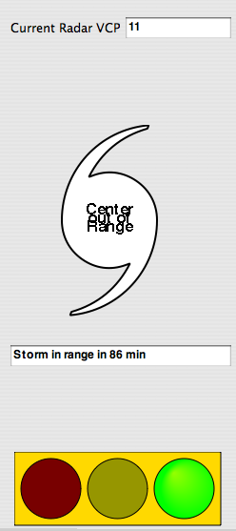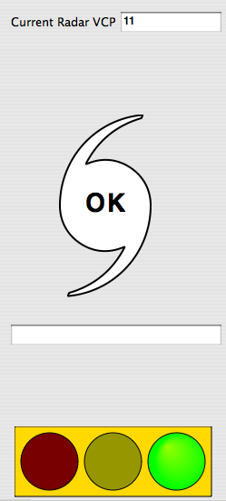
Figure 8. (a) Storm Signal indicating hurricane is out of range of radar; Status signal indicating program is operating properly, and (b) hurricane has come into range and analysis has started.

D. Modifying the Configuration

There are two ways to modify the XML configuration file which controls the program operation: (1) manually with a text editor or script, or (2) via the GUI interface. It is not recommended to change the file manually during program operation since the values are stored in memory once the analysis begins, but certain parameters can be modified ‘on-the-fly’ while the program is running. Configuration options that should not be modified after the program starts are blanked out and disabled. Technical details on all of the configurable parameters are described in Sec. 4. There is a one-to-one mapping of the displayed parameters in the GUI to the nodes in the XML file. The default configuration has several blank parameters that are filled in when the user loads the file, but all values are filled and written once the file is saved.
The program can be operated with a minimum number of changes to the default values. The mandatory changes are described under Basic Operation in Sec. 2A. The most common other change would be to the simplex search radii under the Simplex Configuration Panel. The minimum and maximum search radii define an annulus that should bracket the radius of maximum wind. The maximum width of the annulus is 30 km for memory and computational reasons. Inspection of the Doppler velocity and Simplex search rings on the Current Cappi display should show the maximum velocities inside the annulus. If not, the radii should be shifted or widened accordingly. Other configuration options should only be adjusted after careful review of Sec 4A and considerable experience with the program and algorithms.

E. Starting, Stopping & Restarting

VORTRAC was designed to run simply, and hence there are only two buttons controlling the primary operation: ‘Run’ and ‘Abort’. The most challenging time for the analysis is at the beginning, due to limited radar coverage and motion statistics. The Simplex algorithm may fail within the first few volumes, requiring the user to Abort the analysis and adjust the initial position. This may be as simple as changing the Start time, to ensure that the specified observation is used, but may require inputting a new position. This should not require a full Close and Open of the Configuration, however. If the Start time is changed, the analysis will begin anew without regard to the previous products. Once the analysis ‘takes hold’ of the circulation, it can run for many hours without intervention. For weaker storms or at those at the edge of the Doppler domain, it may require some restarts during the initial period. Due to the long times involved for some hurricane landfalls, the XML output products can be reloaded following a crash or manual restart, however. In this instance, the program will ask if the user would like to continue a previous run if there are existing output products with the same start time. Multiple ‘Abort’ and ‘Run’ sequences may cause some unstable program behavior due to resident memory issues. It is recommended that the user start the program over if multiple aborts are necessary.

G. Saving Products & Trials

All of the analysis products are saved to ascii files, mostly XML, as well as the Status log. These products can be found in the designated working directory, and can be viewed by any text editor or XML reader. Archived cases can be reloaded later as described above in Sec. 2E. Since the focus of VORTRAC was real-time operations, individual algorithms cannot be run separately at this time. However, the object oriented software design could allow for different modes of operation in the future.
3. Algorithm Components
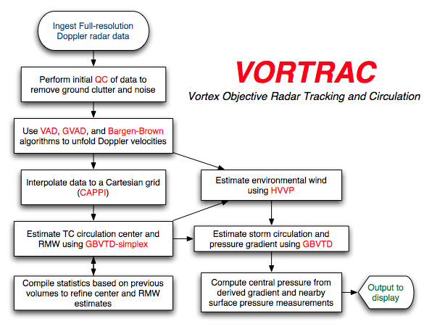
Figure 9. VORTRAC Algorithm Outline

A. GBVTD

The GBVTD technique provides an objective approach to estimate the primary circulation of TCs from single-Doppler velocity patterns. The GBVTD technique uses the least squares method to fit the primary TC circulation onto the Doppler velocities on a ring with constant radius from the TC center. The along-beam environmental wind and the axisymmetric radial and tangential winds can be retrieved for each radius and altitude. The asymmetric radial flows and the across-beam environmental can not be resolved, and they also alias into the tangential along-beam environmental winds. These quantitative TC structures cannot be retrieved from a pattern recognition method. The GBVTD technique retrieves good total wind in nearly all cases tested. It has been shown that the GBVTD technique is able to retrieve unsampled wind maxima that were not directly observed by a Doppler radar because it retrieves wind maximum using the tendency embedded in the Doppler velocity pattern, not relying on the observed absolute maxima or minima. This characteristic, in conjunction with the ability to identify basic TC structures, are the two most important advantages of using the GBVTD technique over the conventional pattern recognition methods in nowcasting landfalling TCs.
The TC axisymmetric tangential winds are governed approximately by gradient wind balance. Hence, the perturbation pressure of a TC can be computed from the GBVTD-retrieved axisymmetric tangential winds. The bias in the axisymmetric tangential wind due to the across-beam environmental wind is corrected by utilizing the environmental wind estimate provided by the HVVP method (described in section D). Given environmental surface pressures near the exterior of the domain, one can then estimate the absolute central surface pressure from the perturbation pressure field derived from the Doppler velocities.

B. GBVTD-Simplex

The TC circulation center can be defined as a point that possesses the maximum overall axisymmetric tangential wind. For each given TC center, the GBVTD technique can derive a corresponding axisymmetric tangential wind at certain radius. The GBVTD-simplex algorithm conducts a simplex search of a constant altitude Doppler velocity field in order to find the circulation center that maximizes the retrieved axisymmetric tangential wind for a given radius. Since there may be multiple local relative maxima in the wind field, the search is started from different initial locations in order to find a consensus of centers that are associated with the absolute tangential wind maximum for that ring. The consensus location is determined by calculating the mean location of the search results, removing centers beyond 1 standard deviation from that mean, and recalculating. The resulting reduced standard deviation and number of centers used in the final calculation (hereafter referred to as “converging centers”) is retained in addition to the mean location, and is used to determine the quality of the consensus. The mean tangential wind associated with these points is also calculated, and this process is repeated for multiple rings in order to construct a radial profile of axisymmetric tangential wind. The RMW can be identified from this profile, and a center associated with the annulus about that radius is selected as the best estimate of the TC circulation center. Dependent on TC and radar characteristics, the user can modify the width of the annulus, maximum allowable data gaps, and number of initial guesses.
The GBVTD-simplex algorithm therefore provides multiple possibilities for the location of the TC circulation center. Using 16 initial guesses and allowing a range of 20 km for the RMW yields 320 possible centers for each radar volume and height. A single location must therefore be determined from the significant amount of output provided by the GBVTD-simplex searches.

C. Choose Center

The ‘Choose Center’ algorithm is an extension of the GBVTD-simplex TC circulation center finding algorithm that further improves the accuracy and consistency of TC center estimates from single Doppler radar data. This improved algorithm considers all possible TC centers from the GBVTD-simplex output over a period of time to ensure spatial and temporal continuities on four primary TC characteristics: the radius of maximum wind, the maximum axisymmetric tangential wind, the latitude and longitude of the TC circulation center. Four independent polynomial fits on these four parameters are performed to establish the most probable solutions and the degrees of scattering at each analysis time. Then, a normalized membership function is constructed for each parameter for all possible GBVTD-simplex TC centers. Finally, the center that possesses the highest total score of the four membership function is selected as the optimal center at each analysis time. The newly employed statistical analysis improves the consistency of the TC centers over time since the polynomial fits can be updated as new observations become available. Hence, it is possible to automate the GBVTD-simplex algorithm once reasonable statistics of these four parameters are established for landfalling TCs.
The characteristics and performance of this improved algorithm were evaluated using datasets from Hurricane Danny (1997) and Bret (1999) during several-hour periods where both storms were observed by two coastal WSR-88Ds simultaneously. Independent centers were computed and used to assess the absolute accuracy of the GBVTD-simplex algorithm. It was found that statistics over 3 hours (~30 observations) yielded 47% and 13% improvements for Danny and Bret, respectively, over the original GBVTD-simplex method. The uncertainty in circulation center estimates depends on the TC intensity, with a mean uncertainty from 1.16 km for Bret (category 3 on the Saffir-Simpson scale) to 1.67 km for Danny (category 1). This resolution yields mean errors of less than 5% in the retrieved RMW and axisymmetric tangential wind, and ~30% error in the wavenumber one asymmetric component.

D. HVVP

A vertical profile of the horizontal wind directly above a single-Doppler radar can be estimated from the Doppler velocity data by making assumptions about the wind field. The Velocity Azimuth Display (VAD - Browning and Wexler 1968) and the Volume Velocity Processing (VVP – Waldteufel and Corbin 1979; Koscielny et al. 1982) methods were developed around the assumption of linearity; that is, the wind field is estimated from a first-order Taylor series expansion of its components. The VVP method is an extension of the VAD method that involves an analysis of full-volume Doppler velocity data. It provides estimates of many of the kinematic properties of the wind field that are not extractible in the VAD scheme, such as the vertical variations in the wind field. Donaldson and Harris (1989) showed that the VAD method could also be applied to nonlinear wind fields that included combinations of axisymmetric curvature, diffluence and shear that are likely found in hurricanes. Building upon these results and the findings of Donaldson (1991), Harasti and List (1995) derived explicate expressions for the wavenumber zero wind components and their parameters in terms of the VAD coefficients. This work led to the development of the Hurricane-customized Extension of the VAD (HEVAD) method (Harasti and List 2001). The HEVAD method provides vertical profiles of the wavenumber zero components of the swirling hurricane wind and the environmental wind at the radar-origin of coordinates. Just as VVP is the next logical extension of VAD, the Hurricane VVP (HVVP – Harasti 2003) is the full-volume extension of the HEVAD method. The complete separation of the zeroth-, first-, and second-order (non-linear) Taylor Series coefficients of the Cartesian wind components (u and v) in HVVP, including the allowance for vertical variations, provides for a more robust alternative to HEVAD. The coefficients of the HVVP least squares fit to the Doppler velocity data are related to the equation parameters of an analytic model that assumes that the wind can be well-approximated by a superposition of a uniform environmental wind with a modified Rankine vortex that includes particular asymmetries in the azimuthal direction, concentric to the circulation center. The environmental wind vector is estimated by removing HVVP’s estimate of the modified Rankine vortex from u and v. Irrotational wavenumber one asymmetries that have properties described by Lamb (1932, Article 158) have been shown analytically to not bias the HVVP environmental wind estimates. An uncertain degree of bias is possible though for other types of asymmetries; numerical simulations are planned in the future to quantify any biases that may occur in other situations.

E. Quality Control Methodology

The Doppler velocity data are thresholded according to the Quality Control Parameters settings section of the QUALITY CONTROL CONFIGURATION PANEL (see section 4A) in order to remove noise and ground clutter. The Doppler velocity are de-aliased according to the Bargen and Brown (1980) method. This method requires a reference wind field to initial the procedure. The reference wind is derived from either the gradients of VAD (GVAD) method of Gao et al (2004), the VAD method, or a manually inserted estimate of the boundary layer wind. The accuracy of this estimate should be approximately 3 m/s in speed and 30° in direction. The choice of method is selected by the user in the Method For Finding Reference Wind section of the QUALITY CONTROL CONFIGURATION PANEL. The default reference wind is provided by GVAD.

F. Uncertainty calculation

The uncertainty of the RMW results is taken directly from the variance of the polynomial curve fits used in the Choose Center algorithm, with a minimum of +/- 0.5 km sigma due to the grid spacing of the analysis. Pressure uncertainty is more problematic, since it depends on many factors including radar data quality, center error, aliasing from asymmetries, HVVP environmental wind uncertainty, gradient wind balance assumption, and anchor pressure variability. Here we assume that radar data quality is good, and that the primary sources of uncertainty are believed to be center error and anchor pressure variability. The standard deviation of the derived pressure estimate is calculated by perturbing the center 1.5 km in each cardinal direction and recalculating the pressure gradient. These four estimates are then subtracted from each anchor pressure yielding multiple ‘samples’ of the central pressure. The standard deviation from the best estimate from this Monte Carlo approach is used to calculate the 67% and 95% confidence intervals. In the absence of anchor pressures 1013 hPa is used and the sigma is set to 5 hPa, however, attention should be focused on the pressure deficit estimates instead since the true values of the absolute pressure could be out of the bounds of the confidence intervals of the absolute pressure estimates in this situation. Poor radar velocity unfolding or significantly erroneous center placement may yield higher errors, but these are difficult to quantitatively determine.
4. Technical Documentation

A. VORTRAC XML Configuration File

All entries are organized as they appear on the panel that contains them
XML Label: Tag name that appears in XML file (default xml value)
Panel Label: Label that appears on panel
Range: Range of Acceptable Values for the Parameter
Description: Description of parameter and its participation in the software

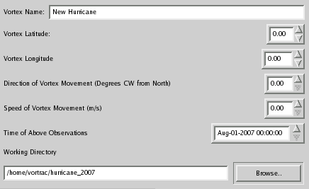
Figure 10. Vortex Configuration Panel

VORTEX CONFIGURATION PANEL (XML Node: “vortex”)
The VORTEX CONFIGURATION PANEL holds several parameters that are used to identify, locate and track the storm circulation. The user can set the name of the storm on this panel in addition to the working directory for the VORTRAC analysis. Other parameters on this panel help VORTRAC to initially locate the tropical cyclone.

XML Label: name (default: New Hurricane)
Panel Label: Vortex Name
Description: This parameter holds the name of the tropical cyclone that VORTRAC is tracking. This parameter is used internally for labeling and also for labeling various output files.

XML Label: lat (default: 0 deg)
Panel Label: Vortex Latitude
Range: [-90, 90] deg
XML Label: lon (default: 0 deg)
Panel Label: Vortex Longitude
Range: [-180, 180] deg
Description: These parameters hold the first observation latitude and longitude of the tropical cyclone. The latitude and longitude of the storm given here should correspond with the time shown in “Time of Above Observation” so that VORTRAC can accurately locate the tropical cyclone. VORTRAC accepts latitude (longitude) in a decimal format where a negative value is in the Northern (Western) hemisphere and a positive value is in the Southern (Eastern) hemisphere. Initializing the VORTRAC analysis with an accurate storm location and time is required for a successful run and the accuracy of these parameters affects VORTRAC's ability to follow the storm as it evolves.

XML Label: direction (default: 0 deg)
Panel Label: Direction of Vortex Movement (Degrees CW from North)
Range: [0, 359.9] deg
XML Label: speed (default: 0 m/s)
Panel Label: Speed of Vortex Movement (Degrees CW from North)
Range: [0, 100] m/s
Description: These parameters should hold the direction and speed of the initial storm movement. These measurements should correspond with the time set in “Time of Above Observation” so that VORTRAC can accurately follow the tropical cyclone. While these parameters are not required for a successful run, it is highly recommended that the user obtain this information about the storm. These parameters are particularly useful when the initial observation (observation time, latitude and longitude on the VORTEX panel) is outside of the range of the Doppler radar. When the initial observation is outside Doppler range VORTRAC will linearly interpolate the initial position based on direction of storm movement and storm speed until the circulation enters the Doppler range of the radar.

XML Label: obsdate (default: current date UTC)
Panel Label: Time of Above Observation
Range: Any Valid Date (format: YYYY-MM-DD)
XML Label: obstime (default: current time UTC)
Panel Label: Time of Above Observation
Range: Any Valid UTC Time (format: HH:MM:SS)
Description: These parameters are used to set the time of the initial observation which is described by Vortex Latitude, Vortex Longitude, Vortex Speed and Vortex Direction parameters contained in this panel. If this time of observation occurs before the starting time in RADAR CONFIGURATION PANEL, then VORTRAC will attempt to interpolate a starting location that is in the Doppler domain after the indicated initial time in the RADAR CONFIGURATION PANEL.

XML Label: dir (default: 'default' sets to current working directory at run time)
Panel Label: Working Directory
Range: Any directory where the user has permission to read and write files
Description: This parameter holds the location of the working directory which will contain many of the products and temporary files that VORTRAC uses during a run. When other directories in the configuration are left on the default setting they will default to subdirectories of this working directory. It is recommended that the user not change the working directory once a run has begun processing because this can cause difficulties in locating data products and intermediates. The working directory is also important when restarting an old run, since VORTRAC will search the working directory for traces of previous runs to restart.

RADAR CONFIGURATION PANEL (XML Node: “radar”)
The RADAR CONFIGURATION PANEL contains many parameters that give VORTRAC the information it requires about the radar that is capturing Doppler data containing the tropical cyclone of interest. The parameters in this panel include information about the location of the radar, the location of data from this radar on the local network, and parameters that control which radar volumes are used for analysis.

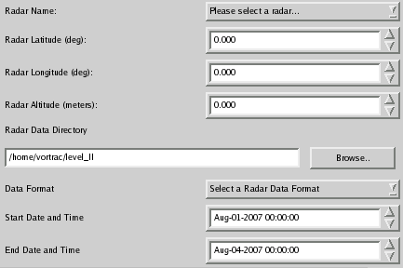
Figure 11. Radar Configuration Panel

XML Label: name (default: WSR-88D)
Panel Label: Radar Name
Range: Any four letters (preferably radar call letters)
Description: This parameter is intended to hold the radar call letters for WRS-88D radar that is being used to observe the storm. The drop down box in the RADAR CONFIGURATION PANEL can be used to select from several existing radars near the Atlantic and Gulf coasts. Additionally the user may choose to add new radars to this list by clicking 'Other Radar ...' and entering or editing parameters as necessary. The radar call letters entered here are used for identifying radar volume data, in addition to internal labeling and naming data products, so entering these correctly is highly recommended.

XML Label: lat (default: 0 deg)
Panel Label: Radar Latitude (deg)
Range: [-90, 90] decimal degrees
XML Label: lon (default: 0 deg)
Panel Label: Radar Longitude (deg)
Range: [-180, 180] decimal degrees
XML Label: alt (default: 0 m)
Panel Label: Radar Altitude (meters)
Range: [-999, 999] m
Description: These three parameters describe the location of the radar in latitude, longitude and altitude. They will be automatically set when a radar is selected from the radar name drop box. These can be manually adjusted in the panel or in the radar list dialog which can be accessed by choosing 'Other Radar ...' in the Radar Name drop box. These three parameters are all required to successfully run VORTRAC.

XML Label: dir (default: 'default')
Panel Label: Radar Data Directory
Range: Any existing directory where the user has read permissions
Description: This parameter should hold the name of the directory that contains the level II radar data from the radar specified in this panel. The level II data in this directory should be the same format as that selected in the format drop box on this panel. Additionally, the level II data should be named in the following format:
KXXXyyyyMMdd_hhmmss
Where KXXX is the station call letters specified in the radar name parameter. The call letters are followed by the UTC time stamp of the volume in above format. This parameter will default to the working directory if no other directory is given.

XML Label: format (default: LEVELII)
Panel Label: Data Format
Range: [LDMLEVELII, NCDCLEVELII]
Description: This parameter is used to select the radar data format of the files contained in the directory specified in dir. These formats are explained in greater detail in Sec 1A. This is a required parameter, selecting a format that doesn't correspond with the files located in the Radar Data Directory will cause VORTRAC to run improperly.

XML Label: startdate (default: current date UTC, format: YYYY-MM-DD)
XML Label: starttime (default: current time UTC, format: HH:MM:SS)
Panel Label: Start Date and Time
Range: Any valid date and time
Description: These date and time parameters indicate the earliest time stamp that a volume of level II radar data may have in order to be processed by VORTRAC. This parameter is intended to help the user control which volumes are read in by VORTRAC for each analysis.

XML Label: enddate (default: current date UTC + 3 days, format: YYYY-MM-DD)
XML Label: endtime (default: current time UTC, format: HH:MM:SS)
Panel Label: End Date and Time
Range: Any valid date and time
Description: These date and time parameters indicate the latest time stamp that a volume of level II radar data may have in order to be processed by VORTRAC. This parameter is intended to help the user control which volumes are read in by VORTRAC for each analysis.

CAPPI CONFIGURATION PANEL (XML Node: “cappi”)
The CAPPI CONFIGURATION PANEL contains parameters that are used in building a Common Altitude Plan Position Indicator from the volumes of level II radar data prior to full VORTRAC processing. The parameters below control the dimension of the CAPPI, how the points in CAPPI are interpolated from the radar volume, and where the CAPPI outputs are stored.

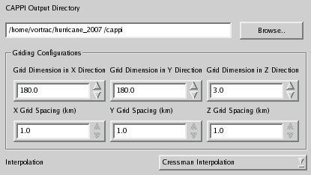
Figure 12. CAPPI Configuration Panel

XML Label: dir (default: default)
Panel Label: CAPPI Output Directory
Range: Any directory where the user has read and write permission
Description: This directory will be used to store CAPPI output files in the .asi format. More information on the .asi format can be found in Sec 1A. When the xml parameter dir is set to 'default' this directory will default to subdirectory of the working directory selected in the VORTEX CONFIGURATION PANEL. If such a subdirectory does not exist, one will be created. The user can also choose to adjust this directory independent of the main working directory.

XML Label: xdim (default: 150)
Panel Label: Grid Dimension in X Direction
Range: [0, 256]
XML Label: ydim (default: 150)
Panel Label: Grid Dimension in Y Direction
Range: [0, 256]
XML Label: zdim (default: 3)
Panel Label: Grid Dimension in Z Direction
Range: [0, 20]
Description: These three parameters allow the user to adjust the size of the CAPPI used in the analysis. The default dimensions are intended to meet the needs of the 'average' circulation, but these parameters can be adjusted to meet specific needs. Larger grids provide more data for analysis, but they also increase processing times considerably.

XML Label: xgridsp (default: 1.0 km)
Panel Label: X Grid Spacing (km)
XML Label: ygridsp (default: 1.0)
Panel Label: Y Grid Spacing (km)
XML Label: zgridsp (default: 1.0)
Panel Label: Z Grid Spacing (km)
Description: These values control the grid spacing of the CAPPI. Currently these value are fixed at 1 km, but VORTRAC's functionality may be expanded later to allow adjustments in these parameters.

XML Label: interpolation (default: cressman)
Panel Label: Interpolation
Range: [cressman]
Description: This parameter contains the interpolation method used for mapping data from the level II radar volume to the CAPPI for further processing. Currently Cressman interpolation is the only option for interpolating.

SIMPLEX CONFIGURATION PANEL (XML Node: “center”)
The 'SIMPLEX CONFIGURATION PANEL' contains parameters that control several aspects of the automated search for the tropical cyclone circulation center within each radar volume. This algorithm uses the GBVTD algorithm to repeatedly compare different locations and radii in order to find the best circulation center. The parameters in this panel control how the GBVTD algorithm is used in addition to aspects of the search algorithm.

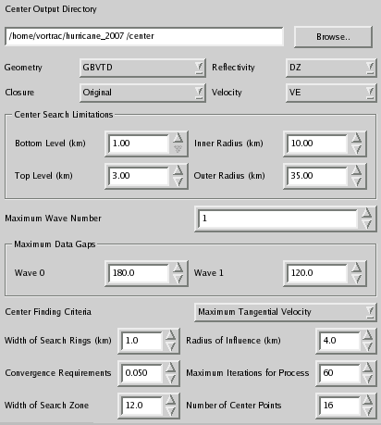
Figure 13. Simplex Configuration Panel

XML Label: dir (default: 'default')
Panel Label: Center Output Directory
Range: Any directory where the user has read and write permission
Description: This parameter stores the directory where the results of each simplex search will be stored. These files are intermediates which are only valuable to the advanced user, but if they are discarded the user will be unable to restart the VORTRAC run. A list of these files are stored in the working directory (file ending in simplexList.xml). This directory will default to use or create a center subdirectory in the working directory if its value is not altered.

XML Label: geometry (default: GBVTD)
Panel Label: Geometry
Range: [GBVTD]
Description: This parameter holds the geometry for the VORTRAC analysis. Currently only the GBVTD geometry is implemented so this parameter should not be changed.

XML Label: closure (default: original)
Panel Label: Closure
Range: [original]
Description: This parameter holds the closure assumption to be used in the VORTRAC analysis. Currently only the original closure assumption is available for use. This closure assumption is used in the simplex search for the vorticity center. For more about closure assumptions see Sec. 3A Algorithm Overview.

XML Label: reflectivity (default: DZ)
Panel Label: Reflectivity
Range: [DZ]
Description: This parameter holds the letters that identify the reflectivity data within the radar volumes. There is currently only one option for this parameter but it may be expanded later to suit user needs.

XML Label: velocity (default: VE)
Panel Label: Velocity
Range: [VE]
Description: This parameter holds the letters that identify the velocity data within the radar volumes. There is currently only one option for this parameter but it may be expanded later to suit user needs.

XML Label: bottomlevel (default: 1 km)
Panel Label: Bottom Level (km)
Range: [1, 5] km
XML Label: toplevel (default: 3)
Panel Label: Top Level (km)
Range: [2, 20] (km)
Description: These two parameters control which height range within the CAPPI is used in the SIMPLEX search algorithms. The user can adjust these parameters, but the total number of levels used cannot exceed 20 due to memory constraints. Examining a greater number of levels may provide greater accuracy, but at the cost of computation time. The default values for these parameters should be appropriate for most cases. The user should also be cautioned that trying to examine levels outside of those contained in the CAPPI could yield undesirable results due to absent data.

XML Label: innerradius (default: 10)
Panel Label: Inner Radius (km)
Range: [1, 120]
XML Label: outerradius (default: 35)
Panel Label: Outer Radius (km)
Range: [2, 150]
Description: These two parameters control the range that the SIMPLEX algorithm searches for a circulations radius of maximum wind. These parameters should be adjusted based on outside information on the approximate radius of the tropical cyclone. If a cyclone's RMW is not enclosed in this range SIMPLEX is unlikely to accurately locate a center. These are required parameters, they should also be adjusted if the storm changes size during the analysis. The SIMPLEX radius search range is displayed on the CAPPI DISPLAY once VORTRAC has completely processed a volume. This visual display should help the user locate the best radius range for subsequent simplex searches.

XML Label: ringwidth (default: 1.0 km)
Panel Label: Width of Search Rings (km)
Range: [0.01, 10.00] km
Description: This parameter controls the width of the search ring for each radius search preformed by the SIMPLEX algorithm. This parameter does not change the ring spacing (SIMLEX will search in 1 km increments between the Inner Radius and the Outer Radius). This parameter controls the thickness of the annuli of data points from the CAPPI that are used for each search. It may be useful to increase this value when data in the region of interest is very sparse. However, increasing this value significantly may cause greater uncertainty in the radius of maximum wind.

XML Label: search (default: MAXVT0)
Panel Label: Center Finding Criteria
Range: [MAXVT0]
Description: This parameter contains the criteria that simplex searches for when attempting to locate the tropical cyclone center. Currently the only available option is MAXVT0. This selection indicates that the SIMPLEX search will attempt to locate the tropical cyclone based on the greatest primary circulation wind that it can locate during its search.

XML Label: influenceradius (default: 4.0)
Panel Label: Radius of Influence (km)
Range: [2, 10] km
Description: This parameter controls the initial spacing of points in the SIMPLEX search algorithm. While this parameter can be adjusted to begin searching smaller or greater areas based on user needs, it is recommended that this parameter only be adjusted by advanced users.

XML Label: convergence (default: 0.05)
Panel Label: Convergence Requirements
Range: [0.001, 2.000]
Description: This parameter controls the extent of the convergence of centers required by the SIMPLEX algorithm for agreement between separate searches. While this parameter can be adjusted to require more or less convergence based on user needs, it is recommended that this parameter only be adjusted by advanced users.

XML Label: maxiterations (default: 60)
Panel Label: Maximum Iterations for Process
Range: [10, 100]
Description: This parameter sets the maximum number of iterations possible within a SIMPLEX search. Increasing this parameter may increase computation time. It is recommended that this parameter only be adjusted by advanced users.

XML Label: boxdiameter (default: 12.0 km)
Panel Label: Width of Search Zone (km)
Range: [9, 25]
XML Label: numpoints (default: 16)
Panel Label: Number of Center Points
Range: [1, 25]
Description: These two parameters control the distribution of initial SIMPLEX searches that are independently run to locate the circulation center. The Width of Search Zone parameter controls the width of the initial range where SIMPLEX searches are started. The Number of Center Points parameter controls the number of starting points distributed within this box. It is recommended that these parameters only be changed by advanced users, the defaults should perform well for most cases.

XML Label: maxwavenum (default: 1)
Panel Label: Maximum Wave Number
Range: [0, 4]
XML Label: maxdatagap (default: 0 deg)
Panel Label: Wave #
Range: [0, 359] deg
Description: These parameters control how much data can be missing within a ring of analysis at each wave number. The Maximum Wave Number controls the order of the Fourier fit used to calculate the winds at each ring. The SIMPLEX CONFIGURATION PANEL will hold multiple Wave # boxes corresponding to the value assigned maxwavenum. The maximum data gap for each wave number should be assigned based on an understanding of how missing data affects the quality of the fit. The defaults should work well form most cases.

CHOOSE CENTER CONFIGURATION (XML Node: “choosecenter”)
The parameters in the CHOOSE CENTER CONFIGURATION PANEL determine how information from previous volumes is used to choose the best simplex center for the currently processing volume. The parameters in this panel control how VORTRAC locates the best fit center based on a polynomial fit of previous volumes' position, radius of maximum wind, and wind speeds. To obtain the best balance of characteristics in this fit we recommend leaving the parameters in this panel on the defaults which have been thoroughly tested.

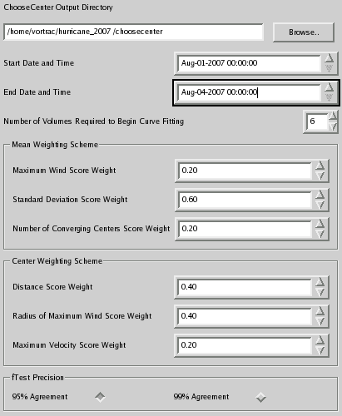
Figure 14. Choose Center Configuration Panel
XML Label: dir (default: 'default')
Description: This parameter designates a directory where the user has read and write permissions to store choose center intermediate outputs and diagnostics. This parameter is not currently implemented.

XML Label: startdate (default: current date UTC, format: YYYY-MM-DD)
XML Label: starttime (default: current time UTC, format: HH:MM:SS)
Panel Label: Start Date and Time
Range: Any valid date and time
Description: These date and time parameters indicate the earliest time stamp that a volume of radar data may have in order to be included in the polynomial fit. This parameter is intended to help the user control which results are used to guide the center finding algorithm for future volumes. We recommend excluding volumes where the circulation center is near the edge of the radar range.

XML Label: enddate (default: current date UTC + 3 days, format: YYYY-MM-DD)
XML Label: endtime (default: current time UTC, format: HH:MM:SS)
Panel Label: End Date and Time
Range: Any valid date and time
Description: These date and time parameters indicate the latest time stamp that a volume of radar data may have in order to be included in the polynomial fit. This parameter is intended to help the user control which results are used to guide the centering algorithm for future volumes. We recommend excluding volumes where the circulation center is near the edge of the radar range.

XML Label: min_volumes (default: 6)
Panel Label: Number of Volumes Required to Begin Curve Fitting
Range: [3, 100]
Description: This parameter controls the minimum number of volumes that must process successfully before curve fitting begins. The user can avoid curve fitting by setting this parameter higher than the number of volumes he expects to process.

XML Label: wind_weight (default: 0.20)
Panel Label: Maximum Wind Score Weight
XML Label: stddev_weight (default: 0.60)
Panel Label: Standard Deviation Score Weight
XML Label: pts_weight (default: 0.20)
Panel Label: Number of Converging Centers Score Weight
Range: [0.0, 1.0]
Description: This set of weights determines the mean centers and the radius of maximum wind on each level of the CAPPI from the centers located by the SIMPLEX algorithm. The sum of all three of these weights should add to one. Adjusting these weights allows the user to put greater emphasis on a specific characteristic when determining the location of the circulation center and corresponding radius of maximum wind. It is recommended that these parameters only be adjusted by the advanced user.

XML Label: position_weight (default: 0.40)
Panel Label: Distance Score Weight
XML Label: rmw_weight (default: 0.40)
Panel Label: Radius of Maximum Wind Score Weight
XML Label: vt_weight (default: 0.20)
Panel Label: Maximum Velocity Score Weight
Range: [0.0, 1.0]
Description: This set of weights determines the fitted center and radius of maximum wind on each level of the CAPPI based on information from previously processed volumes. The sum of all three of these weights should add to one. A polynomial fit is constructed based no the position, radius of maximum wind, and the maximum wind from all previous volumes included in the fit to determine the best circulation center of those located by simplex. Adjusting these parameters will effect which characteristics are given a greater emphasis is determining the best center, it is recommended that these parameters only be adjusted by the advanced user.

XML Label: stats (default: 95)
Panel Label: fTest Precision
Range: {95, 99} %
Description: This parameter determines the statistical significance level required to increase the order of the polynomial curve fits used to constrain the selected centers. The higher significance level results in a stricter requirement, and therefore most likely a lower order fit. It is recommended that this parameter only be adjusted by the advanced user.
VTD CONFIGURATION PANEL (XML Node: “vtd”)
The VTD CONFIGURATION PANEL contains parameters that control the final use the GBVTD algorithm to determine the winds and ultimately the pressure deficit of the circulation center and selected by the Choose Center and Simplex algorithms.

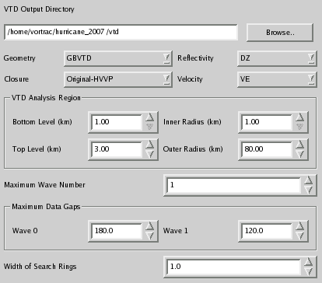
Figure 15. VTD Configuration Panel

XML Label: dir (default: 'default')
Panel Label: VTD Output Directory
Range: Any directory where the user has read and write permission
Description: This parameter stores the directory where the results of the final GBVTD search will be stored. These files are intermediates which are only valuable to the advanced user, but if they are discarded the user will be unable to restart the VORTRAC run. A list of these files are stored in the working directory (file ending in vortexList.xml). This directory will default to use or create a center subdirectory in the working directory if its value is not altered.

XML Label: geometry (default: GBVTD)
Panel Label: Geometry
Range: [GBVTD]
Description: This parameter holds the geometry for the VORTRAC analysis. Currently only the GBVTD geometry is implemented so this parameter should not be changed. This parameter controls the same functionality as the parameter of the same name in the SIMPLEX Configuration Panel, but is only used in the final calculation of the circulation winds.

XML Label: closure (default: original_hvvp)
Panel Label: Closure
Range: {original, original_hvvp}
Description: This parameter holds the closure assumption to be used in the VORTRAC analysis. Selecting the 'original' closure assumption assumes the component of the environmental wind perpendicular to the radar's line of view to the storm is negligible. Selecting 'original_hvvp' allows VORTRAC to use the HVVP algorithm to calculate this environmental wind component. This closure assumption is used in the GBVTD final analysis of the selected vorticity center. For more about closure assumptions see Sec. 3A Algorithm Overview. This parameter controls the same functionality as the parameter of the same name in the SIMPLEX CONFIGURATION PANEL, but is only used in the final calculation of the circulation winds. The 'original_hvvp' closure assumption is not available in the simplex search because it increases calculation times considerably.

XML Label: reflectivity (default: DZ)
Panel Label: Reflectivity
Range: [DZ]
Description: This parameter holds the letters that identify the reflectivity data within the radar volumes. There is currently only one option for this parameter but it may be expanded later to suit user needs. This parameter controls the same functionality as the parameter of the same name in the SIMPLEX CONFIGURATION PANEL, but is only used in the final calculation of the circulation winds.

XML Label: velocity (default: VE)
Panel Label: Velocity
Range: [VE]
Description: This parameter holds the letters that identify the velocity data within the radar volumes. There is currently only one option for this parameter but it may be expanded later to suit user needs. This parameter controls the same functionality as the parameter of the same name in the SIMPLEX CONFIGURATION PANEL, but is only used in the final calculation of the circulation winds.

XML Label: bottomlevel (default: 1 km)
Panel Label: Bottom Level (km)
Range: [1, 5] km
XML Label: toplevel (default: 3)
Panel Label: Top Level (km)
Range: [2, 20] (km)
Description: These two parameters control which height range within the CAPPI is used in the final calculation of the circulation winds. The user can adjust these parameters, but the total number of levels used cannot exceed 15 due to memory constraints. Examining a greater number of levels may provide greater accuracy, but at the cost of computation time. The default values for these parameters should be appropriate for most cases. The user should also be cautioned that trying to examine levels outside of those contained in the CAPPI and those processed by SIMPLEX could yield undesirable results due to absent data.

XML Label: innerradius (default: 1)
Panel Label: Inner Radius (km)
Range: [1, 100]
XML Label: outerradius (default: 60)
Panel Label: Outer Radius (km)
Range: [2, 150]
Description: These two parameters control the range of radii that are included in the pressure deficit calculation using the final circulation winds. These parameters should be adjusted to encompass as much of the circulation as possible without exceeding memory limitations (current memory limitations are 150 rings). These are required parameters, they should also be adjusted if the storm changes size during the analysis. It is highly recommended that the user leave the inner radius at the 1 km default. The Outer VTD radius is displayed on the CAPPI DISPLAY once VORTRAC has completely processed a volume. This visual display should help the user locate the best radius range for analysis of subsequent volumes.

XML Label: ringwidth (default: 1.0 km)
Panel Label: Width of Search Rings (km)
Range: [0.01, 10.00] km
Description: This parameter controls the width of the search ring for each radius analysis preformed in the final calculation of circulation winds. This parameter does not change the ring spacing (VTD will extract information on circulation winds in 1 km increments between the Inner Radius and the Outer Radius). This parameter controls the thickness of the annuli of data points from the CAPPI that are used for each search. It may be useful to increase this value when data in the region of interest is very sparse. However, increasing this value significantly may cause greater uncertainty in the radius of maximum wind.

XML Label: maxwavenum (default: 1)
Panel Label: Maximum Wave Number
Range: [0, 4]
XML Label: maxdatagap (default: 0 deg)
Panel Label: Wave #
Range: [0, 359] deg
Description: These parameters control how much data can be missing within a ring of analysis at each wave number. The Maximum Wave Number controls the order of the Fourier fit used to calculate the winds at each ring. The VTD CONFIGURATION Panel will hold multiple Wave # boxes corresponding to the value assigned maxwavenum. The maximum data gap for each wave number should be assigned based on an understanding of how missing data affects the quality of the fit. The defaults should work well form most cases.

HVVP CONFIGURATION PANEL (XML Node: “hvvp”)
The parameters in the HVVP CONFIGURATION PANEL control how the HVVP algorithm selects horizontal layers of data in the vertical direction to analyze when calculating the environmental wind. The altitude AGL of the vertical mid-point of the layer is the effective “level” altitude. The parameter values are only used if “original-hvvp” is selected as the closure assumption in the VTD Configuration panel. For more information on how these parameters effect the calculations see the references on HVVP.

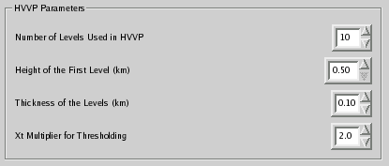
Figure 16. HVVP Configuration Panel

XML Label: levels (default: 10)
Panel Label: Number of Levels Used in HVVP
Range: [1, 50]
Description: This parameter controls the number of levels used in the HVVP analysis to calculate the crosswind component for the environmental wind.

XML Label: hgt_start (default: 0.5 km)
Panel Label: Height of the First Level (km)
Range: [0.5, 50.0] km
Description: This parameter controls the height of the first level of HVVP analysis.

XML Label: hinc (default: 0.1 km)
Panel Label: Thickness of the Levels (km)
Range: [0.01, 2.00]
Description: This parameter controls the thickness of each level used in the HVVP analysis.

XML Label: xt (default: 2)
Panel Label: Xt Multiplier for Thresholding
Range: [0,10]
Description: The HVVP algorithm applies a threshold against levels with an modified Rankine exponent, Xt, greater than this parameter times the standard deviation of Xt across all the levels examined.
PRESSURE CONFIGURATION PANEL (XML Node: “pressure”)
The parameters contained in the PRESSURE CONFIGURATION PANEL control how pressure estimates are calculated within the VORTRAC algorithm. This panel includes parameters that adjust the location of external pressure data feeds, in addition to parameters which control how pressure anchors are used and when pressure warning signals are displayed.

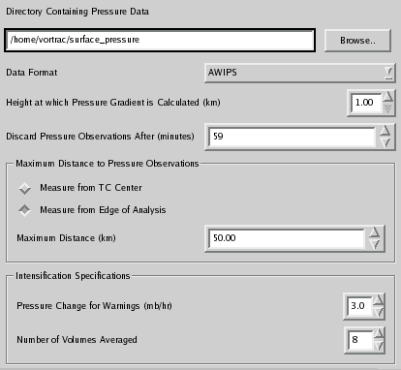
Figure 17. Pressure Configuration Panel

XML Label: dir (default: default)
Panel Label: Directory Containing Pressure Data
Range: Any directory where the user has read permissions
Description: This parameter is used to specify the directory that holds files containing the pressure anchor data for the tropical cyclone that is currently being processed. This directory will be repeatedly checked for any additional pressure data files while the algorithm is running.

XML Label: format (default: AWIPS)
Panel Label: Data Format
Range: [AWIPS, Hwind]
Description: This parameter indicates the format of the incoming pressure data that is found in the directory specified by the Directory Containing Pressure Data parameter. More information about the expected input format is found in Sec. 4B.

XML Label: height (default: 1 km)
Panel Label: Height at which Pressure Gradient is Calculated (km)
Range: [1, 20] km
Description: This parameter is used to specify the height that will be used when the pressure deficit is calculated. The height is measured in km above the radar. Best results are obtained when examining the lowest level containing viable data. Usually this is 1 km but in some circumstances the user may want to adjust this parameter.

XML Label: maxobstime (default: 59 min)
Panel Label: Discard Pressure Observations After (minutes)
Range: [1, 1000] minutes
Description: This parameter indicates the maximum number of minutes which can elapse between the time a volume is created and time of the external pressure observation used to anchor the VORTRAC pressure calculation. VORTRAC requires external pressure anchors to accurately calculate the central pressure of the circulation. The algorithm will use near by pressure observations in conjunction with the pressure gradient of the storm to calculate the central pressure. The pressure observations used to anchor the calculation of the central pressure for each volume are limited to those which were recorded maxobstime minutes before the volume.

XML Label: maxobsdist (default: 50 km)
Panel Label: Maximum Distance (km)
Range: [1, 1000]
Description: External pressure observations used to anchor the VORTRAC central pressure estimate are also weighted by the distance of the external observation from the tropical storm. This parameter specifies the maximum distance between a pressure measurement and the tropical cyclone being examined which permits the measurement to be used in the anchoring calculation. External pressure observations beyond this distance will not be used as part of the anchor pressure calculation.

XML Label: maxobsmethod (default: ring)
Panel Label: Maximum Distance to Pressure Observations
Measure from TC Center, Measure from Edge of Analysis
Range: [ring, center]
Description: Checking one of the two radio buttons in this box will set the method for deciding which pressure estimates should be used as anchors in the VORTRAC pressure calculation. If ‘Measure from TC Center’ is down only pressure within the Maximum Distance parameter value of the tropical cyclone center are used to calculate the anchor pressure for the VORTRAC central pressure estimate. If ‘Measure from Edge of Analysis’ is down then the pressure observations used in this calculation must be less than the Maximum Distance parameter value from the edge of the VORTRAC analysis domain (described in VTD Configuration Panel in the Outer Radius parameter).

XML Label: av_interval (default: 8)
Panel Label: Number of Volumes Averaged
Range: [3, 12]
Description: This parameter holds the number of volumes that will be averaged together to determine the rate of change in central pressure for the tropical cyclone. The Storm Signal on the VORTRAC display will indicate when there has been a significant change in the pressure trend of the storm being analyzed. In order to avoid signals based on small volume to volume fluctuations several volumes are averaged and compared to radar volumes collected during the previous hour to diagnose the rate of change of storm central pressure.

XML Label: rapidlimit (default: 3)
Panel Label: Pressure Change for Warnings (mb/hr)
Range: [1, 10] mb/hr
Description: This value sets the rate of change in the tropical cyclone central pressure that will trigger a change in the Storm Signal on the VORTRAC display. This parameter is used in conjunction with the Number of Volumes Averaged parameter to determine the thresholds for displaying pressure change warnings.
GRAPHICS CONFIGURATION PANEL (XML Node: “graphics”)
The parameters in the GRAPHICS CONFIGURATION PANEL control how information is displayed on the Pressure/RMW Display within the VORTRAC display. Adjusting these parameters will affect the quantity and type of data displayed by this graph. All of these parameters are optional, default parameters should work fine for most cases.

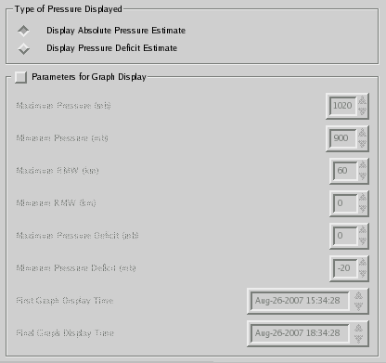
Figure 18. Graphics Configuration Panel

XML Label: autolimits (default: on)
Panel Label: Parameters for Graph Display (radio button)
Range: {on, off}
Description: This box of items is used to manually adjust the scale and parameters of the radius of maximum wind (RMW) and pressure display in the GUI. The Pressure/RMW Display is set to automatically adjust the scales to include the results from every successfully processed volume. Should the user want to adjust these parameters, the xml autolimits parameter can be turned off (by checking the Parameters for Graph Display box), making available a number of adjustment parameters.

XML Label: pressmin (default: 900.00 mb)
Panel Label: Minimum Pressure (mb)
Only available when “Parameters for Graph Display” is checked
Range: [0, 1000] mb
Description: This value is the user defined minimum pressure measurement that will be displayed on the Pressure/RMW Display. Any pressure measurements below this value will not be displayed on the graph.

XML Label: pressmax (default: 1020 mb)
Panel Label: Maximum Pressure (mb)
Only available when “Parameters for Graph Display” is checked
Range: [700, 1100] mb
Description: This value is the user defined maximum pressure measurement that will be displayed on the Pressure/RMW Display. Any pressure measurements above this value will not be displayed on the graph.

XML Label: rmwmin (default: 0 km)
Panel Label: Minimum RMW (km)
Only available when “Parameters for Graph Display” is checked
Range: [0, 200]
Description: This value is the user defined minimum radius of maximum wind (RMW) measurement that will be displayed on the Pressure/RMW Display. Any RMW measurements above this value will not be displayed on the graph.

XML Label: rmwmax (default: 60 km)
Panel Label: Maximum RMW (km)
Only available when “Parameters for Graph Display” is checked
Range: [0, 200]
Description: This value is the user defined maximum radius of maximum wind (RMW) measurement that will be displayed on the Pressure/RMW Display. Any RMW measurements above this value will not be displayed on the graph.

XML Label: startdate (default: current date UTC, format: YYYY-MM-DD)
XML Label: starttime (default: current time UTC, format: HH:MM:SS)
Panel Label: First Graph Display Time
Only available when “Parameters for Graph Display” is checked
Range: Any valid date and time
Description: This is the user defined minimum time for pressure and RMW measurements that will be displayed on the Pressure/RMW Display. This value should be within the period of currently processed radar data.

XML Label: enddate (default: current date UTC + 3 days, format: YYYY-MM-DD)
XML Label: endtime (default: current time, format: HH:MM:SS)
Panel Label: Final Graph Display Time
Only available when “Parameters for Graph Display” is checked
Range: Any valid date and time
Description: This time is the user defined maximum time for pressure and RMW measurements that will be displayed on the Pressure/RMW Display. This value should be within the period of currently processed radar data

QUALITY CONTROL CONFIGURATION PANEL (XML Node: “qc”)
The parameters in the QUALITY CONTROL CONFIGURATION PANEL control the incoming radar data is filtered to avoid common data quality issues in Doppler radar data. These parameters include simple thresholds in addition to parameters which control volume de-aliasing. The defaults for these parameters should work fine for most cases.

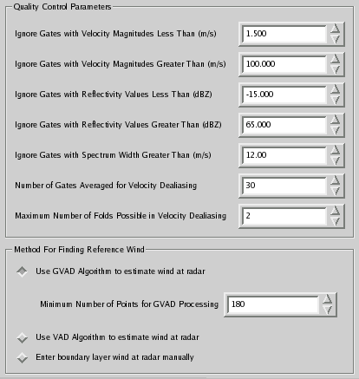
Figure 19. Quality Control Configuration Panel

XML Label: wind_method (default: GVAD)
Panel Label: Method For Finding Reference Wind
Changed by selecting any of the radio buttons enclosed in the box with this label
Range: {gvad, vad, user}
Description: This radio button is used to select the method for calculating the starting winds used for radar de-aliasing. The successful de-aliasing of each ray is largely dependent on the accuracy of the reference wind estimates at the first gate. Selecting “Use GVAD Algorithm to estimate wind at radar” instructs the software to use gradient velocity azimuth display (GVAD) methods to calculate the reference wind. When the volume contains insufficient data for GVAD calculations the algorithm will automatically revert to the velocity azimuth display (VAD) method to estimate the reference wind. Selecting “Use VAD Algorithm to estimate wind at radar” will directly attempt the VAD estimate for the reference wind. Selecting “Enter boundary layer wind at radar manually” will allow the user to set the reference wind based external information about environmental conditions at the radar. See Sec. 5.

XML Label: vel_min (default: 1.5 m/s)
Panel Label: Ignore Gates with Velocity Magnitudes Less Than (km/s)
Range: [0,10] km/s
Description: This value sets the minimum acceptable Doppler velocity magnitude used in further analysis of the radar volume. This threshold is intended as an elementary data quality control to eliminate clutter in the radar volume. This threshold is applied before de-aliasing the radar volume.

XML Label: vel_max (default: 100 m/s)
Panel Label: Ignore Gates with Velocity Magnitudes Greater Than (km/s)
Range: [1,999] km/s
Description: This values sets the maximum acceptable Doppler velocity magnitude used in further analysis of the radar volume. This threshold is intended as an elementary data quality control to eliminate anomalous Doppler velocity data. This threshold is applied before de-aliasing of the radar volume.

XML Label: ref_max (65 dBZ)
Panel Label: Ignore Gates with Reflectivity Values Greater Than (dBZ)
Range: [-500, 500] dBZ
Description: This value sets the maximum acceptable reflectivity values used in further analysis of the radar volume. This threshold is intended as an elementary data quality control to eliminate clutter in the radar volume.

XML Label: ref_min (default: -15 dBZ)
Panel Label: Ignore Gates with Reflectivity Values Less Than (dBZ)
Range: [-500, 500] dBZ
Description: This value sets the minimum acceptable reflectivity values used in further analysis of the radar volume. This threshold is intended as an elementary data quality control to eliminate anomalous data in the radar volume.

XML Label: sw_threshold (default: 12 m/s)
Panel Label: Ignore Gates with Spectrum Width Greater Than (km/s)
Range: [0, 50] m/s
Description: This value sets the maximum acceptable spectrum width value. A spectrum width datum is a measure of the standard deviation of its corresponding Doppler velocity datum; i.e., it is estimated about the mean of the sampled Doppler velocity measurements at each range gate and azimuth location throughout the entire radar scan domain. This threshold is intended as an elementary data quality control to eliminate noisy or suspicious Doppler velocity data.

XML Label: bbcount (default: 30 velocity gates)
Panel Label: Number of Gates Averaged for Velocity De-aliasing
Range: [0,150] velocity gates
Description: This value sets the number of gates averaged in velocity de-aliasing. This implementation of the Bargen and Brown de-aliasing method relies on gate averaging to de-alias each ray in a volume. The number of gates averaged for the unfolding of each ray affects the quality of the results of the de-aliasing algorithm.

XML Label: maxfold (default: 4 folds)
Panel Label: Maximum Number of Folds Possible in Velocity De-aliasing
Range: [0, 20]
Description: This value sets a limit on the number of folds used when unfolding a single ray of radar data. This is a realistic limit intended to discourage unrealistic de-aliasing behavior within the de-aliasing algorithm.

XML Label: windspeed (default: 0 m/s)
Panel Label: Reference Wind Speed (m/s)
Only available when “Enter Environmental Wind Parameters” is selected
Range: [0, 200] km/s
Description: Allows the user to specify the wind speed (TC wind plus background environmental wind ) of the environmental wind present near the radar. Given boundary layer wind observations near the radar, the user can enter this parameter to be used as the reference wind in the de-aliasing algorithm.

XML Label: winddirection (default: 0 deg) degrees measured clockwise from north
Panel Label: Reference Wind Direction (degrees from North)
Only available when “Enter Environmental Wind Parameters” is selected
Range: [0, 359.9] degrees clockwise from north
Description: Allows the user to specify the wind direction of the environmental wind present near the radar. Given outside information on environmental conditions at the radar, the user can enter this parameter to be used in conjunction with the windspeed parameter to determine the reference wind used in the de-aliasing algorithm.

XML Label: vadlevels (default: 25 levels)
Panel Label: Number of VAD Levels Used
Only available when “Use GVAD and VAD Algorithms” is selected
Range: [5, 50]
Description: This value designates the number of 1 km thick layers that should be used in GVAD & VAD analysis for calculating the reference wind. The levels are enumerated from the altitude of the radar.

XML Label: numcoeff (default: 3 coefficients)
Panel Label: Number of Coefficients Used in VAD Fits
Only available when “Use GVAD and VAD Algorithms” is selected
Range: {3, 5}
Description: The VAD and GVAD algorithms attempt to calculate Fourier coefficients to describe the reference wind near the radar, this parameter determines the number of coefficients used in the Fourier fit.

XML Label: vadthr (default: 30 gates)
Panel Label: Minimum Number of Points for VAD Processing.
Only available when “Use GVAD and VAD Algorithms” is selected
Range: [1, 360]
Description: Designates the minimum number of gates at fixed distance within a single sweep that must be present for VAD analysis to take place. VAD levels without sufficient data will not contribute to the calculation of the reference wind.

XML Label: gvadthr (default: 180 gates)
Panel Label: Minimum Number of Points for GVAD Processing.
Only available when “Use GVAD and VAD Algorithms” is selected
Range: [1, 360]
Description: Designates the minimum number of gates at fixed distance within a single sweep that must be present for GVAD analysis to take place. GVAD levels without sufficient data will not contribute to the calculation of the reference wind.

B. Formats for Output Products

i. ASI files
Cappi output is to .asi files which are an ascii gridded data format similar to the binary Cedric format used in radar analysis. It consists of a 510-word header, followed by the data sorted by level, variable, and the horizontal dimensions. Details about the format can be found in the Cedric documentation available from NCAR/MMM at http://box.mmm.ucar.edu/pdas/Postscript/cedric_doc.ps

ii. Vortex and Simplex Lists
Since there may be many radar volumes analyzed during a particular case, a master list of the data products is maintained such that a single file does not become to large. These lists contain nodes which point to the individual data files.

ii. Vortex Data XML Products
The Vortex data XML files contain the estimated center position, central pressure, RMW, uncertainties, and Fourier coefficients from the GBVTD analyses, separated by height and radius.

iii. Simplex Data XML Products
The Simplex data XML files contain the results of the Simplex searches for each initial guess at each height and radius. These are used by the Choose Center algorithm to select the best estimate of the center at each time.

iv. Pressure List XML File
Pressure observations are compiled into a single file since they contain only a small amount of data per observation compared to the radar volume. Pressure obs which are in the analysis timeframe and within 500 km of the radar are recorded to the pressure list.

v. HVVP Results Text File
The HVVP results are output to a text file in the working directory. Nine quantities are output for each HVVP analysis layer: central altitude of layer (z), u (environmental), v (environmental), across-beam environmental wind, modified Rankine Xt (tangential) parameter, wave zero tangential wind, wave zero radial wind, and modified Rankine Xr (radial) parameter. The radar is located at x=y=0, thus the HVVP results are estimates of these quantities at the points (x, y, z)=(0,0,z) along a vertical profile above the radar.

vi. Log files
An autolog is generated for each new run, and is incremented numerically for multiple trials in the same working directory. Log files are flat text files containing the status of the run as it proceeds.

C. Troubleshooting

i) Status Light

Red indicators are conditions in which the program cannot continue. These require the user to fix the problem before continuing, and may require a restart. Most are self explanatory, but a few are listed here

Error: Observation Date or Time is not of valid format! Date: yyyy-MM-dd Time: hh:mm:ss please adjust the configuration file (ObsDate or ObsTime invalid in Config)
Solution: Qt requires that the format of dates and times be consistent with its internal structures. Check that all aspects of the date and time specification match the above format.

Error: Error reading file or directory
Solution: VORTRAC requires certain files for operation, and that permissions be set for reading and/or writing. This is the most common Red condition, but should be easy to fix given the warning details.

Error: Time or Distance extrapolation exceeds maximum values of 6 hours or 500 km
Solution: To prevent erroneous position and motion estimates, the maximum length of time the program can be started in advance is 6 hours, and the position must be within 500 km of the radar. Change your position, motion, and observation time accordingly.

Error: Simplex outer-inner is too large
Solution: The maximum annulus used to search for the RMW is set by the ‘Outer radius’ and ‘Inner radius’ in the Simplex configuration. Due to memory and computational limits, this is restricted to 31 km. Reduce the outer radius or increase the inner radius until this condition is met.

ii) CAPPI Display Quality Control Troubleshooting

If the user notices de-aliasing failure in the CAPPI display of Doppler velocity, this means that GVAD, or GVAD and VAD, were not able to find a reliable reference wind. Note that the log message output shown at the bottom of the VORTRAC display should be examined first before selecting the reference wind method since VAD is automatically selected if there is an insufficient amount of data for GVAD (requires more data than VAD). Only one of either the GVAD or VAD reference winds are labeled and displayed in the output to the log, depending on which one was used in the default calculation. Occasionally there are situations where there is a sufficient amount of data for GVAD, however, its results are biased and yield an insufficiently accurate reference wind – in such situations, a user-forced VAD reference wind should be chosen next. The performance of GVAD and VAD may be improved in some situations if the number of GVAD and/or VAD points is increased somewhat from their default values shown in this section of the QUALITY CONTROL CONFIGURATION PANEL. If the VAD reference wind fails then a manually inserted estimate of the boundary layer wind is the last resort. If de-aliasing failure persists after all the above is attempted, one may also try to increase the minimum Doppler velocity threshold to approximately 2 m/s and/or decrease the spectrum width threshold to approximately 8 m/s in the Quality Control Parameters settings section of the QUALITY CONTROL CONFIGURATION PANEL as another possible remedy to de-aliasing failure.

D. Building VORTRAC

On Linux, issue the commands ‘qmake’ followed by ‘make’ in a terminal window to build VORTRAC. On Mac, issue ‘qmake’ in a terminal to create an Xcode project. Open the project file and then click ‘Build’. GCC/g++ was used in developing the code.

E. References

Bargen D. W., and R. C. Brown, 1980: Interactive radar velocity unfolding. Preprints, 19th Conference on Radar Meteorology, Miami Beach, FL, Amer. Meteor. Soc.,278-285.
Bell, M. M., and W.-C. Lee, 2007: Objective tropical cyclone center tracking using single Doppler radar. In preparation.
____, and W.-C. Lee, 2003: Improved tropical cyclone circulation centers derived from the GBVTD-simplex algorithm. Preprints, 31st Conf. on Radar Meteor., Seattle, WA, Amer. Meteor. Soc., 6-12 August 2003, 1012-1014.
Browning, K. A., and R. Wexler, 1968: The determination of kinematic properties of a wind field using Doppler radar. J. Appl. Meteor., 7, 105-113.
Donaldson, R. J. Jr., 1991: A proposed technique for diagnosis by radar of hurricane structure. J. Appl. Meteor., 30, 1636-1645.
______, and F. I. Harris, 1989: Estimation by Doppler radar of curvature, diffluence, and shear in cyclonic flow. J. Atmos. Oceanic Technol., 6, 26-35.
Gao, J., K. K. Droegemeier, J. Gong, and Q. Xu. 2004: A method for retrieving mean horizontal wind profiles from single-Doppler radar observations contaminated by aliasing. Mon. Wea. Rev., 132, 1399–1409.
Harasti, P. R., 2003: The hurricane volume velocity processing method. Preprints, 31st Conf. on Radar Meteorology, Seattle, WA, Amer. Meteor. Soc., 1008-1011.
______, C. J. McAdie, P. P. Dodge, W.-C. Lee, J. Tuttle, S. T. Murillo, F. D. Marks Jr., 2004: Real-Time Implementation of Single-Doppler Radar Analysis Methods for Tropical Cyclones: Algorithm Improvements and Use with WSR-88D Display Data. Wea. Forecasting, 19, 219–239.
______, and R. List, 2001: The hurricane-customized extension of the VAD (HEVAD) method: wind field estimation in the planetary boundary layer of hurricanes. Preprints: 30th Conf on Radar Meteorology, Munich, Germany, Amer. Meteor. Soc., 463-465.
Koscielny, A. J., R. J. Doviak, and R. Rabin, 1982: Statistical considerations in the estimation of divergence from single-Doppler radar and application to prestorm boundary-layer observations. J. Appl. Meteor., 21, 197-210.
Lamb, H., 1932: Hydrodynamics. 6th ed. Dover, 732pp.
Lee, W.-C., F. D. Marks, and R. E. Carbone, 1994: Velocity Track Display – A technique to extract real-time tropical cyclone circulations using a single airborne Doppler radar. J. Atmos. Oceanic Technol., 11, 337-356.
___, B. J.-D. Jou, P.-L. Chang, and S.-M. Deng, 1999: Tropical cyclone kinematic structure retrieved from single Doppler radar observations. Part I: Interpretation of Doppler velocity patterns and the GBVTD technique. Mon. Wea. Rev., 127, 2419-2439.
___, and F. D. Marks Jr., 2000: Tropical cyclone kinematic structure retrieved from single Doppler radar observations. Part II: The GBVTD-simplex center finding algorithm. Mon. Wea. Rev., 128, 1925-1936.
___, B. J. D. Jou, P. L. Chang, and F. D. Marks, 2000: Tropical Cyclone Kinematic Structure Retrieved from Single-Doppler Radar Observations. Part III: Evolution and Structures of Typhoon Alex (1987). Mon. Wea. Rev., 128, 3982–4001.
Waldteufel, P., and H. Corbin, 1979: On the analysis of single-Doppler radar data. J. Appl. Meteor, 18, 532-542.

UCAR/National Center for Atmospheric Research, Boulder, CO
UCAR/Naval Research Laboratory, Monterey, CA
UCAR/NCAR and Naval Postgraduate School, Monterey, CA
UCAR/National Center for Atmospheric Research, Boulder, CO

