Student Name: Mohammad Billah

Student ID: 21011762

Lab 8: NAT, Firewalls, Perimeter Defense

Q2 Results:

Only PC1-Student can access Server-HR. None of the other VPCs can. The results of pings from all these VPCs is that destination host is unreachable.

Q4 Results:

Now PC2-Student can also access Server-HR. Except for these 2, all other VPCs remain blocked.

Q6 Results:

Now also PC3-Student can access Server-HR. All other VPCs remain blocked.

Q7 Results:

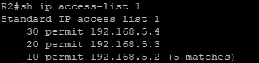

Q9 Results:

Both Finance VPCs can now access Server-HR, as the pings give replies.

Q10 Results:

