Student Name: Mohammad Billah

Student ID: 21011762

Date: 23/07/2021

Laboratory Practical 01

1. List the PDU at layers 2, 3, and 4 that were used to transmit your HTTP GET packet.

Frame 118 at layer 2, Ethernet II at layer 3, and Transmission Control Protocol (TCP) at layer 4 were all used to transmit the HTTP GET packet.

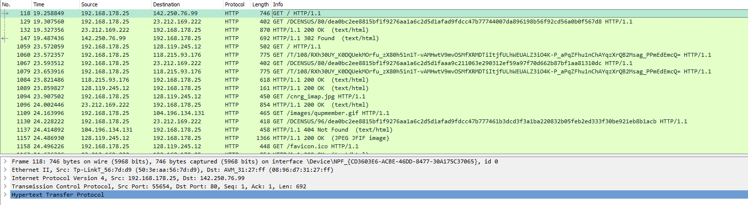

2. How many different HTTP GET packets were sent by your browser?

Four separate HTTP GET packets were sent by my browser (all HTTP / 1.1).

3. List at least five other protocols that Wireshark displayed in the Packet List window.

TLSv1.3, SSDP, DNS, ICMP, TLSv1.2, ARP, QUIC, etc.