Student Name: Mohammad Billah

Student ID: 21011762

Date: 15/08/2021

Lab Practical 2

*1) Do a print screen (screenshots) from two separate Web sites that shows your HTTP requests and the servers' HTTP responses.*

I used Rex Swain’s HTTP viewer to do this exercise.

Checked out a request to my sfs-webdev.massey.ac.nz personal website:

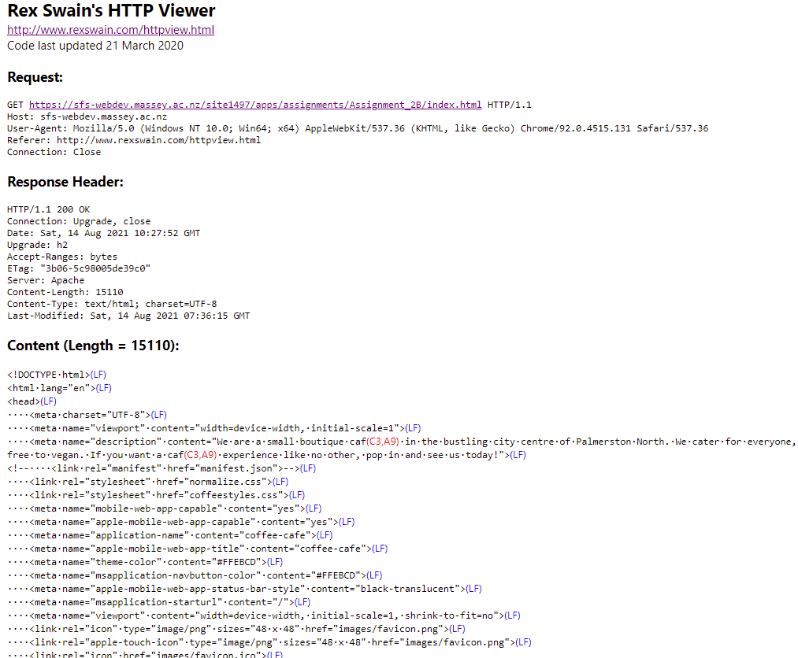

Also, tried an HTTP request to the massey.ac.nz website:

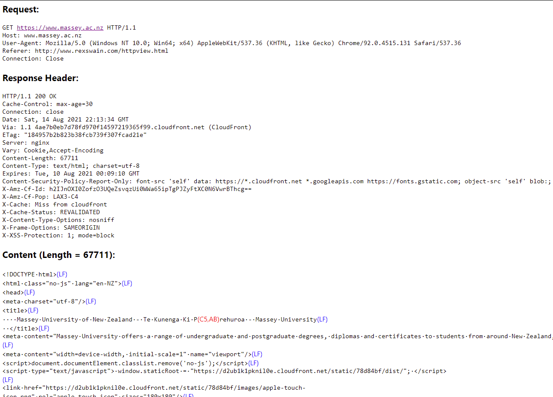

I believe both were non-persistent HTTP connections as there were no additional resources fetched and the connection to the server was requested (by the client) to be closed immediately after sending the response.

*2) Trace one email. Print the original email message and the trace results.*

The original message was a lab practical meeting sent by Dr. Dube:

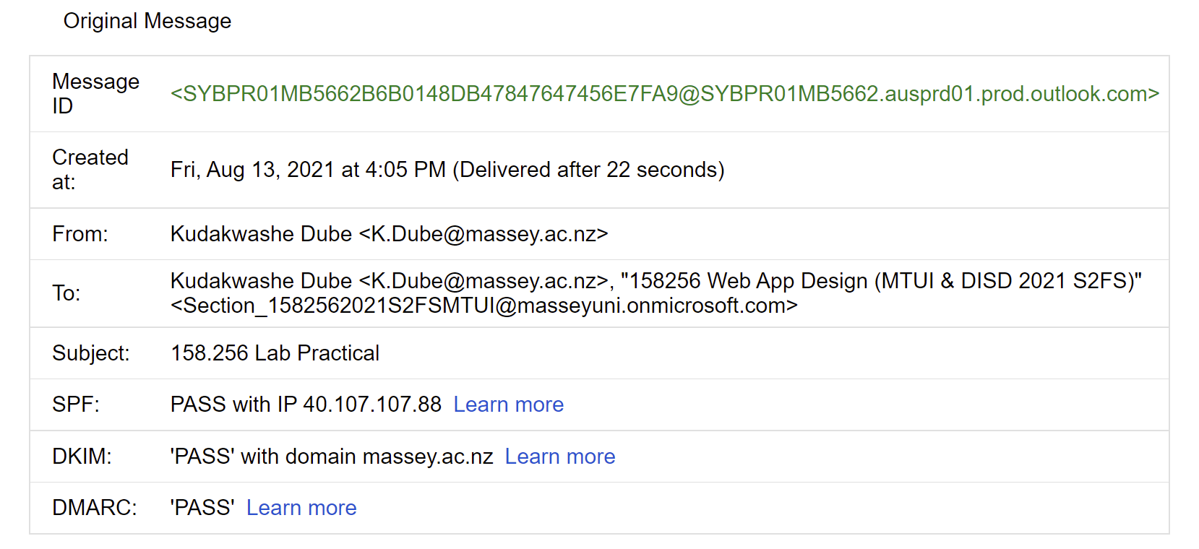

The header for the email message (partial screenshot) is here:

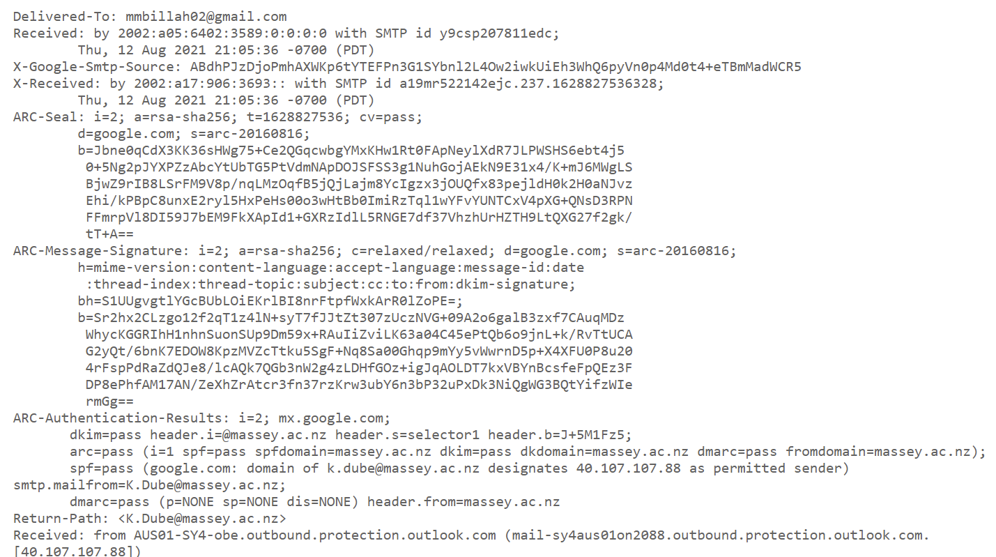

And the trace results (using <https://whatismyipaddress.com/trace-email>) are here:

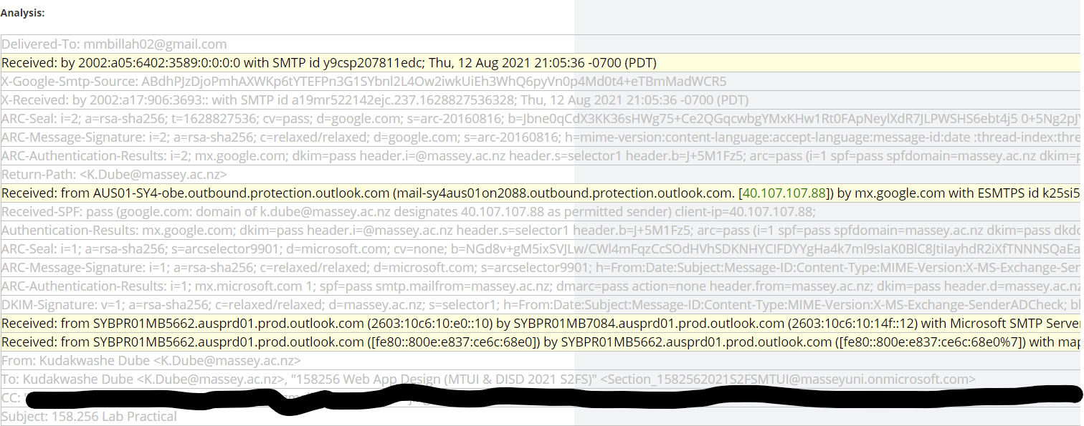

*3) Seeing SMTP and POP PDUs*

*Part 1: SMTP*

Here is the information in the SMTP header:

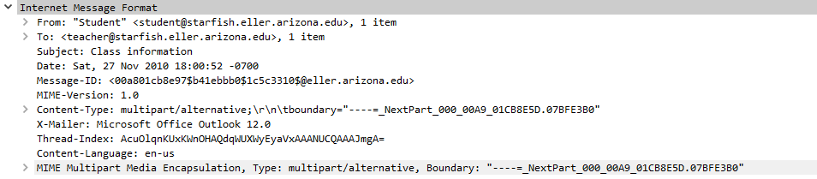

The sender’s name is Pat Green, her birth date is February 10, 1980, and her SSN is 123-44-3211. This was found by looking at the text data of the email message she sent.

Some experts believe that sending an email is akin to sending a postcard because anyone handling the email message can look and see it. SMTP email originally was not that secure, but now it has more security extensions, such as authentication. SMTP email can be made more secure by using third-party protocols like SMTPS (SMTP-Secure) and encryption layers like SSL (now deprecated) and TLS (which is now the industry standard).

*Part 2: POP*

Yes, it is possible to read the user id (teacher) and password (just4teacher). This makes sense because it is part of the authentication phase; it makes sure the client is whoever he/she purports to be.

It is the same user again, just from the perspective of the recipient. The sender’s name is Pat Green, her birth date is February 10, 1980, and her SSN is 123-44-3211.