Student Name: Mohammad Billah

Student ID: 21011762

Date: 13/10/2021

Lab Practical 9 – Network Address Translation

Q1: Show unsuccessful ping from Network 1 to Network 2

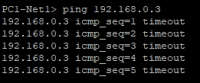

Q2: Show IP NAT Translation

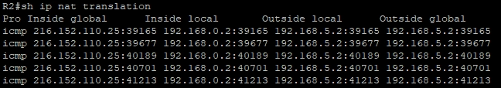

Q3: Show unsuccessful pings from Net 1 to Net 2 and vice versa

Net 1 to Net 2:

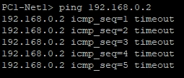

Net 2 to Net 1:

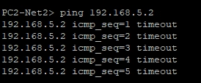

Q4: Show NAT on R1 and R2

R1:



R2:

