{{ date_shamsi_slash }}
{{ p03_k }}
{{ p01_k }}
{{ engine_not_moving }}
{{ arzesh }}
{{ shasi }}
{{ addres_bimeg }}
کد ملی / کد اقتصادی: {{ national_id }}
{{ phone_bimeg }}
{{ name }}
{{ plate_part1 }}
{{ plate_letter }}
{{ plate_part2 }}
{{ plate_part3 }}
{{ engine_moving }}
{{ engine_running }}
{{ p33_s }}
{{ p32_s }}
{{ p31_s }}
{{ p30_s }}
{{ p29_s }}
{{ p28_s }}
{{ p27_s }}
{{ p26_s }}
{{ p25_s }}
{{ p24_s }}
{{ p23_s }}
{{ p19_s }}
{{ p21_s }}
{{ p20_s }}
{{ p22_s }}
{{ p18_s }}
{{ p38_s }}
{{ p38_k }}
{{ p39_s }}
{{ p39_k }}
{{ p40_s }}
{{ p40_k }}
{{ p41_s }}
{{ p41_k }}
{{ p42_s }}
{{ p42_k }}
{{ p43_s }}
{{ p43_k }}
{{ p44_s }}
{{ p44_k }}
{{ p45_s }}
{{ p45_k }}
{{ p46_s }}
{{ p46_k }}
{{ p47_s }}
{{ p47_k }}
{{ p48_s }}
{{ p48_k }}
{{ p49_s }}
{{ p49_k }}
{{ p50_s }}
{{ p50_k }}
{{ p51_s }}
{{ p51_k }}
{{ p52_s }}
{{ p52_k }}
{{ p53_s }}
{{ p53_k }}
{{ p54_s }}
{{ p54_k }}
{{ p55_s }}
{{ p55_k }}
{{ p56_s }}
{{ p56_k }}
{{ p57_s }}
{{ p57_k }}
{{ p58_s }}
{{ p58_k }}
{{ p59_s }}
{{ p59_k }}
{{ p18_k }}
{{ p19_k }}
{{ p20_k }}
{{ p21_k }}
{{ p22_k }}
{{ p23_k }}
{{ p24_k }}
{{ p25_k }}
{{ p26_k }}
{{ p27_k }}
{{ p28_k }}
{{ p29_k }}
{{ p30_k }}
{{ p31_k }}
{{ p32_k }}
{{ p33_k }}
{{ p17_k }}
{{ p16_k }}
{{ p15_k }}
{{ p14_k }}
{{ p13_k }}
{{ p12_k }}
{{ p11_k }}
{{ p10_k }}
{{ p09_k }}
{{ p17_s }}
{{ p16_s }}
{{ p15_s }}
{{ p14_s }}
{{ p13_s }}
{{ p12_s }}
{{ p11_s }}
{{ p10_s }}
{{ p09_s }}
{{ p05_k }}
{{ p08_k }}
{{ p07_k }}
{{ p06_k }}
{{ p08_s }}
{{ p07_s }}
{{ p05_s }}
{{ p06_s }}
{{ p04_k }}
{{ p03_s }}
{{ p04_s }}
{{ p02_k }}
{{ p02_s }}
{{ p01_s }}
{{ plate_other_text }}
{{ plate_other }}
{{ plate_police }}
{{ plate_government }}
{{ plate_public }}
{{ plate_personal }}

{{ motor }}
{{ rang }}
{{ cylinder_count }} سیلندر
{{ sal_sakht }}
{{ zarfiat }} نفر / تن
{{ time }}
{{ noecar }}
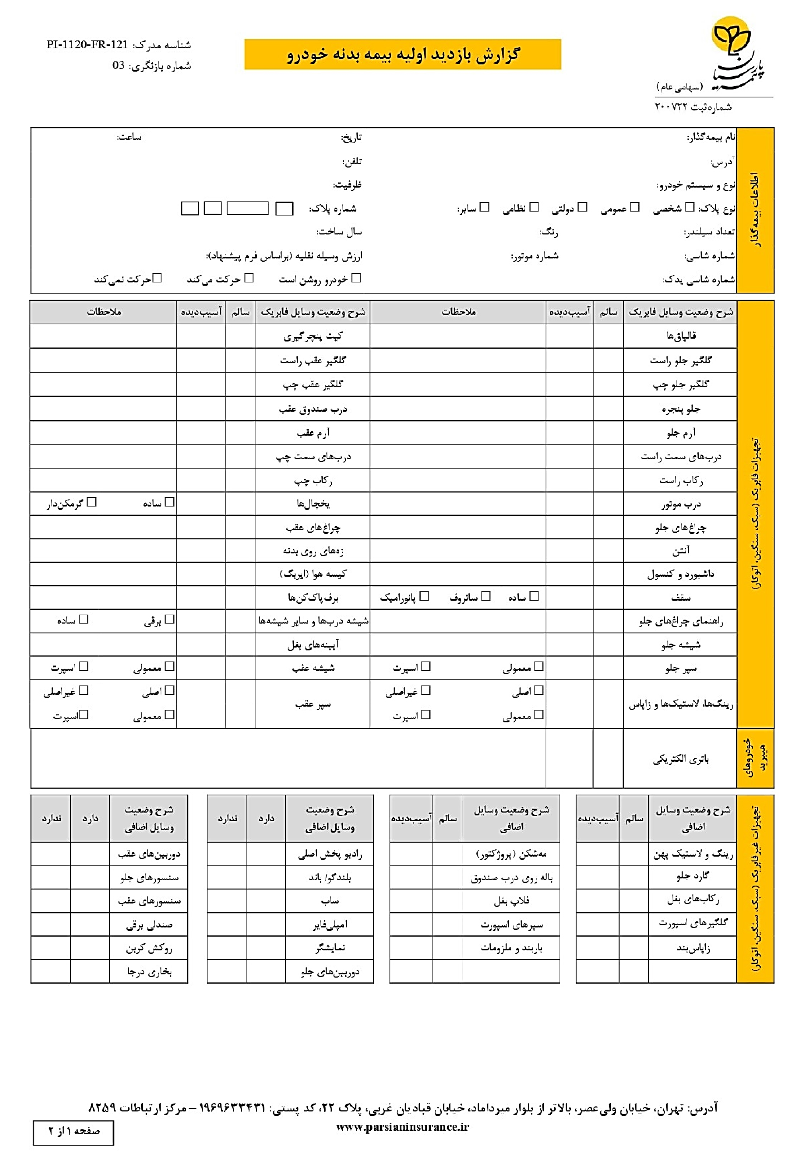
{{ date_shamsi_slash }}
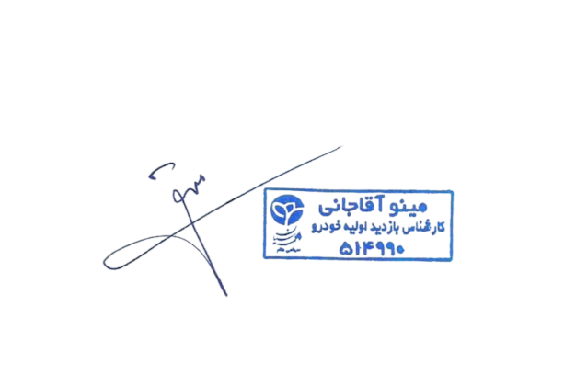
{{ arzesh_words }}
{{ plate_part1 }}
{{ plate_letter }}
{{ plate_part2 }}
{{ plate_part3 }}
{{ time }}

مینو آقاجانی
{{ arzesh }}
{{ overall_bad }}
{{ overall_medium }}
{{ overall_good }}
{{ damage_description_5 }}
{{ damage_description_4 }}
{{ damage_description_3 }}
{{ damage_description_2 }}
{{ damage_description_1 }}
{{ damage_location_5 }}
{{ damage_location_4 }}
{{ damage_location_3 }}
{{ damage_location_2 }}
{{ damage_location_1 }}
