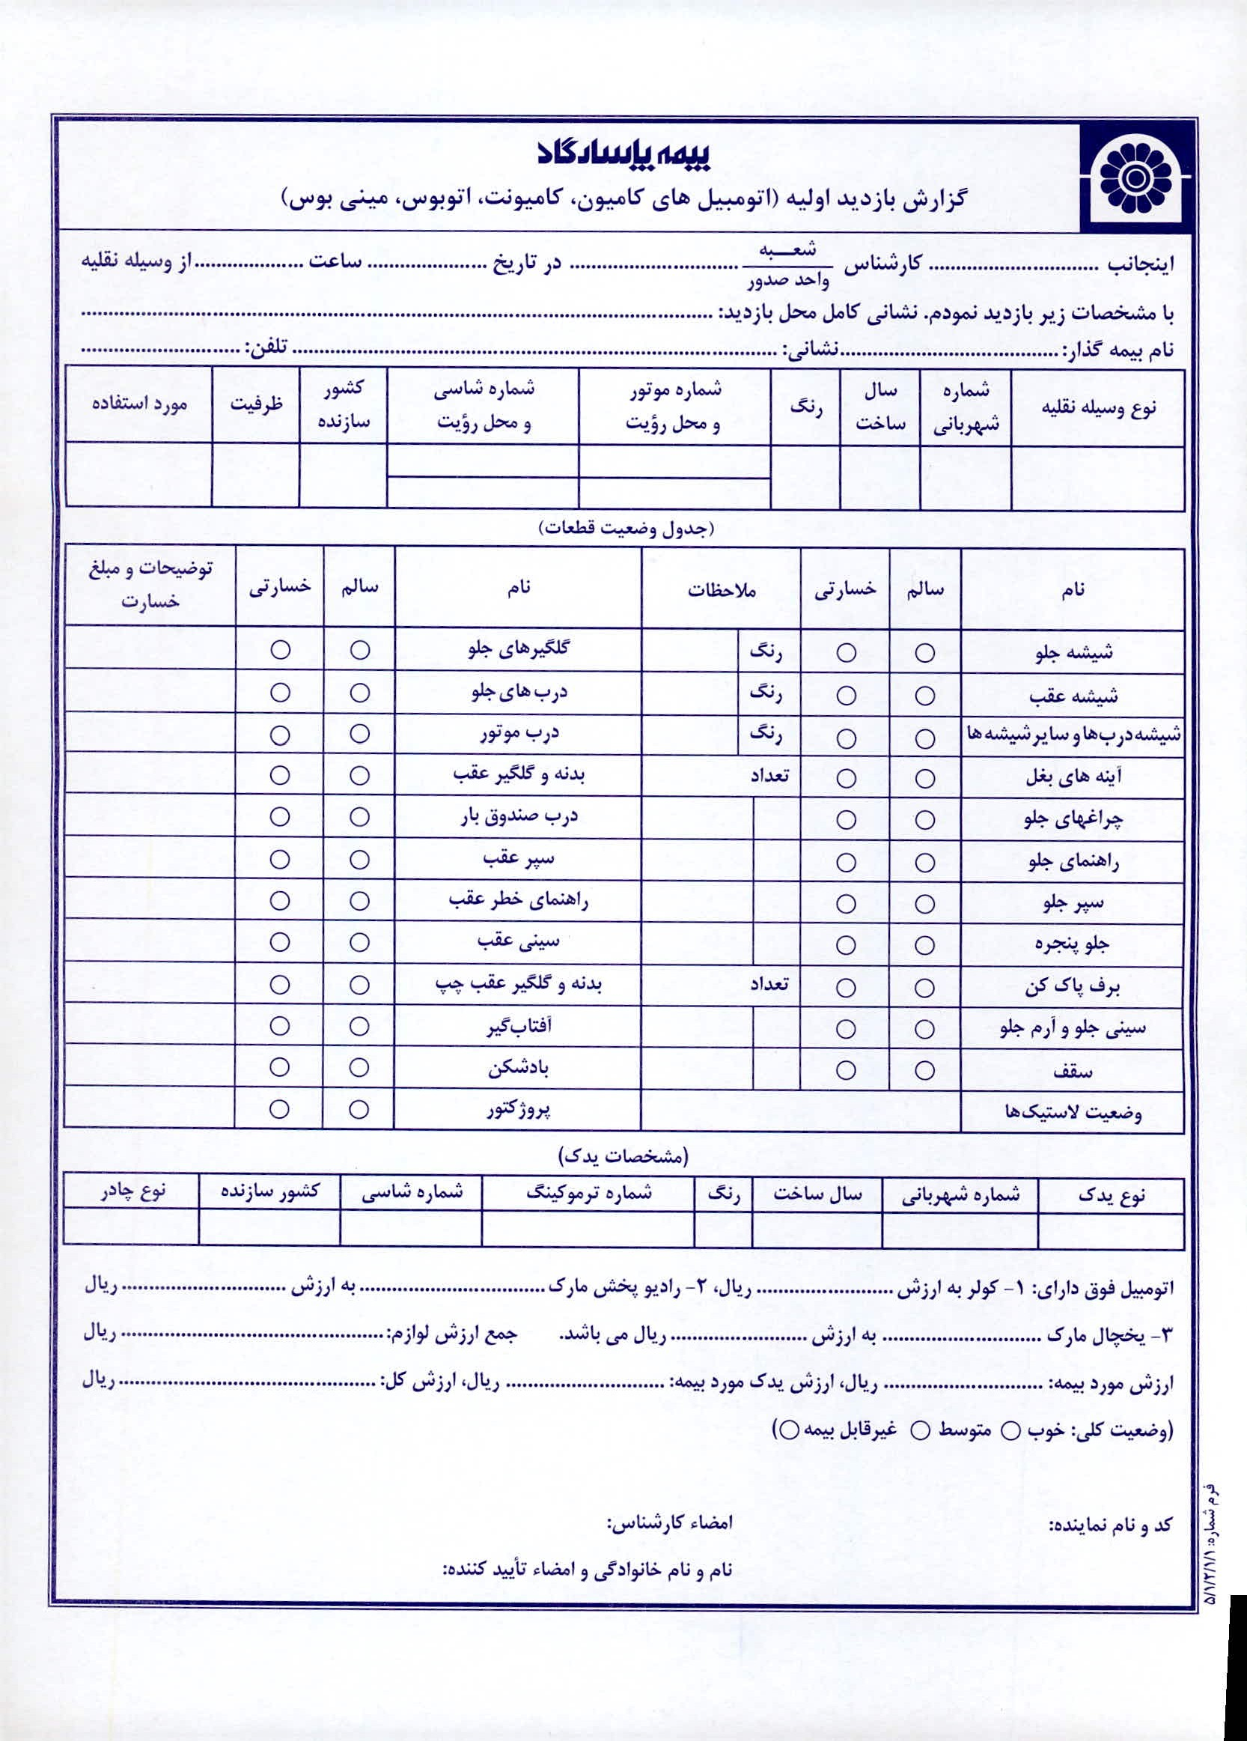
{{ t24_s }}
{{ t24_k }}
{{ t23_k }}
{{ t23_s }}
{{ t22_k }}
{{ t22_s }}
{{ t21_k }}
{{ t21_s }}
{{ t20_k }}
{{ t20_s }}
{{ t19_k }}
{{ t19_s }}
{{ t18_k }}
{{ t18_s }}
{{ t17_k }}
{{ t17_s }}
{{ t16_k }}
{{ t16_s }}
{{ t15_k }}
{{ t15_s }}
{{ t14_k }}
{{ t14_s }}
{{ t13_k }}
{{ t13_s }}
{{ t9_k }}
{{ t9_s }}
{{ t11_k }}
{{ t11_s }}
{{ t10_k }}
{{ t10_s }}
{{ t8_k }}
{{ t8_s }}
{{ t7_k }}
{{ t7_s }}
{{ t6_k }}
{{ t6_s }}
{{ t5_k }}
{{ t5_s }}
{{ t4_k }}
{{ t4_s }}
{{ t3_k }}
{{ t3_s }}
{{ t2_k }}
{{ t2_s }}
{{ t1_k }}
{{ t1_s }}
{{ arzeshyadak }}
{{ arzeshsa }}

{{ addres_bimeg }}

{{ timesa }}

{{ arzeshyakchal }}
{{ lastikka }}
نماينده اصلي - مائده آقاجاني:49357

ایران
{{ plate_part3 }}
{{ plate_letter }}
{{ rangsa }}

{{ sal_sakhtsa }}

{{ karshenassa }}

{{ mordessa }}

{{ plate_part1 }}
{{ plate_part2 }}
محل کار بیمه گذار
{{ name }}

{{ date_shamsi }}

{{ motorsa }}

{{ noecarsa }}

{{ shasisa }}

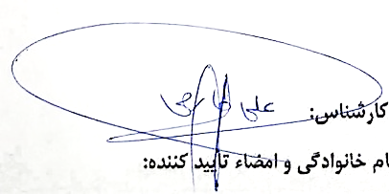

{{ shasiyk }}
{{ termoshk }}
{{ rangyk }}
{{ salsayk }}
{{ pelakk }}
{{ yadaknk }}

{{ phone_bimeg }}

