Validating Transaction Data Against Master Account List

Purpose
This procedure outlines the steps to validate the integrity and completeness of a transaction data file. The process ensures that all beneficiary accounts exist within the master account list and verifies control totals for record count and transaction amounts prior to further processing.

Scope
This SOP applies to the pre-processing validation of any bank transaction data file received. It covers the steps from opening the file to the final verification of control totals. This process does not cover the correction of identified errors or the subsequent uploading of the data.

Prerequisites
- Microsoft Excel installed on the workstation.
- The transaction data file containing a 'data' tab and an 'accounts' tab.
- The 'data' tab must contain a column for 'Bene. Account' (Beneficiary Account) and 'USD Amount'.
- The 'accounts' tab must contain the master list of all valid account numbers in Column A.
- A control total for the number of records and the sum of transaction amounts from the source system.

Step-by-Step Instructions
Open the transaction data file in Microsoft Excel and navigate to the 'data' worksheet.
Insert a new column to the right of the existing data. For this procedure, use Column N and label it 'Vlookup'.
In the first data cell of the new column (e.g., N2), enter the VLOOKUP formula to verify the beneficiary account exists in the master list.
Formula: =VLOOKUP(J2, accounts!A:A, 1, FALSE)
J2: The cell containing the beneficiary account number in the current row.
accounts!A:A: The range containing the master list of accounts on the 'accounts' tab.
1: Instructs the formula to return the value from the first column of the lookup range.
FALSE: Ensures an exact match is found.
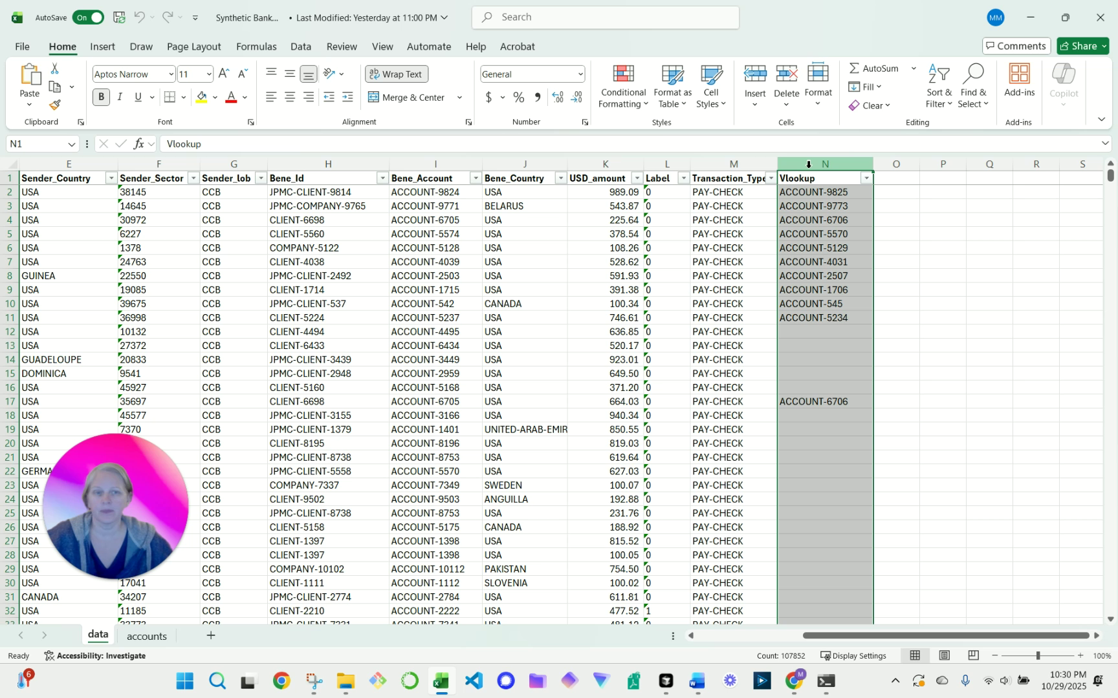
Screenshot 1: User highlights the VLOOKUP formula in column N of the spreadsheet.
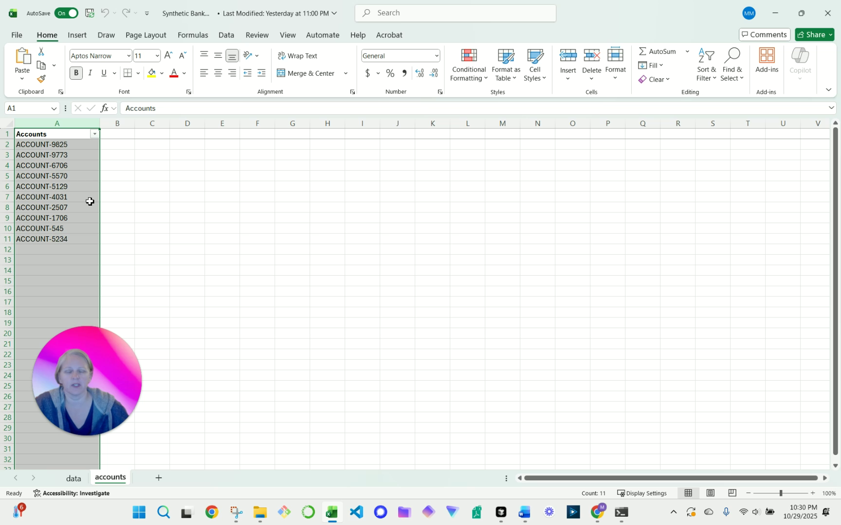
Screenshot 2: User shows the 'Accounts' tab, highlighting column A which is used in the VLOOKUP.
Apply the formula to all rows containing data by double-clicking the fill handle (the small square at the bottom-right corner of the cell).
Review the 'Vlookup' column for any '#N/A' errors. An '#N/A' error indicates the beneficiary account in that row is not found in the master 'accounts' list.
Perform a data completeness check by verifying the total record count.
Select the entire 'Bene. Account' column (Column J) by clicking the column header.
Observe the 'Count' value in the Excel status bar at the bottom of the window.
Compare this count to the expected record count from the source system control total.
Perform a data accuracy check by verifying the total transaction amount.
Select the 'USD Amount' column (Column K) by clicking the column header.
Observe the 'Sum' value in the Excel status bar.
Compare this sum to the expected total amount from the source system control total.
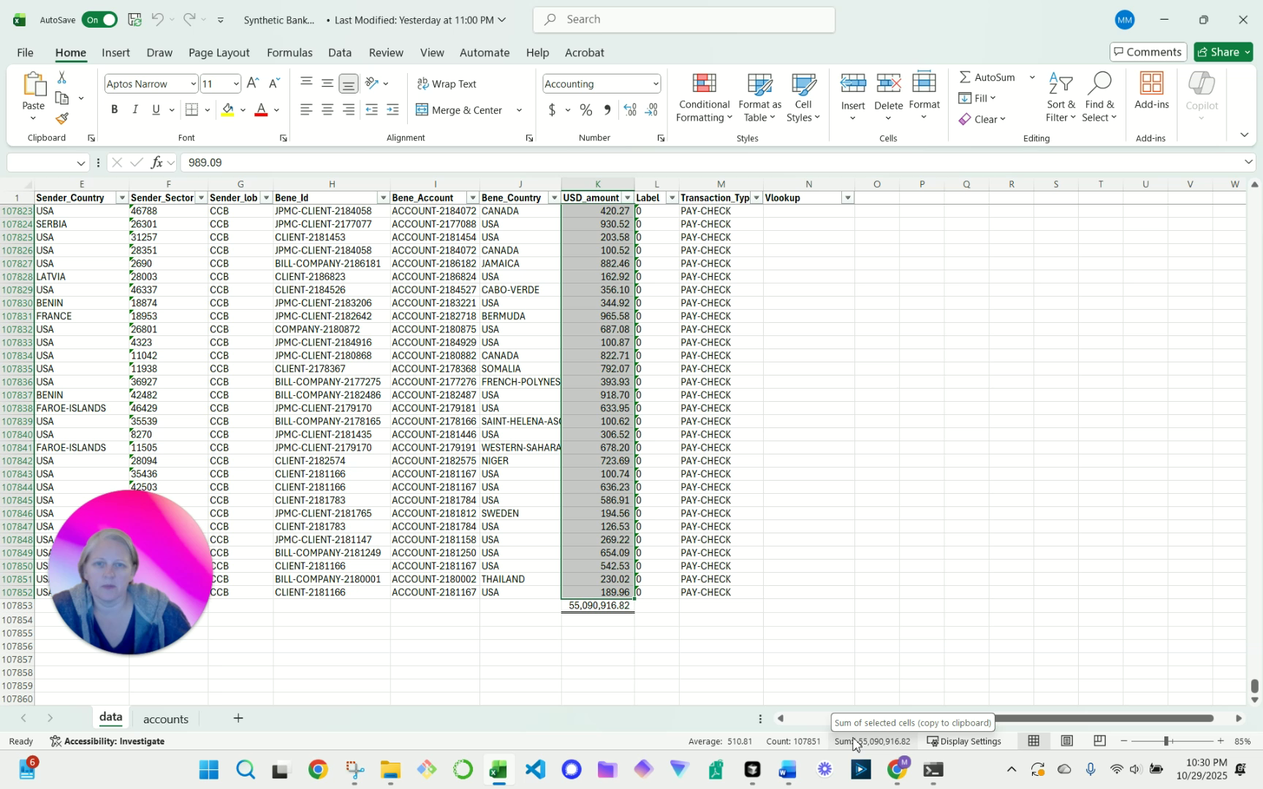
Screenshot 3: User points to column K, the record count, and the sum to demonstrate data completeness and accuracy.

Control Points

Account Validation
The 'Vlookup' column (Column N) must be free of '#N/A' errors. Any errors must be investigated and resolved before proceeding.
This control ensures that payments are only processed to valid, approved beneficiary accounts.

Record Count Reconciliation
The record count identified in the Excel status bar must exactly match the control total provided by the source system.
This control prevents the processing of incomplete or duplicated data files.

Financial Total Reconciliation
The sum of the 'USD Amount' column (Column K) must exactly match the financial control total provided by the source system.
This control ensures the financial accuracy of the data file and prevents erroneous payment totals.

Common Issues & Troubleshooting
Issue: '#N/A' errors appear in the 'Vlookup' column.
Solution: Filter the 'Vlookup' column to show only '#N/A' values. Investigate each invalid account. The account number may be mistyped in the data file or it may be a new account that requires setup in the master list. Escalate to the appropriate team for correction or approval.
Issue: The record count does not match the source control total.
Solution: Verify that the correct file was used. The file may be incomplete or contain header/footer rows that are being counted. Request a re-extraction of the data from the source system.
Issue: The sum of the 'USD Amount' column does not match the source control total.
Solution: Investigate for missing rows, duplicate rows, or rows with incorrect or non-numeric values. This may indicate a data corruption issue that requires a re-extraction of the file.

Frequency
This process is performed each time a new transaction data file is received for processing.

