Daily Transaction File Beneficiary Account Verification

# Purpose

* To verify that all beneficiary accounts listed in the daily transaction file are present on the master list of approved accounts.
* To perform a completeness and accuracy check by reconciling the file's total transaction value and record count against control totals.

# Scope

* This procedure covers the initial validation of the daily transaction file received from the Operations team.
* This SOP applies to the accounting team members responsible for the daily reconciliation process.
* It does not cover the subsequent steps of the reconciliation or the process for adding new accounts to the master list.

# Prerequisites

* The daily transaction data file (in .xlsx format) must be received from the Operations team.
* An accompanying email from the Operations team containing the control totals (total USD amount and total record count) for the file.
* Microsoft Excel or a compatible spreadsheet application must be installed.

# Step-by-Step Instructions

1. Open the daily financial data spreadsheet provided by the Operations team.

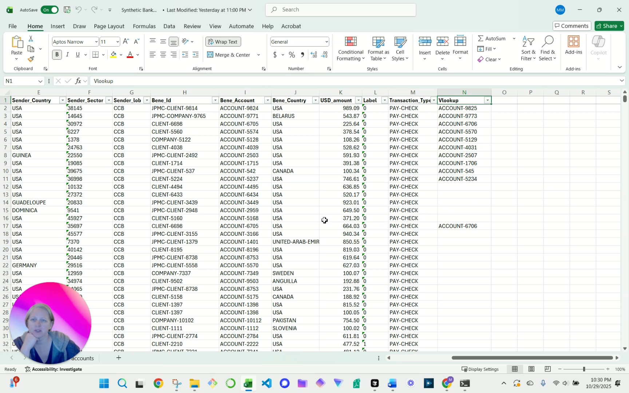

*Screenshot 1: Initial view of the financial data spreadsheet.*

1. Ensure you are on the 'data' tab.
2. Review Column N, titled "Vlookup". This column is used to validate that the beneficiary account in each transaction is on the approved master list.

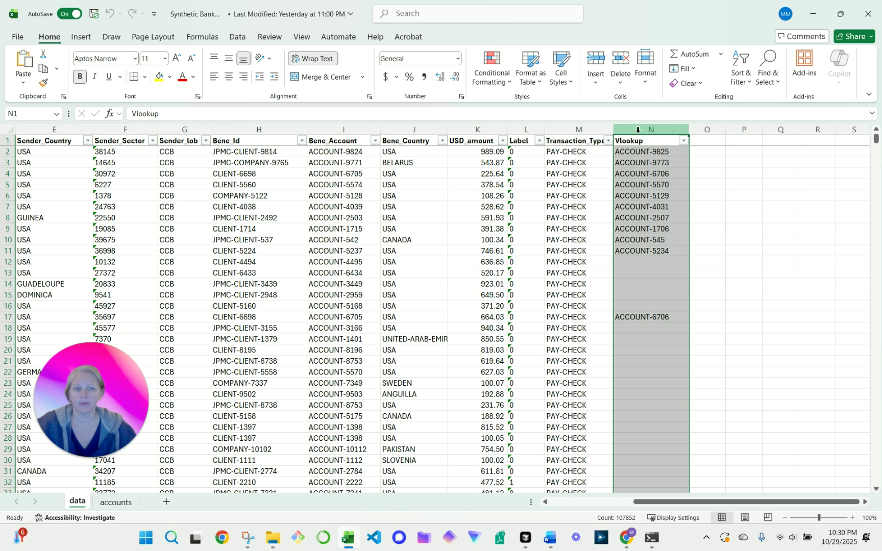

*Screenshot 2: User highlights the VLOOKUP in column N for review.*

* A valid account number in this column indicates the corresponding 'Bene_Account' from Column J was successfully found on the master list.
* An error, such as #N/A, indicates the beneficiary account is not on the approved list and must be investigated.

1. To view the master data source, navigate to the 'accounts' tab. Column A contains the master list of all approved beneficiary accounts used for the VLOOKUP validation.

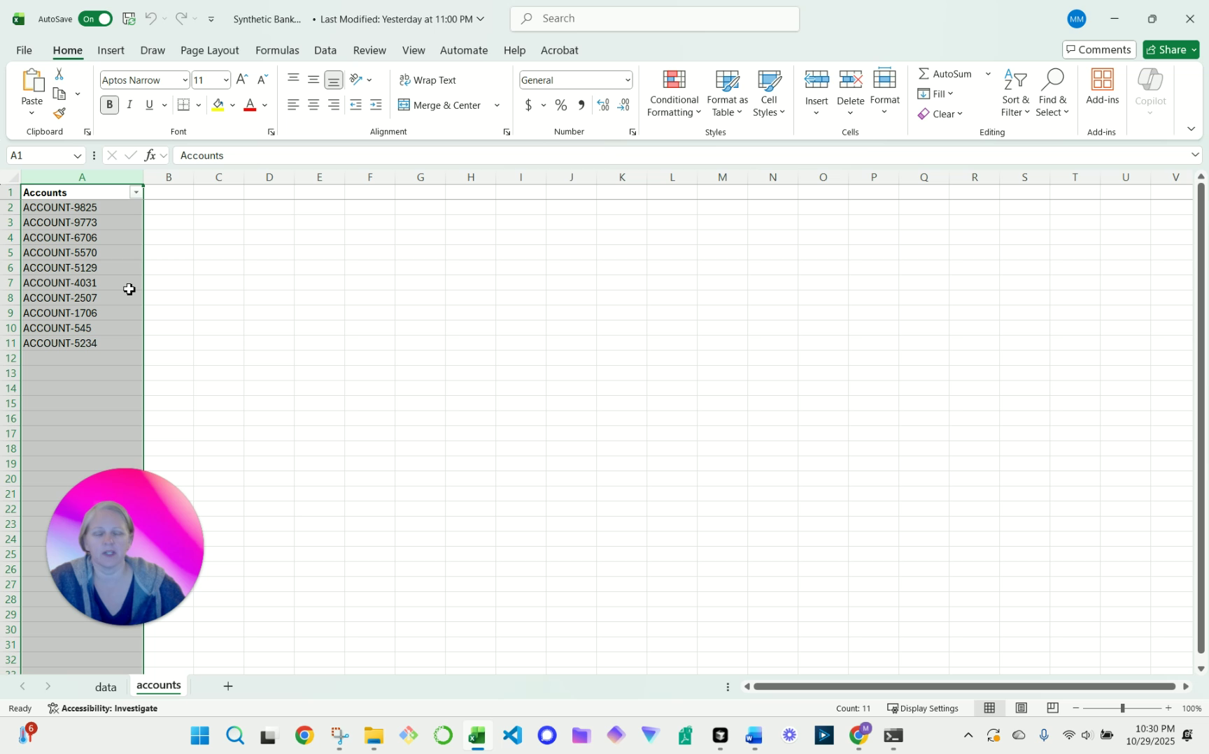

*Screenshot 3: User navigates to the 'accounts' tab to show the source data in column A.*

1. Return to the 'data' tab to perform the completeness check.
2. Select the entire 'USD amount' column (Column K) by clicking on the column header.
3. Observe the Excel status bar at the bottom right of the window to identify the calculated 'Sum' and 'Count' of the selected cells.

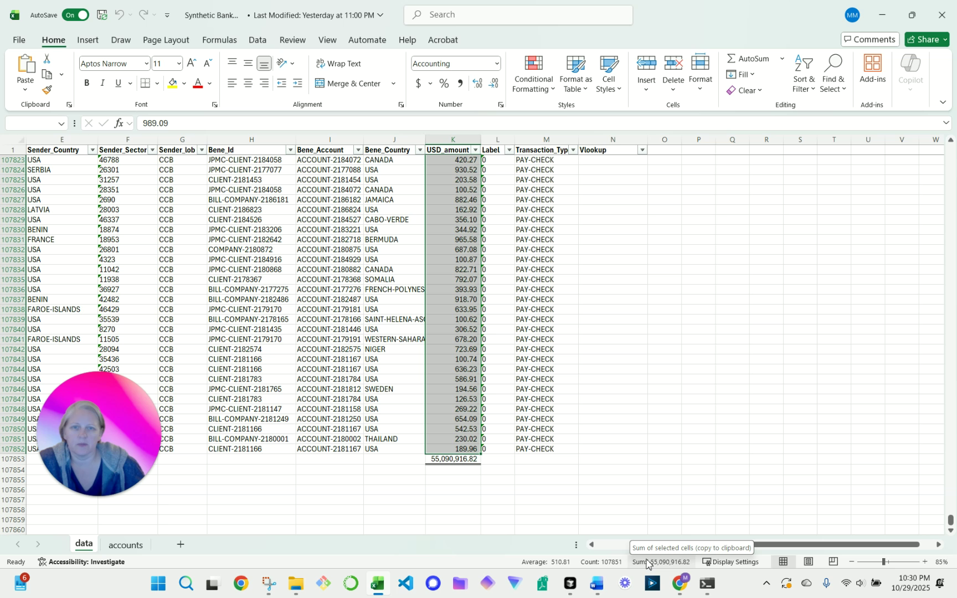

*Screenshot 4: User verifies data completeness and accuracy by comparing the sum of column K with the calculated total sum and record count.*

1. Compare the 'Sum' value from the status bar with the total USD amount control total provided in the email from the Operations team.
2. Compare the 'Count' value from the status bar with the total record count control total provided in the email from the Operations team.
3. If both totals match and no VLOOKUP errors are present, the file is considered validated.
4. If any discrepancies are found, contact the Operations team immediately to report the issue before proceeding.

# Control Points

* VLOOKUP Verification: Column N must be reviewed for any #N/A or other errors. The presence of an error indicates a transaction with an unapproved beneficiary account, which is a critical exception that must be resolved before processing.
* Sum Reconciliation: The sum of the 'USD amount' (Column K) must exactly match the control total provided by the Operations team. This confirms the financial value integrity of the file.
* Record Count Reconciliation: The transaction count from Column K must exactly match the record count control total provided by the Operations team. This confirms the transactional completeness of the file.

# Common Issues & Troubleshooting

* Issue: An #N/A error appears in the VLOOKUP column (Column N).
* Solution: This signifies that a beneficiary account listed in Column J for that row does not exist on the approved master list in the 'accounts' tab. Report the specific transaction details to the Operations team for immediate investigation. Do not proceed with reconciliation until the issue is resolved.
* Issue: The calculated 'Sum' or 'Count' in Excel does not match the control totals from the Operations team's email.
* Solution: First, ensure the entire 'USD amount' column was selected without any filters applied. If the discrepancy persists, there is an issue with the file data. Notify the Operations team immediately that the file has failed the completeness check and provide them with both the expected and the actual totals.

# Frequency

* This procedure is performed daily upon receipt of the transaction file from the Operations team.