Synthetic Bank Statement File Validation

Purpose

To verify the data integrity and completeness of the daily synthetic bank statement file.

This procedure ensures that all transactions recorded in the data set are associated with a valid, active account from the master account list.

Scope

This SOP covers the validation of the 'data' tab against the master list in the 'accounts' tab within the daily transaction Excel workbook.

This includes the review of a VLOOKUP formula for data validation and a final check of record counts and total transaction values.

This process does not cover the initial generation of the synthetic bank statement file.

Prerequisites

Receipt of the current day's "Synthetic Bank Statement" Excel file.

Access to and a working knowledge of Microsoft Excel.

Step-by-Step Instructions

Account Number Validation

Open the "Synthetic Bank Statement" Excel file and navigate to the 'data' tab.

Review Column N, labeled "Vlookup". This column uses a `VLOOKUP` formula to cross-reference each account in Column I ("Bene_Account") against the master list.

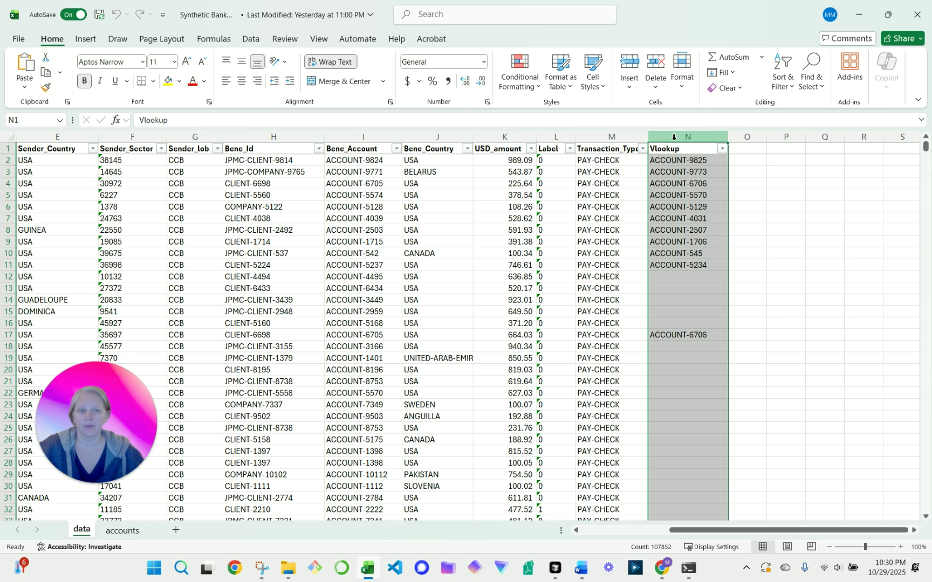

*Screenshot 1: User points out the VLOOKUP formula in column N for cross-referencing.*

Navigate to the 'accounts' tab to view the source data for the validation. Column A contains the master list of all valid accounts.

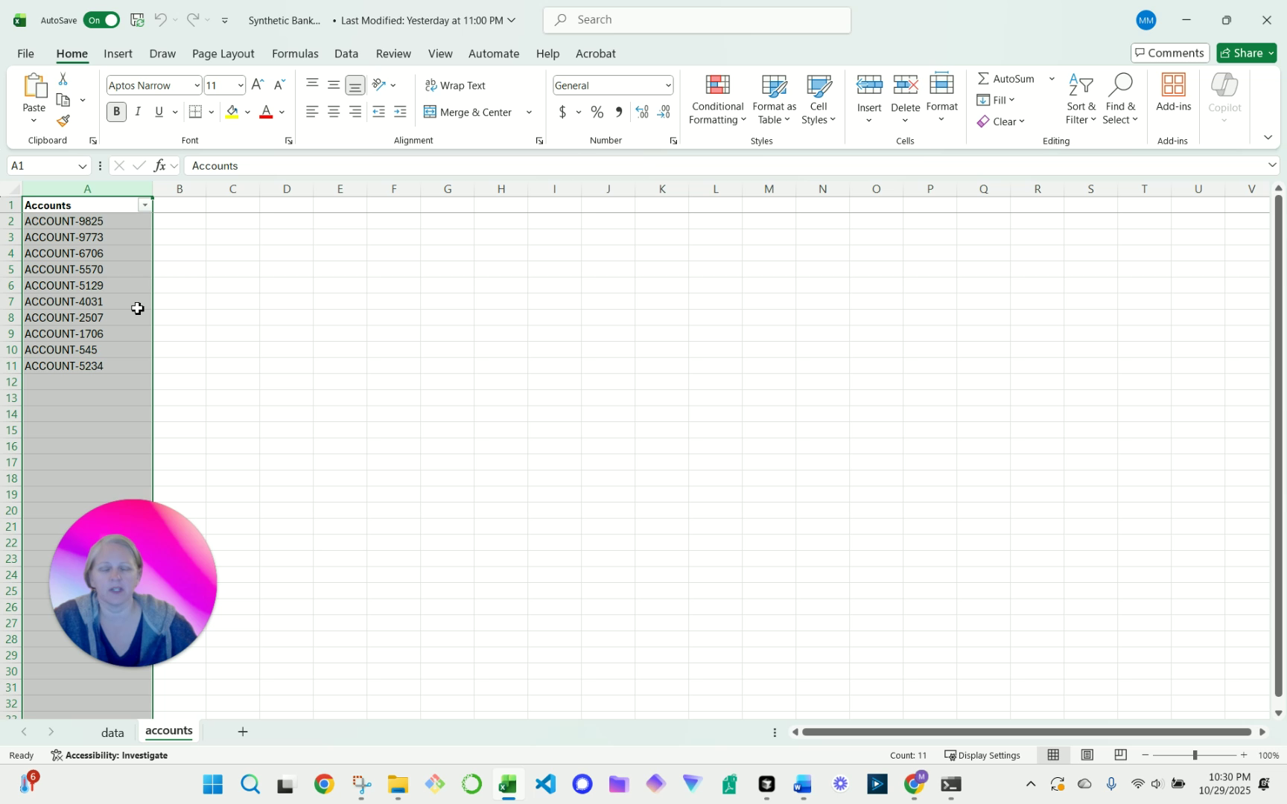

*Screenshot 2: Showing the 'accounts' tab, specifically column A, which is the source for the VLOOKUP.*

Return to the 'data' tab.

Apply a filter to the header row and filter Column N ("Vlookup") to check for any "#N/A" errors.

An "#N/A" error indicates that the "Bene_Account" listed in that row does not exist on the master 'accounts' tab.

If errors are found, proceed to the "Common Issues & Troubleshooting" section for resolution steps. All errors must be resolved before proceeding.

Completeness and Accuracy Verification

Once all account numbers have been validated (i.e., no "#N/A" errors exist), click on the column header for Column K ("USD amount") to highlight the entire column.

Observe the status bar at the bottom-right of the Excel window to verify the record count and the total sum of the transaction amounts.

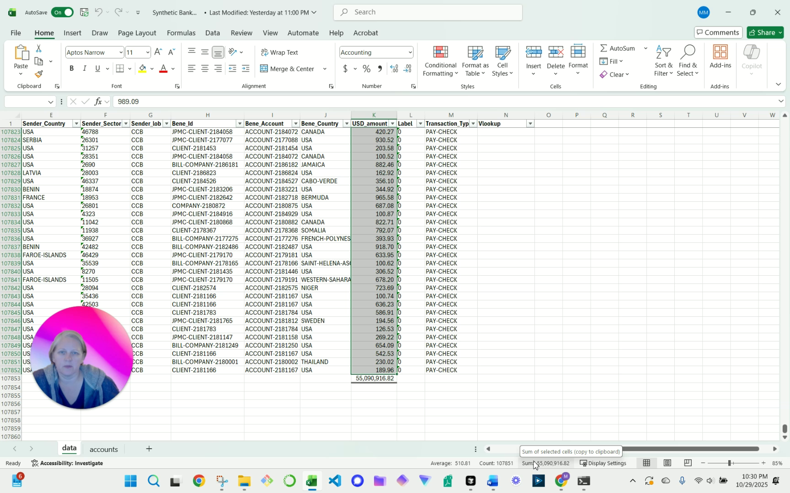

*Screenshot 3: User highlights column K (dollar amount), the record count, and the sum to verify completeness and accuracy.*

Compare the observed record count and total sum against control totals from the source system or daily report to confirm the file is complete and accurate.

Control Points

**Control 1: Account Validation:** Verification that the VLOOKUP in Column N returns no "#N/A" errors. This is a critical control to ensure all posted transactions belong to valid accounts. Any failures must be investigated and remediated immediately.

**Control 2: Completeness Check:** The final comparison of the record count and total sum of "USD amount" (Column K) against expected control totals. This control confirms that the data extract is complete and has not been unintentionally altered.

Common Issues & Troubleshooting

**Issue:** The "Vlookup" column (Column N) displays one or more "#N/A" errors.

**Resolution:** This indicates an account number in the 'data' tab does not exist in the master 'accounts' list. Investigate the invalid account number to determine if it is a data entry error or a new account that must be added to the master list. Escalate to the data management team to correct the source transaction or update the master account list.

**Issue:** The record count or total sum of Column K does not match the expected control totals.

**Resolution:** This may indicate an incomplete or corrupt data file. Request that the file be regenerated from the source system. If the discrepancy persists, escalate to the technical team responsible for the data extract process for further investigation.

Frequency

This process is performed daily upon receipt of the synthetic bank statement file.