Modeling the 4 x 3 x 2 contingency table for evidence of a three-way interaction

We create a 4x3x2 contingency table displaying frequencies for Year (4 levels: 2009, 2010, 2011, 2012), Season (3 levels: Spring, Summer, Fall), and Prey (2 levels: Spider and Non-Spider). Our goal is to test for independence among the variables, and discover any potential relationships. One technique to model this is to use a log-linear model with a log link function and a Poisson response (Christensen 1997; Agresti 2002). Data analysis was carried out using SAS v.9.4. There are several types of independence that can be considered.
- Mutual independence is when the product of all marginal distributions is equal to the joint distribution. If variables are mutually independent, then any pair of variables will also be independent.

- Jointly independent considers one variable independent versus the other two variables taken together. For example: a) Year might be jointly independent of Season and Prey, b) Season might be jointly independent of Year and Prey, or c) Prey might be jointly independent of Year and Season.

- Conditionally independent is when two variables are independent, given the third variable. In this type of independence, one variable is considered fixed, and then independence among the other two variables is investigated. If variables are jointly independent, then they are also conditionally independent.

In running the analysis, we consider 9 possible models. Let Y =1 = Year, S = 2 = Season, and P = 3 = Prey:

- (Y, S, P) = [1][2][3] = Model that includes all main effects. No interactions are considered. This model considers mutual independence.
- (Y, SP) = [1][23] = Model that includes all main effects, and only the SP interaction. This model considers joint independence. Year is jointly independent of Season and Prey.
- (S, YP) = [2][13] = Model that includes all main effects, and only the YP interaction. This model considers joint independence. Season is jointly independent of Year and Prey.
- (P, YS) = [3][12] = Model that includes all main effects, and only the YS interaction. This model considers joint independence. Prey is jointly independent of Year and Season.
- (YS, YP) = [12][13] = Model that includes all main effects, and only the YS, YP interactions. This model considers conditional independence, where Season and Prey are conditionally independent given Year.
- (YS, SP) = [12][23] = Model that includes all main effects, and only the YS, SP interactions. This model considers conditional independence, where Year and Prey are conditionally independent given Season.
- (YP, SP) = [13][23] = Model that includes all main effects, and only the YP and SP interactions.
This model considers conditional independence, where Year and Season are conditionally independent given Prey.
- (YS, YP, SP) = [12][13][23] = Model that includes all main effects, and all two-way interactions. Each pair has homogeneous association (Agresti 2002), where “conditional odds ratios between any two variables are identical at each category of the third variable”. This displays a sort of “marginal” independence.
- (YSP) = [123] = Saturated model that includes all main effects, all two-way interactions, and the THREE-WAY INTERACTION.

We can perform goodness-of-fit tests using either a chi-square test statistic (X^2), or by considering the deviance, G^2 (the likelihood-ratio chi-square statistic). These tests are “equivalent” in that X^2 – G^2 converges in probability to zero. When performing these tests, we use the G^2 value, and calculate p-values according to a chi-square distribution.

Step 1: We identify which models fit the best. Consider G^2 as our test statistic and compare all models to the saturated model [123]. Based on these results, (YS, YP, SP) and (YS, SP) fit the best. This is based on both the p-value, and the fact that the AIC is the smallest for these two models. The mutual independence model of (Y, S, P) is not a good model to consider (it has the largest AIC), so it is possible that there may be some relationships among the variables.

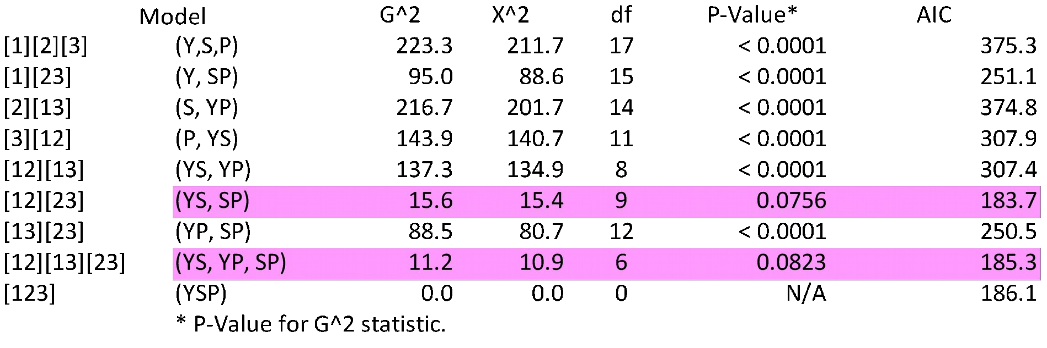

The best two models are (YS, SP) and (YS, YP, SP). Due to the size of the p-values, there is no clear evidence that neither model does not hold. However, we also do not have much confidence that either is a good model. But these are the best models that we have for our dataset, and NEITHER MODEL INCLUDES THE THREE-WAY INTERACTION BETWEEN YEAR, SEASON, AND PREY [Model (Y, S, P)].

Step 2: We will test our two models against each other. It is easy to see that (YS, SP) is a smaller model than (YS, YP, SP). Can we use the smaller model, or should we use the larger model?

To test this, we hypothesize that (YS, SP) fits better than (YS, YP, SP). The alternative is that (YS, SP) does not fit better than (YS, YP, SP). To perform this chi-square test, we consider the difference in G^2 between the two models, where the degrees of freedom is the difference between the degrees of freedom between the two models (Christensen 1997).

G^2_(YS,SP) – G^2_(YS,YP,SP) = 15.6036 – 11.2018 = 4.4018
DF_(YS,SP) – DF(YS,YP,SP) = 9 – 6 = 3P-Value (upper tail) = 0.2212 Decision: Do Not Reject H0
Conclusion: (YS, SP) fits better than (YS, YP, SP). There is no reason to use the larger model. This also agrees with AIC values.

Overall summary of analysis:

- There is no support for a model that includes the three-way interaction.

- We found that the best model out of all possible options is the (YS, SP) model, This model implies that Year and Prey are conditionally independent given season. For example, if you run a Chi-Square Test for independence for Year and Prey (assuming a specific season), you will find that Year and Prey are independent:
Season | Chi-Square Statistic | Degrees of Freedom | P-value
Spring | 4.8026 | 3 | 0.1868
Summer | 5.1542 | 3 | 0.1608
Fall | 5.4893 | 3 | 0.1393

Thus, % IGPrey does not differ between years for each of the three seasons.

- Our analysis does not support any of the other potential model options (due to their “large” test statistic values or a much larger AIC value than the (YS, SP) model). In particular, there is no support for the model (YS, YP). If this were a “good model”, then season and prey would be independent, given year. Since this model is not valid, this means that for a given year, season and prey can depend on each other. When running an independence analysis on Season and Prey (given year), we do find that Season and Prey depend on each other.

Year | Chi-Square Statistic | Degrees of Freedom | P-value
2009 | 22.9747 | 2 | < 0.0001
2010 | 30.7305 | 2 | < 0.0001
2011 | 68.8022 | 2 | < 0.0001
2012 | 12.3492 | 2 | 0.0021

Thus, because prey varies by season, % IGPrey varies between seasons for each year.

- Overall, our analysis follows the same trends that we see visually in Figures 6 -7 in the text. Given season, % IGPrey does not vary across the years, but given year, % IGPrey varies across the seasons. Furthermore, the pattern of variation between seasons does not substantially differ across years.

REFERENCES
Agresti, A. (2002) Categorical Data Analysis (2nd edition) John Wiley & Sons, Inc., Hoboken, NJ.
Christensen, R. (1997) Log-Linear Models and Logistic Regression (2nd edition). Springer, New York.

