**Student Assistant Website**

**Peer to Peer Assisted Learning**



# 

# **Introduction**

**Brief Overview**

This report details our Team Project development which was completed throughout the semester.

Our project is a dynamically driven website that aids students in their quest of academic greatness. The website aims to provide a platform where students may post problems or queries, academia related and other students may post and comment solutions.

The name of the website is *Logos*. The site was developed using a number of different software’s. These include the following:

* UML
* HTML
* CSS
* PHP
* JavaScript
* SQL
* XAMP
* GITHUB
* Various text editors

We have examined closely how we want the overall look of the website and how we can make it more engaging to the web user. For the best consistent design, we have incorporated the CRAP principles to bring out good visual design. In turn this will make the website much easier to navigate for the end-user. Considering usability and accessibility for all web users, we use the hierarchical organisation structure in the creation of my website. There will be a clearly defined home page that links to the other major links in my website, this will be outlined later in the web design section of the document.

**Short Description (inspirations, references)**

Our group decided as a whole that we could implement something of a cross between *Blackboard* and *Reddit.* We deliberated for a brief period before settling on this idea. *Logos* translates to *student* in ancient Greek. The hope is that students can come with a problem and leave with a solution in a timely manner.

On a technical level, the site will have two major outlooks, the first, user accessible site which is a collection of modules and their content which is neatly accessed when a student first logs on. The second, administrator accessible side of the side where admins can delete users and modules and this can only be accessed through search bar.

Each stage of development was uploaded to *GitHub* where the team would submit their efforts and review each-others work before committing to the master branch. Through trial and error this turned out to be the most efficient way of developing the site.

**Summary of conclusions**

The site was primarily documented with a Use Case, Sequence, Class and Behavioural State diagram. We stayed on target throughout and followed our design goals. Our site corresponds to our UML design goals.

The team’s relationship remained strong throughout and we are all agreed that we enjoyed the development of this website. A Facebook group chat was setup early on so we could remain in constant contact. We will now live out our lives as Facebook friends for life.

After each commit to the *master* branch on *GitHub*, the site became more and more functional and we quickly realised that it is very easy to turn beautiful code into incompatible gibberish. It was through sheer will and determination that five men could come together and produce a fully functional project on time.

**Roles of Team Members**

**Andrew**- Created the topics and comments forms and pages. Small design and *css* contribution.

**David**- Created the settings and meetings pages also other small pages. Added to database.

**Ademolu**- Created alternative settings and assisted in each aspect of development.

**Matthew**- Worked on almost all aspects and ensured functionality throughout.

**John Lee**- Designed the whole look of the site and contributed to almost all other aspects.

All team members also assumed leadership roles, which changed every week. We took turns in filling out weekly journal.

**Application Design**

**Summary Breakdown**

Major tasks involved were getting setup on GitHub and implementing code. Each member was given specific tasks to complete each week with some members going above and beyond to secure a meaningful week of development.

Keeping the database up to date proved challenging at times and a lot of *dropped* databases did occur. Xampp failing to load was another issue that could be deemed a major task at times.

Each team member was expected to spend between two and four hours minimum per week on the project. Some of the work done by members was also dropped as a result of incompatibility.

**Functional Requirements**

**Member**

* **Login**
* **Logoff**
* **Editprofile**
* **ViewCoursemodules**
* **Find specific topic**
* **Post**
* **Comment**
* **Report**
* **Create meeting**
* **View meeting**

**Non Member**

* **Create account**

**Admin**

* **Remove user**
* **Remove content**
* **Populate modules**

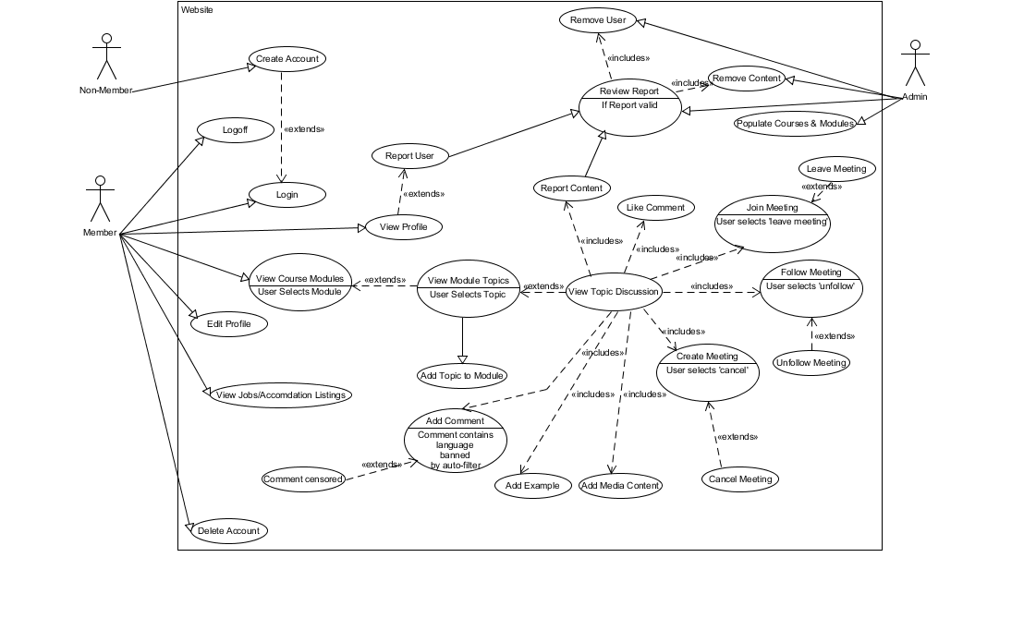UseCase

Some functionality changed throughout the project, some was lost and some was gained

**Technical Description**

Hardware Requirements

|  |  |
| --- | --- |
| **Item** | **Requirement** |
| **Processor** | Dual Core and up preferred |
| **RAM** | 4 GB RAM or more recommended for database  2 GB RAM or more recommended for web server |
| **HDD** | 40 GB or more recommended |

Software Requirements

|  |  |
| --- | --- |
| **Item** | **Requirement** |
| Internet Browser | Google Chrome or Firefox |
| Text Editor | Subline, Atom, Scite, brackets |
| OS | Windows |
| Server | XAMPP |
| Database | MySQL |

**Database Design**

Database name is studentsupport, the tables included are as follows

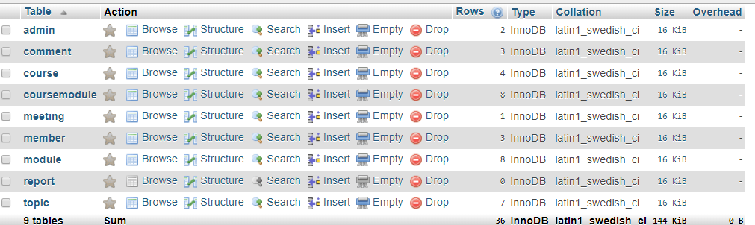

**Implementation Issues**

* + Implementation issues --- technical choices, coding styles, changes, risks and weaknesses. Description of main technical issues/problems, include code snippets and explanations if appropriate.

Main issue was keeping all the code in sync. If it wasn’t a compatibility issue, it was a database issue.

The technical side of things went well, it doesn’t take much to run a dynamic website of this scale.

We did encounter some problems with uploading and merging branches. Time and care was taken to ensure the highest level of competency was taken to add new data. There was a few teething problems as well as some recurring issues but we pulled through.

As far as risks go, there were little or none involved in the development of this website.

Coding styles were chopped and changed throughout until we decided on a handler page to complement each corresponding page. This made the code appear more professional and aided and abetted us when debugging. All code is indented properly and team members have signed/commented their name at tops of the pages they developed.

**Reflections of Teamwork**

**Evidence of Cooperation**

*GitHub* provided a useful tool in keeping track of all stages of development and each user’s contribution. Each member has their own contributions and a count of all code provided. At beginning of project the group were unsure of how exactly GitHub worked so any branches deleted or code that reverted back to another stage, are unaccounted for. This is the only issue with *GitHub* and a small issue at that.

*Blackboard* was used for submitting weekly journal and in some rare instances, sharing of code.

Team members kept in constant contact through means of social media and email.

**Description of Activities**

Many informal discussion were had. We decided as a group to rotate the team leader on a weekly basis. The team leader was responsible for allocating tasks and filling out weekly journal.

The team leader was to assume the responsibility of a captain and motivate the team on those dreary all night coding sessions. As the cold wind and rain battered the crumbling windows of our dilapidated student accommodations, baked beans burned on the hob, no hope in sight, the team leader was there to provide a reassuring assistance.

The team leader provided a light in the darkest of Black Holes.

*Blackboard* tools such as file exchange and group discussion board were used before we had *GitHub* up and running correctly

**Description of Individual Contribution**

Pro Forma Individual Reflections and Comments on the Team Project in appendix below for each individual member.

**Team Self-Assessment**

How were decisions made by the team?

The team met for two, two-hour in class sessions per week and almost all design and coding decisions were made in these classes. Some of the stronger coders in the team had more of an input when discussing how and where to implement certain code. Other less code-oriented members contributed using their strengths of human interaction and provided foresight into what functionality is required and what may be surplus to requirements.

Did all the team members contribute equally to the development of the project?

The team gelled well together from the start and each provided their own strengths and weaknesses. As an hourly measurement, all team members have contributed significantly to this project. As stated already, every member played to their strength.

How much communication occurred during the project? What different forms did it take?

Communication between team members occurred in class and through electronic means. The team has been very vocal about their opinions since day one and this has ultimately led to the completion of a magnificent and fully functional website.

Describe one technical problem that was overcome by the team.

One technical issue that kept reoccurring was the sizing of the header banner. On a Pc, it was fine but on a laptop it drooped down over our content. This was swiftly fixed.

Describe one team problem that was overcome by the team.

At a late stage of development, the team was forced to revert back to an older version due to incompatibility issues. This set us back by about a week. No major issue but it had to be addressed and we all feel like we done the right thing.

How does working on a team project compare to working individually on a project?

I think the team will agree that there are pros and cons of each. Coming together as a team has ultimately been a positive experience for all involved. It showcased unforeseen personal weaknesses and we got to address those.

It also has prepared us for work in a team based environment, which we all know is the standard in the IT sector.

Individual projects give a developer more chance to express themselves and keep all code in check. Team project provided a helping hand to those who may not have too comfortable with coding.

What were the strengths of the team?

Most definitely team spirit. Every day the team had a new idea or inspiration to bring to the table. Attendance between members was as close to excellent as you’ll get. The rotation of the team leader role gave a different insight into the mind of the individual student.

What were the weaknesses of the team?

Some of the members of the team are not strong coders and this may well have impacted the development of the project but for the heroics of some of the more able coding members.

On reflection after the fact, how could the team be improved to improve performance and avoid problems? If you were to start again what would you, as a team, change?

On reflection, a more thorough inspection of each other’s work on a more frequent basis would be a must. Would also take away the team leader rotation as while it had its positives, it had its drawbacks which we would all have liked to address sooner. The optimal leader in my opinion would be the strongest coder. Look to him for inspiration. Also we had an overload of ideas at the start of the project to implement but we did not take into consideration the time given, as time was running short some ideas we had could not be implemented.

**Conclusion**

Overall though we had many problem’s and conflict within the group I think the project has turned out very well although we don’t have as many functions as we first thought we would have, that was mainly down to the time we had to complete the project. From taking part in this project we have all gained an insight in how to work in a team and gave us an insight in what aspect of computing that our strengths are and where we can improve.

Although our project didn’t turn out to be exactly what we wanted, Our project was still successful as the main functions of the website do in fact work as a student can sign up and find help on a topic of their choice.

As a team we worked reasonably well, if one member had a problem getting their code to work other members would help until the problem has been dealt with

**Appendices**

**Journal**

**Week 1**

**Previous period of work completed**

Andrew Campbell, 6 hours.

David Doherty, 6 hours.

John Lee Heaney, 6 hours.

Matthew Mc Clean, 6 hours.

**Evaluation of outstanding items of previous period of work or additional work completed**

None - all previously scheduled items of work have been completed

**Scheduled work for next period of work**

Andrew Campbell: UML Part 1.

David Doherty: UML Part 2.

John Lee Heaney: UML Part 3.

Matthew Mc Clean: UML Part 4.

**Week 2**

**Previous period of work completed**

Andrew Campbell, 3 hours.

David Doherty, 3 hours.

John Lee Heaney, 3 hours.

Matthew Mc Clean, 4 hours.

**Evaluation of outstanding items of previous period of work or additional work completed**

None - all previously scheduled items of work have been completed

**Scheduled work for next period of work**

Andrew Campbell: Discussion Board.

David Doherty: Meeting.

John Lee Heaney: Login/Registration.

Matthew Mc Clean: Module/Topic Page.

** Additional Comments  
Ademolu Ogunnaike added to group, Edit profile

**Week 3**

**Previous period of work completed**

Andrew Campbell, 5 hours.

David Doherty, 5 hours.

John Lee Heaney, 6 hours.

Matthew Mc Clean, 5 hours.

**Evaluation of outstanding items of previous period of work or additional work completed**

Ademolu-5 hrs

Andrew-discussion board outstanding

David-meeting page incomplete

Ademolu-settings page incomplete

**Scheduled work for next period of work**

Andrew Campbell: discussion board.

David Doherty: meeting place.

John Lee Heaney: css and footers etc..

Matthew Mc Clean: admin page/login.

** Additional Comments  
Ademolu-report button

**Week4**

**Previous period of work completed**

Andrew Campbell, 4 hours.

David Doherty, 6 hours.

John Lee Heaney, 5 hours.

Matthew Mc Clean, 5 hours.

**Evaluation of outstanding items of previous period of work or additional work completed**

Ademoulu - 4 hrs

Add topic - get form added, fix bug with creatorNo

Admin page

comments page

**Scheduled work for next period of work**

Andrew Campbell: Comments page - add comment, edit, remove, etc.

David Doherty: Meetings page.

John Lee Heaney: Validate user cannot register for 'all' courses.

Matthew Mc Clean: Module filter.

** Additional Comments  
Ademoulu - reports generator

**Week5**

**Previous period of work completed**

Andrew Campbell, 10 hours.

David Doherty, 1 hours.

John Lee Heaney, 1 hours.

Matthew Mc Clean, 2 hours.

**Evaluation of outstanding items of previous period of work or additional work completed**

Ademoulu - 1h

**Scheduled work for next period of work**

Andrew Campbell: Comments page.

David Doherty: Meetings connected.

John Lee Heaney: Clean up css.

Matthew Mc Clean: Admin pages.

** Additional Comments  
Ademoulu - reports page

**Week6**

**Previous period of work completed**

Andrew Campbell, 4 hours.

David Doherty, 4 hours.

John Lee Heaney, 8 hours.

Matthew Mc Clean, 4 hours.

Ademolu - 1hr

**Evaluation of outstanding items of previous period of work or additional work completed**

Comments page!!!

**Scheduled work for next period of work**

Andrew Campbell: New Comment form.

David Doherty: Settings Page.

John Lee Heaney: Css.

Matthew Mc Clean: Add courses admin.

Ademoulu - start topic page

** Additional Comments

**Week7**

**Previous period of work completed**

Andrew Campbell, 3 hours.

David Doherty,6 hours.

John Lee Heaney, 4 hours.

Matthew Mc Clean, 6 hours.

**Evaluation of outstanding items of previous period of work or additional work completed**

None - all previously scheduled items of work have been completed

**Scheduled work for next period of work**

Andrew Campbell: Comments and threads.

David Doherty: settings .

John Lee Heaney: css      .

Matthew Mc Clean:  admin stuff.

** Additional Comments  
demelou--search bar if is able to implement

**Week8**

**Previous period of work completed**

Andrew Campbell, 4 hours.

David Doherty, 4 hours.

John Lee Heaney, 4 hours.

Matthew Mc Clean, 4 hours.

**Evaluation of outstanding items of previous period of work or additional work completed**

ademulo-4

**Scheduled work for next period of work**

Andrew Campbell: get comment page functioning.

David Doherty: settings page functioning.

John Lee Heaney: css.

Matthew Mc Clean:  fixing up admin.

** Additional Comments  
ademulo-searchbar

**Week9**

**Previous period of work completed**

Andrew Campbell, 2 hours.

David Doherty, 2 hours.

John Lee Heaney, 2 hours.

Matthew Mc Clean, 2 hours.

ademulo-2

**Scheduled work for next period of work**

Andrew Campbell: comment handler.

David Doherty: report topic.

John Lee Heaney: admin stuff.

Matthew Mc Clean: admin stuff.

** Additional Comments  
ademulo-searchbar functioning

**Week10**

**Previous period of work completed**

Andrew Campbell, 6 hours.

David Doherty, 4 hours.

John Lee Heaney, 10 hours.

Matthew Mc Clean, 4 hours.

**Evaluation of outstanding items of previous period of work or additional work completed**

ademulo-2

**Scheduled work for next period of work**

Andrew Campbell: report.

David Doherty: report.

John Lee Heaney: finalising website.

Matthew Mc Clean:  finalising website.

**Week11**

**Previous period of work completed**

Andrew Campbell, 4 hours.

David Doherty, 4 hours.

John Lee Heaney, 4 hours.

Matthew Mc Clean, 4 hours.

Ademolu, 4 hours

**Scheduled work for next period of work**

Andrew Campbell: Project Report

David Doherty: Project Report.

John Lee Heaney: css.

Matthew Mc Clean:  admin stuff.

 Ademulo: Searchbar and report

** Additional Comments  
ademulo-searchbar functioning

**Uml Diagrams**

**UseCase**



**Class diagram**

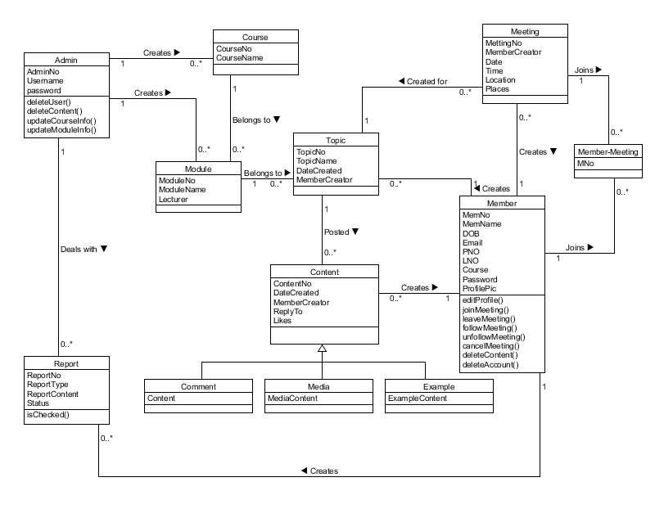

**Behavioural State**

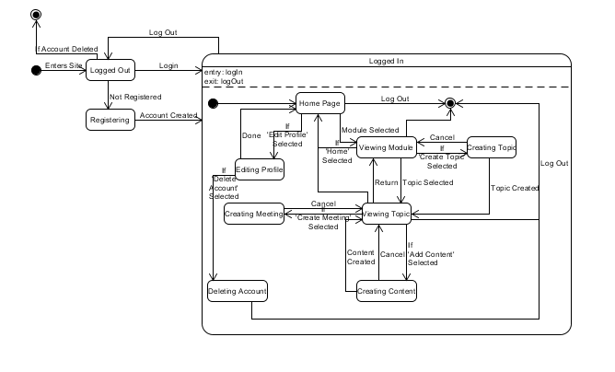

**Sequence Topic**

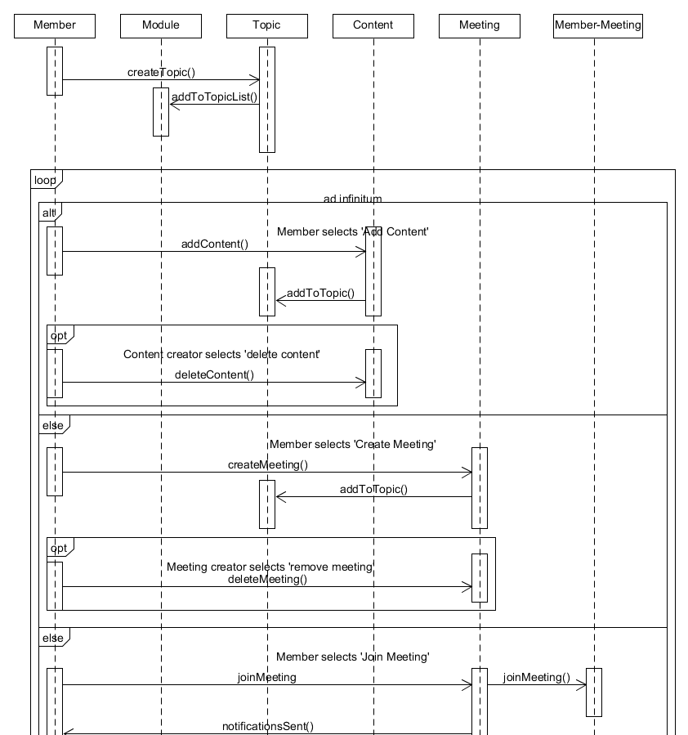

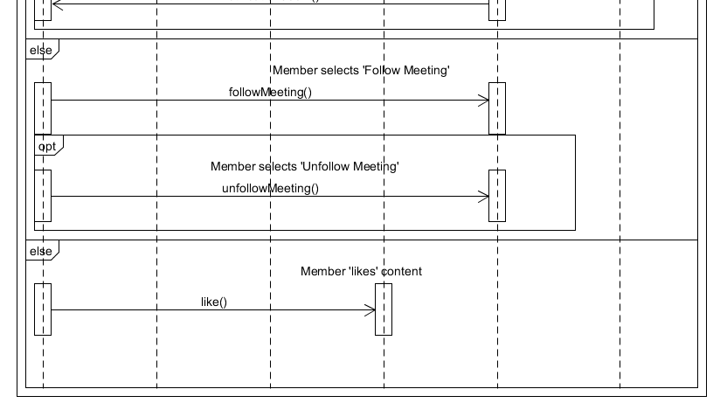

**Sequence Login**

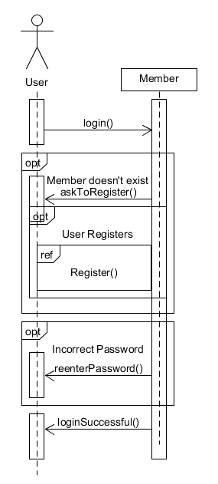

**Sequence Register**

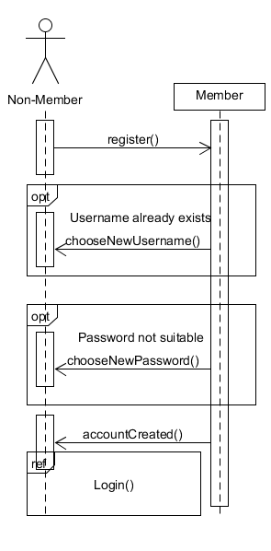

**Sequence Course Module**

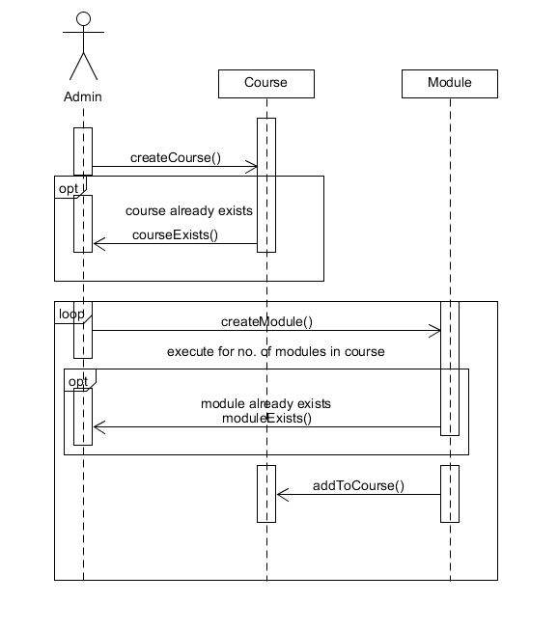

Pro Forma Individual Reflections and Comments on the Team Project

**David**

1. What were your major contributions?

My main contribution was the meetings page where student can create a meeting and then view any meeting that already exist, Also I contributed majorly in team communication as I set up a facebook group for the team to easily communicate outside class hours

1. What do you consider you did well?

I believe I did well in doing what I could for team to the best of my capabilities

1. What do you consider you did less well?

I did less in the coding certain aspects as I am not very strong in that aspect

1. What grade would you award the project? Why?

I would award this project 80% because the functionality is there and we did our best in the time we had

1. How could the grade be improved? Justify your answer.

With more features on the website as it has very basic features at the minute

1. What behavioural and work changes would you adopt in any future team work that you might be involved in?

I would take under consideration the time you have so you can make your project more adequate to time you have

1. Any other comments.

Pro Forma Individual Reflections and Comments on the Team Project

**Matthew**

1. What were your major contributions?
2. What do you consider you did well?
3. What do you consider you did less well?
4. What grade would you award the project? Why?
5. How could the grade be improved? Justify your answer.
6. What behavioural and work changes would you adopt in any future team work that you might be involved in?
7. Any other comments.

Pro Forma Individual Reflections and Comments on the Team Project

**Andrew**

1. What were your major contributions?

For the website I was tasked with adding topics and then commenting on a thread on those topics. We went with matthews add module but kept my form. The comment page and handlers for each and updated sql accordingly.

1. What do you consider you did well?

I was happy with how the forms turned out

1. What do you consider you did less well?

I didnt commit to github enough. At the start I was using Facebook and email for contact and to append code and files. I was never confident in where and how to upload but I have a grip on it now.

1. What grade would you award the project? Why?

I would give the grade a 70% or more grade as I think the team put in countless hours on the project and it does as it meant to do perfectly.

1. How could the grade be improved? Justify your answer.

For the grade to improve overall for the team, we could have met up more outside of class to stay more in tune as there were some Github issues. There was a lot of time spent of compatibility issues and the word 'rollback' was used more than once.

1. What behavioural and work changes would you adopt in any future team work that you might be involved in?

I would definitely recommend the use of a social media platform for a group chat.

1. Any other comments.

Pro Forma Individual Reflections and Comments on the Team Project

**John Lee**

1. What were your major contributions?

In terms of subject matter each page will contain, tables, text and graphics. The programming languages that I used were, PHP, JavaScript, jQuery, html and CSS. I used brackets editor as the tool for writing my code. My contribution to helping design the website can be categorized as follows:

Main Website

1. Website Registration & login

2. Navbar

3. Content area

4. Sidebar

5. Footer

6. CSS

Website Registration & Login

The Registration login and register forms were created using a PHP file that reads in values from user input. In order to execute the code a register handler file was created, all SQL queries and form validation was implemented here. It was decided a good feature to add to our login form would be an animated scroll function. This enhancement was created using some JQuery. Trying out various types of background images for the registration page we all agreed on our final background image. Styling on the register form was done using external CSS.

Navbar

The navigation was created using div tags and list tags. External CSS file was use to style the navigation bar. Media queries were used in external CSS file to make the navigational bar responsive. All content in this page was saved as the header page. This meant that every other file could use the Include or Require statement to copy the header file. This method meant not duplicating code reuse, that otherwise would be redundant.

Content Area

Content area was created using a div tag and names for styling in CSS. All tables and buttons were styled using bootstrap. The CDN files were copied directly from the bootstrap website and pasted into the header of the file. This allowed me to tag selected elements from our working files, and enhance their appearance by using built in libraries from bootstrap. All tables and buttons were styled using bootstrap.

Sidebar

The Sidebar was created using a div tag, the div was labelled so that it could be modified using CSS. Within the side bar I used SQL queries to pull in the user image and user name from the database. These queries output the user profile picture and the user logged to the side bar. The menu choice from the sidebar was created using a slide navigation. To make the menu more striking I downloaded font awesome files and inserted icons above menu names. Various tags and ids were used when constructing the slide navigation. To create the sliding effect a JavaScript file was created and two function were made to open and close the sidebar. All content in this page was saved as sidebar.php, all other files can use the Include or Require statement to copy this file.

Footer

The footer area was created using a bootstrap template that I downloaded. The template did not fit well with our website originally so I had to edit the footer CSS file. A PHP script was created to show the current year .Anchor tags in the footer were adapted by our team, so that we could create our own pages.

CSS

An external CSS file was created so that we could fully optimize the aesthetics of our website. This is our websites primary location for styling our website, and setting the responsiveness of each file. Class and div tags were instrumental to giving the power to, position, style and customize our website’s appearance.

Administration

1. Admin Login

2. Navbar

3. Sidebar

4. Footer

5. CSS

6. Alert messages

Admin Login

The Admin login page was created from a bootstrap template, I added our logo picture as an added feature to this file. The PHP code to execute the admin login file was created by Matthew and myself.

Navbar

The navigation was created using div tags and list tags. External CSS file was use to style the navigation bar. Media queries were used in external CSS file to make the navigational bar responsive. All content in this page was saved as the header page. This meant that every other file could use the Include or Require statement to copy the header file. This method meant not duplicating code reuse, that otherwise would be redundant.

Sidebar

Sidebar was created using html div tags, anchor tags as well as using some components from bootstrap to style. Similar to font awesome, Glyph icons were used to emphasise better appearance to the sidebar.

Footer

The admin footer was constructed with just a div tag id which allows for the styling in CSS. A PHP script was written to show the current year.

CSS

An external CSS file was created for admin webpage, again all elements that were added to the webpage were customized in this file.

Alert messages

When the administrator carries out some common tasks for example add or delete, a good idea was to output a success or error message on screen. To complete this task a PHP file was created called Session that has two functions. The first function message displays an error message and the second function a success message. When an SQL query is performed for an administrative task the functions are triggered when an if else condition is performed. A message will be display on notifying the administrator if the task was a success or error.

REFERENCES

<https://glyphicons.com/>

<https://fontawesome.com/>

<https://getbootstrap.com/>

1. What do you consider you did well?
2. What do you consider you did less well?
3. What grade would you award the project? Why?
4. How could the grade be improved? Justify your answer.
5. What behavioural and work changes would you adopt in any future team work that you might be involved in?
6. Any other comments.

Pro Forma Individual Reflections and Comments on the Team Project

**Ademulo**

1. What were your major contributions?
2. What do you consider you did well?
3. What do you consider you did less well?
4. What grade would you award the project? Why?
5. How could the grade be improved? Justify your answer.
6. What behavioural and work changes would you adopt in any future team work that you might be involved in?
7. Any other comments.