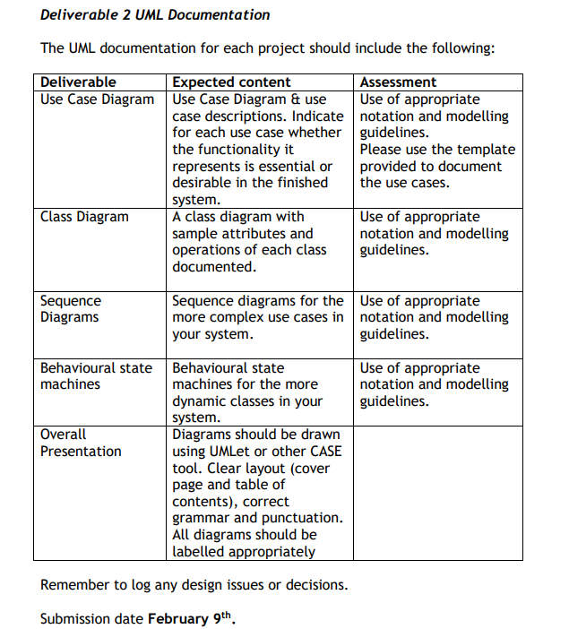

**THIS WILL BE A GROUP ASSIGMENT NO INDIVIDUALS, WE WILL NEED TO SIT AROUND AND DRAW ON PAPER USE CASE AND CLASS DIAGRAM THIS WILL GIVE US THE BASIS FOR DRAWING THE BEHAVOURIAL AND SEQUENCE DIAGRAM. IN YOU OWN TIME JUST START SKETCHIN ON PIECE OF PAPER WHAT PAGES AND FUNCTIONALITY YOU WANT ON THE WEBSITE.**

**CURRENT WE HAVE…**

**HOME PAGE** – CAN BE A LIST OF ALL THE MODULES THAT THE USERS CAN CHOOSE TO QUERY ON THERE PROBLEM, CAN BE A LIST OF HYPER LINKS THAT TAKE THEM TO THE DISCUSSION BOARD OF THERE CHOICE. OR ANY OTHE IDEA OF LAYOUT..ADD HERE AND ADDINTIONAL INFOR!!

**SETTINGS PAGE** - FOR USER TO UPDATAE PERSONAL INFORMATION..PRETTY MUCH DONE CAN MODIFY LATER, OR ANY OTHE IDEA OF LAYOUT..ADD HERE AND ADDINTIONAL INFOR!!!!

**DICUSSION BOARD PAGE** – WERE THERE IS INFINITE LOOP FOR USERS TO ADD CONTTENT, VIDEO AND IMAGE CONTENT, OR ANY OTHE IDEA OF LAYOUT..ADD HERE AND ADDINTIONAL INFOR!!.

ADD OTHER WEB PAGE CONTENT HERE WITH A SHORT EXPLANATION OF WHAT IT WILL INLCUDE AS I HAVE DONE ABOVE,, FEEL FREE TO ADD ANYTING OR MODIFY!!!!!!

**MATTHEW, ANDREW, DAVID JLEE ADD CONTENT HERE!!!!!**

ADD OTHER WEB PAGE CONTENT HERE JUST LIKE I HAVE DONE ABOVE SO WE CAN SEE VISUALLY WHAT WE ARE GOING TO ADD TO YOUR WEB PROJECT!! THIS WILL MAKE IT EASIER FOR US TO DRAW THE UML DIAGRAMS. WHEN WE HAVE THEM SKETCH IN PAPER WE CAN ALL DO ONE EACH ON UMLET. WE CAN DO THAT AFTER WE GET THEM DONE ON PAPER FIRST!