**TEAM PROJECT**

* **SPECIFICATION DUE WEEK TWO: 5%**
* **2 PAGE DOCUMENT 500 WORDS APPROX – I THINK GUYS BULLET POINTS IS GOOD YA, BUT TRY GIVE A SHORT PARAGRAPH OR TWO, WE NEED 500 WORDS MINIMAL ID SAY.**
* **SHARE POINTS BELOW**

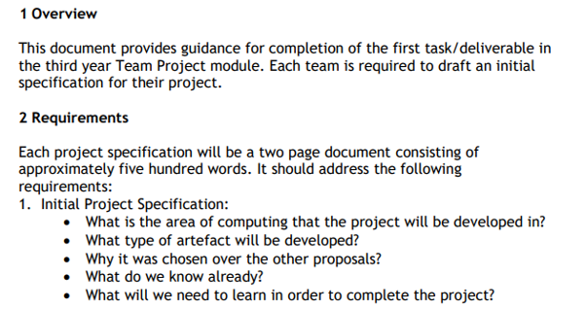

**MATTHEW** 

**ANDREW**

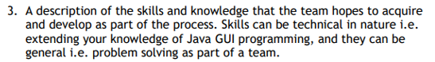

**JOHN LEE**



**DAVID**



**ANDREW & DAVID – U CAN USE SOME OF THESE ANDREW IF ANY GOOD I DON’T KNOW I JUS NOTED EARLIER APPEND AND MODIFY AS YOU LIKE, JUST LEFT THEM ON HERE**

**FUNCTIONAL AND NON-FUNCTIONAL**

**FUCNTIONAL REQUIRMENTS – WHAT THE SYSTEM SHOULD DO**

1. **COMMENT – ENABLE USER TO SUBMIT HIS/HER COMMENTS ON SUBJECT MATTER AND READ OTHER USERS COMMENTS**

**NON-FUCNTIONAL REQUIRMENTS – DESCRIBE HOW SYSTEM WORKS**

1. **OPERATIONAL REQUIRMENTS**
2. **PERFORMANCE REQUIREMENTS**
3. **SECURITY REQUIREMENTS**
4. **POLICITCAL REQUIREMENTS**

**NO SPECIAL CULTURAL AND POLICTICAL REQUIREMETS ARE ANTICAPTED**

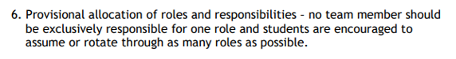

**JOHN LEE – IL JUST WRITE A FEW LINES EXPLAIN THE IMPORTANCE OF CHANGING ROLE BLAH BLAH BLAH.**



**EVERYBODY TASK – EACH ONE OF US GUYS APPEND ENVIRONEMENT/ENVIRONMENTS YOU THINK WE WILL BE USING.**

**THIS IS EXAMPLE BELOW OF WHAT I HAVE LISTED SO FAR, ADD OTHER APPLICATIONS TO THE LIST THAT YOU GUYS THINK WE WILL BE USING, TRY TO FORECAST LATER INTO PROJECT WHAT WE WILL BE USING.**

**SOFTWARE ENVIRONMENTS WILL INCLUDE THE FOLLOWING:**

* **BRACKETS EDITOR FOR CODING JS, HTML, CSS**
* **UMLET FOR USE CASE, CLASS DIAGRAMS**

**SUBMIT ANYMORE ENVIRONEMENT WE WILL BE USING I USED BRACKETS FOR CODING IM SURE U GUYS HAVE UR OWN EDITORS SO ON!!!**



**EVERYBODY TASK – WRITE DOWN ANY BOOKS, WEBSITES, TUTORIAL VIDEOS THAT ANY OF YOU GUYS WILL USE FOR THIS PROJECT SUBMIT TO BLACK CAN APPEND ALL THE ITEMS TOGETHER IN ONE LIST.**

**RESOURCES THAT WILL BE USING INCLUDE:**

* **LIST GOES HERE**

**FINAL NOTES:**

**TRY AND HAVE EVERTHING SUBMITTED ON BLACK TOMORROW GUYS ASAP AS I CAN APPEND ALL INFORMATION AND HAVE IT CONSTRUCTED IN A FLOWY TYPE WAY FOR SUBMISSION. IL BE THE TEAM LEAD FOR THE NEXT TWO WEEKS AND WE WILL ROTATE IT SO THAT EVERYONE HAS A CHANCE. WHEN THE TASKS START FROM NEXT WEEK ONWARDS, IF IT COMES TO THE POINT WERE SOMEBODY IS ASSIGNED SOMETHING AND THEY FIND IT VERY DIFFICULT WE CAN NEGOTIATE AND SWAP TOPICS. THAT IS IF SOMEONE ELSE FEELS COMFORTABLE DOING SOMETHING ELSE. JUST MESSAGE AND WE SEE WHAT BEST SUITS EACH INDIVIDUAL, ONE PERSON LAGGING BEHIND MEANS WE ALL LAG BEHIND, IF ANY NEEDS HELP, HELP THEM OUT!**

**ONE LAST THING IF ANYONE HAS ANY PROBLEMS WITH THERE QUESTION JUS QUERY ON BLACKBOARD WHAT YOU UNSURE ABOUT AND IM SURE ANY OF US GUYS WHO KNOW THE ANSWER TO THE QUERY CAN RESPOND.**

**CHEERS!**