data

Autogenerated data summary from dataReporter

2021-12-16 18:34:04

# Data report overview

The dataset examined has the following dimensions:

|  |  |
| --- | --- |
| Feature | Result |
| Number of observations | 37312 |
| Number of variables | 11 |

### Checks performed

The following variable checks were performed, depending on the data type of each variable:

|  |  |  |  |  |  |  |  |  |
| --- | --- | --- | --- | --- | --- | --- | --- | --- |
|  | character | factor | labelled | haven labelled | numeric | integer | logical | Date |
| Identify miscoded missing values | × | × | × | × | × | × |  | × |
| Identify prefixed and suffixed whitespace | × | × | × | × |  |  |  |  |
| Identify levels with < 6 obs. | × | × | × | × |  |  |  |  |
| Identify case issues | × | × | × | × |  |  |  |  |
| Identify misclassified numeric or integer variables | × | × | × | × |  |  |  |  |
| Identify outliers |  |  |  |  | × | × |  | × |

Please note that all numerical values in the following have been rounded to 2 decimals.

# Summary table

|  |  |  |  |  |
| --- | --- | --- | --- | --- |
|  | Variable class | # unique values | Missing observations | Any problems? |
| state | character | 33 | 0.00 % |  |
| prod_year | numeric | 91 | 0.00 % |  |
| rate_class | numeric | 22 | 0.00 % |  |
| num_oil_wells | numeric | 2947 | 0.00 % | × |
| oil_prod_BBL | numeric | 21180 | 0.00 % | × |
| ADgas_prod_MCF | numeric | 16694 | 0.00 % | × |
| oil_wells_dayson | numeric | 13373 | 0.00 % | × |
| num_gas_wells | numeric | 2883 | 0.00 % | × |
| NAgas_prod_MCF | numeric | 19276 | 0.00 % | × |
| conden_prod_BBL | numeric | 12759 | 0.00 % | × |
| gas_wells_dayson | numeric | 12627 | 0.00 % | × |

# Variable list

## state

|  |  |
| --- | --- |
| Feature | Result |
| Variable type | character |
| Number of missing obs. | 0 (0 %) |
| Number of unique values | 33 |
| Mode | “AR” |

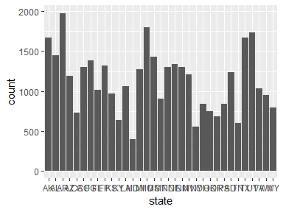

## prod_year

|  |  |
| --- | --- |
| Feature | Result |
| Variable type | numeric |
| Number of missing obs. | 0 (0 %) |
| Number of unique values | 91 |
| Median | 1983 |
| 1st and 3rd quartiles | 1968; 1996 |
| Min. and max. | 1919; 2009 |

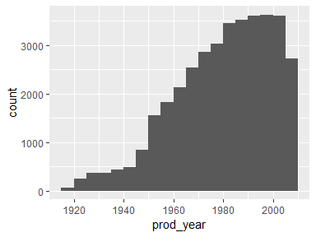

## rate_class

|  |  |
| --- | --- |
| Feature | Result |
| Variable type | numeric |
| Number of missing obs. | 0 (0 %) |
| Number of unique values | 22 |
| Median | 11.5 |
| 1st and 3rd quartiles | 6; 17 |
| Min. and max. | 1; 22 |

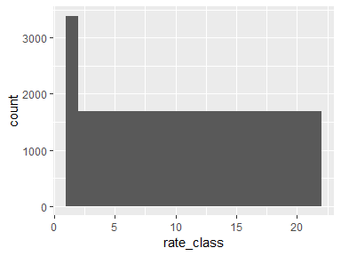

## num_oil_wells

|  |  |
| --- | --- |
| Feature | Result |
| Variable type | numeric |
| Number of missing obs. | 0 (0 %) |
| Number of unique values | 2947 |
| Median | 3 |
| 1st and 3rd quartiles | 0; 61 |
| Min. and max. | 0; 57276 |

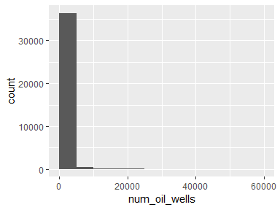

* Note that the following possible outlier values were detected: "1540", "1542", "1546", "1549", "1552", …, "52060", "52451", "52568", "53032", "57276" (1682 values omitted).

## oil_prod_BBL

|  |  |
| --- | --- |
| Feature | Result |
| Variable type | numeric |
| Number of missing obs. | 0 (0 %) |
| Number of unique values | 21180 |
| Median | 12717.5 |
| 1st and 3rd quartiles | 0; 567621.25 |
| Min. and max. | 0; 943867597 |

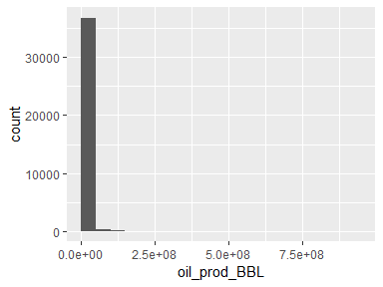

* Note that the following possible outlier values were detected: "15732003", "15744915", "15747529", "15767609", "15788926", …, "297244166", "299067726", "300464746", "302370398", "943867597" (1627 values omitted).

## ADgas_prod_MCF

|  |  |
| --- | --- |
| Feature | Result |
| Variable type | numeric |
| Number of missing obs. | 0 (0 %) |
| Number of unique values | 16694 |
| Median | 0 |
| 1st and 3rd quartiles | 0; 194309.75 |
| Min. and max. | 0; 557239615 |

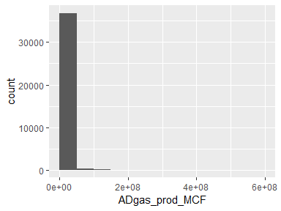

* Note that the following possible outlier values were detected: "6061957", "6063026", "6064537", "6064715", "6064989", …, "472476336", "516921980", "523429921", "537619834", "557239615" (2141 values omitted).

## oil_wells_dayson

|  |  |
| --- | --- |
| Feature | Result |
| Variable type | numeric |
| Number of missing obs. | 0 (0 %) |
| Number of unique values | 13373 |
| Median | 732 |
| 1st and 3rd quartiles | 0; 20229 |
| Min. and max. | 0; 20529331 |

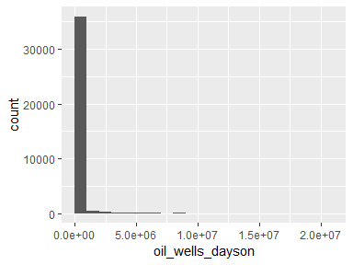

* Note that the following possible outlier values were detected: "538138", "538221", "539469", "539488", "539629", …, "18653292", "18714027", "18744502", "18950934", "20529331" (1840 values omitted).

## num_gas_wells

|  |  |
| --- | --- |
| Feature | Result |
| Variable type | numeric |
| Number of missing obs. | 0 (0 %) |
| Number of unique values | 2883 |
| Median | 1 |
| 1st and 3rd quartiles | 0; 55 |
| Min. and max. | 0; 22891 |

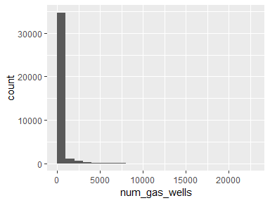

* Note that the following possible outlier values were detected: "1578", "1579", "1580", "1581", "1583", …, "20262", "20547", "21316", "21586", "22891" (1516 values omitted).

## NAgas_prod_MCF

|  |  |
| --- | --- |
| Feature | Result |
| Variable type | numeric |
| Number of missing obs. | 0 (0 %) |
| Number of unique values | 19276 |
| Median | 8097.5 |
| 1st and 3rd quartiles | 0; 3455082.75 |
| Min. and max. | 0; 4403588033 |

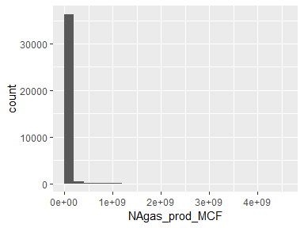

* Note that the following possible outlier values were detected: "106288352", "106388910", "106625151", "106751200", "106868685", …, "1517730796", "1543618072", "1555722249", "1620157808", "4403588033" (1583 values omitted).

## conden_prod_BBL

|  |  |
| --- | --- |
| Feature | Result |
| Variable type | numeric |
| Number of missing obs. | 0 (0 %) |
| Number of unique values | 12759 |
| Median | 0 |
| 1st and 3rd quartiles | 0; 11818.5 |
| Min. and max. | 0; 101923219 |

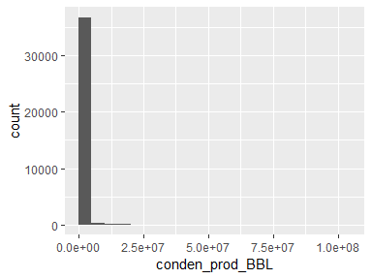

* Note that the following possible outlier values were detected: "368019", "368039", "368778", "369068", "369389", …, "82799635", "83306127", "86267250", "90836584", "101923219" (3695 values omitted).

## gas_wells_dayson

|  |  |
| --- | --- |
| Feature | Result |
| Variable type | numeric |
| Number of missing obs. | 0 (0 %) |
| Number of unique values | 12627 |
| Median | 365 |
| 1st and 3rd quartiles | 0; 17931.25 |
| Min. and max. | 0; 8187788 |

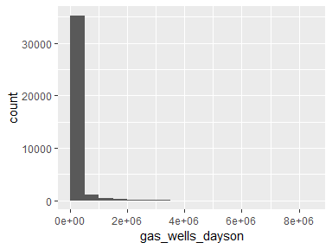

* Note that the following possible outlier values were detected: "507866", "508309", "508375", "508741", "508972", …, "7342243", "7468223", "7731613", "7788045", "8187788" (1975 values omitted).

Report generation information:

* Created by: mmccormick14 (username: mmcco).
* Report creation time: Thu Dec 16 2021 18:34:06
* Report was run from directory: C:/Users/mmcco/OneDrive/Desktop/shiny-oil-growth
* dataReporter v1.0.2 [Pkg: 2021-11-11 from CRAN (R 4.1.2)]
* R version 4.1.2 (2021-11-01).
* Platform: x86_64-w64-mingw32/x64 (64-bit)(Windows 10 x64 (build 22000)).
* Function call: makeDataReport(data = data)