1. Go to <https://github.com/> Sign in or sign up.



1. We recommend creating a team to keep your lab’s projects together. Typically, this group will be called by the PI’s surname, such as PayneLab in our examples. For more instructions on creating a team, visit: <https://help.github.com/en/github/setting-up-and-managing-organizations-and-teams/creating-a-team>
2. Create a new repository. Creating it on the lab page is recommended.



Repositories may instead be created on an individual’s account.

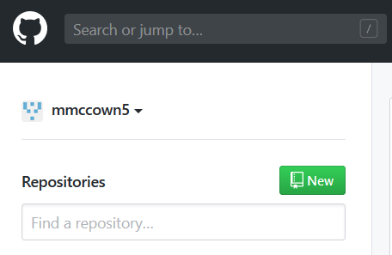

1. Add initial information. On the “Create a new repository” page,

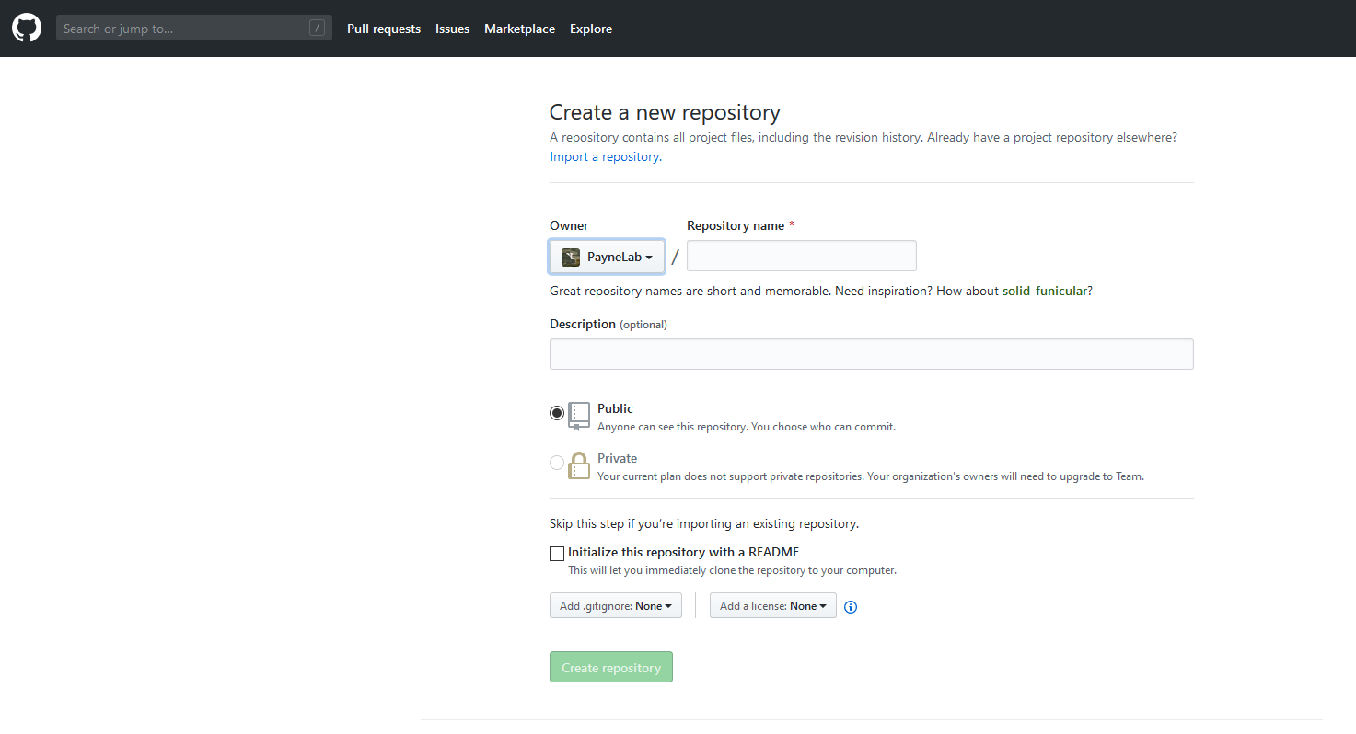

Next, name the repository. This name is generally brief, and a more length description may be provided in addition. Note the owner here is set to the lab.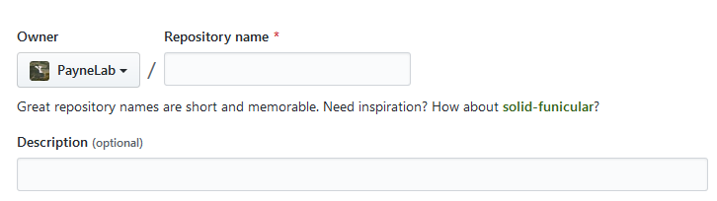

Choose whether the repository is public or private. For publication, this should be public. 

There are three final options. To upload a finished directory as a repository, a README and .gitignore do not need to be added here. Github also provides several common licensing options which we will not discuss here.

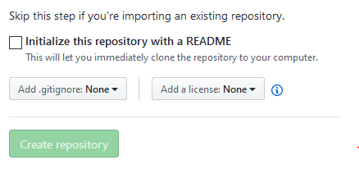

1. There are four options to connect code. The simplest is to upload existing files. Under Quick setup, follow the link for “uploading an existing file.”

