Project 3: Object Oriented Chess

Problem Definition:

This program will let two players play chess. A very basic interface will allow the user to load a chess board from a file using the Smith Notation, display a board on the screen using a text user interface, change the position of the different pieces, and finally write the status of the game to a file using Smith Notation.

Design Overview:

The board is an 8x8 array of characters. Each character refers to a single piece. Uppercase letters are black pieces, and lowercase letters represent white pieces. Additionally there is an array of moves which keeps track of the game.

When the board is read from a file, moves will be automatically loaded into the game, parsed for any problems, and then adjusted to display on the board. It works exactly as if the user were to enter the moves one move at a time. The user is given an opportunity repeatedly to enter moves until they specify to quick.

Interface Design:
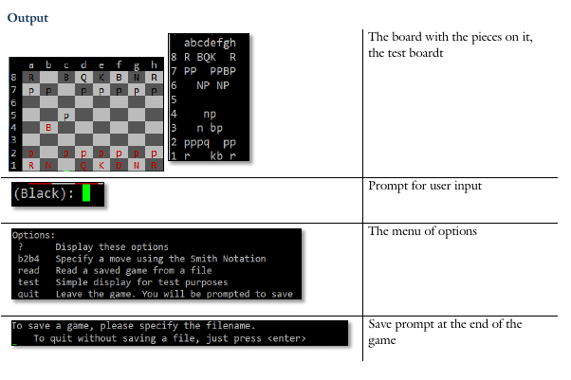
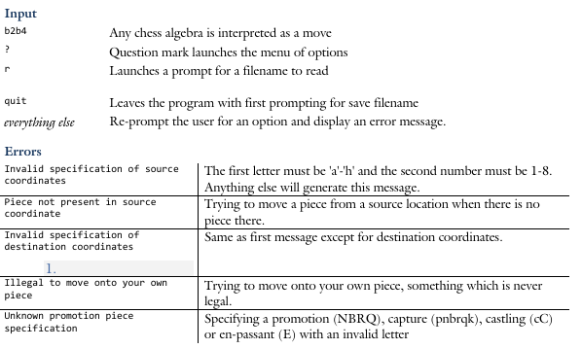
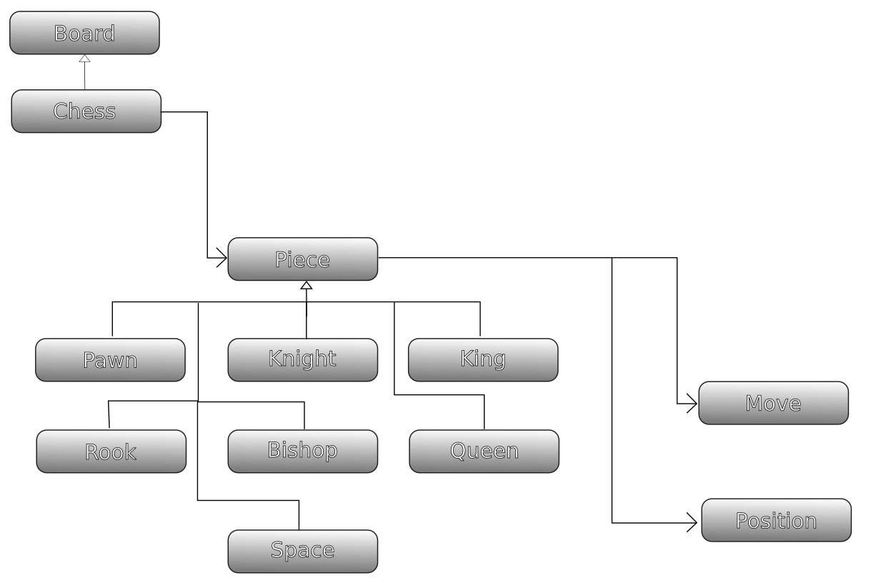

Structure Chart:
Board
- test
- allocated
-square
+ Board
+ getPiece
+ swap
+ resetBoard
+ freeBoard
+ getTest
+ setTest
+ []
+ <<

Chess
-board
-move
-moves
-numMoves
-fileName
-fQuit
+Chess
+interact
+displayOptions
+displaySmith
+getFileName

Move
- source
- dest
- piece
- capture
- enpassant
- castleK
- castleQ
-isWhite
-error
+ Move
+ Move(copy)
+ getDes
+ getSrc
+ getText
+ getPromotion
+ getCapture
+ getEnPassant
+ getCastleK
+ getCastleQ
+ getWhiteMove
+ ==
+ !=
+ =
+ <<
+ >>
+ setCapture
+ setWhiteMove
+ setSrc
+ setDes
+ setEnPassant
+ setPromote
+ setCastle
Position
- row
- col
+ Position
+ Position(row, col)
+ getRow
+ getCol
+ setRow
+ setCol
+ isValid
+ =
+ ==
+ >>
+ <<

Piece
-+ Position
-+ isWhiteSquare
-+ letter
-+ fWhite
+ Place()
+ Place(white, row, col, letter)
+ display
+ getLetter
+ getScore
+ getColor
+ isWhite
+setSquareColor
+ <<

Pawn : Piece
- fMoved
+ Pawn(white, row, col)
+ getMoves
+ getScore

Rook : Piece
-fMoved
+Rook (white, row, col)
+ getMoves
+ getScore

Knigth : Piece
-
+ Knight (white, row, col)
+ getMoves
+ getScore

Bishop : Piece
-
+ Bishop (white, row, col)
+ getMoves
+ getScore

Queen : Piece
-
+ getLetter
+ getMoves
+ getScore

King : Piece
- fMoved
+ King (white, row, col)
+ getMoves
+ getScore

Space : Piece
-
+ Space()
+ Space(white, row, col)
+ getMoves
+ getScores

Algorithms:
FUNCTION freeBoard
IF (allocated is true)
FOR ( i=0, i<8, i++)
FOR (p=0, p<8, p++)
Delete square[i][p]
ENDFOR
ENDFOR
ENDIF
ENDFUNCTION
FUNCTION displayOptions
PUT: Options: <NEWLINE>
?
B2b4
Read
Help
Test
Rank
Quit
Smith
ENDFUNCTION
FUNCTION getText
IF (error with the length)
RETURN error
ENDIF

PUT source and destination

IF (enpassant)
PUT “E”
ENDIF

IF (castleK)
PUT "c"
ENDIF

IF (castleQ)
PUT "C"
ENDIF
IF (space not empty)
PUT original piece
ENDIF

IF (capture and not empty)
PUT lower case letter or upper case letter in place
ENDIF

RETURN results

ENDFUNCTION

File Formats:

The game store every move in an array which is written to a file at the end of the game in Smith Notation.
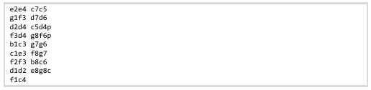

When the file is read, each move is “played” exactly as if the user was to enter each move by hand.

Error Handling:

