Alleluia, Alleluia, Alleluia

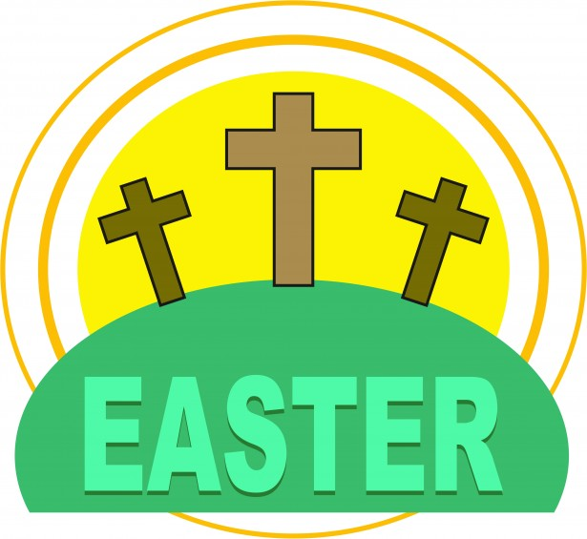

Blessing

May the joy and the confidence of Easter be ours, both in our personal lives, and in our life of obedience and discipleship in the world.

By John Harvey

It's a different, quiet Easter! This is the day our Lord has made: it is time to meet and rejoice in the risen Lord! In the garden of our life, perhaps we don't see clearly, yet this year, he calls us by OUR name! He offers a stunning new take on our life; giving inconceivable hope and friendship.

Let us celebrate this particular Easter day, counting our many blessings. We are formed and equipped differently, shaped to see what God has in store for us. Trust, and obey. Christ Jesus steps before us and knows the way.

May we have grateful hearts for others who keep us safe, work and care for our wellbeing. We are a global village today.

May our transformed lives shine out reaching to others, to the healing of our beautiful planet and its creatures, to us, as the apple of God's eye, to be the people God created us to be, with a new vision.

Let us be Christ to one another! Let us pray for one another: keep talking to each other: it is the voice of Jesus that Mary recognised. Let us be a people of prayer, Resurrection people, newly formed, different, thankful and joyful.

Revd Kathy Barrable, wardens, lay reader and congregations.