**SEVEN WORDS FROM THE CROSS**

**FOR GOOD FRIDAY**

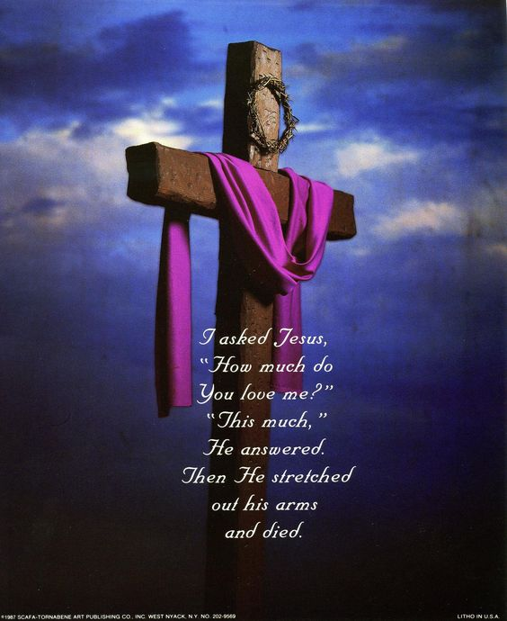

This service starts at 12 noon, the time Jesus died. We reflect on the last words uttered.

Each reflection will be preceded by music for prayer. Words in bold are said together.

1. ***Father, forgive them, for they no not what they are doing***

*Meditation and music*

Before you die, Jesus Christ,

And the world goes into deep darkness,

Take our lives, from our souls,

From our consciences

All that has offended you,

All that has hurt others.

And the obstinacy

Which has made us numb

To the plight of those whom we could help or heal.

Lamb if God, you take away the sin of the world

**Have mercy upon us**

Lamb of God, you take away the sin of the world

Have mercy on us.

Lamb of God, you take away the sin of the world

**Grant us your peace**

On this day, at this time,

Irrespective of our faith or lack of it,

We accept deeply in our hearts

The only words that can set us free;

Your sins are forgiven,

Your sins are forgiven. **Amen**

***Music and reflection……………………………..***

1. ***Today you will be with me in paradise***

Lord Jesus, remember us

When you come into your kingdom

Remember us, not for our impressive CV.

Nor the things we hope will appear in our obituaries

Remember us

Not for the virtues we occasionally display

Or for any credit

We think we have in our oral account.

Remember us,

As one of the criminal community

Who hung at your side,

And if life will not let us be in paradise

With you today,

Keep a place for us.

**Amen**

***Music and reflection……………………………….***

1. ***Mother, there is your son……………***

For our families, where they are open, loving, supportive,

That their joy might be kept safe, Lord hear us,

***Lord graciously hear us***

For our families,

Where they are tense, troubled, fragmented,

That they may find a way through the pain,

Not a path away from it,

Lord hear us.

**Lord, graciously hear us**

For our churches,

Where they have become introverted

Suspicious of the stranger

Obsessed with dead rather than living stones

Suffocated by correctness and tradition

That they might be redeemed

From the pawnshop of past glory

And renewed by the power of the Holy Spirit

Lord, hear us.

**Lord, graciously hear us**

For ourselves, in this place of worship

Surrounded by people

Whose journey we have not travelled,

Whose depth of faith we do not know,

Whose potentials we cannot imagine,

That we might somehow know we belong to each other

**Lord, graciously hear us**

And before you leave the cross

And we vacate this building,

If there is one of our family

For whom we should care more fondly,

Direct our gaze to them,

As you turned Mary towards John.

**Amen**

***Silence and meditation………………***

1. ***My God, my God, why have you forsaken me?***

Lord Jesus

By your cry of desperate honesty,

Rid us of superficial faith

Which is afraid of the dark.

Not so that we might be justified pessimists,

But so that we might discover profound joy.

Give us, when we need it,

The courage to doubt, to rage, to question,

To rail against heaven until we know that we are heard.

We do not ask for easy answers to hard times;

There are many who can offer these.

We ask for a sense of your solidarity,

That will be enough

To let us know

That we do not walk or cry alone;

That will enable us to go through the dark

And find light again in the morning

**Amen**

***Silence and meditation………………***

**Amen**

1. ***I am thirsty***

You have made us for yourself.

We know it, even if we cannot name it.

We have had these bodies and these minds

Long enough to learn to live with our limitations

Yet, despite this, something hankers, yearns, thirsts

For something better, which we know is there.

Beautiful music ends

And we wish it could continue.

We embrace,

Then refrain from embracing

And wish that we could be held forever’

We think deeply, or feel deeply

And wish that this sense of being caught up in living

Would not be interrupted by the mundane things of life.

We sense the disappointment

In dashed hopes that deserve to be fulfilled.

In missed opportunities

Which should have led to joy not frustration.

In people whose potential has been buried

or denied and deserves to flourish.

So much of life demands a resolution.

So thank you for this incompleteness,

Thank you for this yearning,

Thank you for this thirst.

Thank you for giving us enough of you to want more,

And to sense the fullness of eternity

With the limits of time.

1. ***It is finished***

Now Lord Jesus,

You can let go of us.

You have convinced us of our sin

And you have forgiven it.

You have convinced us of your way

And have engaged us on it.

You have shown us a foretaste of heaven

And have made us a part of it.

You can let go of us now.

Having overcome the sin of the world,

Death will be a small obstacle

Just as you foretold

That you would be handed over to be crucified

And this has come true; also you foretold

That on the third day You will rise again

And we will be your witnesses.

**Amen**

***Silence and meditation………………***

1. ***Father, into your hands I commit my Spirit***

God, who before your birth, called you into being,

Now calls you back, his accent still the same.

Lord Jesus, we will let you go.

You cannot cling to life forever,

Nor can we cling to a dying frame, nor do we grudge you

That peace which passes all understanding

Which you have promised to us.

Go to heaven, where you will welcome those

Who die in your faith

Whose death, with your death, we remember

Tell them that we love them. That we miss them.

Even if we need to forgive them,

That they are not forgotten.

And cheered by the prospect of a day

When there will be no more death or parting.

And all shall be weak, and all shall be one,

May they who have died before us

Be among the first to welcome us to heaven

Where, with you enthroned in glory,

And in the company of the Blessed Virgin Mary,

And all the saints, Keep us in faith, fill us with hope,

Deepen us through love,

To the glory of your holy name

**Amen**

***Silence and meditation………………***

***Please leave the church in silence.***

***You are welcome to stay as long as you like.***

Seven words from the Cross’ copyright 1998 Iona Community Glasgow G51 3UU