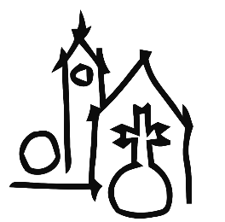
Auld Kirk Charitable Trust

Art &Crafts Fayre
Auld Kirk, Castle Street,
Tayport DD6 9BY
(Next to Primary School)
Saturday and Sunday
17th & 18th May 2025
10.00 am – 4.00 pm

- Craft stalls with handmade goods
- Art for sale by various local artists
- Guess the weight of the cake
- Raffle of Luxury Hamper

Tea/coffee £1.50
All donations go towards the repair/upkeep of the building
Please come and support us!
FREE ENTRY

