**TAYPORT AULD KIRK**

**CASTLE STREET, TAYPORT DD6 9BY**

**(NEXT TO PRIMARY SCHOOL)**

FRIDAY 6TH OCTOBER 2023

7.30 - 9.30PM

**AULD KIRK CHARITABLE TRUST**

**in conjunction with**

**TAYPORT DISTILLERY**

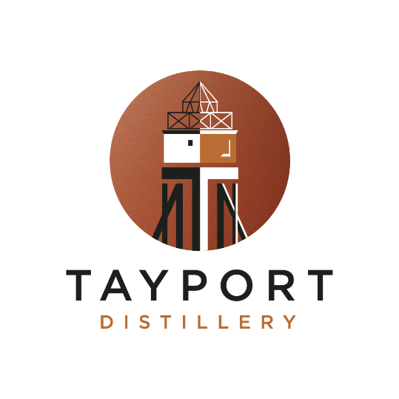

**TASTING EVENING**

Come along and taste a selection of our local distillery’s products

Tickets £15 per person, including nibbles

Tickets available from Dr Christine Barker – Tel: 01382 553701

Auld Kirk Charitable Trust: Scottish Charity Number SC034963