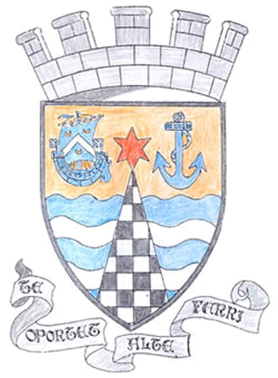
Tayport Ferryport-On-Craig Community Council

Agenda for the Annual General Meeting of Community Council to be held on
Monday 6th May 2019 at 19:00hrs

19:00 Apologies
Declaration of Interest
Minutes of April Meeting

19:10 Guest Speaker – Mr D Baikie

19:20 Matters Arising from previous meeting

19:30 Annual Report from the Chair

19:40 Treasurer’ Annual Report

19:50 Police Matters

19:55 Foodbanks Report

20.00 Action Plan Report

20:10 Fife Council and Other Correspondence

1 Tayport Unknown Bairn – memorial and anniversary
2. Taybridgehead Joint Community Council Forum
3. Application to purchase land adjacent to 54 Queen Street , DD6 9LQ
4. Short Term Lets – Consultation
5. Tayport Car Park – Charging Point.

20:20 Planning Applications

1. Single storey extension at 10 Banknowe Terrace DD69LL
2. Erection of dwelling house (substitution of housetype on Plot 3)
Land to the north and south of Forgan Drive , Drumoig
3. Erection of ground floor extensionat 42 Craigie Hill , Drumoig
4. Planning permission in principle for 2 dwelling houses at
East Downiemount 48 Albert Street DD6 9AT
5. Alterations and extension at 43 Comerton Drive , Drumoig

20:30 Fife Councillors Report

20:45 Questions for Fife Council

20:55 AOCB

21:10 Date of next meeting

G M Beat
Secretary

