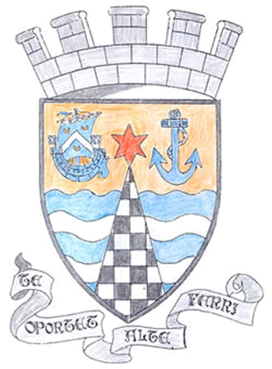
Tayport Ferryport –On-Craig

Community Council

MINUTES OF THE MEETING OF
THE TAYPORT FERRYPORT ON CRAIG COMMUNITY COUNCIL
HELD IN THE DOLPHIN CENTRE ON MONDAY 1ST SEPTEMBER 2025 AT 19:00 HRS

Present: Vice Chair: Mr B de Smid. Secretary: Mr G M Beat: Treasurer: Miss R McCallum
Messrs J Kinnear , N Sneddon:

In Attendance Cllr J Tepp , Cllr L Kennedy – Dalby
David Youle ,Jim Allan, Sharon Fearn, Rosalind Connor, William Ramsay, Lesley Reynolds,
Adele Fotheringham, William Hazle, Fiona McKercher , Ian Ferguson, Shelley Davie , , Roddy Davie , Morag Wallace, Caroline Byrne

Apologies Mrs S Walker , Mr E MacDonald , Mr D Myles

Minutes: The Minutes of the meeting held on 7th July were agreed

Declarations of Interest None

Issues Raised The Notice Board at the Burgh Chambers surface is now dirty and scratched making the
Notices illegible Font sizes and and Minutes could be larger.
Community Council to fund repairs . Copies of Minutes will be available in the Library and
following a request , in the Charity Shop .

Football Ground Access . Concern was raised that the Right of Way paths are padlocked
outside of match days and car boot sales . The Football Club advised paths are closed due
to overhanging trees in the area deemed dangerous . Members questioned why access is
allowed during matches if safety is the issue.
Secretary to continue discussions with the Football Club

Proposed new Co-op Store Lengthy discussion held on location, parking and access
concerns . Crawford Hazle’s rebuttal paper was commended.
Community Council to clarify with Fife Council whether an objection can still be lodged
Copies of the rebuttal to be placed in the Library
Notice to be shared via Facebook and the Mutual Aid page .

Thanks were expressed to Shelley Davie for s contribution to the Christmas Lights fund
donated from the Funeral Collection of her late mother ,Peggy Hunter . en

Matters Arising from Previous Meeting

1. Roundabouts at the School and Maitland Street are in very poor condition , Maitland Street
Is almost unrecognisable ..Issue to be raised again with Fife Council . Residents encouraged to log
Complaints online to strengthen the case.
2. Ongoing hole in the road on Maitland Street is managed by Scottish Water .
3. In Rose Street the area beside the former Band Hall is overgrown This is privately owned
4 At the Pond the reeds are to be cut back and concern have been raised over long grass and debris
being left behind after football games on the Common
5. Spearshill sign has been repaired
6. The new Tayport Signs are noted.

Foodbank Report None

Treasurer’s Report

Christmas Lights fund progressing well with regular donations
Plans to use Community Council funds for planting tubs during Winter/Spring

Agenda Items /Discussion | Action
Fife Council and Other Correspondence

1. Citizen of the Year Award on Saturday 20th September , Gregory Hall 2pm
2. Christmas Lights :Funding progressing well , final figures to follow
3. Fife Council Works ;Rock armour at Caravan Park and Harbour Road Path in
progress .Town Clock repaired. Road markings are being renewed.
4. Yarn Bombing has received a Positive feedback, thanks to those involved
5. Football Ground .Right of Way ; Already discussed

Planning

1. 23/03148/CNDO 01 LBC@9 Inn Street DD6 9AZ
Compliance with condition 1 of Listed Building Consent
Boundary Walls/Method Statements

Fife Councillors Reports  Extension of St Andrews – Dundee cycle path discussed  Concerns raised regarding Grounds Maintenance, Cemetery cleaning , grass cutting  Bins and street cleaning  Cllr Tepp noted that Staff Issues should be reported directly, apparent idling in vans  usually has valid reasons .  Funding for weeding and cleaning is limited and prioritised accordingly  Speeding on the Tay Road Bridge was raised , Cllr Tepp has discussed with the  Bridge Manager | .
Summary of Actions and Decisions

1. Notice Board - Community Council to fund repairs , copies of minutes to be
placed in Library and Charity Shop
2. Football Ground Access - Secretary to continue discussions with Football Club
locked paths and safety concerns
3. Proposed Co-op Store - Community Council to check with Fife Council whether
an objection can still be lodged
Copies of rebuttal document to be held in Library
Information to be shared on Facebook and Mutual Aid

Meeting closed at 9.15 pm

Date of next Meeting 6th October at 7 pm in Dolphin Centre

