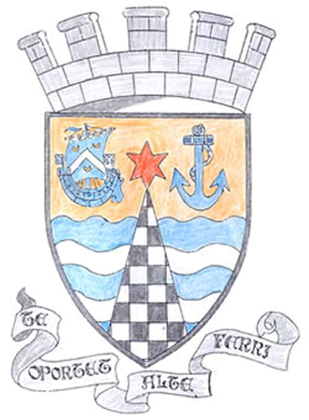
Tayport Ferryport –On-Craig

Community Council

MINUTES OF THE MEETING OF
THE TAYPORT FERRYPORT ON CRAIG COMMUNITY COUNCIL
HELD IN THE BURGH CHAMBERS ON MONDAY 3rd FEBRUARY 2025 AT 19:00 HRS

Present: Chair: Mrs S Walker. Secretary: Mr G M Beat: Treasurer:Miss Rhona McCallum

Messrs N Sneddon , D Myles , J Kinnear , E MacDonald , B de Smid

In Attendance: Councillor J Tepp , Jan Davidson

Apologies: Councillor Louise Kennedy Dalby

Declarations of Interest : Mr D Myles – Foodbank

Minutes: The Minutes of the meeting held on 2nd December 2024 were agreed

Matters Arising from Previous Minutes:

1. Camper Vans at both East Common Car Parks . Robbie Blyth from Fife Coastal Paths is willing to
help in discussion. Such as areas where 1 night Parking is allowed Could signage be an Option .
2. School barriers have been replaced
3. Bins at Broad Street – returned to the rear of the Bell Rock Bar, only brought out on Collection Day
Thanks to Vicky Walker of Fife Council for her intervention.
4. Mud on B945 from Farm vehicles , notices should be erected and Farmers must rectify or it becomes
an offence . Can be reported as a road fault to the Fife Council site
5. Once again road markings and drains need urgent attention , list made
6. Storm Eowyn, Final Report available , mailed out to Members
7 Town Clock has gone haywire .
8 Larick Centre Community Consultation posters are being put up

.
Agenda Items/Discussion  Police; No questions | Action
Foodbank Report:

Numbers of clients up , Food donations down .Applied for 2 grants (From Pilkington
Trust and Fife Council) .No Utility assistance given out as no funds available .
.
Treasurer’s Report :

All Fife Council Grants received . Refund for Christmas Lights from Blachere also .
received ..For Flower Grant , Jim Kinnear is to pull together a list of plants for tubs ..
PLANT may be able to raise plants .

.
Fife Council and Other Correspondence :

1. Operation Kukhri Dawn at Leuchars , Exercise from 3/2 – 14/2 , increased
Flying activity . Enquiries should be directed to Air Traffic Control at Leuchars
2. Local Place Plan emailed out to Members . Jan from PLANT is looking for TCC
to take on formulation of plan/consultation . Detailed place plans are online for
St Andrews , Largo etc . Share to TCC Facebook page to gauge interest in plan
Councillor Tepp is going back to local Place Planning department for more
Information , regarding closing dates etc.
3. Dolphin Centre putting out a newsletter and could add about local Place
Planning
4. Emergency Resilience , Newport , Wormit ,Forgan Plan to be adopted locally for
Tayport
5. Taybridgehead Forum , raised the issue of SSEN works at Guardbridge leading
to regular delays of School buses and disruption locally , many points made .. 6. Christmas lighting , subgroup to be set up to look at funding etc .
7. Burgh Chambers Cedar tree lost a 25 foot branch in the storm .. Reported to
Fife Council . Councillor Tepp will speak to Fife Council to check damage’

Planning:

None.

Fife Councillors Report

1. Traffic Wardens asked to visit Shanwell Road turning circle to enforce parking
2. Speed Survey on William St , cause for more action to be taken.
3. Concerns raised about buddleja seeding,/spreading and causing damage
4. EV charging - looking at legislation on charging EV vehicles over pavements

Questions for Fife Council

1. Drains still needing cleared , list made .
2. Scotmid ,cars parking and blocking deliveries ,road markings required or
Wardens to be informed.
3. Harbour Road , path is subsiding
4. Burn by Community Garden needing cleared .
5. Community Payback did a great job repainting and gardening at Dolphin Centre
6. Town Clock , time wrong and chiming randomly

A.O.C.B.

TCC Facebook page , more admin added , but still needs work
Questions asked about what TCC’s remit is

Date of next Meeting Monday at 7pm in Dolphin Centre

The Meeting closed at 9.00 pm

G M Beat Secretary

