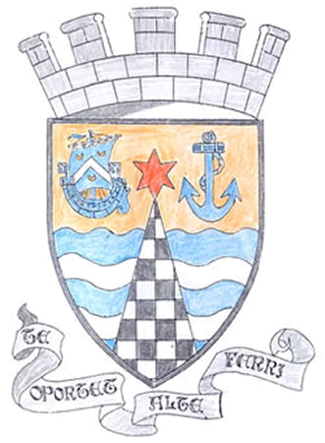
Tayport Ferryport –On-Craig

Community Council

MINUTES OF THE MEETING OF
THE TAYPORT FERRYPORT ON CRAIG COMMUNITY COUNCIL
HELD IN THE BURGH CHAMBERS ON MONDAY 1ST JULY 2019 AT 19:00 HRS

Present: Chair: Mr D Gray: Secretary: Mr G M Beat: Treasurer: Mr J Kinnear
Mrs M Taylor, Mrs S Walker, Mrs H Lowe .

In Attendance: Cllr Tim Brett , Cllr Bill Connor

Apologies: Mrs L White , Ms N Walker , Mr D Myles , Mr M Mitcham

Declarations of Interest: Mr G Beat regarding planning at 14 Harbour Rd , Mrs H Lowe regarding planning at
24 Banknowe Ave .

The Minutes of the meeting held on 3rd June to be agreed at the September meeting

Matters arising from previous Minutes :.

1. Provision of Memorial Bench for the late Mrs Fisher is back on track
2. Applied for Grants for Green Flag , from Locality Budget £5000 granted , awaiting reply from RBLS
3. Letter of support to Tayport Football Club for retention of present football pitch, wider consultation should be considered .
4. The boat at the harbour was planted by schoolchildren from Primary 4 . thanks to all others who helped .
5. Donations received towards flower tubs all other donations will be accepted .
6. Tentsmuir point Education Centre was opened , Mrs Jean Massie attended to represent Tayport CC
7. Hub News , looking for name for the centre and planned for mid October opening .
8. Community Councill will have a stall at the Gala
9. Beautiful Fife Judging will be on 18th July , we will have new flags on boats and the Memorial Garden
needs some attention . .

Agenda Items /Discussion | Action
Police:
Were unable to attend , Report will be sent out later

Foodbanks Report:
No report , noted that the group have received a considerable sum of money .
Treasurer’s Report:  £125 of sponsorship received , with more to come . Suggested we seek more donations using Notice Boards and Facebook to advertise .  Thanks to Mr Balsillie for planting out the boat at Scotscraig Drive | .
Action Plan:

No Report

Fife Council and Other Correspondence:

1. Blachere Illuminations have agreed to have the Christmas lights fitted and ready for switch on Sunday 1st December , also getting a refund of £43.00 for an overcharge last year .
2. Tayport Harbour Trust are carrying out remedial work on rough ground at the bottom of Foundry Wynd .
3. Scottish Water are asking for feedback on their quality of service .
4. Café inc project is a free lunch club open to children , young people and families in North East Fife at Various dates published on posters etc throughout the region , in Tayport 9th July – 31st July in Tayport School

Planning:

1. Erection of porch extension to front and side of 14 Harbour Road DD6 9EX
2. Erection of fence (retrospective) at 24 Banknowe Ave DD6 9LJ
Concerns raised about sight lines and traffic safety
3. Approval for the erection of dwelling house at 44 Grey Street DD6 9HU
Letter to planning sent previously .
4. Certificate of Lawfulness (proposed) for erection of double garage at 1
Banknowe Road DD6 9LG
5. Non material variation to erection of dwelling house on Land to the North and
South of Forgan Drive , Drumoig

No objections to 1, 4 and Comments made to 2 and 3 .

Fife Councillors Reports:

Written reports given and appended

Questions for Fife Council:

1. 20mph sign in Queen Street is obscured by growth
2, Could the play area beside the Library be available during the Summer . Contact Play Group
3. Questions reference access to Rights of Way at football ground and about lease or purchase .
Discussion on consultation with the Community including possible press notice .
4. Mr J Cowie , (A member of the Public) raised questions about the condition of the Cemetery ,
Especially footpaths . What is Fife Council Policy towards maintenance of Graveyards as there
is concern at the quality of work and shortage of staff .

Meeting closed at 8.45 pm

Next Meeting on Monday 2nd September at 7.00pm

