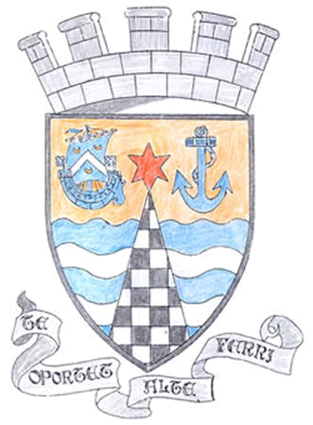
Tayport Ferryport –On-Craig

Community Council

MINUTES OF THE MEETING OF
THE TAYPORT FERRYPORT ON CRAIG COMMUNITY COUNCIL
HELD IN THE BURGH CHAMBERS ON MONDAY 3rd JUNE 2024 AT 19:00 HRS

Present: Chair: Mrs S Walker , Secretary: Mr G M Beat:
Messrs J Kinnear , B de Smiid , N Sneddon , D Myles , E MacDonald

Attending Councillor J Tepp

Apologies: Mrs R Dawson , Miss R McCallum , Councillor L Kennedy-Dalby

Minutes: The Minutes of the meeting held on 6th May were agreed

Declarations of Interest: D Myles – Foodbank

Matters Arising from Previous Minutes

1. Cross Street – still leaves on pavement
2. Pond Lane – Kerb now repaired
3. Mercury Cottage Path – completely overgrown
4. Spearshill to Scotscraig Drive – undergrowth needs cut back
5. St Michaels Road – trees needing trimmed
6. East Common – Giant weeds and grass cuttings and broken trees not cleared, requires maintenance
7. East Common –Coastal erosion adjoining the Caravan site, dangerous as high grass is hiding the
edges of the erosion
8. King Street , potholes and broken surface needing attention

Police Matters:
Report submitted to Members , Parking at Primary School noted as an issue – No questions
for Police

Foodbanks Report: Numbers of clients steady , food donations are down , Cash Donations received
from Rotary and the Pilkington Trust , more Volunteers are needed , especially in
the Newport Area

Treasurer’s Report: N/A

Agenda Items /Discussion | Action
Fife Council and General Correspondence

1. Christmas Lights , posts put up looking for Volunteers to help with a Lights
Committee , little response as yet . Secretary to discuss costs with Blachere
2. Citizen of the Year , Voting boxes at Larick and Library , Suggestion made
for this year’s Commendation .

3. Beach Advertisement , Company speaking to Fife Council , Nature Scot etc ,
for relevant permissions .
4. Community Speedwatch , 14 Volunteers and 5 registered for Interest in
North East Fife .
5. Tay Bridgehead Forum Meeting will take place at Guardbridge Bowling Club
on12th June
6. Cross Street – Temporary Road Closure – Diversions in Place
7. Summary of Insurance Cover for Community Councils will remain with
Zurich Municipal for 2024 – 2025

Planning

1. 11/05909/CDC1 Completion of Development for 11/05909/FULL extension
to Dwelling House at 9 Greenside Place DD6 9DE
Fife Councillor’s Report.

Cycle Path – Embankment Repaired
Burn Edge / Coffin Walk – Resurfaced , Community Councillor visiting site with Fife
Councillor J Tepp to show existing issues
Road Maintenance - Barriers can be reported to Fife Council if left behind when work is finished .
Disabled access/ dropped kerbs – serious infractions /blocking should be reported
Election on 4th July , Postal Votes are available
Flooding – Fife Council asking for an audit/review of flooding support scheme

Questions for Fife Council .

Castle Street kerbstone (outside former Coloured Soul shop)needs repair
Road signs , especially to Tay Road Bridge, are obscured by undergrowth
Have the Welcome to Tayport Heritage Signs received funding
Sightlines at top of Glebe Gardens/Queen Street obscured by parked vehicles .
Excessive tractor speed at Shanwell

A.O.C.B

Planters throughout Tayport to be maintained
Motor bikes speeding on Newport Road
Resident’s request for minutes to be posted in timely manner and printed copy available in Library.

The meeting closed at 8.40 pm

Next Meeting in the Burgh Chambers at 7.00 pm on 1st July 2024

