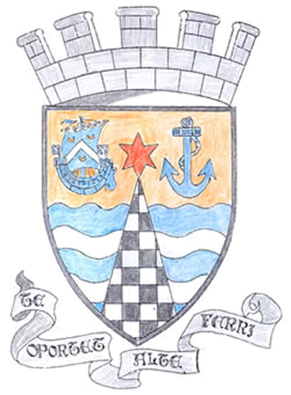
Tayport Ferryport –On-Craig

Community Council

MINUTES OF THE MEETING OF
THE TAYPORT FERRYPORT ON CRAIG COMMUNITY COUNCIL
HELD IN THE BURGH CHAMBERS ON MONDAY 4TH MARCH 2024 AT 19:00 HRS

Present: Chair: Mrs S Walker: Secretary: Mr G M Beat: Treasurer :Miss R McCallum
Mrs R Dawson Messrs J Kinnear , B de Smid , N Sneddon , E MacDonald

Apologies: Mr D Myles , Councillor L Kennedy – Dalby , Councillor J Tepp

Statement by Mr David Finlay on the need for double yellow lines at Shanwell turning circle and farm access areas and need for Official No Parking sign on the Centre on the centre of the turning circle .

Minutes: The Minutes of the meeting held on Monday 5th February were agreed

Matters Arising from Previous Minutes :

1. Confirm Miss R Mc Callum as Treasurer and Chair , Mrs S Walker as signatories for Community
Council and retiral as Treasurer of Mr J Kinnear , confirm with Fife Community Council Staff .
2. Queen Street Crossing , is there sufficient time for children and adults to cross .
3. Shipping container on East Common appears to contain a mini tractor for gritting purposes and
will be removed later this year
4. Tay Bridge contraflow begins today , some signage requires to be clarified .
5. Bus Shelter at Shanwell – still waiting for it to be erected .
6. Community Council training resources – uploaded to dedicated website

Police Matters: No questions – Issued to all Members .

Agenda Items/Discussion | Action
Treasurers Report: No change from last meeting – No communication from Bank
.
Fife Council:and General Correspondence::

1. Community Council Insurance – Zurich have renewed the Policy for a
further year
2. Fife Council Committee Calendar - link sent
3. Loading Bay at Scotmid on Castle Street – Agreed
4. Temporary Road closure from Inverdovat A92 to B945 Tayport Road
5. Scottish Empty Homes Partnership Webinar taking place .
6 Temporary Traffic restrictions throughout Tayport for cabling by various
Firms may carry on for a considerable time yet and notices do not always
show the completion date.
7. Taybridgehead Forum on 20th March – Planning Officer to attend

Planning::  1. 24/00413/CLP Certificate of Lawfulness (proposed) for external alterations to  Dwelling house (removal of staircase , block up existing window and change  door to window ) at 3 Spearshill Road DD6 9HT. No objections | .
Fife Councillors Report:

Not available

Questions for Fife Council::

1. Sandyhill Road markings require repainting , also Give Way Notice
2. School railings /safety barrier missing near crossing , need renewed .
3. 2 Kerb stones in Pond Lane still broken or missing .20 yds from Nelson Street
4. Drains needing cleared – William Street {opposite School) and at the cottage
at the foot of the Loan
5. Bridge on burn edge /Coffin Walk – Foundations wearing away due to water
flow excess .
6. Bridge at Community Garden to Tennis Courts – wood planks need to be
replaced

A,O,C.B

The Dolphin Centre ownership is to be transferred at 3st March

The Meeting closed at 20.40

Next Meeting in the Burgh Chambers at 7 pm on 1st April 2024

