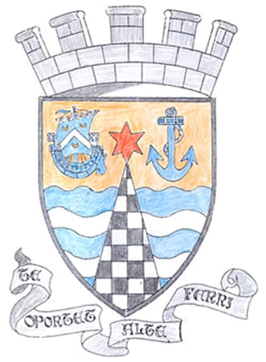
Tayport Ferryport –On-Craig

Community Council

MINUTES OF THE MEETING OF
THE TAYPORT FERRYPORT ON CRAIG COMMUNITY COUNCIL
HELD IN THE BURGH CHAMBERS ON MONDAY 5th FEBRUARY 2018 AT 19:00 HRS

Present: Chair: Mr C Veitch: Secretary: Mr G M Beat: Treasurer: Mr J Kinnear: Vice Chair: Mr D Gray
Mrs J Massie, Mrs S Walker Mrs H Lowe , Mrs L White ,Mr M Mitcham

In Attendance: Madras School Representative , Nicole Walker , Councillor B Connor , Councillor T Brett .

Apologies: Mrs M Davidson and Mr C Torrance . Both tendered their resignations and letters will be
sent out thanking them for their service on Community Council .

Minutes of the Previous Meeting – 4th December 2017: The minute was approved as an accurate record .

Community Council Membership: There were 3 Nominations for the 4 Vacancies on the Community Council They were duly elected .

Mr John Cuthbertson Proposer – Mr Robert Pirie Seconder – Mr Alec Burden

Mr Henry Orr Proposer – Mr Donald John McLeod Seconder – Mrs Margaret Wells -

Mrs Margaret Taylor Proposer – Mr Dave Green Seconder – Mrs Christine Mackenzie

Matters Arising from previous minutes :

1. Christmas Lights – there were a few problems throughout the lighting period , all dealt with , we are
meeting up with the Blachere Project Manager in April to look at next year’s programme .
2. Road works on B945 completed on time
3. Invitation to take part in this year’s Beautiful Scotland Programme , a meeting with Keith Jackson
of Fife Council and PLANT group will take place this month .
4. A bench to remember the late Tom Gray of William Street has been placed at the Common by North
East Fife Rotary . .

Agenda Items/Discussion | Action
Police Matters:

Report is appended .
Foodbanks Report:

There are at present 10 volunteers and 4 Drivers . Slight increase in numbers needing help although 3 long term clients off the list due to getting employment .119 people were helped over Christmas in Tay Bridgehead area ..

Finance Report:

Annual Grant paid into funds and a donation of £400.00 from Scotscraig Golf Club .
Action Plan /Emergency Planning

Action Plan carried forward , initial plan to be sent out to new members

Emergency Planning programme needs to be updated, Grants are available for equipment . Also refresher courses for CPR training suggested .

Fife Council and Other Correspondence:

1. Tayport Community Trust Review discussed , Trust AGM is in Tayport Parish
Church Hall on 22nd February
2. Forgan Old Kirk remedial work ongoing
3. Some grit bins returned , only 2 have gone .
4. Bus Timetables , changes proposed to services 70 and 53 later this year
5. Update on what can be put into green bins
6. Agreed to take part in Beautiful Fife 2018 Campaign
7. Food Waste bags are now available at Tayport Library , £1.30 for 25 bags
8. Scottish Fire and Rescue Service is for people who have a particular asset or
skill which could be used to support the Emergency Services . Volunteers can
get further information www.firescotland.gov.uk
9. Tayport Tennis Club granted permission to change to Charitable Status

Planning Applications:

1. Erection of dwelling house at 5 West Lights , Tayport .Concerns about disabled access, design , access
for works vehicles and agreement of neighbours passed from Community Council to Planner .
2. 26 Albert Street , Tayport - Extension to rear - Permitted with conditions
3. 42 Craigie Hill , Drumoig – Extension – Permitted with conditions

Fife Councillors - Written Reports appended

Questions for Fife Council:

1. Speed bumps in Queen Street are breaking up at their sides , need attention
2. Please look at Parking congestion on Castle Street
3. Dog fouling is on the increase , could wardens be informed.
4. Pot Hole at Tayport Primary School not filled properly .
5. Parking at the roundabout at the top of Scotscraig Drive should be monitored
6. Brambles and Ivy overgrowing on the footpath near the top of Ogilvy Street
7. Pavement outside 5 Nelson Street requires repair .
8. Wall supporting Castle Terrace has not been fully repaired .
9. Litter level , specifically bottles and cans , on West Common should be monitored

A.O.C.B.

Curling Pond now disposed to Fife Council from Dolphin Centre .
Post Box at old Post Office is now disabled
Tay Bridgehead Forum Meeting scheduled for 24th March in Burnside Hall , Balmullo
Photographs of Past Chairpersons of Community Council suggested
Access to maps showing boundaries requested

Next meeting on 5th March 2018 at 7 pm in the Burgh Chambers

The meeting closed at 9.16 pm

